“Will this anticancer drug suit my body? Predicting ‘treatment success rate’ before administration” GIST develops technology to quantify the efficacy of immunotherapy drugs based on individual cancer cell analysis
- Professor Jihwan Park's team from the School of Life Sciences develops technology to precisely predict responses to immuno-oncology treatment by analyzing tens of thousands of cells within tumors at the single-cell level… Overcoming the limitations of the ‘trap of averages’ in existing bulk analysis
- Quantitatively identifying cell-specific genetic errors and intratumoral heterogeneity accelerates the era of ‘1:1 personalized precision medicine’… Published in the international journal Briefings in Bioinformatics
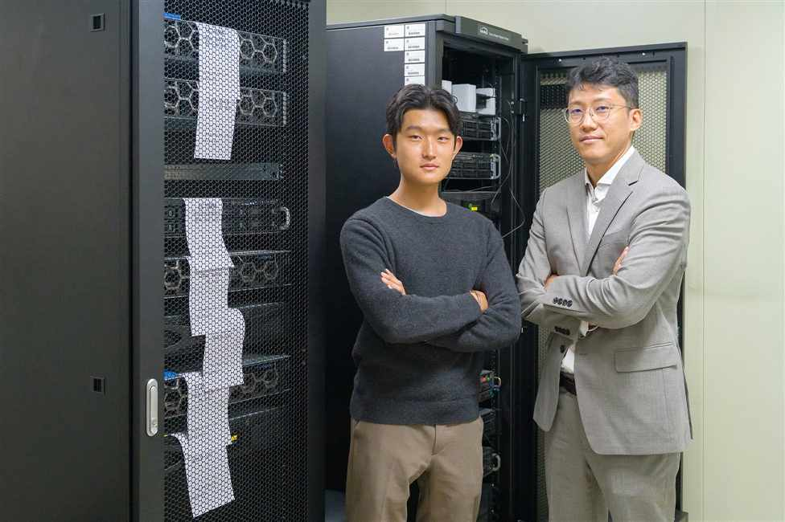

▲ (From right) Professor Jihwan Park from the School of Life Sciences, and Gyumin Park, integrated master's and doctoral student
A "personalized diagnostic technology" capable of accurately predicting the response to immunotherapy by precisely analyzing even minute differences within a tumor at the cellular level has been developed by Korean researchers. This technology is expected to significantly enhance the potential for one-on-one personalized cancer treatment based on individual patient characteristics.
The Gwangju Institute of Science and Technology (GIST, President Kichul Lim) announced that a research team led by Professor Jihwan Park from the School of Life Sciences has developed an analysis technology (scMnT) capable of precisely predicting the response to immunotherapy at the single-cell level.
This technology is significant in that it overcomes the limitations of existing "bulk analysis," which analyzes multiple cells simultaneously and only looks at average values, by enabling the quantitative identification of differences within each individual cell that makes up a tumor.
Immunotherapy is a treatment method that activates the body's immune system to induce immune cells to recognize and attack cancer cells.
However, even for the same type of cancer, treatment efficacy varies significantly depending on the patient; in some cases, the treatment is ineffective or an excessive immune response occurs.
* immunotherapy: A treatment method that does not directly target cancer cells but rather activates the patient's immune system to induce it to attack the cancer cells.
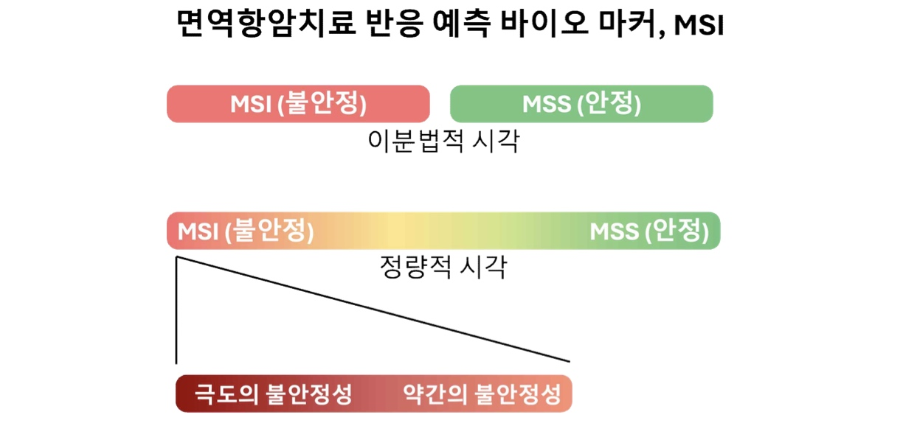

▲ Conceptual diagram of MSI, a biomarker that predicts the response to immunotherapy. Current immunotherapy relies on a simple dichotomous (Positive/Negative) approach that assesses only whether a patient possesses MSI. Based on the observation that cells in various states coexist within a tumor, this study proposes a new analytical framework that suggests MSI should be understood not merely as a 'presence or absence,' but as a quantitative 'intensity.'
These differences are closely related to the genetic characteristics of cancer cells.
During cell division, cells replicate DNA and transmit genetic information. During this process, 'insertion and deletion errors' can occur, in which the bases (A, T, G, C) that make up the cell are incorrectly inserted or omitted. In particular, in sections where the same base is repeated, such as ‘AAAAA’, errors such as an extra base being inserted (AA→AAA) or a missing base (AAA→AA) occur relatively more easily during the replication process.
Normally, these errors are repaired, but if there is a problem with the repair function, errors accumulate, leading to ‘microsatellite instability (MSI)*’. Cancer cells with high MSI are known to respond relatively well to immuno-oncology because they produce more abnormal proteins (neoantigens) that are easily recognized by immune cells.
However, existing MSI evaluations have remained based on a ‘positive/negative’ dichotomy, which has limitations in precisely identifying treatment responses for each patient.
* microsatellite instability (MSI): This refers to a state where mutations accumulate because errors in short repeating segments of DNA are not properly repaired. Cancer cells with high MSI levels produce more abnormal proteins (neoantigens) that differ from normal cells; this allows immune cells to recognize cancer cells more easily, leading to a tendency for them to respond relatively well to immunotherapy.
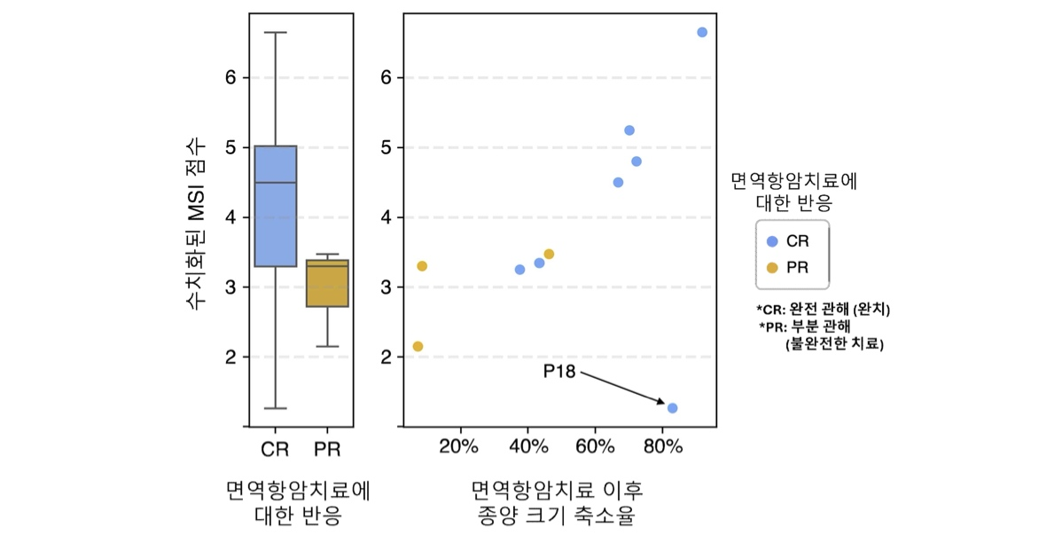

[Figure 2] Correlation between quantitative MSI levels and response to immunotherapy. (Left) The patient group that achieved complete remission (CR) after immunotherapy administration shows a higher distribution of MSI scores compared to the partial response (PR) group. (Right) A correlation is observed where the rate of tumor size reduction increases proportionally with higher MSI levels.
Viewing MSI not merely as a matter of 'presence or absence' but as a continuous indicator with varying degrees of intensity, the research team developed an analytical technique called 'scMnT*' to measure it quantitatively.
In particular, the key feature of this technology is that it focuses on the ‘heterogeneity’ of MSI within tumors, enabling the individual comparison and analysis of differences at the cellular level rather than relying on the overall average value as in conventional methods. This allows for the precise differentiation of individual cells, much like distinguishing the state of fruit in a box, given that the degree of replication error varies among cancer cells even within a single tumor.
* scMnT (single-cell Microsatellite and Transcriptome sequencing): An analytical method that utilizes single-cell RNA sequencing data to analyze DNA repeat mutations in each cancer cell and quantify microsatellite instability (MSI) at the cellular level.
When this technology was applied to actual colorectal cancer patient data, heterogeneity was confirmed, with cells exhibiting both high and low MSI levels coexisting within the same patient's tumor.
Notably, it was observed that immune cells (T lymphocytes) were concentrated and actively attacked cancer cells in regions with high MSI intensity, whereas the immune response was relatively blunted in regions with low MSI intensity. This suggests that differences within the tumor can lead to differences in actual treatment response.
These results highlight the limitations of conventional bulk analysis, which classified MSI as "positive" or "negative" based solely on the average value of all cells. This is because relying on average values ​​makes it difficult to account for subtle differences within the tumor, potentially missing "blind spots" such as areas with low treatment response.
Furthermore, this is expected to serve as a turning point for realizing optimal precision medicine tailored to individual patient tumor characteristics and dramatically increasing the success rate of immuno-oncology.
The research team subsequently confirmed that tumors with higher MSI intensity tended to contain a greater abundance of immune cells (particularly T lymphocytes) and exhibit a better response to immuno-oncology.
This demonstrates that scMnT technology provides a foundation for more precise prediction of treatment response and can be utilized to establish treatment strategies based on individual patient tumor characteristics.
Professor Jihwan Park stated, “This study is significant in that it lays the foundation for understanding MSI not merely as a dichotomous indicator, but as a ‘quantitative indicator.’ It is expected to contribute to establishing personalized treatment strategies for cancer patients and improving the success rate of immuno-oncology in the future.”
This research, supervised by Professor Jihwan Park of the School of Life Sciences, and conducted by Gyumin Park, a student in the integrated master’s and doctoral program, was supported by the Ministry of Science and ICT and the National Research Foundation of Korea (NRF) through the Mid-Career Researcher Support Program; the Ministry of SMEs and Startups and the Technology Information Promotion Agency (TIPA) through the SME Technology Development Support Program; and the Korea-U.S. Joint Research Fund (KUCRF) under the Ministry of Science and ICT and the Ministry of Health and Welfare.
The research results — Analysis of microsatellite instability intensity in single-cell resolution with scMnT reveals tumor heterogeneity in colorectal cancer — were published online on April 14, 2026, in the international bioinformatics journal Briefings in Bioinformatics.
Meanwhile, GIST stated that this research achievement takes into account both its academic significance and potential for industrial application, and that discussions regarding technology transfer can be conducted through the Technology Commercialization Office (hgmoon@gist.ac.kr).

