“Scratched hard with a pencil lead or dropped from a height, OK” GIST develops next-generation transparent protective film resistant to both scratches and impacts
- Research team led by Deputy Director Hongkyu Kang of the Research Institute for Solar and Sustainable Energies realizes a material that simultaneously secures rigidity and flexibility based on interfacial engineering… Durability proven through application to organic solar cells and repeated bending tests
- Presents a highly durable protection platform applicable to large-area panels such as curved displays and solar cells
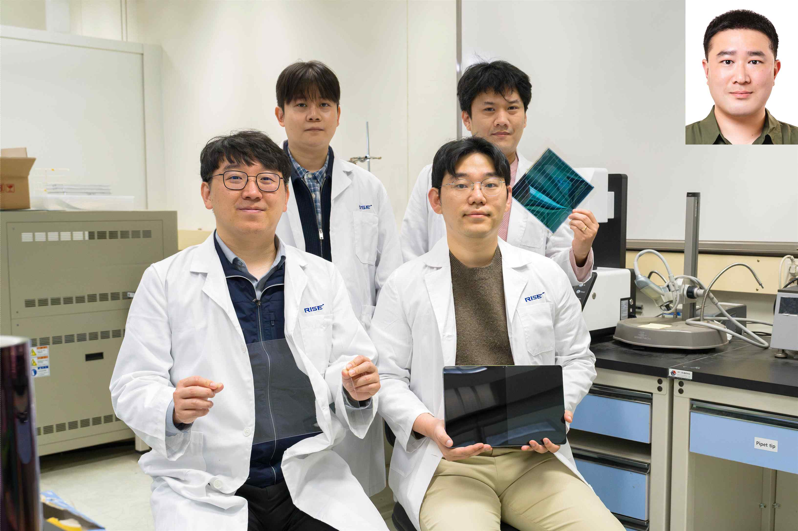

▲ (Back row, from left) Hyeon-Seok Jeong, researcher at Resell Co., Ltd.; Jun-Ho Jang, researcher at Heeger Research Center; (Front row, from left) Hongkyu Kang of the Research Institute for Solar and Sustainable Energies; Sangcho Kim, researcher; (Top right) In-Bok Kim, researcher at Unitest
Minor scratches on smartphone screens and damage caused by unexpected drops remain a persistent source of inconvenience for users. In particular, organic solar cells and flexible displays, which are attracting attention as next-generation energy sources, have also been cited as limitations to commercialization due to their vulnerability to external impact and friction. However, a next-generation protective material has been developed that is resistant to scratches yet flexible in responding to impacts, utilizing "interface engineering" technology that precisely controls the interfaces of materials.
The Gwangju Institute of Science and Technology (GIST, President Kichul Lim) announced that a research team led by Deputy Director Hongkyu Kang of the Research Institute for Solar and Sustainable Energies has developed a manufacturing technology for protective films that are both hard and resistant to breakage. Instead of altering the material itself, they achieved this through a strategy of precisely controlling the "boundaries" where different materials meet.
This research is significant because it simultaneously resolves the limitations of existing materials—which are either resistant to scratches but weak against impact, or strong against impact but easily scratched—and demonstrates the feasibility of realizing protective materials capable of meeting the durability requirements of actual usage environments.
Organic photovoltaics (OPVs), utilized in building facades (BIPV), wearable devices, and indoor lighting, are next-generation solar cell technologies that convert light into electricity using conductive organic materials capable of conducting electricity.
However, they are vulnerable to external impacts, friction, and environmental factors such as ultraviolet rays and moisture, making a cover window material essential for protection.
Just as a reinforced film is applied to a smartphone to prevent scratches and damage, the cover window is a key protective layer that determines the lifespan and stability of organic solar cells.
However, existing materials such as polycarbonate have limitations; their relatively soft surfaces make them susceptible to scratches, and prolonged exposure to ultraviolet rays or moisture can cause microcracks, leading to performance degradation.
* organic photovoltaics (OPV): A solar cell fabricated based on organic materials. It is a next-generation solar cell technology that is lightweight and flexible, allowing it to be applied to various types of surfaces.
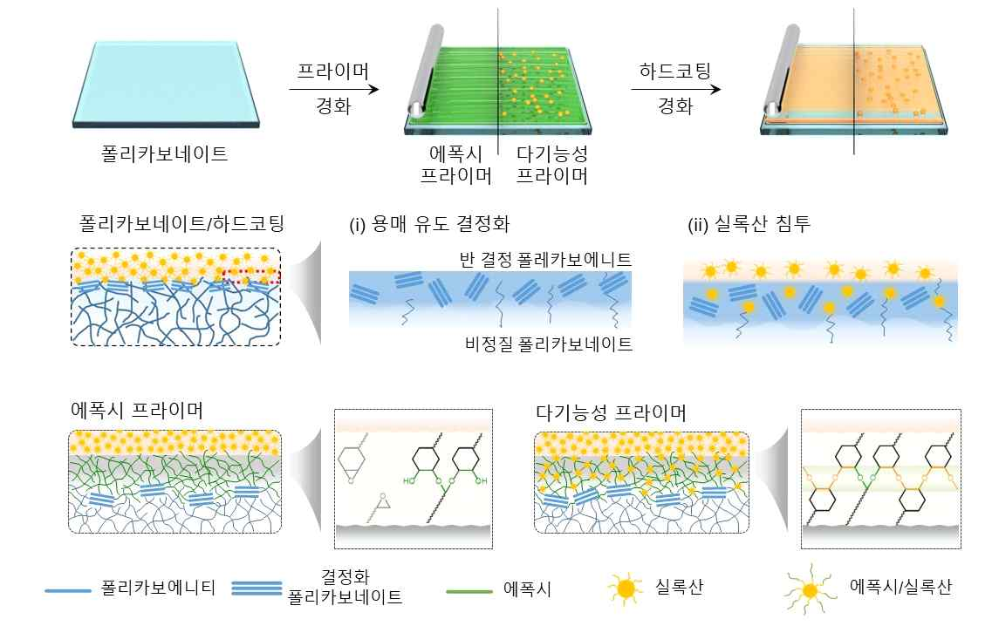

▲ Schematic diagram of the primer and hard-coating processes and changes in the interface structure of a polycarbonate-based cover window. It illustrates the sequential primer and hard-coating process (top), solvent-induced crystallization without primer application (middle), interface destabilization due to siloxane penetration (bottom), and the interfacial bonding structure of the epoxy primer and the siloxane-epoxy hybrid primer.
To overcome these limitations, the research team applied an interface engineering strategy to precisely design and control the 'interface' where different materials meet, rather than changing the material itself.
The key was to resolve the issues of stress concentration and adhesion imbalance existing between the polycarbonate and the surface protection layer.
To achieve this, they constructed an intermediate adhesive layer combining high-durability siloxane with epoxy, which offers excellent adhesion.
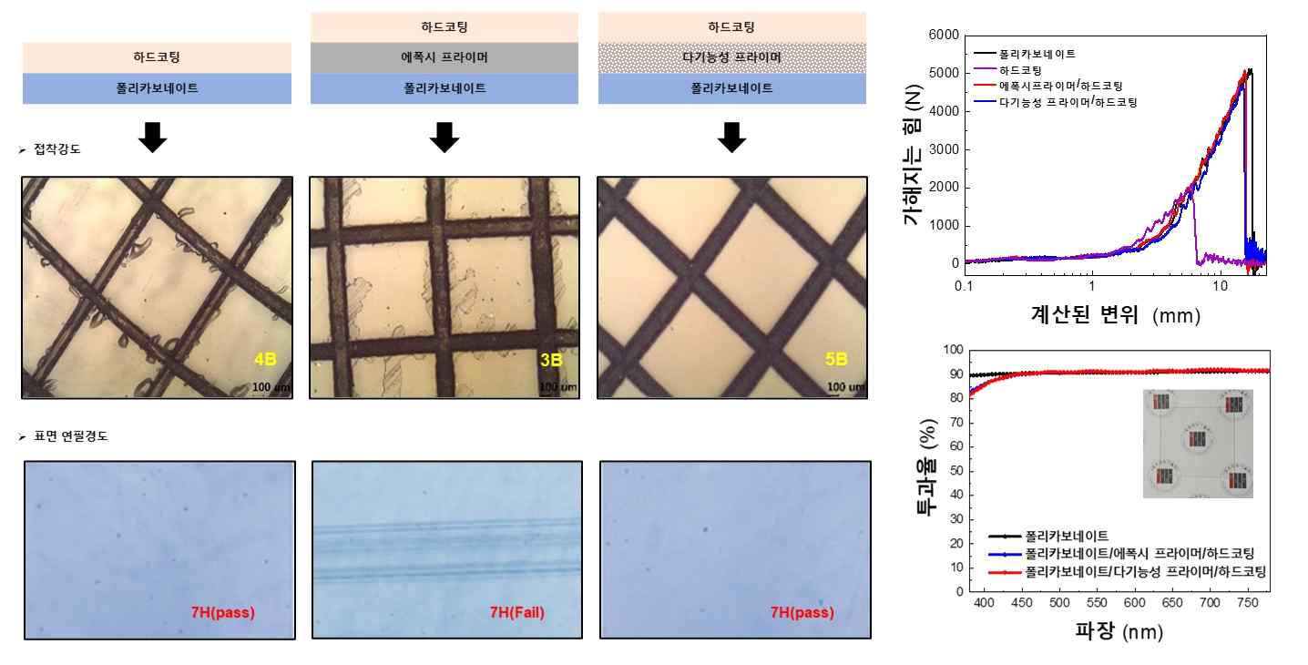

▲ Comparison of mechanical, impact, and optical performance of cover windows according to the structure of the intermediate adhesive layer. The hybrid primer-based structure demonstrated excellent adhesion and durability in cross-cut and pencil hardness (7H) tests (left), and exhibited stable behavior without breakage in impact tests (top right). Additionally, excellent optical performance was confirmed by maintaining high transmittance in the visible light range (bottom right).
Siloxane forms a three-dimensional network structure in which silicon (Si) and oxygen (O) bonds are repeated and intertwined like a net. This structure effectively disperses external impact while increasing surface hardness, thereby enhancing the stability of the material.
In addition, cycloaliphatic epoxy and glycidyl epoxy were utilized together to design a structure where some reactive portions remain even after curing. It was confirmed that these portions form additional chemical bonds with the upper coating layer, further strengthening interfacial adhesion.
The research team comprehensively verified the performance through ▴ scratch tests, ▴ drop and impact tests, ▴ optical transmittance measurements, and ▴ repeated durability tests.
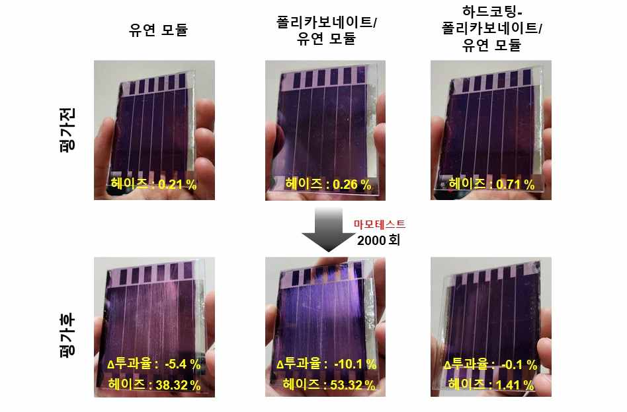

▲ Changes in wear durability and optical properties of the coating structure studied in this study when applied to flexible organic solar cells. The superior mechanical stability and optical property retention of the hard-coated module were confirmed through the results comparing specimens with polycarbonate and hard-coated polycarbonate (top) and changes in transmittance and haze after 2,000 wear cycles (bottom).
As a result, it was confirmed that almost no scratches occurred even under strong friction equivalent to pencil hardness (7H, equivalent to a very hard pencil lead), and structural stability was maintained without breakage even under impacts of approximately 40J (equivalent to the impact of a small object falling rapidly).
Furthermore, when applied to organic solar cell modules, both mechanical stability and reliability were found to be improved compared to existing polycarbonate-based structures.
Furthermore, flexibility was maintained without performance degradation in additional repeated bending tests, confirming the potential for application in various forms, such as large-area panels or curved displays.
This is significant in that it realizes a protective material platform that satisfies not only surface hardness and impact resistance but also optical properties and flexibility by simultaneously achieving interfacial bonding and structural formation within a single process.
Deputy Director Hongkyu Kang stated, “This research presents a universal protective material technology that secures both characteristics simultaneously by resolving the trade-off between surface hardness and impact resistance through interfacial engineering,” adding, “It can be expanded into a platform technology applicable to large-area processes across various industrial fields, such as displays, solar cells, and mobility.”
This research — Simultaneous enhancement of surface hardness and impact strength in flexible and transparent cover windows for organic photovoltaic films — was supported by the Nano and Materials Technology Development Project of the Ministry of Science and ICT and the National Research Foundation of Korea, as well as the Deep-Tech TIPS program of the Ministry of SMEs and Startups.
The technology was recognized for its excellence by obtaining an AA rating from the Korea Invention Promotion Association (KIPA)’s Patent Analysis Evaluation System (SMART5), and the research results have been confirmed for publication in the June issue of Progress in Organic Coatings, an international academic journal in the field of materials and coatings.
Meanwhile, GIST stated that this research achievement takes into account both its academic significance and potential for industrial application, and that discussions regarding technology transfer can be conducted through the Technology Commercialization Office (hgmoon@gist.ac.kr).

