“Results differed even with the same budget... ‘Focus and Personalization’ More Effective” GIST presents optimization strategy for senior health campaigns based on AI simulation
- Professor Duk-Jo Kong's team at the Graduate School of Al Policy & Strategy confirmed a 'dilution effect' through AI-based 'policy experiments,' where dispersion across multiple media actually reduces effectiveness... Single, customized strategies boosted participation rates more than dispersion across media
- Group-tailored allocation increased participation rates among vulnerable groups and reduced inter-group disparities by up to 33%
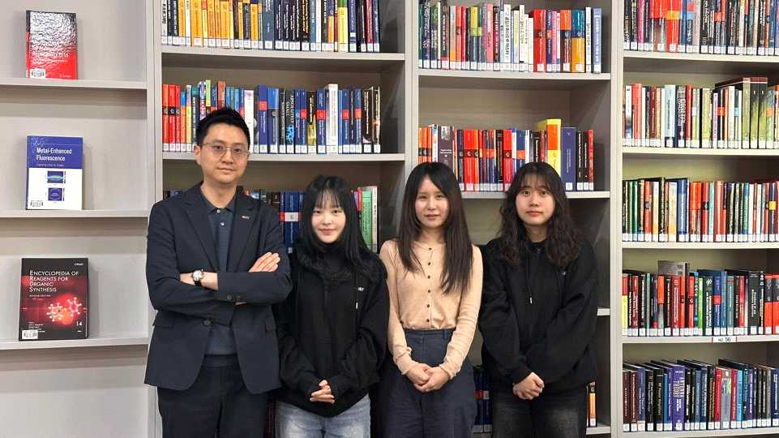

▲ (From left) Professor Duk-Jo Kong of the Graduate School of Al Policy & Strategy, master's student Yuna Kim, Principal Researcher Jihye Lee of Seoul National University (GIST External Researcher), and master's student Juyoung Park.
The Gwangju Institute of Science and Technology (GIST, President Kichul Lim) announced that a research team led by Professor Duk-Jo Kong of the Graduate School of Al Policy & Strategy has presented a media distribution strategy utilizing AI-based simulations to simultaneously consider the effectiveness and equity of health prevention campaigns for the elderly in response to a super-aged society.
This study empirically confirmed the potential to increase participation in preventive health services among the elderly while mitigating inter-group disparities arising from differences in digital accessibility, income, and social conditions. Furthermore, it is significant in that it presented an AI-based decision-making framework capable of considering both effectiveness and equity from the policy design stage.
As our society rapidly enters a super-aged society, prevention-oriented health policies, such as vaccinations and health checkups, are becoming increasingly important.
However, existing campaigns are often designed based on the overall average participation rate, so even if the participation rate increases, there are limitations in that some elderly people are excluded from information due to differences in ▴ digital accessibility, ▴ literacy, ▴ living environment, and ▴ income level.
This structure can consequently widen disparities in health levels and lead to increased social costs in the long term, raising the need for policy design that considers both efficiency and equity simultaneously.
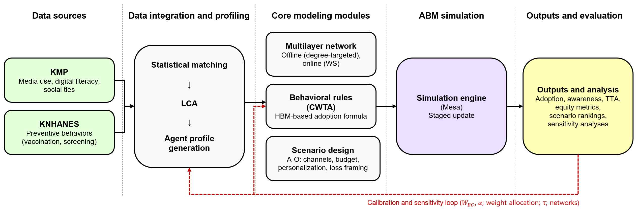

▲ Analysis framework for elderly prevention campaign strategies utilizing Agent-Based Modeling (ABM). Virtual agents are generated by combining the Korea Media Panel (KMP) and the Korea National Health and Nutrition Examination Survey (KNHANES) through statistical matching and Latent Class Analysis (LCA). Campaigns are then simulated under conditions of channel, budget, personalization, and loss framing through modules for multi-layer networks, behavioral rules (based on HBM), and scenario design. Indicators such as adoption rate, awareness, Time to Adoption (TTA), and equity are calculated, and key parameters are iteratively calibrated through correction and sensitivity loops.
To address these issues, the research team utilized agent-based modeling (ABM)* techniques, which set individuals as "agents" (virtual individuals) interacting within social relationships and reproduce the process of information and behavior diffusion on a computer.
By combining data from the Korea Media Panel Survey and the Korea National Health and Nutrition Examination Survey, approximately 2,400 elderly individuals reflecting media usage, digital competence, social relationships, and health behaviors were recreated in a virtual environment. The study simulated the process by which these individuals accessed information through TV, digital, and print media, interacted with those around them, and ultimately led to actual preventive behaviors (such as vaccination and participation in health checkups).
In particular, rather than a single strategy, the research team established 15 distinct policy scenarios to systematically compare and analyze how factors such as media distribution methods, budget levels, group customization strategies, and message delivery methods influenced the outcomes.
* agent-based modeling (ABM): Agent-based modeling (ABM) is an analytical technique that sets individual actors as virtual agents and simulates overall social phenomena through their interactions. The analysis results showed that, contrary to intuition, distributing the budget across multiple media actually resulted in a ‘dilution effect’ that lowered the effectiveness of the campaign.
Under the same budget conditions, a multi-channel strategy utilizing both TV and digital channels resulted in a lower average participation rate compared to a strategy focusing on a single channel.
This was analyzed to be due to the dispersion of the social diffusion effect, which typically involves repeated exposure on a single channel, sharing with others, and ultimately leading to action.
The research team did not view the elderly as a single group but rather divided them into six distinct groups based on media usage patterns, digital literacy, and social activity.
For instance, each group had different ways of accessing information, such as a group with high digital usage but low TV viewing, or a group with high TV dependency but low digital usage.
Reflecting these differences, the team designed a "group-specific channel allocation strategy" that applied different approaches—TV-centric, digital-centric, or mixed—to each group.
As a result of applying these customized strategies, both effectiveness and equity were improved simultaneously.
In the case of vaccination, the participation rate of the group with the lowest rate rose from 86.8% to 90.9%, and for health checkups, it increased from 77.6% to 85.3%; simultaneously, the participation gap between groups (the difference between the top and bottom groups) decreased by up to approximately 33%.
This demonstrates that it is possible to design policies that go beyond simply raising the average participation rate to elevate vulnerable groups.
This study presented a "policy experiment environment" that allows for the comparison of various scenarios before policy implementation through AI simulations.
This enables the prediction of the effectiveness of resource allocation methods and targeting strategies prior to actual policy execution, and holds significant potential for future application in various fields such as energy, urban planning, and public services.
Professor Duk-Jo Kong stated, "This study shows that AI can go beyond being a technical tool and contribute to solving complex social problems, such as a super-aged society." He added, "In the future, policies designed to ensure no one is left behind will become more important than policies with high average effectiveness, and AI will become a key means of realizing these social values."
This research, supervised by Professor Duk-Jo Kong of the GIST Graduate School of Al Policy & Strategy and conducted by Jihye Lee, a principal researcher at Seoul National University (first author), and Juyoung Park and Yuna Kim, master's students at the GIST Graduate School of AI Policy & Strategy (co-authors), was supported by the Ministry of Science and ICT and the Institute of Information & Communication Technology Planning & Evaluation (IITP) AI Graduate School Support Program, the Korea R&D Foundation's Science & Technology Project for Opening the Future of Regions, the Korea Institute of Land & Technology Promotion's Urban Convergence Special Zone R&D Project, and the GIST-InnoCORE Project.
The research results — Channel Allocation and Equity in Preventive Campaigns for Older Adults: Agent-Based Modeling Study — were published online on April 1, 2026, in the international academic journal Journal of Medical Internet Research, which covers the fields of digital and medical information.

