“Before cancer grew, the ‘soil’ inside the body was changing” GIST, for the first time in the world, identifies the process of formation of a ‘tumor-friendly microenvironment’ prior to lung cancer development… published in Nature
- Professor Jinwook Choi's team from the Department of Life Sciences, in collaboration with a research team from the Memorial Sloan Kettering Cancer Center (MSK) in the U.S., identified the ‘chain reaction structure’ by which lung stem cell mutations reorganize surrounding cells into a cancer-friendly environment
- Confirmed potential as a therapeutic target through validation in actual patient models... Presenting a prevention-centered cancer treatment strategy
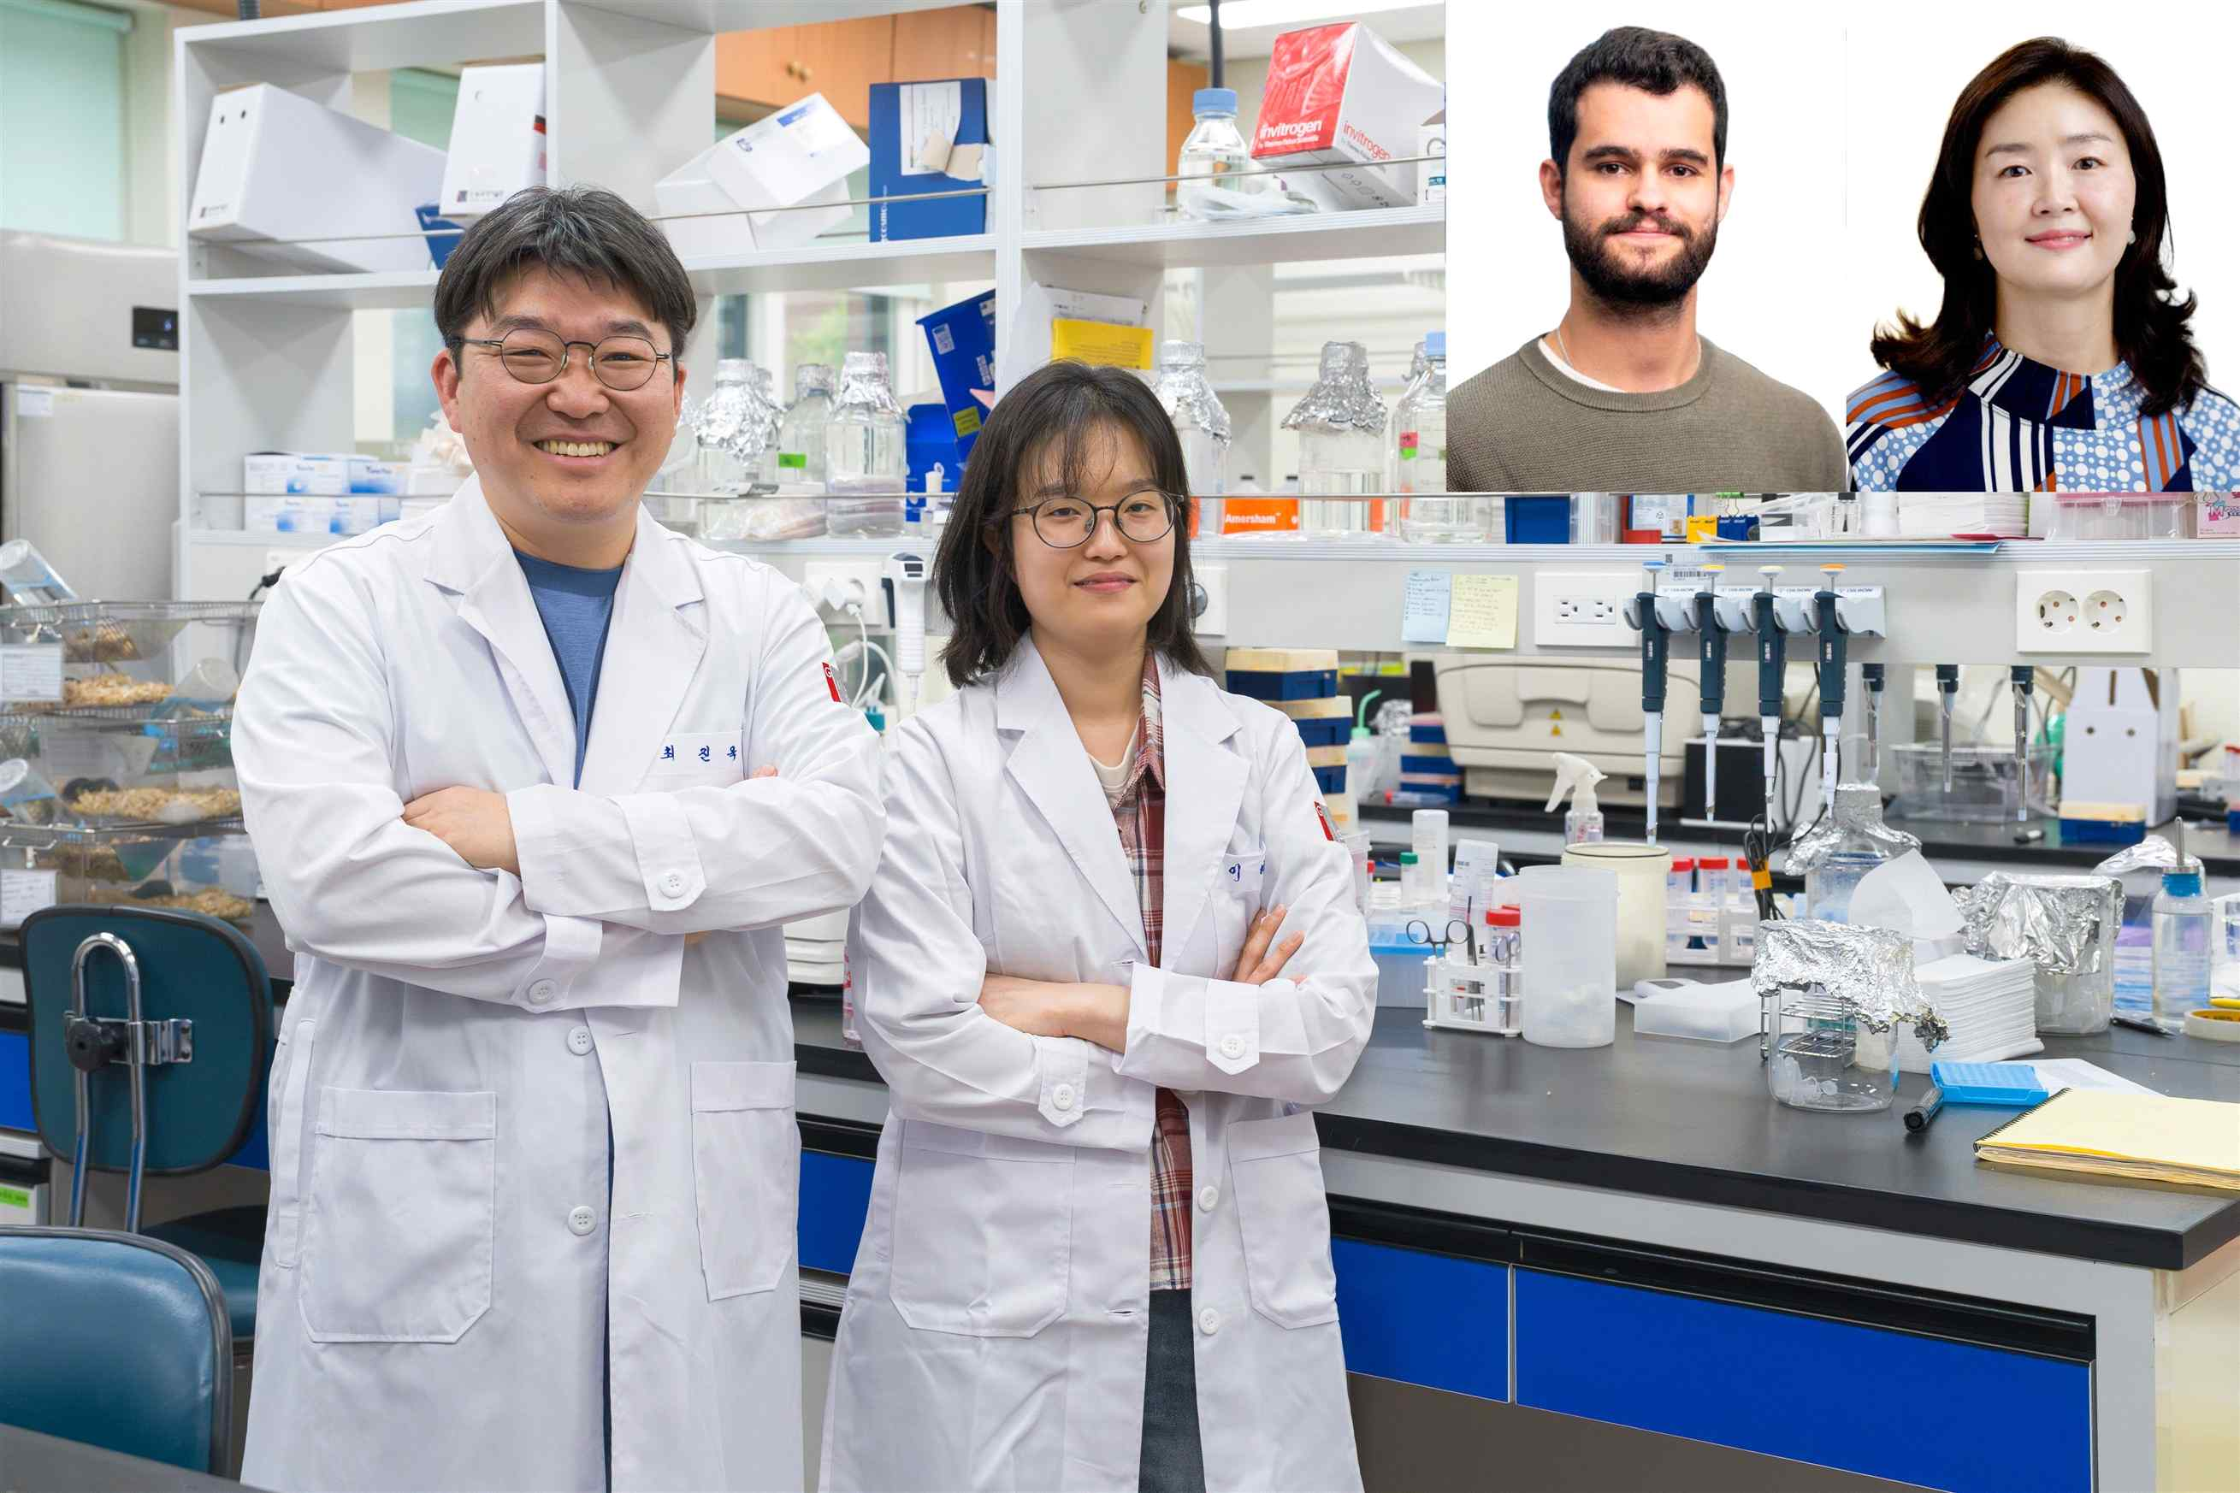

▲ (From left) Professor Jin-Wook Choi of the Department of Life Sciences at GIST, PhD student Hyeyoung Lee, (from top right left) PhD student Erik Cardoso of MSK, Professor Joo-Hyeon Lee
A team of Korean researchers has identified, for the first time in the world, a cascade structure in which mutant cells exchange signals with surrounding cells to create "soil favorable for cancer growth" long before lung cancer develops into a visible tumor. This is considered to open a new path to fundamentally block the onset of cancer at its very early stages, moving away from the conventional approach of treating cancer after it develops.
The Gwangju Institute of Science and Technology (GIST, President Kichul Lim) announced that a research team led by Professor Jin-Wook Choi of the Department of Life Sciences, in collaboration with a research team led by Professor Joo-Hyeon Lee of the Memorial Sloan Kettering Cancer Center (MSK) in the United States, has identified the structure of the intercellular cascade in the early stages of lung cancer development.
This study presented a treatment strategy that can suppress the occurrence of cancer at a pre-progression stage, and the results—Early fibrotic niches establish tumour-permissive microenvironments—were published online in the world's most prestigious scientific journal, Nature, on April 22, 2026.
Lung adenocarcinoma (LUAD) is a type of cancer with a very high mortality rate; however, because it presents with almost no early symptoms, most patients are diagnosed when the disease has already progressed significantly, limiting treatment options.
While the academic community has long studied how the gene mutation (KRAS G12D) in lung stem cells (AT2*) develops into cancer, the specific process by which these mutated cells tame surrounding normal tissue into a cancer-friendly "fibrotic niche" has remained shrouded in mystery.
* AT2 cells (Alveolar Type 2 cells): These cells exist in the areas of the lungs where gas exchange occurs and play a role in maintaining lung tissue homeostasis and repairing damaged epithelium. They are also known as one of the primary originating cells for the development of lung adenocarcinoma (LUAD).
The research team tracked the "communication" of cells occurring during the early stages of cancer development through experiments using mouse models and "3D lung organoids," which are artificial organs.
By breaking down lung tissue to the single-cell level and precisely analyzing genetic changes in fibroblasts (stromal cells), lung cancer cells (mutant lung stem cells), and macrophages (immune cells), researchers discovered a ‘self-sustaining circuit’ in which mutant cells recruit surrounding cells to aid in tumor formation.
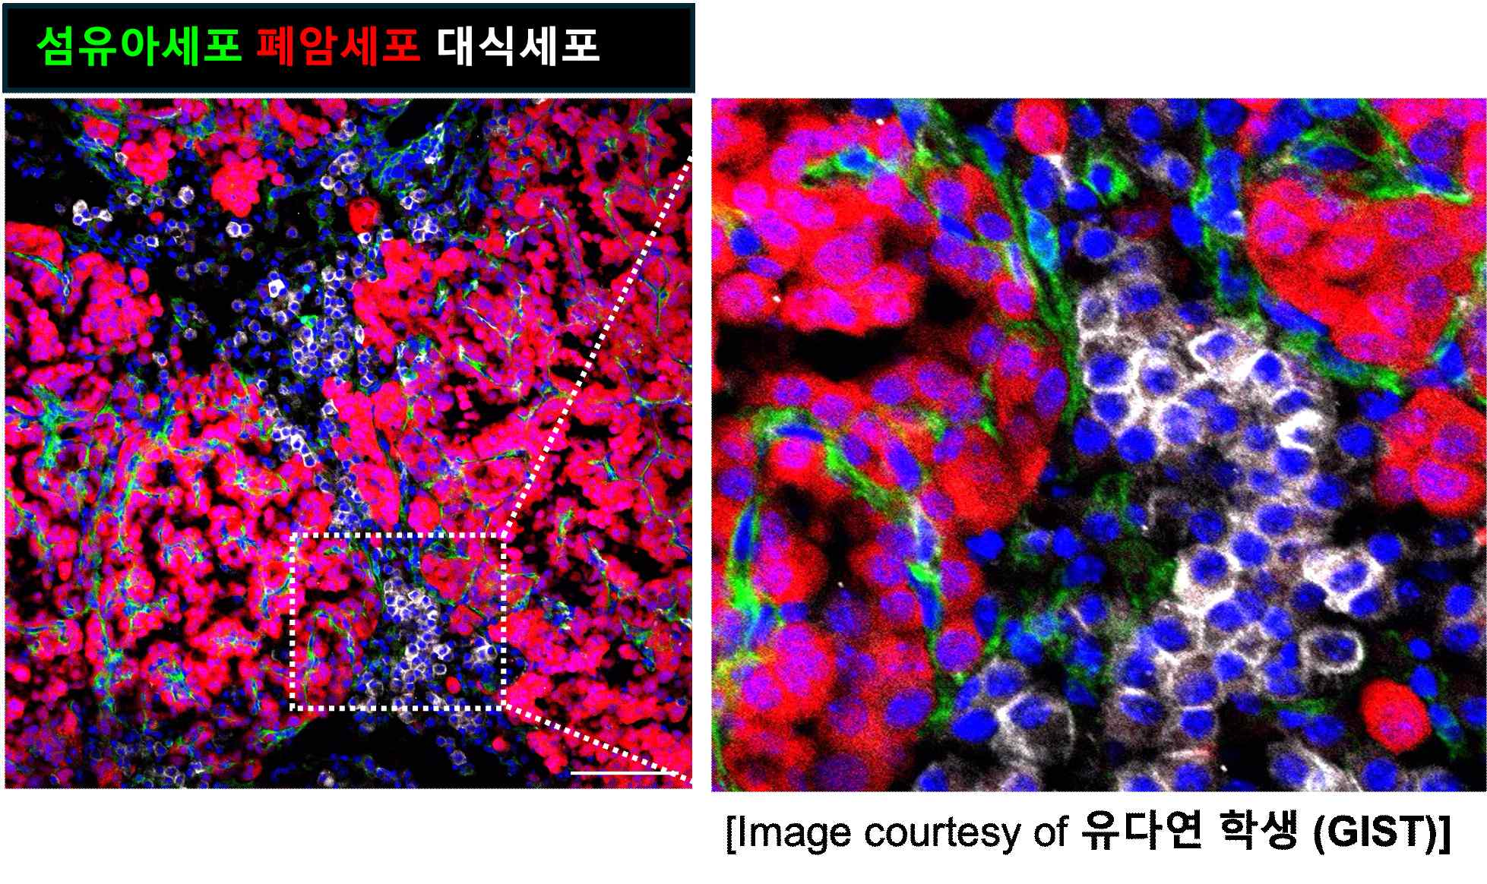

▲ Diagram illustrating the process by which mutated stem cells alter the surrounding environment in early-stage lung cancer. During the early stages of lung cancer, mutated stem cells (red) send signals to fibroblasts (green) and macrophages (white), altering their properties. As a result, the surrounding tissue is reorganized into an environment conducive to cancer growth, which appears to promote tumor development.
According to the research team, the development of lung cancer undergoes a chain reaction consisting of three major stages. First, in Stage 1, lung stem cells with genetic mutations secrete large amounts of a signaling molecule called "Ampyregulin (AREG)," beginning to send aggressive signals to surrounding cells.
In the subsequent second stage, surrounding fibroblasts receiving this signal lose their original tissue repair function and transition into a "fibrotic state," which hardens and deforms the tissue. This is akin to fertile soil being cultivated into a specialized environment optimized for cancer cell growth.
In the final third stage, the established fibrotic environment attracts immune cells (macrophages) to maximize the inflammatory response, completing a "self-amplifying circuit" in which these inflammatory signals further promote the malignant transformation of mutated cells. Consequently, a vicious cycle is created where cancer cells and the surrounding environment aid each other, leading to the development of a full-blown tumor.
In particular, the research team confirmed that when the "ampyregulin signaling axis," the core link in this chain reaction, was blocked through genetic and pharmacological methods, the formation of the fibrotic microenvironment was suppressed, significantly halting the early onset of lung cancer. This is highly significant as it identifies a new therapeutic target capable of blocking cancer development at its root, overcoming the limitations of existing treatment methods that focus on treating cancer after it has developed.
* ampiregulin (AREG): A protein of the epidermal growth factor (EGF) family that regulates cell proliferation and tissue regeneration, and binds to a specific receptor (EGFR) to transmit signals related to cell growth and inflammatory responses.
To verify whether this discovery could be reproduced beyond the laboratory level in the pathophysiological environment of actual patients, the research team collaborated with Professor Moo Suk Park's research team at Severance Hospital, Yonsei University. They constructed a 3D organoid lung cancer model mimicking the patient's condition and evaluated the feasibility of ex vivo reproduction.
As a result, it was confirmed that a fibrotic microenvironment is induced within actual lung tissue, even in a KRAS mutation model, which is a key gene regulating cell growth and division. This suggests that the mechanism of lung cancer development identified in this study may also function in actual clinical settings.
Professor Jinwook Choi of GIST stated, "This research is significant in that it departs from conventional methods that attacked only the cancer cells themselves and presents a strategy to fundamentally prevent cancer development by blocking the 'communication' between cancer cells and their surrounding environment." He added, "It will serve as a turning point in opening a next-generation paradigm for prevention and precision personalized treatment that suppresses lung cancer development at the very early stages."
This research, jointly supervised by Professor Jinwook Choi of the Department of Life Sciences at GIST and Professor Joo-Hyeon Lee of Memorial Sloan Kettering Cancer Center (MSK), and conducted with PhD student Hyeyoung Lee of the Department of Life Sciences at GIST and PhD student Erik Cardoso of MSK as first authors, was supported by the Ministry of Science and ICT and the National Research Foundation of Korea's Mid-Career Researcher Support Program, the Excellent Research Global Matching Support Program (Korea-UK), the Science and Engineering Academic Research Support Program, and the Bio-Innovation Infrastructure Development Program, as well as the Ministry of Health and Welfare and the Korea Health Industry Development Institute's Physician-Scientist Global Joint Research Support Program and the Regional Medical Research Capacity Enhancement Program.
Meanwhile, GIST stated that this research achievement was considered to have both academic significance and potential for industrial application, and that discussions regarding technology transfer can be conducted through the Technology Commercialization Center (hgmoon@gist.ac.kr).

