AI that learns new things without forgetting existing knowledge... GIST develops ‘balanced learning’ technology
- Professor Kyung-Joong Kim's team from the Department of AI Convergence proposes ‘FIRE’ strategy to solve AI learning stagnation and knowledge forgetting problems
- Weighted reordering method simultaneously satisfies preservation of existing knowledge and new learning… selected for oral presentation at ‘ICLR 2026’


▲ (From left) Professor Kyung-Joong Kim (Department of AI Convergence, GIST), Dr. Hojoon Lee (KAIST), Isaac Han (integrated master's and Ph.D. program student, Department of AI Convergence, GIST), Sangyeon Park (master's), Seungwon Oh (integrated master's and Ph.D. program student), and , Donghu Kim (researcher, KAIST).
A new learning strategy capable of resolving the so-called "stagnation phenomenon"—where artificial intelligence (AI) forgets existing knowledge or gradually slows down during the process of learning new information—has been developed by a team of Korean researchers.
The Gwangju Institute of Science and Technology (GIST, President Kichul Lim) announced that an AI learning strategy presented by Professor Kyung-Joong Kim's research team in the Department of AI Convergence has been accepted as an "Oral Presentation" paper at "ICLR 2026," one of the world's top three AI conferences.
Approximately 19,000 papers were submitted to ICLR 2026 this year, but only 223 of them were selected for oral presentation.
Instead of storing memories like humans, AI learns by converting all information into numerous numerical "weights."
These weights represent the importance of information and are continuously adjusted during the learning process to reduce errors and improve performance.
However, as learning is repeated, a problem called "plasticity degradation" arises, where the AI ​​becomes accustomed to specific patterns and fails to respond flexibly to new data or tasks. To address this, methods such as continuous learning that forcibly preserve existing knowledge or re-initialization techniques that return the model to its initial state have been proposed; however, the limitation that it becomes increasingly difficult to accept new information as learning progresses still remains.
In response, the research team proposed a new learning technique called "FIRE*" that can effectively accommodate new information while maintaining existing knowledge.
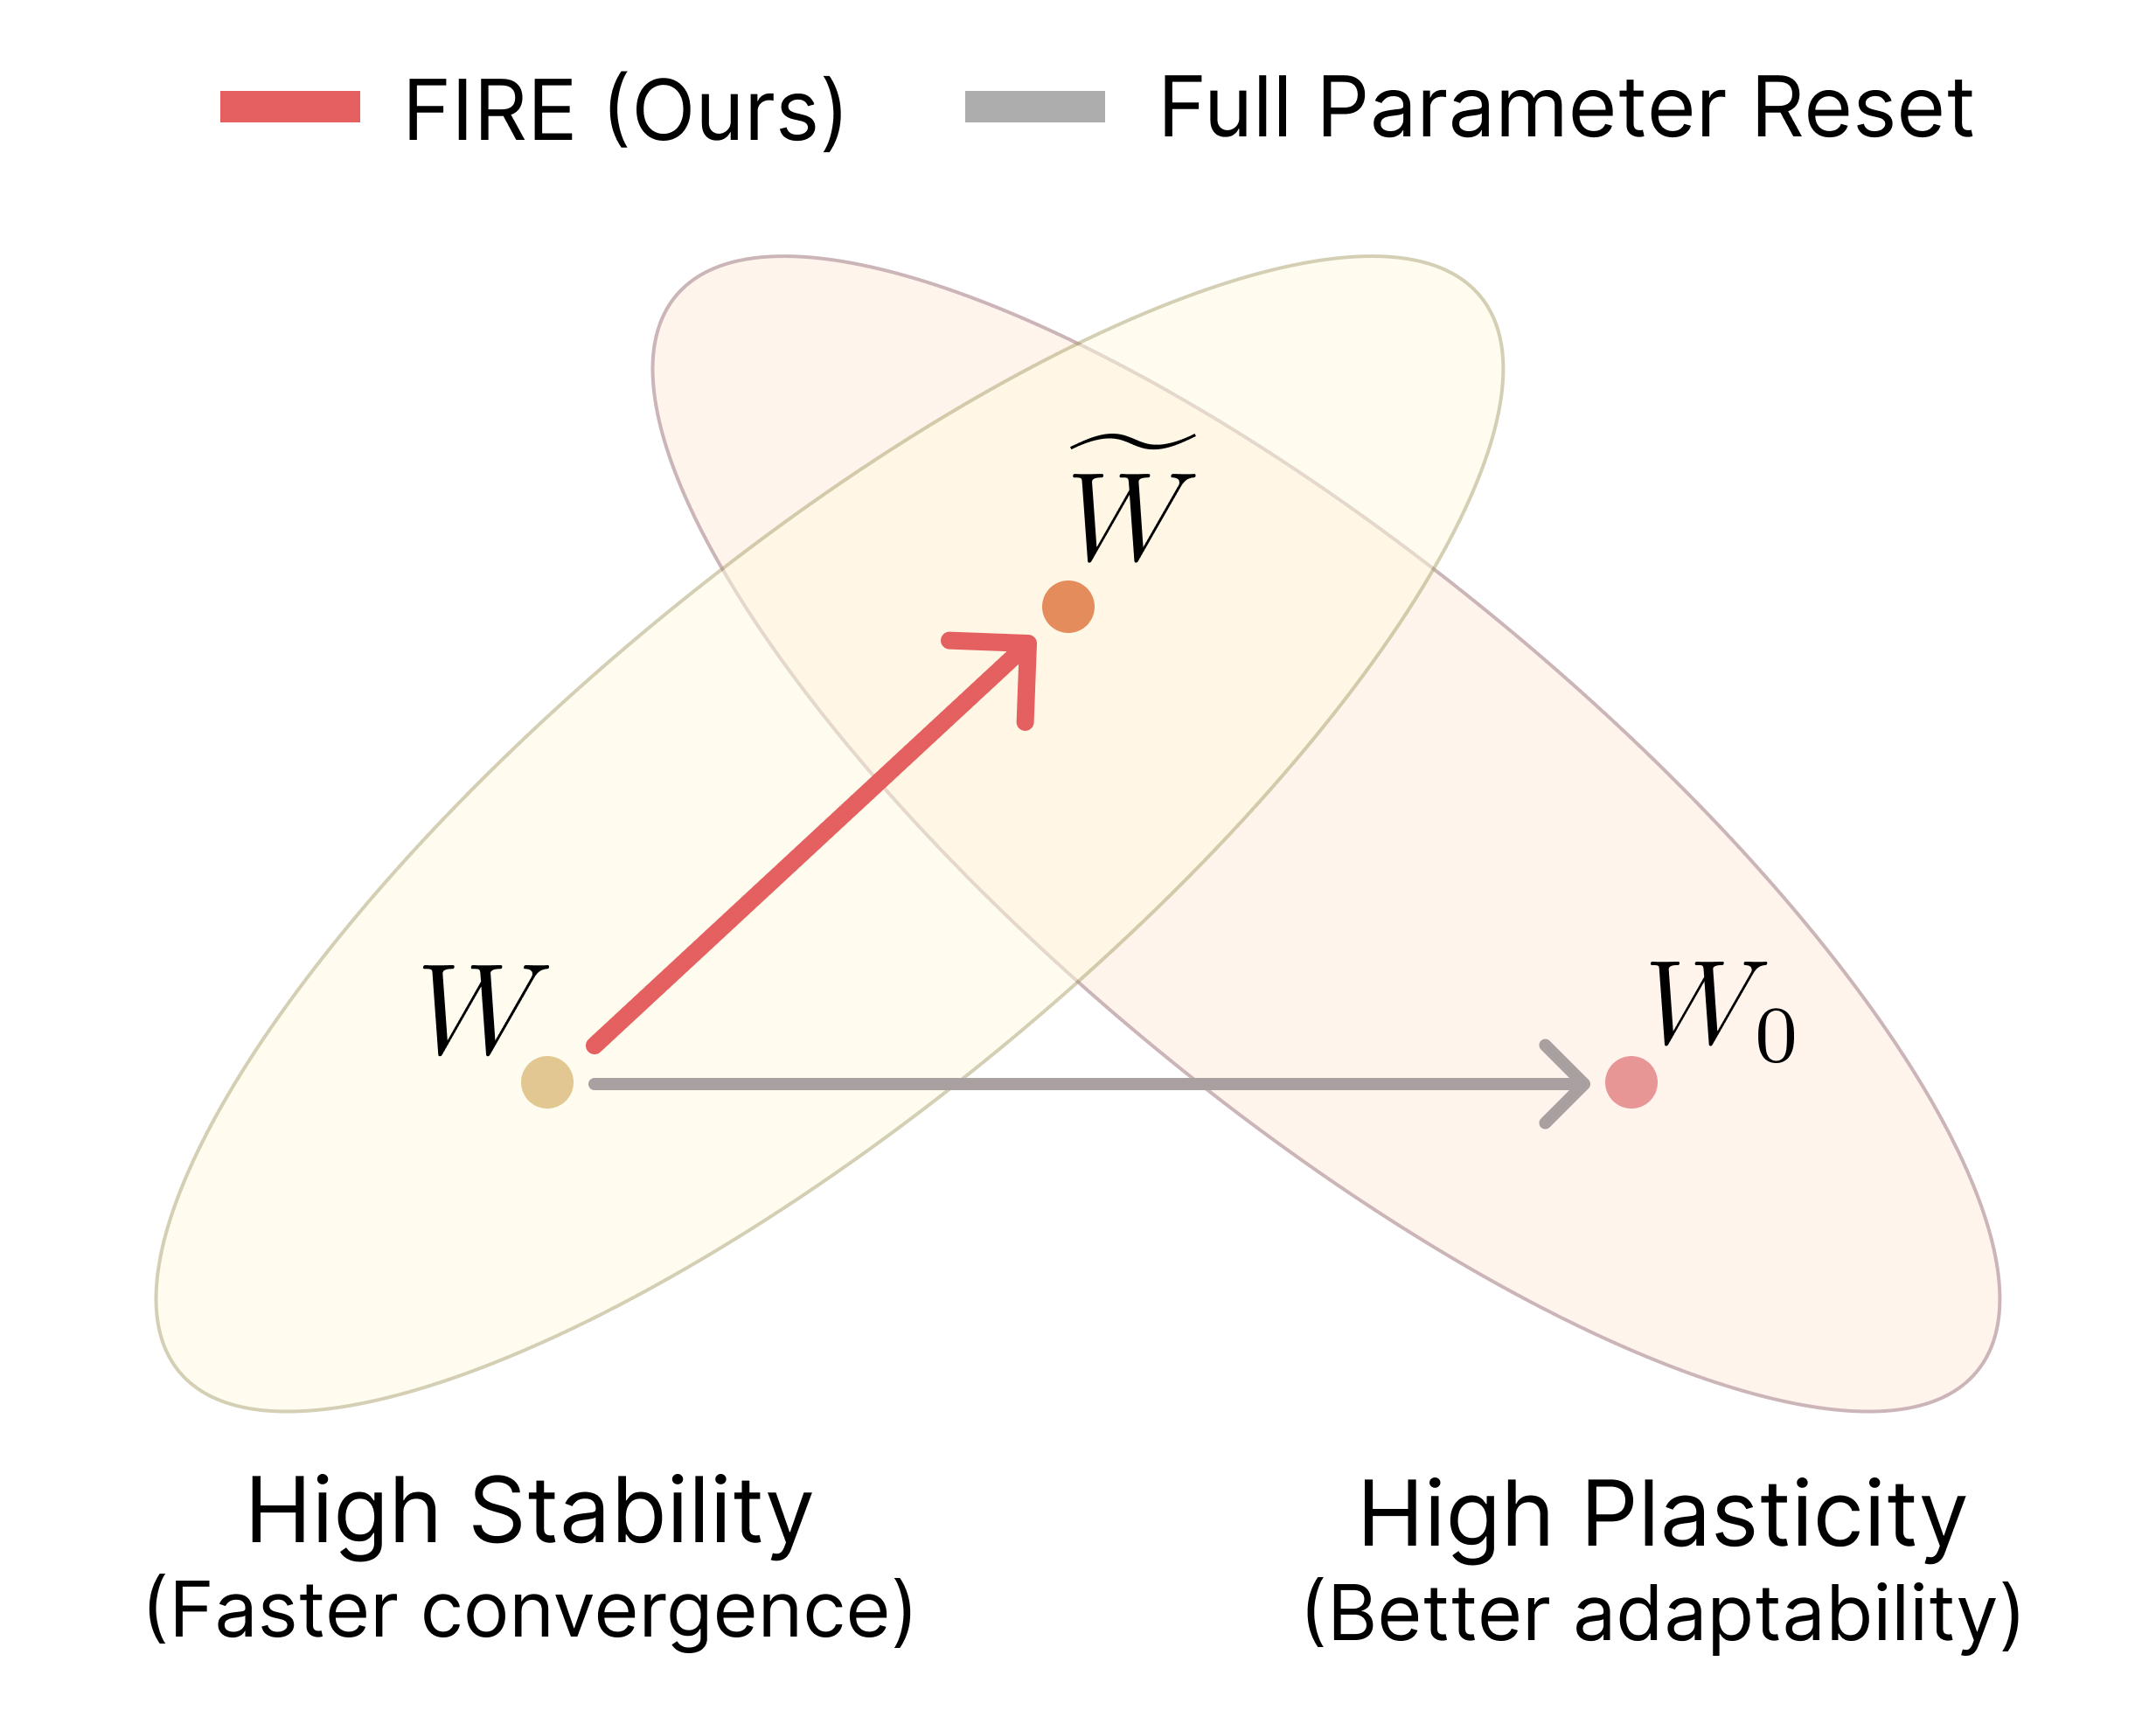

▲ Schematic diagram of the weight realignment technique ‘FIRE’. The FIRE method proposed by the joint research team calculates how far the current model has deviated from previous learning results (stability) and how well it maintains a structure conducive to accepting new information (plasticity). It then readjusts the model to a point where these two conditions are balanced.
This technique works by numerically evaluating how well the AI ​​retains its previously learned content and how well it can accept new learning, thereby balancing these two factors.
Subsequently, by finding the point where this balance is best maintained and realigning (resetting) the weight structure, it ensures that new learning proceeds stably while preserving existing knowledge.
Simply put, just as one rearranges the positions of books on a full bookshelf while considering the overall balance without removing every single book, the principle is that the AI ​​adjusts its weight structure while maintaining existing knowledge to naturally accept new information.
* FIRE: This is a method that re-initializes the weight structure by finding a balance point between the two factors: the Frobenius criterion, which numerically measures how much weights have changed from their existing state, and isometry, which indicates the degree to which a structure capable of accommodating new learning is maintained.
The research team applied this technique to various AI fields, including image and video recognition (computer vision), language comprehension and generation (language models), and reinforcement learning that learns through behavior.
As a result, it demonstrated stable performance while maintaining existing knowledge even during the process of learning new data. In reinforcement learning, it was found that previously learned behavioral patterns (strategies) and performance criteria (rewards) were stably maintained without data loss.
In particular, the additional computation required to calculate the balance between the two elements is very small—less than 1% of the total training volume—allowing for immediate application without slowing down training speed and resulting in almost no increase in computational cost.
Professor Kyung-Joong Kim stated, “Through this research, we have laid the foundation for effectively learning new information while maintaining existing knowledge by rebalancing the weight structure of AI.” He added, “This can be widely utilized in various AI platforms that require continuous updates, such as large language models, autonomous driving, and robot control.”
This research was conducted by Professor Kyung-Joong Kim of the Department of AI Convergence at GIST and Dr. Hojoon Lee of the Korea Advanced Institute of Science and Technology (KAIST) as corresponding authors, with Isaac Han, a student in the integrated master's and doctoral program, serving as the first author. Sangyeon Park (master's), Seungwon Oh (integrated master's and doctoral program), and Donghu Kim (researcher at KAIST) participated as co-authors.
The research was supported by the Artificial Intelligence Graduate School Support Program of the Ministry of Science and ICT and the Institute of Information and Communication Technology Planning and Evaluation (IITP), the Global Research Network Support Program of the National Research Foundation of Korea (NRF), the Industrial Technology International Cooperation Program of the Ministry of Trade, Industry and Energy and the Korea Institute for Industrial Technology Advancement (KIAT), and GIST SCENT (Center for High-Performance Computing and Collaborative Environments).
The research results — FIRE: Frobenius-Isometry Reinitialization for Balancing the Stability-Plasticity Tradeoff — were presented at ‘ICLR 2026,’ held in Rio de Janeiro, Brazil, from April 23 to 27, and the paper was published on the preprint site ‘arXiv’ on February 8.

