Because it is sufficient to record only the ‘essence’ instead of everything... GIST develops AI technology that reads emotions like humans... Drastically improving the burden of data collection
- An international joint research team led by Professor Kyung-Joong Kim of the Department of AI Convergence presents an ‘inflection point-based AI model’ that precisely reconstructs the overall flow of emotions while reducing the burden of recording user emotions
- Achieves 70% accuracy by mimicking the human method of ‘relative comparison’... Selected as one of the top 5% outstanding papers at ‘CHI 2026,’ the world’s premier academic conference in the field of Human-Computer Interaction (HCI)
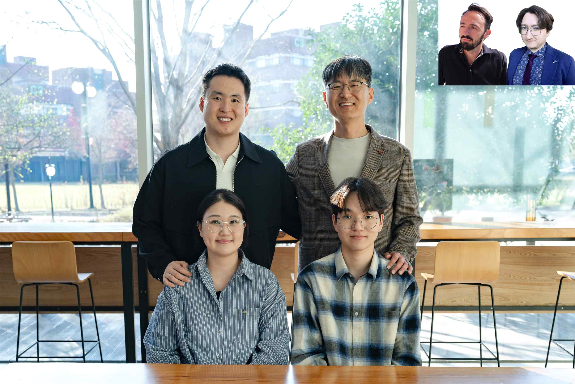

▲ The international joint research team led by Professor Kyung-Joong Kim of the Department of AI Convergence. (back row, from left) PhD student Jaeyoung Moon (first author), Professor yung-Joong Kim (corresponding author), (front row, from left) postdoctoral researcher Youjin Choi, integrated master's and PhD student Yucheon Park, (top right, from left) Professor Georgios N. Yannakakis of the University of Malta, Professor David Melhart of the University of Southern Denmark
A research team led by Professor Kyung-Joong Kim of the Department of AI Convergence at the Gwangju Institute of Science and Technology (GIST, President Kichul Lim) has been recognized for its excellence at the world's most prestigious academic conference in the field of Human-Computer Interaction (HCI) for its "efficient AI technology that reads emotions like a human."
GIST announced that an international joint research team led by Professor Kyung-Joong Kim received an "Honorable Mention," awarded to the top 5% of outstanding papers, for presenting a technology at "CHI* 2026" that precisely reconstructs the entire process of emotional change based solely on a user's core emotional records.
This study was highly praised for its innovation, as it broke the conventional wisdom that "more data leads to greater accuracy" and presented a new, human-centered data collection paradigm suggesting that "recording only the moments (inflection points) that people feel intensely is sufficient."
* CHI (Conference on Human Factors in Computing Systems): Considered the most prestigious international academic conference in the field of Human-Computer Interaction (HCI), it is organized by the Association for Computing Machinery (ACM). Every year, researchers from around the world participate to present the latest research findings on user experience, interaction design, and AI-based interfaces.
For artificial intelligence (AI) to provide more sophisticated, personalized services to users, it is essential to go beyond behavioral data and grasp the "affective data" that users feel.
While AI can precisely analyze behaviors such as clicks, viewing time, and scrolling, it has limitations in directly identifying the underlying emotions, such as pleasure or stress. For this reason, a method in which users directly record their own emotions has been utilized, but the inconvenience and fatigue of having to record every single moment individually have been a major barrier.
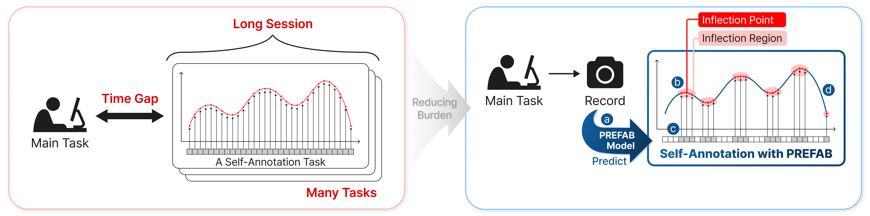

▲ Comparison of the existing self-reporting method and the PREFAB-based selective self-reporting method. The existing method requires continuous emotional recording throughout the entire duration, resulting in a significant time and cognitive burden. In contrast, PREFAB enhances efficiency by selectively recording only key segments (inflection points) where emotional changes are significant, with the model supplementing the remaining segments.
To overcome these limitations, the research team proposed a new modeling technology (PREFAB*) that accurately interprets the overall emotional flow by recording only the "inflection points"—key moments where emotions change rapidly.
This technology works by having the AI ​​predict emotional changes in advance based on user behavioral data, then independently identifying points where emotions fluctuate significantly (inflection points) and asking the user questions.
Users only need to lightly confirm their emotions at the key points recommended by the AI, and the AI ​​then precisely reconstructs the entire emotional curve based on this information. Consequently, the accuracy of the emotions understood by the AI ​​is maximized while reducing the user's effort.
* PREFAB (Preference-based Self-Annotation on a Low-Budget): This is a low-cost, self-report-based emotion data collection method designed to allow users to selectively record only key points (inflection points) where significant emotional changes occur, rather than recording every segment.
In addition, the research team applied a "Preference Learning" approach, enabling the AI ​​to learn the "flow of change" rather than the absolute numerical values ​​of emotions.
This approach is based on the observation that when people express their mood, it is much easier and more natural to compare two points in time—e.g., "I feel better now than I did earlier"—rather than quantifying it by saying, "My happiness index is 85 points right now."
By mimicking this human judgment method, the research team's AI model more precisely estimates the rise and fall of the emotion curve by comparing emotions at different moments. With this approach, users only need to identify key points (inflection points) where emotional changes are significant, and the AI ​​accurately reconstructs the entire emotional flow based on this, thereby drastically reducing the fatigue associated with data recording.
The research team verified the effectiveness of this approach through user experiments involving 25 adults.
Compared to the existing method, which required recording every segment without omission, the inflection point-based recording method was found to significantly reduce the user's cognitive burden while actually improving the quality of emotional data reconstruction.
In particular, the model proposed by the research team precisely reconstructed the overall emotional flow to approximately 70% accuracy (correlation coefficient 0.69), which is superior performance to the existing method that simply assigned scores to emotions.
Consequently, this study holds great significance in that it statistically demonstrates that when natural human cognitive processes are combined with AI modeling, AI can understand the complex flow of human emotions much more effectively.
Professor Kyung-Joong Kim stated, “This research is significant in that it demonstrates that the entire flow of emotion can be accurately restored using only key moments, overcoming the limitations of existing methods where users had to record every segment,” adding, “It is expected to be utilized in various fields in the future, including emotion recognition AI, game user experience analysis, education, and healthcare.”
This research, supervised by Professor Kyung-Joong Kim (corresponding author) of the Department of AI Convergence at GIST and conducted by doctoral student Jaeyoung Moon (first author), postdoctoral researcher Youjin Choi (co-author), and integrated master's and doctoral student Yucheon Park (co-author), included Professor Georgios N. Yannakakis of the University of Malta and Professor David Melhart of the University of Southern Denmark as co-authors.
This research — PREFAB: PREFerence-based Affective Modeling for Low-Budget Self-Annotation — was supported by the Artificial Intelligence Graduate School Support Program of the Ministry of Science and ICT and the Institute of Information and Communication Technology Planning and Evaluation (IITP), the Overseas Excellent Research Institution Cooperation Hub Establishment Project of the National Research Foundation of Korea, and GIST SCENT (Center for High-Performance Computing and Collaborative Environments).
The international academic conference ‘CHI 2026,’ where the research results were officially announced, was held in Barcelona, ​​Spain, from April 13 to 17 under the auspices of the Association for Computing Machinery (ACM), and the content was published on the preprint site ‘arXiv’ on January 21.
Meanwhile, GIST stated that this research achievement takes into account both its academic significance and potential for industrial application, and that discussions regarding technology transfer can be conducted through the Technology Commercialization Center (hgmoon@gist.ac.kr).

