"Why are there still so many one-arm robots in automated factories?" GIST develops AI dual-arm robot grafting technology that handles objects like a human
- Professor Kyoobin Lee's team from the Department of AI Convergence solves dual-arm movement collision and force imbalance issues through integrated learning, achieving stable cooperative grasping... Scheduled to present at the international robotics conference ‘ICRA 2026’
- Applied to actual robots without additional training... Proven field applicability with a success rate of over 88%
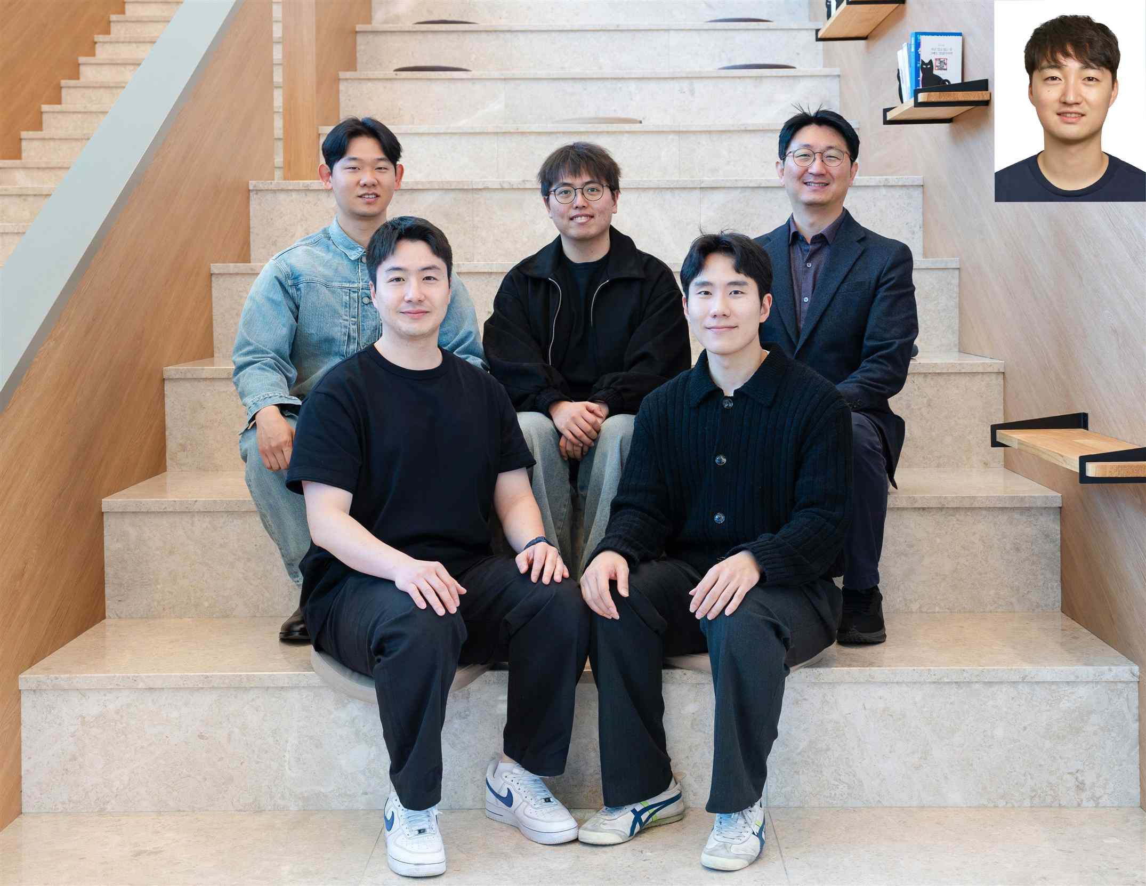

▲ (Back row from left) PhD student Sangjun Noh, integrated master's and PhD student Sangbeom Lee, Professor Kyoobin Lee, (Front row from left) PhD student Geonhyup Lee, PhD student Kangmin Kim (Top right) Seunghyeok Back, senior researcher at the Korea Institute of Machinery and Materials
The Gwangju Institute of Science and Technology (GIST, President Kichul Lim) announced that a research team led by Professor Kyoobin Lee of the Department of AI Convergence has developed "AI Dual-Arm Robot Grasp Technology," which enables robots to move both arms together like humans to maintain balance and stably pick up and manipulate objects.
The core of this technology lies in the robot's ability to autonomously learn and resolve instability caused by collisions between the two arms or imbalances of force when grasping an object, thereby achieving a stable posture. It is expected to contribute to the advancement of research on humanoid robots that manipulate objects using their upper bodies in a manner similar to humans.
With the recent increase in demand for "physical AI"—which performs physical tasks in real-world environments across various industries such as logistics, manufacturing, and healthcare—"dual-arm robots," which stably grasp and handle objects using two arms, are garnering significant attention.
In particular, large or heavy objects like furniture are difficult to handle with a single arm, making the technology of stable gripping through the cooperation of two arms essential.
However, dual-arm gripping requires considering the position, orientation, and force of each arm, resulting in a large number of variables. Furthermore, it necessitates much more complex control, such as distributing the force applied to the object evenly without the two arms colliding.
Existing studies calculated the movements of each arm separately and then combined them later; consequently, they failed to adequately consider the cooperation between the two arms. This led to issues such as movement collisions or force imbalances, limiting the implementation of stable dual-arm cooperation in real-world environments.
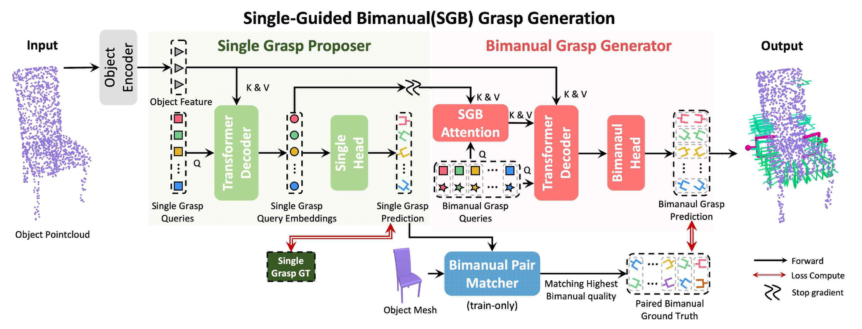

▲ Model structure of the dual-arm gripping robot system (BiGraspFormer). It receives the object's point cloud as input to first generate a single-arm grip (Single Grasp), and then constructs a stable dual-arm gripping (Bimanual Grasp) posture based on this.
To address this problem, the research team developed an AI model called "BiGraspFormer," which considers both arms simultaneously as a single system from the outset.
This technology utilizes an "end-to-end" approach that processes the entire process from input to output as a single step, learning the cooperation of the two arms in a single operation without the need for separate steps.
The system operates in three stages that mimic the process of a human picking up an object.
First, it uses a camera to recognize the target as a point cloud composed of numerous points, and based on this, simultaneously analyzes the overall shape and surface structure. This is similar to the process where a person visually determines where to grasp an object before picking it up.
Next, it first identifies various positions where a single arm can stably grasp the object. Using these as a "guide," it efficiently generates combinations where both arms can grasp together; this process significantly reduces the number of complex cases, enabling rapid calculations.
Finally, the optimal combination is selected where the forces applied to the object are balanced without the two arms interfering with each other, thereby determining the most stable gripping posture.
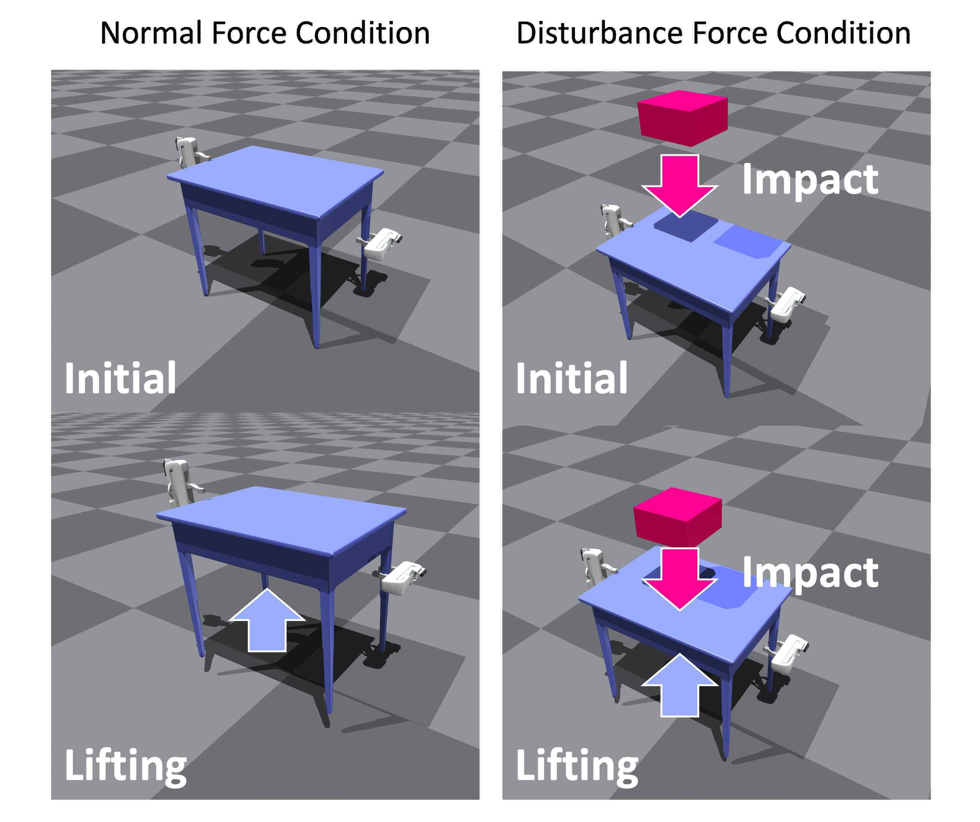

▲ Configuration diagram of the virtual environment evaluation setup. It shows the case where the evaluation was performed in a gravity environment similar to reality (left), and the case where a box of a certain mass (pink) was dropped during the experiment to simulate a situation where external impact is applied in addition to gravity (right).
The research team verified the performance of the technology through virtual environment simulations and actual robot experiments.
In a virtual experiment utilizing 100 objects of various shapes, such as chairs, shelves, and storage boxes, a gripping success rate of 89.67% was recorded, demonstrating performance that improved by approximately 18 percentage points compared to existing technology.
Even under conditions where external impact was applied, a success rate of 59.72% was maintained, an improvement of approximately 23 percentage points compared to existing technology, confirming that the technology can operate stably in real-world environments.
The research team demonstrated field applicability, versatility, and stability by achieving an average grasping success rate of over 88% on various real-world objects—ranging from heavy stair-like structures to irregularly shaped chairs—even though they applied the AI ​​model trained in a virtual environment to a real robot without additional training.
Professor Kyoobin Lee stated, "This study is the first integrated dual-arm grasping system that proves that a robot's two-arm cooperation can be trained in a single, integrated manner and applied directly from a virtual environment to a real robot without separate additional training."
In addition, he stated, “We expect this will advance the practical application of dual-arm robots by one step in various fields where existing single-arm robots have faced limitations, such as transporting large furniture, automating logistics warehouses, and assembling heavy objects in manufacturing sites.”
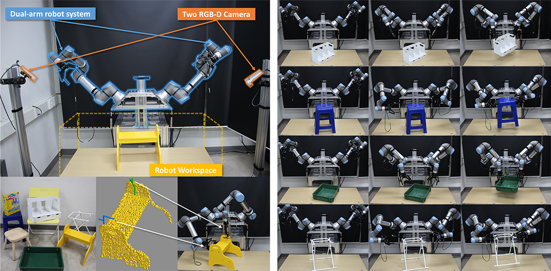

▲ Experimental setup and grasping motion process for real-world environment evaluation. To verify the performance of the AI ​​model in a real-world environment, a robot experimental environment (left) was established, and grasping experiments were conducted on objects of various shapes. As a result, it was confirmed that the generated grasping posture remained stable even during the lifting operation after grasping the object (right).
This research, supervised by Professor Kyoobin Lee of the Department of AI Convergence at GIST and conducted by doctoral student Kangmin Kim (first author), was supported by the AI ​​Graduate School Support Program of the Ministry of Science and ICT and the Institute of Information and Communication Technology Planning and Evaluation (IITP), as well as the Open Simulator Core Technology Support Program for Intelligent Application Development of the National Research Foundation of Korea.
The research results are scheduled to be presented at ‘ICRA 2026,’ the world’s most prestigious academic conference in the field of robotics, to be held in Vienna, Austria, from June 1 to 5. In addition, the study was pre-released* on the international academic server ‘arXiv’ on September 23, 2025.
* ICRA: IEEE International Conference on Robotics and Automation * https://bigraspformer.github.io
Meanwhile, GIST stated that this research achievement takes into account both its academic significance and potential for industrial application, and that discussions regarding technology transfer can be conducted through the Technology Commercialization Office (hgmoon@gist.ac.kr).

