Expensive platinum catalysts, now used down to the very core... GIST develops next-generation catalyst technology that maximizes hydrogen production efficiency by expanding the reaction space
- Professor Myung-Han Yoon's team at the Department of Materials Science and Engineering designs polymer films with porous nanostructures to enable platinum to penetrate and disperse into the interior of electrodes… Published in the international journal Small
- 2.4-fold improvement in active surface area and 3.2-fold improvement in catalytic performance with the same amount of platinum used
- Presents a next-generation electrochemical electrode platform applicable to hydrogen production and fuel cells
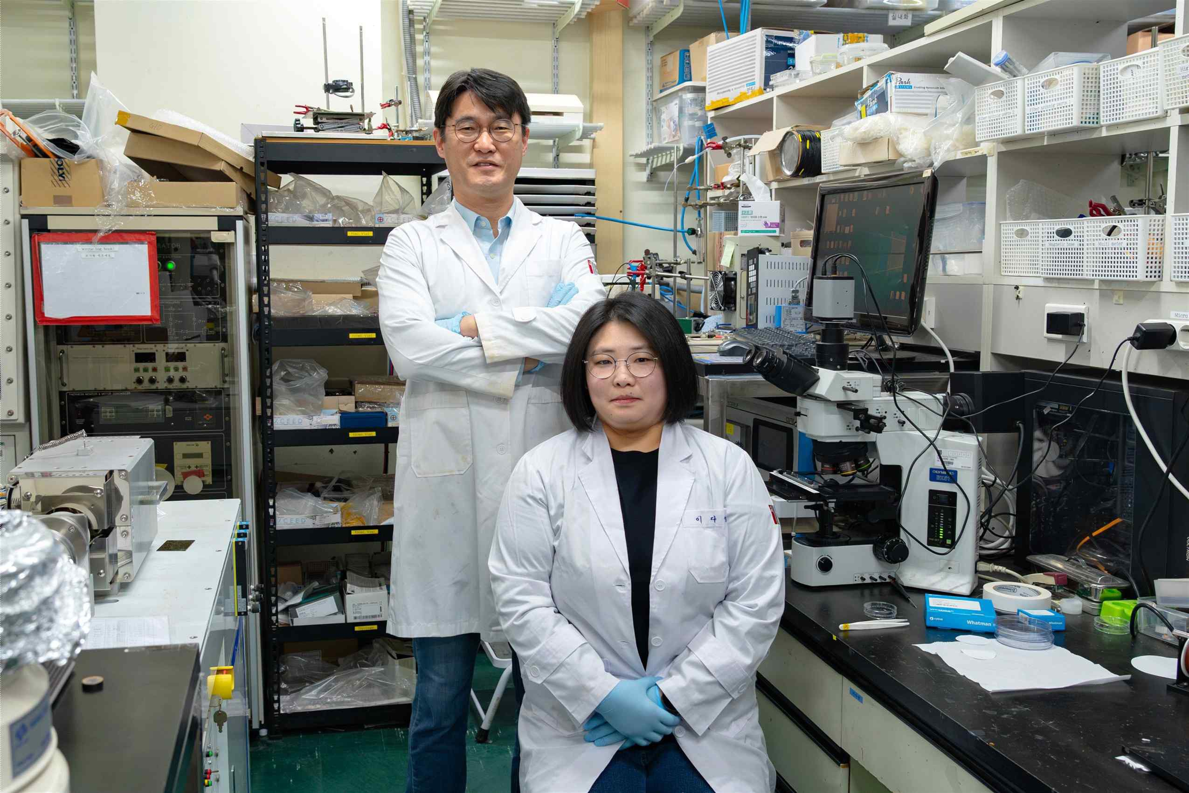

▲ (From left) Professor Myung-Han Yoon, Department of Materials Science and Engineering, and Dr. Da-Young Lee
The Gwangju Institute of Science and Technology (GIST, President Kichul Lim) announced that a research team led by Professor Myung-Han Yoon of the Department of Materials Science and Engineering has developed a next-generation catalyst technology utilizing a conductive polymer film, PEDOT:PSS, which conducts electricity well and has a structure with fine internal voids. This technology enables the platinum (Pt) catalyst, essential for hydrogen production, to spread evenly throughout the "entire interior" of an electrode, extending beyond its "surface."
This research is significant in that it presents a new design strategy capable of achieving high performance with a small amount of platinum by simultaneously enhancing the underwater stability and conductivity of polymers widely used as electrode materials for electronic devices, sensors, and energy devices, while extending the catalytic reaction from the electrode surface to the entire interior.
* poly(3,4-ethylenedioxythiophene) polystyrene sulfonate (PEDOT:PSS): A representative conductive polymer material capable of transmitting both electrons and ions. It is widely used in electronic devices, sensors, and energy devices due to its flexibility and ease of processing. Platinum (Pt) is a key catalyst that exhibits the best performance in the hydrogen evolution reaction (HER)*, which produces hydrogen by electrolyzing water, and has high activity that produces hydrogen stably with a fast reaction rate.
However, due to their very high cost, their use is limited to thin coatings on electrode surfaces, which results in a narrow surface area participating in the actual reaction. Additionally, there are issues where performance degrades over time as particles clump together or detach.
* hydrogen evolution reaction (HER): A process that generates hydrogen through electrochemical reactions, serving as a core reaction for eco-friendly hydrogen production based on water electrolysis.
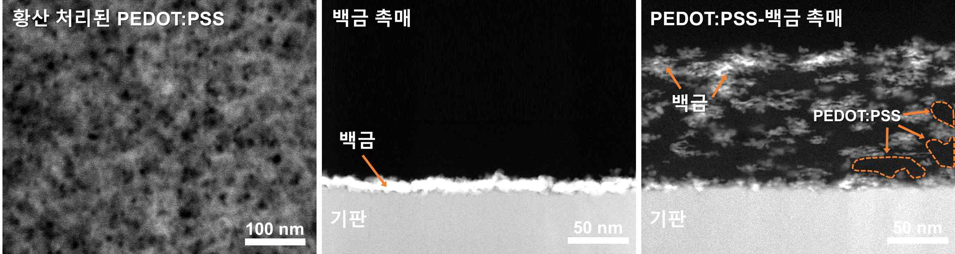

▲ Structural characteristics of the catalyst. Based on the porous nanofiber structure of PEDOT:PSS reconstituted by sulfuric acid treatment (left), the PEDOT:PSS platinum catalyst exhibits a structure where platinum is uniformly dispersed within the conductive polymer, whereas in conventional platinum catalysts, platinum forms only on the electrode surface (center) (right).
To overcome these limitations, the research team proposed a new strategy of extending the "space where the catalyst can operate" into the interior of the electrode, rather than simply making the platinum particles smaller. To this end, a very thin conductive polymer (PEDOT:PSS) film, which is 1/1,000th the thickness of a human hair (about 60 nanometers (nm)) and designed to conduct electricity well and swell in water, was treated with sulfuric acid to remove low-conductivity components and create a ‘porous nanofiber structure’ with micro-channels formed inside.
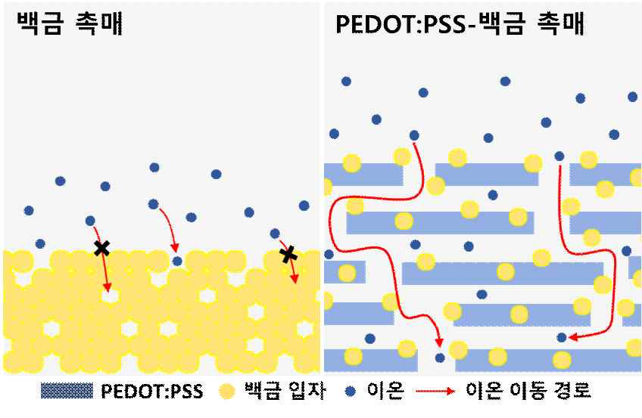

▲ Conceptual diagram of catalyst operation. While conventional platinum catalysts (left) limit the reaction to the electrode surface, the PEDOT:PSS platinum catalyst (right) allows ions to penetrate deep into the porous polymer, expanding the reaction area to the entire electrode. Thanks to this, more active sites can be utilized in the actual reaction with the same amount of platinum.
This structure expands appropriately in water, forming internal channels that allow charges and ions to move freely, and provides an environment where platinum can penetrate deep into the film and settle as nanoparticles.
The research team then applied a "pulse current electrodeposition" process in a solution containing platinum ions to ensure that the platinum permeated into the interior of the film rather than just the surface, forming a uniform structure.
As a result, they succeeded in realizing a structure in which platinum is evenly dispersed throughout the entire film, unlike platinum which is concentrated only on the surface as in conventional methods.
* pulse-current electrodeposition: This is a process of forming metal by repeatedly applying short bursts of electricity rather than a continuous, constant flow. This helps reduce the clumping of metal particles into large masses and promotes the formation of smaller, more uniform particles.
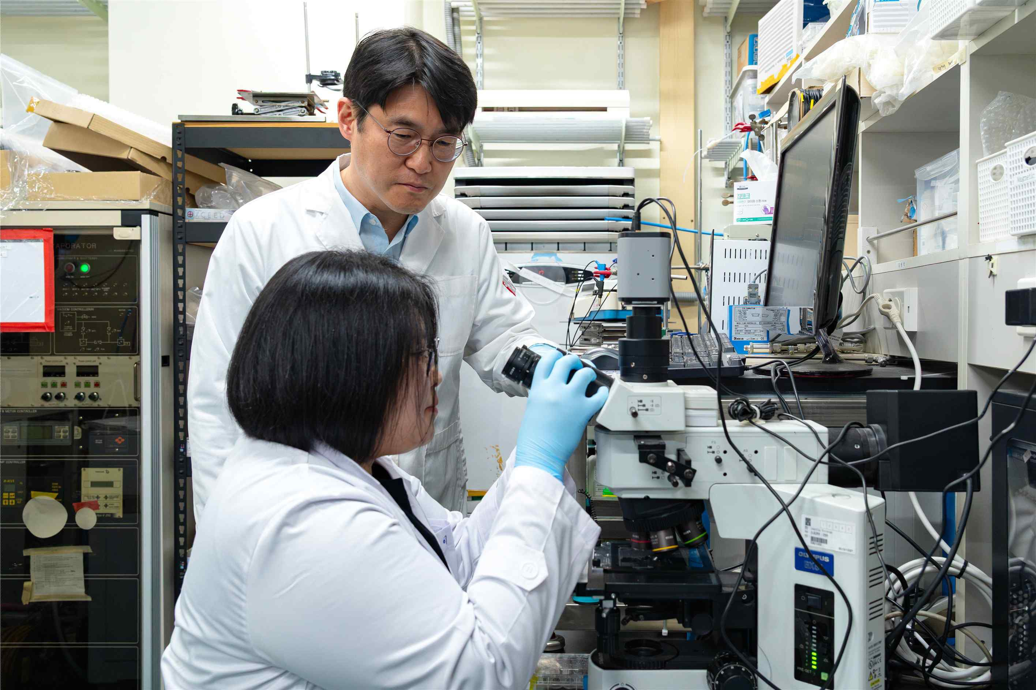

▲ Professor Myung-Han Yoon and Dr. Da-Young Lee of the Department of Materials Science and Engineering at GIST are conducting an experiment. The electrodes fabricated in this way maintain a stable structure even in water and expand appropriately, allowing water molecules and platinum to move freely into the film, thereby enabling catalytic reactions to occur across the electrode's "total volume."
Through this structure, the research team increased the surface area participating in the actual reaction (ECSA)* by more than 2.4 times compared to existing methods when using the same amount of platinum, and improved catalytic performance per gram of platinum by approximately 3.2 times.
Furthermore, they observed higher activity not only in hydrogen generation reactions but also in methanol oxidation reactions (MOR)*, and confirmed that the reaction rate increased further when illuminated.
Through this, the potential for utilizing it as a multi-functional electrode platform capable of achieving high activity and reaction rates even with small amounts of precious metals was confirmed.
* electrochemical active area (ECSA): Refers to the effective surface area of ​​the catalyst that can participate in actual electrochemical reactions. A higher value means that more active sites are utilized in the reaction.
* methanol oxidation reaction (MOR): An electrochemical reaction involved in generating electricity as methanol reacts. It is one of the core reactions in energy conversion devices such as direct methanol fuel cells (DMFCs), and catalysts are used to verify performance.
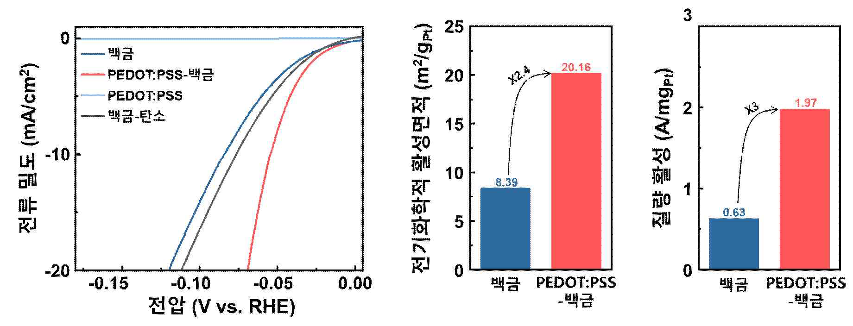

▲ Comparison of the hydrogen generation reaction performance of the catalysts. The PEDOT:PSS platinum catalyst demonstrated superior electrochemical performance in the hydrogen generation reaction compared to catalysts containing only platinum, and exhibited high activity even when compared to commercial platinum-carbon catalysts (left). In addition, the electrochemical active surface area (center) and activity per gram of platinum (right) were significantly improved, demonstrating that the utilization of platinum has increased thanks to a reaction structure that extends into the interior of the conductive polymer.
Professor Myung-Han Yoon stated, “This study is a case that maximizes the utilization efficiency of precious metal catalysts by moving away from the conventional method of placing platinum only on the electrode surface and instead designing the electrode structure itself to extend the reaction space inward.” He added, “Since high performance can be achieved with a small amount of platinum, it can be widely applied not only to hydrogen production, fuel cells, and various electrochemical energy conversion technologies, but also to bio- and bio-friendly electrochemical devices.”
This research, supervised by Professor Myung-Han Yoon of the Department of Materials Science and Engineering at GIST and conducted by Dr. Da-Young Lee (first author) and others, was supported by the Ministry of Science and ICT and the National Research Foundation of Korea’s Mid-Career Researcher Support Program and the Global Matching (Sweden) Basic Research Program; the Ministry of Trade, Industry and Energy and the Korea Institute of Planning and Evaluation for Industrial Technology’s Materials and Components Technology Development Program; and the Ministry of Science and ICT’s GIST-InnoCORE program.
The research results — A Highly Porous Nanofibrillar PEDOT:PSS Matrix for Beyond-Surface Precious-Metal Utilization and Volumetric Electrocatalysis — were published online in the international academic journal Small on March 31.
Meanwhile, GIST stated that this research achievement was considered to have both academic significance and potential for industrial application, and that discussions regarding technology transfer can be conducted through the Technology Commercialization Office (hgmoon@gist.ac.kr).

