GIST develops high-sensitivity sensor that detects harmful gases using visible light… ensures stability even at room temperature
- A joint research team led by Professor Sanghan Lee of the Department of Materials Science and Engineering and Principal Researcher Chang-Lyoul Lee of the Advanced Photonics Research Institute has developed sensor technology capable of precisely detecting nitrogen dioxide (NO₂) from trace amounts to high concentrations under room temperature and visible light conditions
- Reduced power consumption and long-term stability... Expected to be utilized as a portable and smart air quality sensor
- Selected as the back cover article for the international journal Advanced Functional Materials


▲ (From left) Professor Sanghan Lee of the Department of Materials Science and Engineering, Yeonji Yuk (integrated master's and Ph.D. program), Dokyum Kim (postdoctoral researcher) and Principal Researcher Chang-Lyoul Lee of the Advanced Photonics Research Institute
The Gwangju Institute of Science and Technology (GIST, President Kichul Lim) announced that a joint research team led by Professor Sanghan Lee of the Department of Materials Science and Engineering and Principal Researcher Chang-Lyoul Lee of the Advanced Photonics Research Institute (APRI) has developed visible light gas sensor technology based on next-generation semiconductor materials that operates stably over a long period.
This technology overcomes the limitations of existing gas sensors by simultaneously ensuring operation at room temperature, long-term stability, and light responsiveness.
Existing sensor technologies, used for air pollution measurement, industrial safety, and vehicle exhaust gas management, utilize the phenomenon where the electrical resistance inside the sensor changes when a gas (nitrogen dioxide, NO₂) comes into contact with it.
For the sensor to react sensitively, charge transfer must be active during the process of gas attaching to and detaching from the sensor surface; however, this process is restricted at room temperature, leading to performance limitations.
Furthermore, existing light-based sensors primarily require ultraviolet (UV) light, which leads to high power consumption and causes material degradation (performance deterioration), resulting in low long-term stability. To solve this problem, the research team developed a new sensor that combines tiny particles (halide perovskite nanocrystals) that generate an electric charge when exposed to light with a porous, sponge-like structure.
This microcrystal was encased in a very thin glass film (silica shell)* with a thickness of approximately 2 nm (nanometers, one-billionth of a meter), and then bonded onto a pillar-shaped metal oxide material (tin, SnO₂) that allows air to pass through holes like a straw.
This structure generates a large amount of electric charge upon exposure to light, facilitating active charge transfer and enabling the sensor to operate stably even at room temperature. Additionally, the silica shell protects the material from external environmental factors such as moisture and oxygen, thereby ensuring stability.
In particular, the porous metal oxide structure allows for better gas diffusion and increased surface contact, enhancing detection performance.
* silica shell: A protective layer consisting of a very thin and dense glass film that encases the surface of perovskite nanoparticles to prevent decomposition caused by external stimuli such as moisture, oxygen, and light. It prevents the nanoparticles from clumping together or degrading performance, thereby maintaining the structural and optical properties stably.
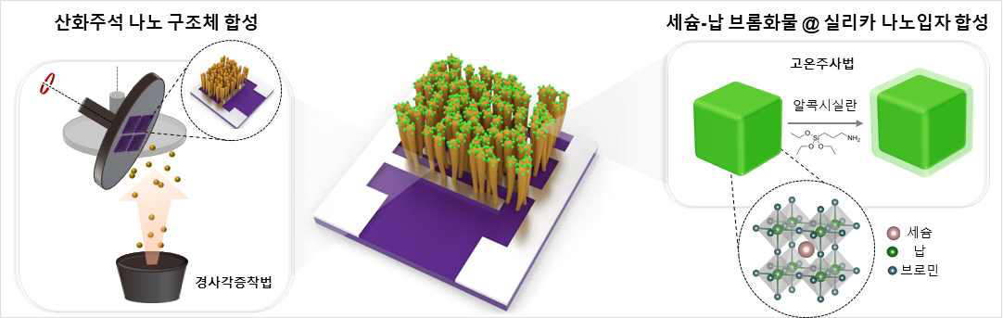

▲ Principle of a high-sensitivity gas sensor operating on visible light. A core-shell structure was designed in which nanoparticles are encased and protected by a thin glass film, and this structure was stacked on top of micro-pillars. This demonstrates the process of realizing a next-generation sensor that detects nitrogen dioxide by reacting sensitively to visible light through this structure.
The research team compared the nitrogen dioxide (NO₂) detection performance of this sensor under dark conditions and under conditions illuminated by visible light (visible and green light).
As a result, the sensor detected nitrogen dioxide across a wide concentration range, from ultra-trace amounts (0.105 ppb) to high concentrations (10 ppm). This indicates high sensitivity capable of detecting levels down to approximately 1/127th of the World Health Organization (WHO) standard (13.3 ppb).
In particular, long-term stability was confirmed, as the sensor operated stably for over five weeks due to the silica protective layer, which acts as a thin glass film.
This technology operates at room temperature without heating and precisely detects the presence and concentration of pollutants using only visible light.
In particular, by detecting nitrogen dioxide (NO2) using only visible light at room temperature, the researchers demonstrated the feasibility of designing light-controlled sensors by enabling sensor performance to be adjusted according to light intensity.
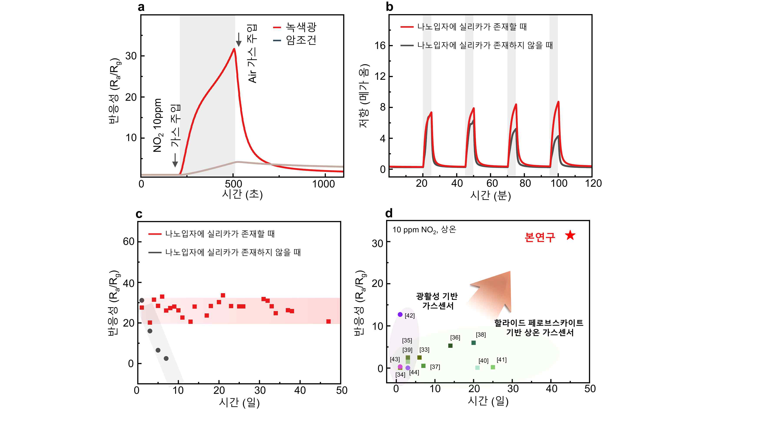

▲ Comparison of sensor lifespan and performance based on a thin glass film (silica protective layer). Gas detection performance is best when illuminated with green light; simultaneously, the thin glass protective film (silica protective layer) protects the core material—the light-emitting particles (perovskite)—from the external environment, allowing the sensor to operate stably.
Since power consumption can be reduced by eliminating the need for a separate heating device, it is expected to be utilized in portable sensors, smart devices, and indoor air quality management systems.
Professor Sanghan Lee stated, "This research is the first instance of applying halide perovskite materials that operate stably even in visible light environments, such as everyday lighting, to gas sensors," adding, "We expect this to accelerate the commercialization of low-power, high-sensitivity next-generation gas sensors."
Co-corresponding author Chang-Lyoul Lee, a senior researcher at the Advanced Photonics Research Institute, stated, “This study is an example demonstrating the potential for expanding halide perovskites into various optoelectronic devices, such as gas sensors, in addition to existing solar cells and light-emitting devices, by improving their structural stability.”
This research, supervised by Professor Sanghan Lee of the Department of Materials Science and Engineering at GIST and Principal Researcher Lee Chang-yeol of the Advanced Photonics Research Institute, and conducted by Yeonji Yuk, a student in the integrated master’s and doctoral program in Department of Materials Science and Engineering, and Dokyum Kim, a postdoctoral researcher at the Korea Institute of Advanced Photonics, was supported by the Ministry of Science and ICT, the National Research Foundation of Korea’s Mid-Career Researcher Support Program, the Future Hydrogen Source Technology Development Program, and the national research talent development program ‘InnoCORE (AI-Space Solar Industry Complex).’
The research results — Ultrastable Photoactive Halide Perovskite Nanocrystal-Sensitized SnO₂ Nanorods for Room-Temperature NO₂ Detection — were published online on March 12, 2026, in Advanced Functional Materials, a prominent international journal in the field of materials science, and were selected as a back cover article.
Meanwhile, GIST stated that this research achievement was considered to have both academic significance and potential for industrial application, and that discussions regarding technology transfer can be conducted through the Technology Commercialization Office (hgmoon@gist.ac.kr).

