Regulating ‘fat’ causing protein aggregation slows Parkinson’s disease progression... GIST presents strategy to block ‘key pathological pathology’ of Parkinson’s disease
- Research team led by Professor Chang-Myung Oh of the Department of Biomedical Science and Engineering confirms that the accumulation of ceramide, a metabolite that acts like fat, is a key cause inducing protein aggregation and neuronal damage
- Proven improvements in motor function and neuroprotective effects in animal and patient-derived models
- Published in the international journal npj Parkinson's Disease


▲ (From left) Professor Chang-Myung Oh and Dr. Eunkyung Lee of the Department of Biomedical Science and Engineering
Gwangju Institute of Science and Technology (GIST, President Kichul Lim) announced that a research team led by Professor Chang-Myung Oh of the Department of Biomedical Science and Engineering has presented the potential for a new therapeutic strategy to alleviate the progression of Parkinson's disease by inhibiting the production of ceramide, a specific lipid component found in brain cells.
Parkinson's disease, which affects approximately 10 million people worldwide, is a neurodegenerative disorder that causes the gradual loss of motor functions, such as tremors in the hands and feet and gait disorders.
Currently, treatment primarily focuses on alleviating symptoms, and there is no cure yet that blocks the root cause of the disease. In particular, because nerve cells are damaged progressively over several years, significant damage often has already occurred by the time symptoms appear.
The research team focused on "ceramide," a substance that acts like lipids within brain cells to regulate cell structure and signal transmission.
Ceramide is known to accumulate abnormally in aging or neurodegenerative diseases, and in Parkinson's disease in particular, it plays a role in promoting the aggregation of the protein 'alpha-synuclein*', which damages nerve cells.
In fact, when a research team compared and analyzed the brain tissues of six patients with Lewy body dementia (LBD) with normal brain tissues (6 cases), it was found that 19 types of ceramide were significantly increased in the patients' brains.
In addition, genetic analysis confirmed that the activity of genes (such as CERS5 and CERS6) associated with the enzyme that produces ceramide in dopaminergic neurons was increased.
* ceramide: A lipid component that makes up the cell membrane and is involved in various signaling pathways, including apoptosis, autophagy, and inflammation. It is known to accumulate abnormally in aging and neurodegenerative diseases, exacerbating mitochondrial dysfunction and protein aggregation.
* alpha-synuclein (α-synuclein): A protein normally involved in synaptic transmission; however, in Parkinson's disease, it aggregates abnormally to form Lewy bodies and damage dopaminergic neurons.
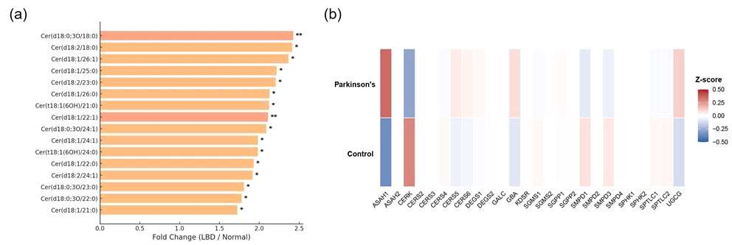

[Figure 1] Increase in ceramide and related gene changes in the brains of Parkinson's disease patients. A specific lipid component (ceramide) was significantly higher than normal in the brains of Parkinson's disease patients (a). The activity of genes (CERS5, CERS6, DEGS1, GBA, etc.) involved in the production or processing of ceramide in dopamine neurons of Parkinson's disease patients was generally increased compared to normal individuals (b).
The research team then verified the effect of inhibiting ceramide production using animal models of Parkinson's disease and patient-derived cells.
When 'myriocin,' a substance that inhibits ceramide production, was administered for 5 to 7 months to experimental mice induced to abnormally aggregate alpha-synuclein proteins, the results showed: ▴ reduced protein aggregation; ▴ improved motor skills and memory; and ▴ significantly reduced damage to dopamine neurons.
Furthermore, this drug (myriocin) also demonstrated the effect of lowering the expression of inflammation-related genes and bringing the signaling function of dopamine neurons, which regulate movement, memory, and concentration, closer to normal levels.
Changes were also confirmed in which the process of removing damaged intracellular mitochondria (mitophagy) was activated, while neuroinflammation and apoptosis were reduced. This effect is attributed to the activation of mitophagy, which removes damaged mitochondria, suggesting that this process acts as a key mechanism for improving the pathology of Parkinson's disease.
* myriocin: A drug derived from fungi that reduces protein aggregation within cells by blocking the first step in ceramide production. Further research is required to confirm its safety when used in humans.
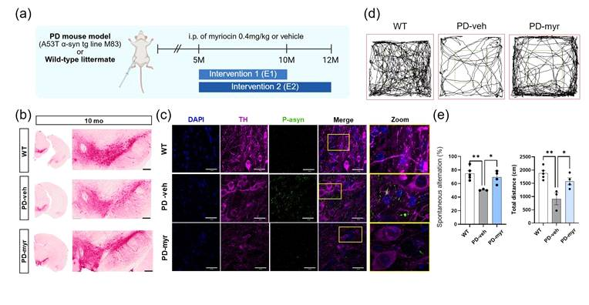

[Figure 2] Pathological and behavioral recovery effects of myriocin in Parkinson's disease mice. The experimental plan involves injecting myriocin (0.4 mg/kg) three times a week into Parkinson's disease model mice starting at 5 months of age (a). In the myriocin administration group, dopaminergic neuron loss and alpha-synuclein aggregation decreased (b, c), and recovery of impaired motor skills and improvement in memory were confirmed through open space and Y-maze tests (d, e).
The research team conducted the same experiments on "midbrain organoids" (mini-brain tissues) created from patient-derived stem cells and on actual patient-derived neurons.
The experimental results consistently showed that administering myriocin resulted in less aggregation of alpha-synuclein proteins and longer survival of dopaminergic neuron cells.
Conversely, the addition of external ceramides caused protein aggregation and neuronal damage to increase again, proving that ceramide accumulation is directly involved in the core pathology of Parkinson's disease (protein aggregation and neuronal damage).
* midbrain organoid: A small, three-dimensional artificial brain tissue created from stem cells obtained from a patient. By creating a structure similar to an actual patient's brain, the progression of the disease and the effects of drugs can be verified in the laboratory in advance.
Professor Chang-Myung Oh stated, "This study is significant in that it presents the possibility of blocking the fundamental pathway of the disease leading to protein aggregation and neuronal death, rather than merely alleviating symptoms." He added, "We plan to continue our research to develop safer synthetic inhibitors for future clinical applications and to verify long-term toxicity."
This research, supervised by Professor Chang-Myung Oh of the Department of Biomedical Science and Engineering at GIST and conducted by Dr. Eunkyung Lee and others, was supported by the Ministry of Science and ICT and the National Research Foundation of Korea’s Biomedical Technology Development Project; the Ministry of Health and Welfare and the Korea Health Industry Development Institute’s National Health Technology Research and Development Project; the Ministry of Science and ICT and the National Science Council’s Convergence Research Group Project; and the Ministry of Education and the Korea Basic Science Institute’s Basic Science Research Capacity Enhancement Project.
The research results — Inhibition of de novo ceramide synthesis mitigates alpha-synuclein pathology in a Parkinson’s disease mouse model — were published online on January 21, 2026, in the Nature-affiliated international journal npj Parkinson's Disease.
Meanwhile, GIST views this achievement as having high potential for industrial application, such as the future development of treatments, in addition to its academic significance. The university stated that discussions regarding technology transfer can be conducted through the Technology Commercialization Office (hgmoon@gist.ac.kr).

