Experimental clues confirmed in ultrathin materials for ‘gyptomagnetism,’ a long-standing theory… GIST-University of Minnesota
- An international joint research team led by Professor Jong Seok Lee of the Department of Physics and Photon Science at GIST experimentally elucidates ‘cross-magnetism’ combining the advantages of ferromagnetism and antiferromagnetism in ultrathin ruthenium oxide… Published in the international journal PNAS
- Provides new clues for research on next-generation ultra-high-speed, low-power spin electronic devices for AI and high-performance computing


▲ (From left) Professor Jong Seok Lee and Dr. In Hyeok Choi of the Department of Physics and Photon Science at GIST
The Gwangju Institute of Science and Technology (GIST, President Kichul Lim) announced that a research team led by Professor Jong Seok Lee of the Department of Physics and Photon Science has experimentally demonstrated, through a joint study with the University of Minnesota, that new magnetic properties can emerge in extremely thin ruthenium oxide (RuO₂)*, which is only about 1/50,000th the thickness of a human hair.
* ruthenium oxide (RuO₂): A metal oxide formed by the combination of the metal ruthenium and oxygen. It conducts electricity well and possesses strong resistance to heat and chemical reactions, making it a material utilized in various advanced technology fields such as batteries, electronic devices, and catalysts.
Magnetic properties are utilized in most electronic devices, such as computers and smartphones, to store and transmit information. For example, hard disks and some semiconductor memory record data by distinguishing differences in magnetic direction as 0 and 1.
However, currently widely used ferromagnetic materials have problems such as reduced stability due to being relatively easily affected by external magnetic fields or the surrounding environment, and limitations in the speed at which they can change the direction of magnetism, making it difficult to significantly increase the operating speed of devices.
Recently, a new magnetic state called cross-magnetism has been theoretically proposed to overcome these limitations. Cross-magnetism is attracting attention as a physical state with potential for use in next-generation ultra-high-speed, low-power electronic devices, as it offers the advantages of rapid information processing while being less affected by the surrounding environment. However, since technology for precisely controlling magnetism has not yet been sufficiently established, further research is required before it can be applied to actual devices.
* ferromagnetism: Materials that behave like magnets even without a magnetic field. While they can store information by utilizing states where the magnetic direction differs, they are relatively sensitive to environmental changes and have limitations in the speed at which they can change direction.
* altermagnetism: A new magnetic state that can store information like conventional magnets (ferromagnetism) while operating as rapidly as antiferromagnetic materials.
To overcome the speed and stability limitations of existing magnetic materials, the research team focused on ruthenium oxide, a metallic material that conducts electricity well and is resistant to heat and chemical reactions. In particular, they noted that creating this material in the form of a very thin film and applying minute deformations to its internal structure could reveal new magnetic states that were not previously observed.
The research team used an advanced thin-film fabrication technique called "Hybrid Molecular Beam Epitaxy (hMBE)" to precisely stack ruthenium oxide layer by layer, one atom at a time. This technology is a precision process technology that can uniformly produce an extremely thin film with a thickness of nanometers (nm), which is about 1/50,000th the thickness of a human hair, without defects by spraying a material very thinly in a vacuum and stacking it layer by layer on a substrate.
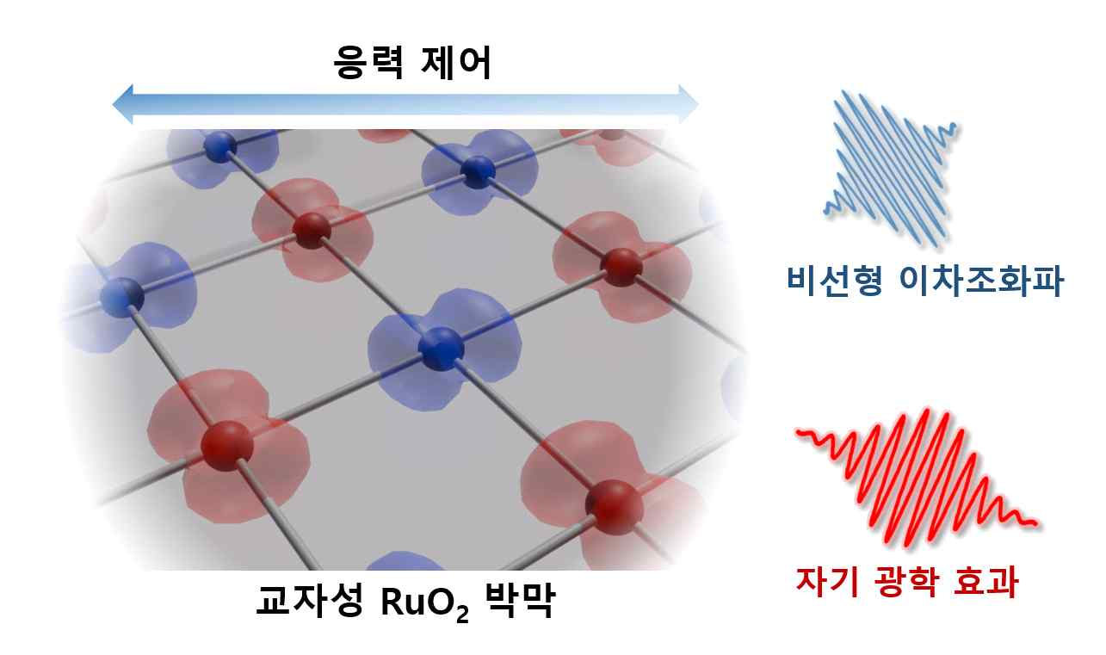

▲ Manifestation of cross-magnetic properties in ruthenium oxide (RuO₂) thin films through stress control. The research team fabricated a thin film (ruthenium oxide, RuO₂) by precisely stacking layers at the atomic level to control thickness and twisting the structure by applying external force (stress). By shining light on the film, they confirmed the "nonlinear second harmonic" phenomenon, where the wavelength of light changes internally, and the "magneto-optical effect," where the material responds to magnetic properties upon light reflection. Through this, they confirmed that controlling the thickness of the film resulted in the material exhibiting a new magnetic property called "cross-magnetism."
The research team observed in real-time how the magnetic properties changed while precisely controlling the thickness and structure of the ultra-thin films produced in this way. Furthermore, by applying a physical force called "strain" to the interior of the material to finely deform the crystal structure—much like stretching a stretchy fabric taut—they identified conditions under which a new magnetic state emerges.
As a result, the research team experimentally confirmed that a new magnetic phenomenon distinct from conventional magnets—namely, cross-magnetism—can appear in stressed ultrathin ruthenium oxide films.
In particular, they experimentally verified that a new physical state can be formed in ultrathin films at the nanometer level, where structurally asymmetric "polar metal" characteristics and cross-magnetism appear simultaneously while maintaining the electrical conductivity of a metal.
This represents a realization of a material state combining the electrical properties of a metal with novel magnetic properties, providing important clues for research on next-generation spin-based electronic devices.
Furthermore, the research team observed a phenomenon where magnetic properties change (magnetic transition) even at a level of approximately 500K (about 227°C), which is much higher than room temperature, confirming that magnetic properties can be maintained even at relatively high temperatures. This result demonstrates the potential for application in environments where actual electronic devices operate.
These characteristics have the potential to be utilized in the development of next-generation spin-based electronic devices that process information faster and more stably in high-performance computing devices, such as AI supercomputers. Furthermore, it is expected to be applied as a low-power electronic device technology that reduces power consumption by increasing energy efficiency.
* spintronics: A next-generation electronic device technology that stores and processes information by utilizing not only the electric charge of electrons but also their subtle magnetic properties (spin), which act like magnets.
Professor Jong Seok Lee stated, "This research is highly significant in that it experimentally verified the possibility of cross-magnetism existing in ruthenium oxide, a topic that has been discussed for some time." He added, "By presenting the potential for developing new functional materials capable of simultaneously controlling magnetism and polarity, this research is expected to contribute to the study of next-generation ultra-high-speed, low-power spintronics."
This research, conducted jointly by Professor Jong Seok Lee's team and a research team from the University of Minnesota, was supported by the Ministry of Science and ICT, the National Research Foundation of Korea (NRF) Mid-Career Researcher Support Program, the Samsung Future Technology Foundation, the U.S. Air Force Scientific and Research Service (AFOSR), the U.S. Department of Energy (DOE), and the National Science Foundation (NSF).
The research results — Altermagnetic polar metallic phase in ultrathin epitaxially strained RuO₂ films — were published online on March 6, 2026, in the international academic journal PNAS (Proceedings of the National Academy of Sciences), published by the U.S. National Academy of Sciences.
Meanwhile, GIST stated that this research achievement is expected to have both academic significance and potential for industrial application, and that discussions regarding technology transfer can be conducted through the Technology Commercialization Office (hgmoon@gist.ac.kr).

