"Coating Medical Device Surfaces to Prevent Bacteria from Adhering" GIST-KIST develop antimicrobial gel to prevent infection in medical devices
- Antimicrobial hydrogel developed by a joint research team led by Professor Jiwon Seo of the Department of Chemistry at GIST inhibits biofilm formation by antibiotic-resistant bacteria by up to 60%... Published in the international journal Nano Letters
- Enables stable coating of medical device surfaces while maintaining safety for human cells


▲ (From left) Professor Jiwon Seo of the Department of Chemistry at GIST, Dr. Jae Hong Kim and Dr. Il-Soo Park of KIST, master's student Jae Won Yun, and Ph.D. student Heewoong Yoon of the Department of Chemistry at GIST
A new technology capable of preventing infections caused by bacteria adhering to the surfaces of medical devices used in hospitals is expected to become a reality.
The Gwangju Institute of Science and Technology (GIST, President Kichul Lim) announced that a joint research team consisting of Professor Jiwon Seo of the Department of Chemistry and Dr. Jae Hong Kim of the Korea Institute of Science and Technology (KIST) has developed a multifunctional antimicrobial hydrogel (a gel-like substance that spreads smoothly like water and can coat surfaces) that effectively inhibits "biofilms" formed on the surfaces of medical devices by bacteria* that are highly resistant to antibiotics.
This research resolves the difficulty of striking a balance between effectively killing bacteria and ensuring human safety in existing antimicrobial materials, and presents the potential to prevent infections caused by medical devices.
To achieve this, the research team utilized an artificial protein-like substance called a peptoid*. Peptoids can be designed to kill bacteria or prevent them from attaching by mimicking the structure of natural proteins. Furthermore, they can simultaneously enhance sterilization efficacy and safety through a self-assembly method in which they gather within a gelatin hydrogel to form a nanostructure.
* biofilm: A structure in which bacteria adhere to medical devices or surfaces and form colonies within a self-made protective barrier; it is difficult to kill even with medication and is one of the major causes of hospital-acquired infections.
* antibiotic-resistant bacteria: Bacteria that have acquired the ability to survive even when exposed to antibiotics.
* peptoid: A novel artificial material created by mimicking the structure and function of proteins (peptides) found in nature. It can be designed to kill bacteria or prevent them from attaching. In this study, these peptoids were combined with gelatin hydrogels to simultaneously enhance pathogen inhibition and safety.
Bacteria adhere to the surfaces of medical devices used in hospitals, such as catheters, stents, and artificial joints, forming biofilms. These biofilms have a structure consisting of multiple layers of bacteria; because their thickness is only about one-fiftieth the thickness of a human hair, they are difficult to see with the naked eye and do not easily detect during examinations.
The bacteria within the biofilm are clustered within a sticky protective layer (EPS), making it difficult for antibiotics to penetrate. Consequently, they exhibit stronger antibiotic resistance than ordinary bacteria, making infection treatment much more challenging.
The problem is that these biofilms form very easily on the surfaces of medical devices. Once an infection begins, it delays patient recovery and increases the risk of infection for the entire hospital.
* protective layer (extracellular polymeric substances, EPS): A sticky substance produced by bacteria themselves that acts as a protective barrier within the biofilm.
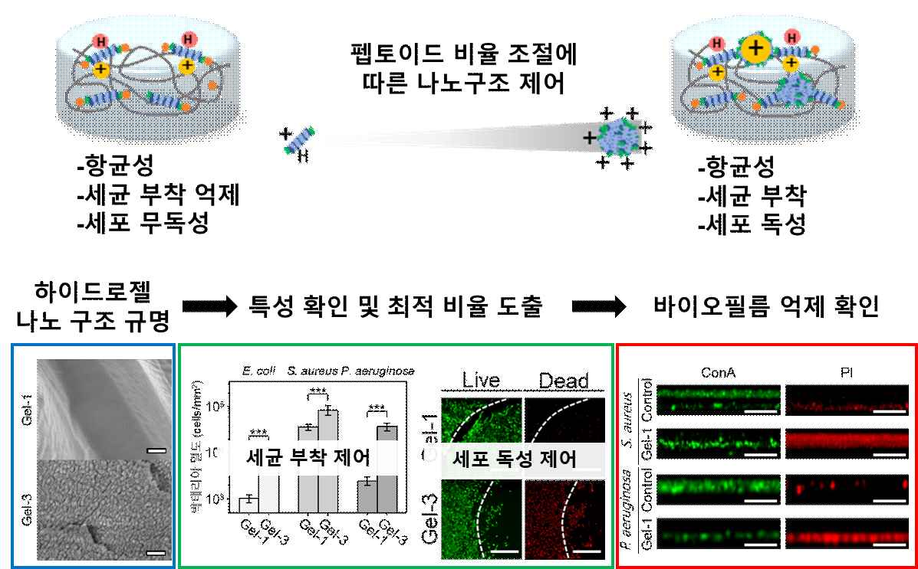

▲ Schematic diagram of changes in nanostructure and function according to peptoid ratio control. This illustrates the process in which the molecular self-assembly state changes as the binding ratio of antimicrobial peptoids within a gelatin hydrogel is controlled, thereby altering surface characteristics and biological functions. It demonstrates that at the optimal ratio, bacterial adhesion is inhibited and cytotoxicity is minimized, resulting in an effective reduction of biofilm formation.
Based on gelatin, which is safe for the human body and can be easily fabricated into a gel form, the research team proposed a novel antimicrobial surface strategy that simultaneously optimizes bacterial sterilization and adhesion inhibition by precisely controlling the distribution of antimicrobial peptoids.
Instead of simply increasing the amount of peptoids, the team created various structures in which the peptoids are completely immobilized within the gel or partially clumped together by controlling the binding ratio with gelatin.
The experimental results showed that when the peptoids were evenly distributed, bacterial adhesion was significantly reduced while the bactericidal effect was maintained, and the material was safe as it had almost no effect on human cells.
Conversely, it was confirmed that when the peptoids clumped together excessively, they affected both bacteria and human cells; while a bactericidal effect was observed, human cell damage could occur.
The research team also used hydrogels to attach Staphylococcus aureus and Pseudomonas aeruginosa—representative bacteria that cause actual infection problems in hospitals—to glass, silicone, and stainless steel surfaces, and then measured the degree of bacterial adhesion, biofilm formation, and the impact on human cells.
The results showed that hydrogels produced under optimal conditions inhibited biofilm formation in both bacteria by approximately 60% compared to conventional methods.
In particular, the antibacterial effect was manifested through direct contact with the hydrogel surface, and the material demonstrated high safety as no antimicrobial substances were released externally.
The results also indicated that the hydrogels produced under optimal conditions inhibited biofilm formation in both bacteria by approximately 60% compared to conventional methods. This study demonstrates that the antimicrobial hydrogel developed by the research team can be stably coated onto various surfaces of medical devices, showing its potential for application in actual hospital environments. Through this, it presents a path to reduce infections occurring on the surfaces of medical devices, such as catheters and artificial joints, and allows patients to receive safe treatment while minimizing antibiotic use.
Dr. Jae Hong Kim of KIST explained, "This study is an example showing that surface characteristics can be actively altered simply by adjusting the molecular binding ratio," adding, "It has the potential to evolve into a material platform expandable not only for antimicrobial functions but also for the design of various bio-surfaces."
Professor Jiwon Seo of the Department of Chemistry at GIST stated, "Developing materials capable of suppressing the spread of antibiotic-resistant bacteria and biofilms, which are causes of infection in hospital settings, is an urgent task required in clinical practice," adding, "This study is highly significant in that it presents a strategy for developing new surface materials capable of inhibiting biofilm formation by combining antimicrobial peptoids and hydrogel materials."
This research, jointly supervised by Professor Jiwon Seo of the Department of Chemistry at GIST and Dr. Jae Hong Kim of KIST, was supported by the Ministry of Science and ICT's GIST-InnoCORE project, the Ministry of Science and ICT and National Research Foundation of Korea's Sejong Fellowship program, the Regional Innovation Leading Research Center Support Program, and the Biomedical Technology Development Project.
The research results were published online in the international academic journal Nano Letters on February 26, 2026.
Meanwhile, GIST stated that this research achievement was considered to have both academic significance and potential for industrial application, and that discussions regarding technology transfer can be conducted through the Technology Commercialization Office (hgmoon@gist.ac.kr).

