GIST develops AI technology for precision robots that can sense the force of human fingertips
- Professor Kyoobin Lee's team in the Department of AI Convergence has developed a hand force measurement device (ManipForce) and an AI model (FMT) that recognizes frequency differences between sensors and even learns force perception... The research is scheduled to be presented at the International Robotics Conference (ICRA) 2026
- The research achieved an 83% success rate in precision manipulation tasks such as gear assembly and cable plug connection... Expected to be utilized in the manufacturing and electronics industries
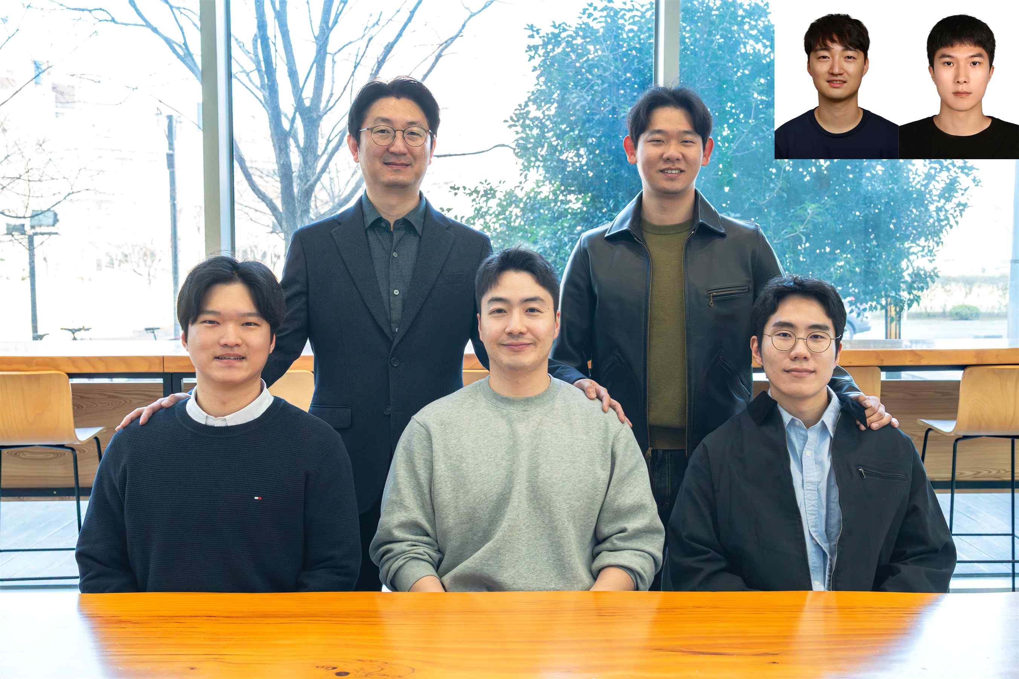

▲ (From left) GIST AI Convergence Department Dr. Seongju Lee, Professor Kyoobin Lee, PhD student Geonhyup Lee, PhD student Sangjun Noh, master's and doctoral student Kangmin Kim, Senior Researcher Seunghyeok Back (Korea Institute of Machinery and Materials), and master's student Yeongjin Lee
The Gwangju Institute of Science and Technology (GIST, President Kichul Lim) announced that a research team led by Professor Kyoobin Lee (Director of the Artificial Intelligence Research Center) in the Department of AI Convergence has developed artificial intelligence (AI) technology that can learn the force a person feels when touching an object, enabling precise tasks.
This technology is unique in that it learns not only the information a person sees visually but also the force and touch sensation felt at the fingertips. To achieve this, the research team jointly developed a "manipforce measuring device" and a "frequency-aware multimodal transformer (FMT)."
In the manufacturing, electronics, and automotive industries, robots perform precision manipulation tasks, such as inserting gears, connecting plugs, and replacing batteries, replacing human hands.
These tasks require not only simple alignment but also the ability to detect and adjust the minute changes in resistance and force that occur when parts are engaged.
However, most existing robot learning methods have relied on imitation learning*, which collects task data solely from camera images (RGB). This approach has limitations, as it relies solely on visual information, making it difficult to detect the subtle resistance and instantaneous force changes that occur when fitting or adjusting parts.
* imitation learning: This AI technique records human-performed movements as data and teaches robots to imitate them. Instead of programming individual rules, robots are taught to observe and imitate human behavior.
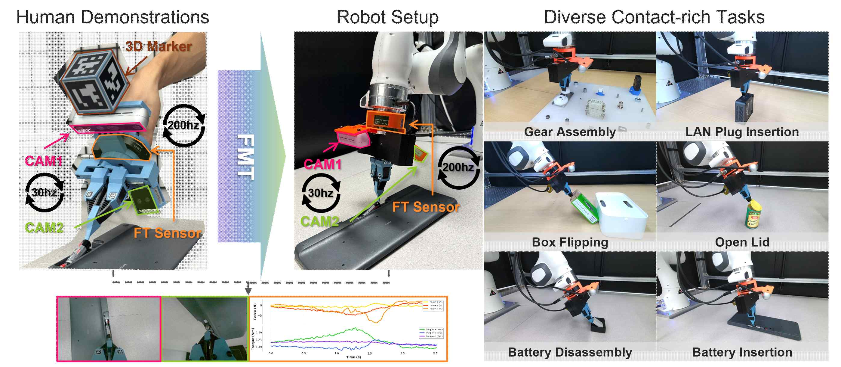

▲ ManipForce system configuration diagram. This device simultaneously records hand movements, forces, and task images while a person directly handles an object. The device consists of ▴ two RGB cameras, ▴ a wrist-mounted force/torque sensor (F/T), ▴ a module that tracks hand position using a 3D marker, and ▴ a robotic hand device that grasps and manipulates objects.
To overcome these limitations, the research team focused on leveraging the "sense of force"—a natural human experience during a task—in robot learning.
The "ManipForce," developed by the research team, records a person's hand movements while simultaneously collecting: ▴ videos of the task captured by two cameras; ▴ force-torque measurements from wrist sensors; and ▴ hand movement and position information.
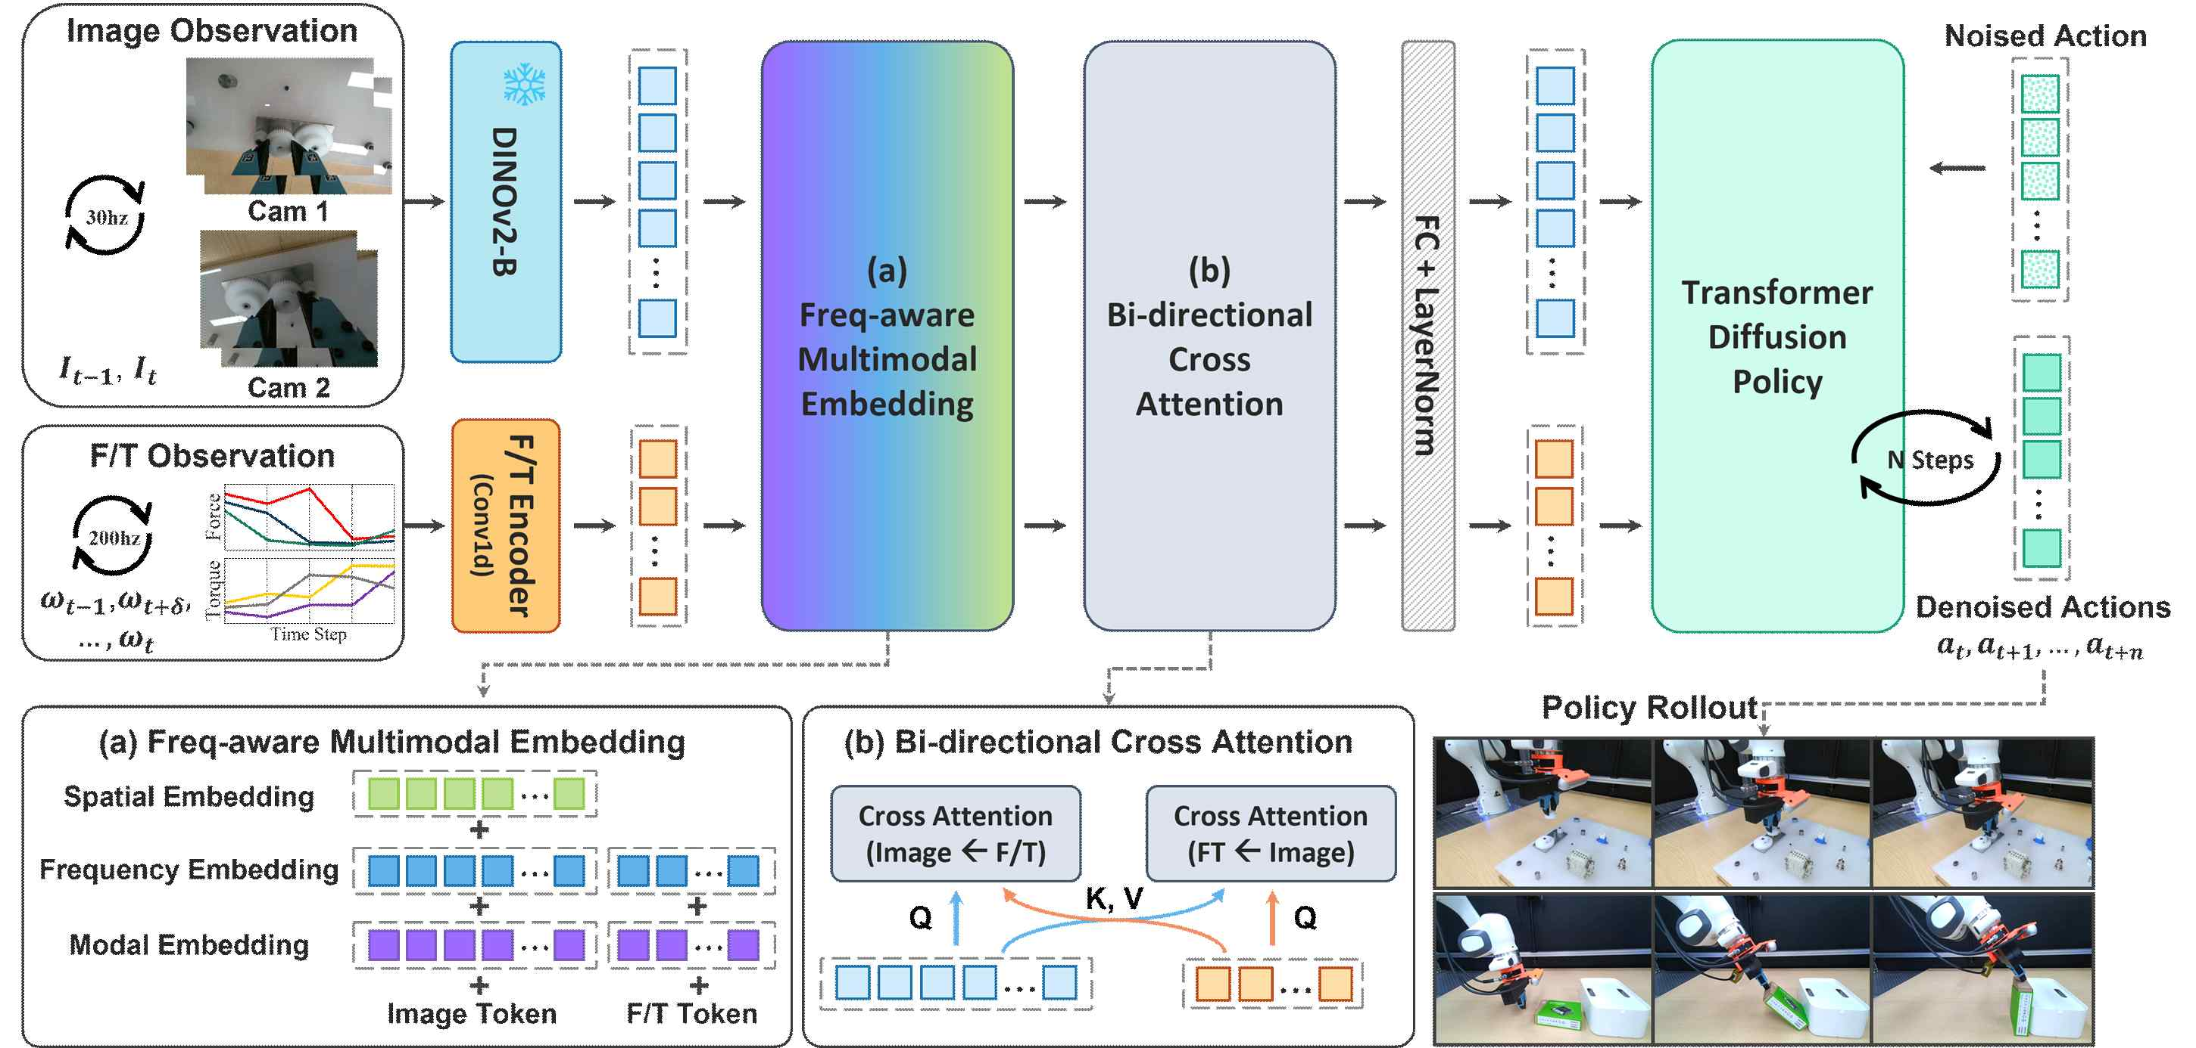

▲ FMT (Frequency-Aware Multimodal Transformer) AI model structure.
The AI ​​understands RGB camera images captured 30 times per second and force data recorded over 200 times, and then references and learns from each other. This learned AI helps the robot adjust its force based on what it sees and feels, enabling precise operation.
Notably, the AI ​​measures images 30 times per second and force data over 200 times per second, enabling it to precisely record not only the visible scene but also the subtle forces generated by the fingertips.
Furthermore, it is designed to precisely measure only the forces generated by actual contact by applying a "3D marker" that accurately tracks the position of objects and hands, and a "device gravity compensation function" that eliminates the force caused by the device's own weight.
This device differentiates itself from existing data collection methods in that it can record the natural movements of a human directly manipulating an object, rather than operating the robot remotely.
To address the issue of different recording speeds for video and force data, the research team also developed a "Frequency-Aware Multimodal Transformer (FMT)."
Video data is recorded 30 times per second, while force data is recorded over 200 times per second, resulting in different time intervals between the two data sets. FMT is an AI model that analyzes, compares, and integrates data from these different sensor frequencies to learn from them.
This allows the robot to simultaneously understand the object's location and contact situation, enabling more stable movements even in precision manipulation tasks involving a high level of contact.
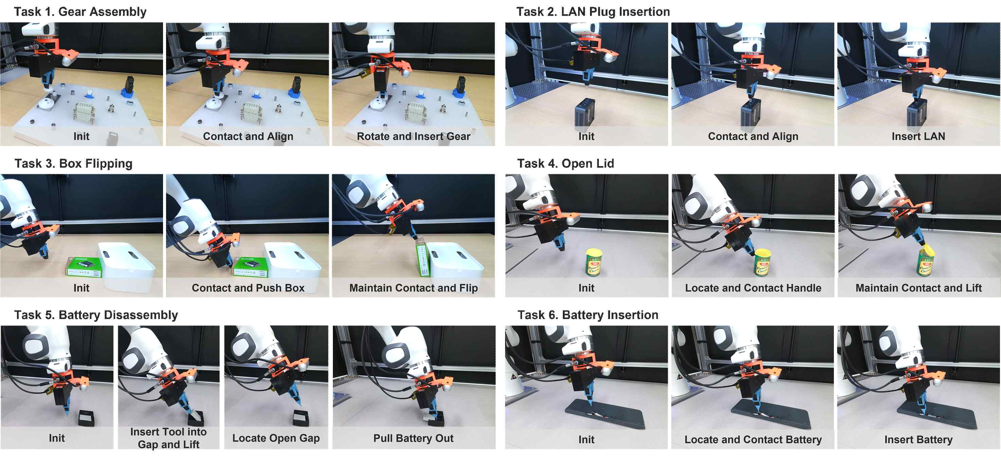

[Figure 3] Comparison of actual task success rates. A robot using FMT achieved an average success rate of 83% across six contact tasks, including gear assembly and battery insertion. This is significantly higher than the existing method (approximately 60%) that used only video information.
The research team verified six tasks through actual robot experiments: ▴ gear assembly, ▴ box flipping, ▴ battery insertion, ▴ internet cable plugging in, ▴ lid opening, and ▴ battery removal.
After performing each task 20 times, the average success rate reached approximately 83%. This represents a significant improvement over the existing method (approximately 20%) that solely utilized RGB camera images.
* RGB camera: This camera records the intensities of red, green, and blue light, enabling color recognition similar to the human eye. It distinguishes the color and shape of objects in the captured images, allowing the robot to understand what it is seeing. Existing robot learning methods rely solely on this image information to collect data.
Professor Kyoobin Lee stated, "This research overcomes the limitations of existing robot learning methods that rely solely on camera footage and presents a new AI learning framework that can effectively utilize force sensor data. We anticipate that this will further advance the use of robots in diverse fields requiring delicate force control, such as parts assembly and connector fastening in manufacturing environments, as well as battery replacement and electronic device component assembly in the home."
This research, supervised by Professor Kyoobin Lee of the Department of AI Convergence at GIST and conducted by Ph.D. candidate Geonhyup Lee of the Department of AI Convergence, was supported by the Robot Industry Technology Development Project of the Ministry of Trade, Industry and Energy and the National Research Foundation of Korea.
The results — ManipForce: Force-Guided Policy Learning with Frequency-Aware Representation for Contact-Rich Manipulation — were pre-released on the international academic server arXiv on September 23, 2025, and are scheduled to be presented at the IEEE International Conference on Robotics and Automation (ICRA 2026), a prestigious academic conference in the field of robotics. ICRA 2026 will be held in Vienna, Austria, from June 1 to 5.
Meanwhile, GIST stated that the results of this research were considered in consideration of both academic significance and industrial applicability, and that discussions regarding technology transfer can be conducted through the Technology Commercialization Office (hgmoon@gist.ac.kr).

