"Now we can see the reactions inside a working hydrogen energy device" GIST develops real-time observation technology for hydrogen production and power generation devices
- Professor Jong Hoon Joo's team from the Department of Environment and Energy Engineering succeeded in real-time analysis of electrode reactions in the "solid oxide electrochemical cell," a key device for hydrogen production and fuel cells
- Simultaneous tracking of oxygen transport and electrochemical reactions is expected to improve the efficiency of hydrogen energy devices
- Published in the renowned international journal Advanced Energy Materials


▲ (From left) Professor Jong Hoon Joo of the Department of Environment and Energy Engineering at GIST, Taeyun Kim, a student in the combined master's and doctoral program at the Department of Environment and Energy Engineering at GIST, and Jinsil Lee, a graduate of GIST (currently a postdoctoral researcher at the Korea Institute of Ceramic Engineering and Technology)
The Gwangju Institute of Science and Technology (GIST, President Kichul Lim) announced that a research team led by Professor Jong Hoon Joo of the Department of Environment and Energy Engineering has developed technology capable of observing changes within a high-temperature energy device used for hydrogen production and power generation in real time.
This technology is significant because it simultaneously tracks oxygen movement and electrochemical reactions occurring at the electrodes during actual operation, enabling precise analysis of internal reactions that were previously difficult to directly observe in real-world operating conditions.
A solid oxide electrochemical cell* is a high-efficiency energy conversion device that uses excess electricity to decompose water to produce hydrogen, which can then be stored and reused to produce electricity when needed.
* A solid oxide electrochemical cell: A next-generation energy conversion device operating at high temperatures, it operates by transporting oxygen ions through a ceramic (solid oxide) electrolyte. This single technology enables both hydrogen production and power generation, making it a highly efficient, clean energy technology.
The performance of this device depends on how smoothly oxygen moves and reacts within the electrodes. However, actual electrodes are made of a porous structure with many microscopic holes like a sponge, making it difficult to directly observe the chemical reactions and structural changes occurring inside.
In particular, in the high-temperature environment where the device actually operates, there were limitations in precisely measuring the oxygen transport and chemical reactions occurring within the electrode.
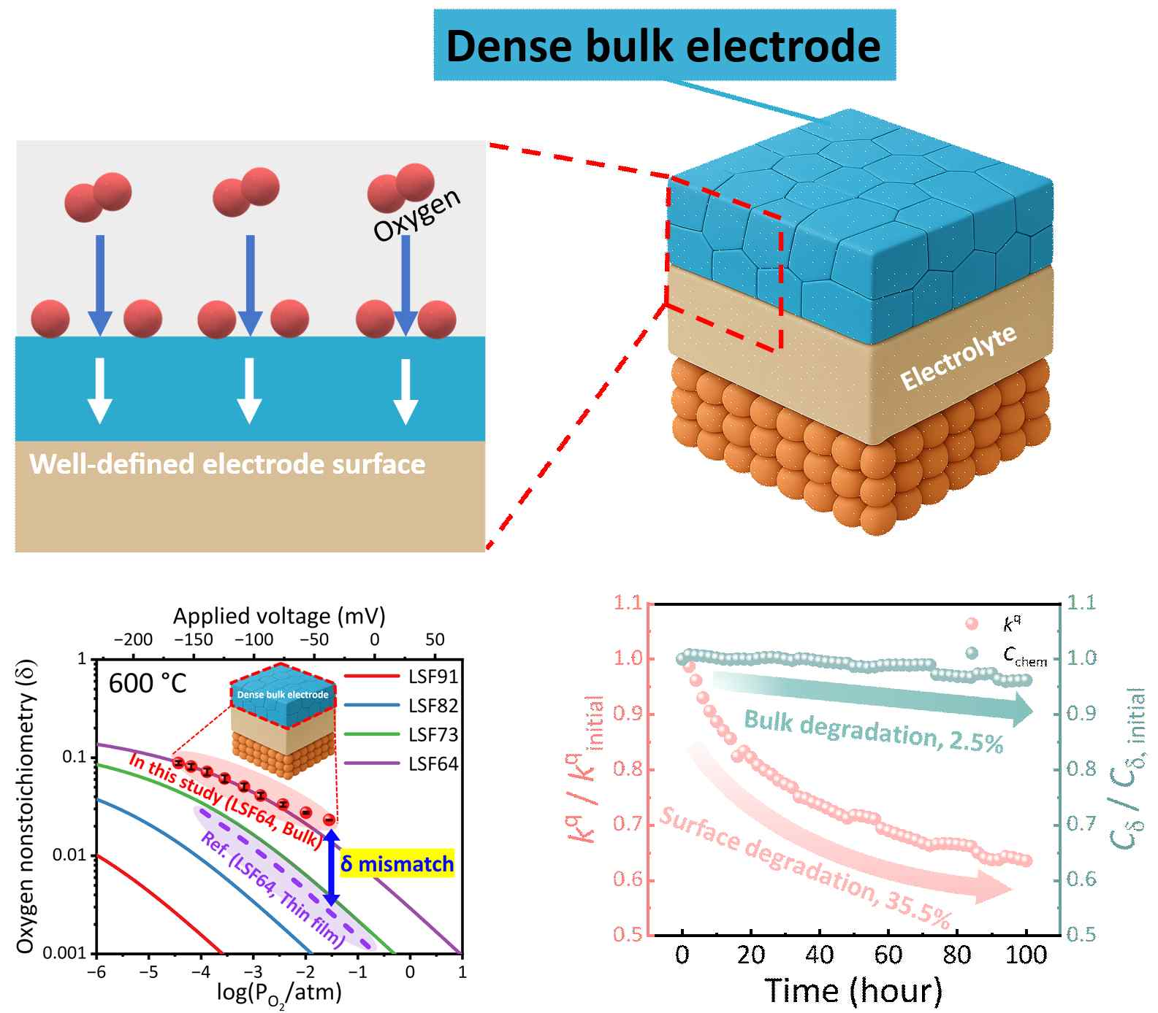

▲ Schematic diagram of a high-density bulk electrode model and real-time electrode performance analysis. Using a high-density electrode model cell, the oxygen reaction rate on the electrode surface and the internal oxygen concentration were measured in real time. This allowed for quantitative analysis of electrode performance changes and confirmed the weakening of the surface reaction over time.
To address these issues, the research team proposed a new experimental model that, instead of a complex porous electrode, created a densely structured electrode model, resembling a tightly stacked brick wall. This model allows for real-time analysis of electrode reactions under actual operating conditions.
The research team simplified the electrode structure by fabricating a dense, rigid ceramic electrode combined with a solid electrolyte. This created an environment where reactions occurring on the electrode surface and oxygen transport within the electrode could be observed separately.
Furthermore, by applying voltage to the electrode to replicate the actual device operation and analyzing the resulting electrical signals to track internal changes in real time, the team was able to accurately and comprehensively evaluate device performance.
In particular, since it is possible to separate and analyze internal and surface reactions of the electrode, it can also be used to diagnose the cause of electrode performance deterioration.
This research is expected to contribute to a more precise understanding of the electrode reaction mechanisms of solid oxide electrochemical cells and to the development of technologies to improve efficiency and durability.
In particular, it is expected to contribute to enhancing the stability and efficiency of eco-friendly hydrogen-based energy systems that store electricity generated from renewable energy and generate electricity when needed.
Furthermore, it is expected to lead to the development of clean energy facilities that maintain performance even after prolonged electrode use, which will positively impact electricity bills and carbon emissions reductions in the long term.
Professor Jong Hoon Joo stated, "Using a compact electrode with a simplified structure, we have developed an analysis system that enables precise, real-time diagnosis of the essential properties of electrode materials under actual operating conditions." He added, "This technology can be widely applied beyond fuel cells to improve the efficiency and lifespan of various high-temperature electrochemical devices."
This research, conducted by Taeyun Kim, a combined master's and doctoral student in the Department of Environment and Energy Engineering at GIST, under the supervision of Professor Jong Hoon Joo, was supported by the Ministry of Trade, Industry and Energy's Materials and Components Technology Development Project, the Ministry of Science and ICT's (MSIT) and the National Research Foundation of Korea's (NRF) Leading Research Center Support Project, and the Hydrogen International Joint Research Program (H2GATHER).
The results — In Situ Measurement of Oxygen Vacancy Dynamics and Surface Exchange Reactions in Oxide Electrode under Solid Electrochemical Cell Operating Conditions — were published online on February 17, 2026, in the renowned international journal Advanced Energy Materials.
Meanwhile, GIST stated that this research achievement considered both academic significance and industrial applicability, and that technology transfer inquiries can be made through the Technology Commercialization Office (hjmoon@gist.ac.kr).

