A joint research team from GIST and the State University of New York has developed a technology that combines robots and sound signals for adults with cerebral palsy
- A joint Korean-American research team led by Professor Jiyeon Kang of the GIST Department of AI Convergence has combined robotic resistance training with auditory biofeedback to improve gait patterns... Suggesting potential clinical applications for adults with cerebral palsy
- Published in the international journal IEEE Transactions on Neural Systems and Rehabilitation Engineering

▲ (From left) Professor Jiyeon Kang of the Department of AI Convergence (corresponding author), Souvik Poddar, a doctoral student at the State University of New York at Buffalo (first author), Jaehyung Park, an undergraduate researcher at the Department of AI Convergence (second author), Professor Jeanne Langan of the State University of New York at Buffalo (co-author), Professor Lora Cavuoto (co-author), and Professor Eleonora M. Botta (co-author)
A joint Korea-US research team led by Professor Jiyeon Kang of the Department of AI Convergence at the Gwangju Institute of Science and Technology (GIST, President Kichul Lim) announced the development of a new robotic rehabilitation technology to assist adults with cerebral palsy (CPP) with walking. This technology combines robotic training that provides appropriate resistance during walking with auditory signals that allow the individual to recognize their own gait.
Cerebral palsy is a neurological disorder caused by brain damage around birth, which results in difficulty controlling muscles and the inability to move multiple muscles simultaneously and naturally. While the disease itself does not worsen over time, the resulting difficulty in walking often persists throughout life.
To date, research on robot-assisted gait rehabilitation has primarily focused on children and adolescents, with limited systematic clinical studies for adult patients.
Furthermore, the lack of sufficient transfer of training benefits from treadmills to daily walking has been a limitation.
Adults with cerebral palsy have a strong desire to improve their gait, but they often struggle to accurately recognize their abnormal gait patterns, and specific guidelines for correcting them are lacking.
To address this issue, the research team combined two approaches.
First, a cable-driven robotic device was used to apply an additional load equivalent to approximately 10% of body weight to the pelvis during walking. This encourages more active leg muscle activation, enhancing muscle activation and gait control.
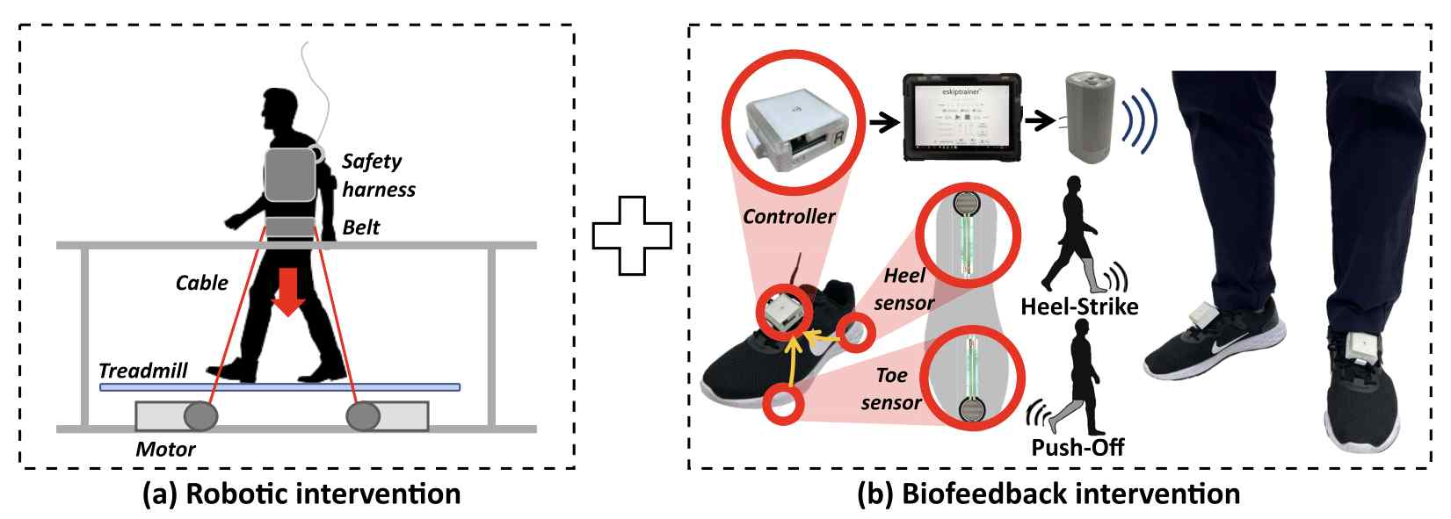

▲ Schematic diagram of a cable-based robot sound feedback gait training. The cable-based resistance rehabilitation robot uses a motor and cable mounted on a treadmill to provide downward resistance equivalent to approximately 10% of body weight to the pelvis for gait training. Biofeedback detects pressure changes in the heel and toes, wirelessly transmitting these changes and generating an auditory signal to aid cerebral palsy patients' gait awareness.
Furthermore, a smart insole was used to provide "self-aware auditory biofeedback," which plays a sound in real time corresponding to the moment the heel touches the ground and the toe pushes off. This method helps patients recognize their own gait through sound and self-regulate it.
The research team explained that the significance of this design lies in its sequential combination of "implicit motor learning (training learned through the body)" through resistance and "explicit feedback (conscious awareness)" through sound, designed to ensure that training effects naturally translate into actual overground walking.
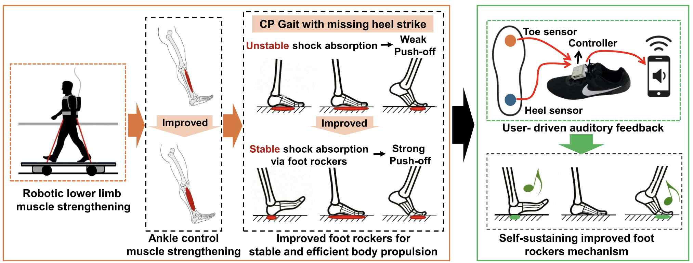

▲ Sound feedback-based gait training diagram. The robotic trainer provides downward resistance during walking, activating lower extremity muscles and improving heel strike and push-off movements, thereby promoting heel-to-toe walking (foot rocker). Smart insole-based auditory biofeedback then provides real-time information on the timing of heel-to-toe contact, helping to maintain the learned gait pattern during actual overground walking.
An experiment involving five adult patients with cerebral palsy revealed significant improvements in key gait parameters, including ▴ increased activity in the tibialis anterior muscle, which lifts the foot during a step; ▴ improved control of the calf muscles (gastrocnemius and soleus) that propel the foot; ▴ increased stride length; ▴ increased toe clearance (enhancing foot clearance) and ▴ decreased double-support time (reducing the time it takes for both feet to touch the ground simultaneously).
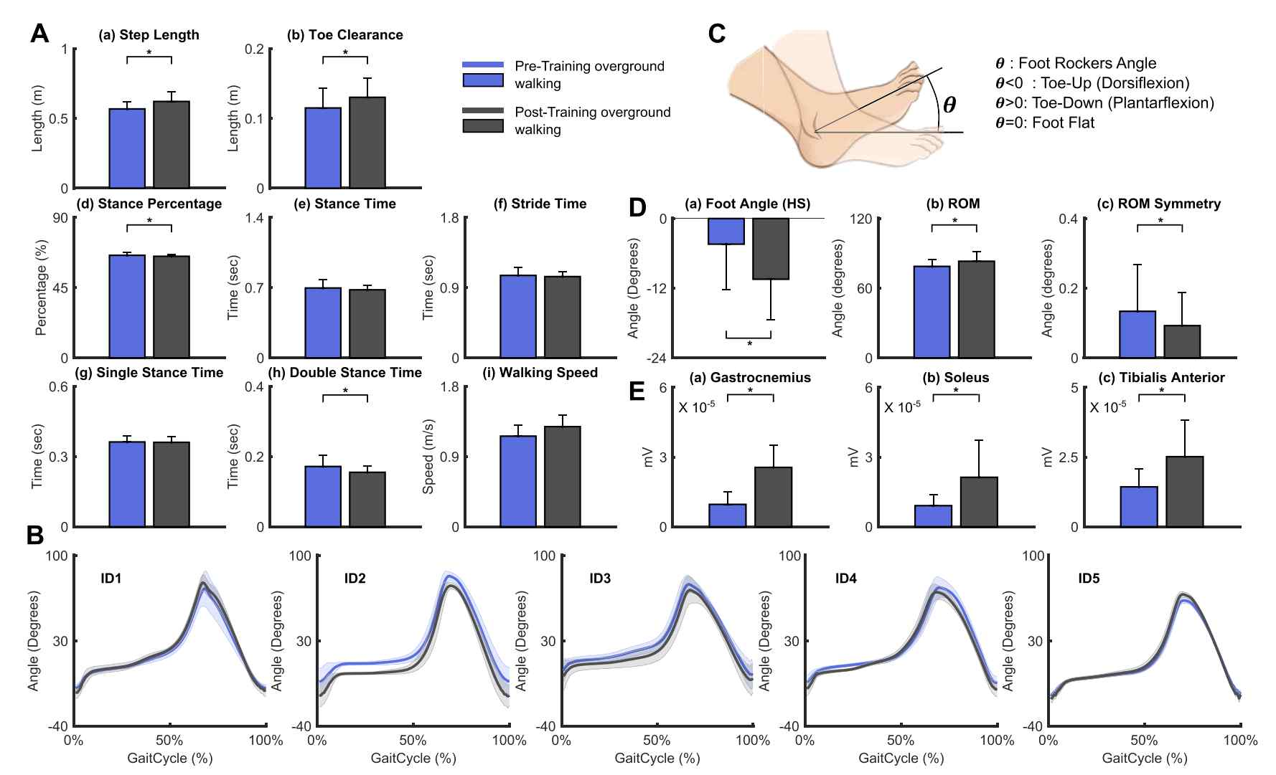

▲ Comparison of overground walking before and after training. Overall improvements were observed in spatiotemporal gait parameters such as stride length and toe clearance, as well as in heel-to-toe walking angle (foot rocker angle) and lower extremity muscle activation. Statistically significant changes were observed, particularly in the gastrocnemius, soleus, and tibialis anterior muscles, demonstrating improved gait function.
A clear improvement in the natural heel-to-toe gait pattern was also observed. Leg joints straightened more, improving overall gait stability and propulsion. These benefits tended to persist even after treadmill training and walking on actual ground.
One participant responded in a post-experiment survey, "For the first time, I became aware of how I walk," and evaluated the combination of robot training and auditory cues as helpful in improving gait.
Professor Jiyeon Kang stated, "Rehabilitation technology for adults with cerebral palsy remains inadequate, and further research aimed at long-term functional recovery is needed. This study serves as a starting point for expanding the clinical application of robotic gait rehabilitation for adults, and we anticipate it will lead to large-scale clinical trials and the development of practical treatment technologies in the future."
This study, supervised by Professor Jiyeon Kang (corresponding author) of the Department of AI Convergence at GIST and conducted by Souvik Poddar, a Ph.D. candidate at SUNY Buffalo (first author), and Jaehyung Park, an undergraduate student at GIST's Department of AI Convergence (second author), was co-authored by Professors Jeanne Langan, Lora Cavuoto, and Eleonora M. Botta of SUNY Buffalo.
The study was supported by the National Science Foundation (NSF) Disability and Rehabilitation Engineering program and the Biomedical Technology Development Program of the Ministry of Science and ICT and the National Research Foundation of Korea. The results of this study — Improving Foot Rocker via Robot-Resisted Gait Training With Self-Awareness Biofeedback in Adults With Cerebral Palsy — were published in Volume 34 (2026) of the international journal in the field of neurorehabilitation engineering, IEEE Transactions on Neural Systems and Rehabilitation Engineering, with the pre-released version published online on December 23, 2025.
Meanwhile, GIST stated that this research achievement considered both academic significance and industrial applicability, and that technology transfer-related discussions can be conducted through the Technology Commercialization Office (hgmoon@gist.ac.kr).

