"A new pathway for treating Dravet syndrome, a pediatric epilepsy causing recurrent seizures" GIST and the Korea Research Institute of Chemical Technology (KRICH) develop a new mechanism-based drug candidate
-A joint research team led by Professor Jin Hee Ahn of the Department of Chemistry at GIST has discovered a small molecule candidate, "GM-91466," that modulates the dysfunction of the SCN1A gene, a gene that causes intractable epilepsy
- Seizure suppression and initial safety were confirmed in animal models, suggesting potential for new drug development
- Published in the international academic journal Journal of Medicinal Chemistry


▲ (From left) PhD student Dong Gun Kim (co-first author, Department of Chemistry, GIST), Dr. Kyu-Seok Hwang (co-first author, Korea Research Institute of Chemical Technology), Dr. Ki Young Kim (corresponding author, Korea Research Institute of Chemical Technology), and Professor Jin Hee Ahn (corresponding author, Department of Chemistry, GIST)
A new turning point has been reached in the development of a treatment for Dravet syndrome (severe myoclonic epilepsy of infancy, SMEI), a rare form of pediatric epilepsy characterized by recurrent convulsive seizures that typically develop within the first year of life.
The Gwangju Institute of Science and Technology (GIST, President Kichul Lim) announced that a joint research team led by Professor Jin Hee Ahn of the Department of Chemistry and Dr. Myung Ae Bae and Dr. Ki Young Kim of the Korea Research Institute of Chemical Technology (KRICT) has developed a new small molecule drug candidate, GM-91466, for the treatment of pediatric intractable epilepsy.
Small molecule drug candidates are chemically synthesized compounds with small molecular sizes. They can easily penetrate cells and modulate the function of specific proteins, making them ideal candidates for oral drug development.
This study is significant in that it suggests a novel treatment method for correcting the dysfunction of the SCN1A gene, the primary cause of Dravet syndrome. Furthermore, it is noteworthy that the compound was designed and synthesized based on a completely new chemical structure, distinct from existing drugs. This novel chemical structure, structurally distinct from existing treatments, is particularly noteworthy in terms of patentability and potential for future drug development.
The SCN1A gene encodes a protein that regulates the flow of neural signals in brain neurons, playing a crucial role in ensuring the normal transmission of neural signals. Abnormalities in this gene can lead to hyperexcitability of neurons, resulting in recurrent seizures, a common condition known as Dravet syndrome.
Dravet syndrome is a rare, serious neurological disorder that begins with fever-related seizures within the first year of life, followed by recurrent convulsions and developmental delays throughout childhood. It is named after French pediatric neurologist Charlotte Dravet, who first systematically described the condition in 1978. Most current treatments rely on drugs previously used for other conditions, which often have limitations such as insufficient efficacy or potential side effects.
The research team explored new drug candidates using an animal model that closely mimics the genetic abnormality responsible for the disease.
First, they created a zebrafish model of the disease that replicated the SCN1A gene dysfunction and compared the effects of various compounds. The results showed that GM-91466 strongly suppressed seizure-related abnormal behaviors while not affecting the movement of normal individuals, demonstrating high safety.
In addition, in experiments with a mouse model in which the function of the SCN1A gene was partially reduced, it showed superior effects to existing drugs, such as significantly reducing the frequency and intensity of seizures and delaying the onset of seizures.
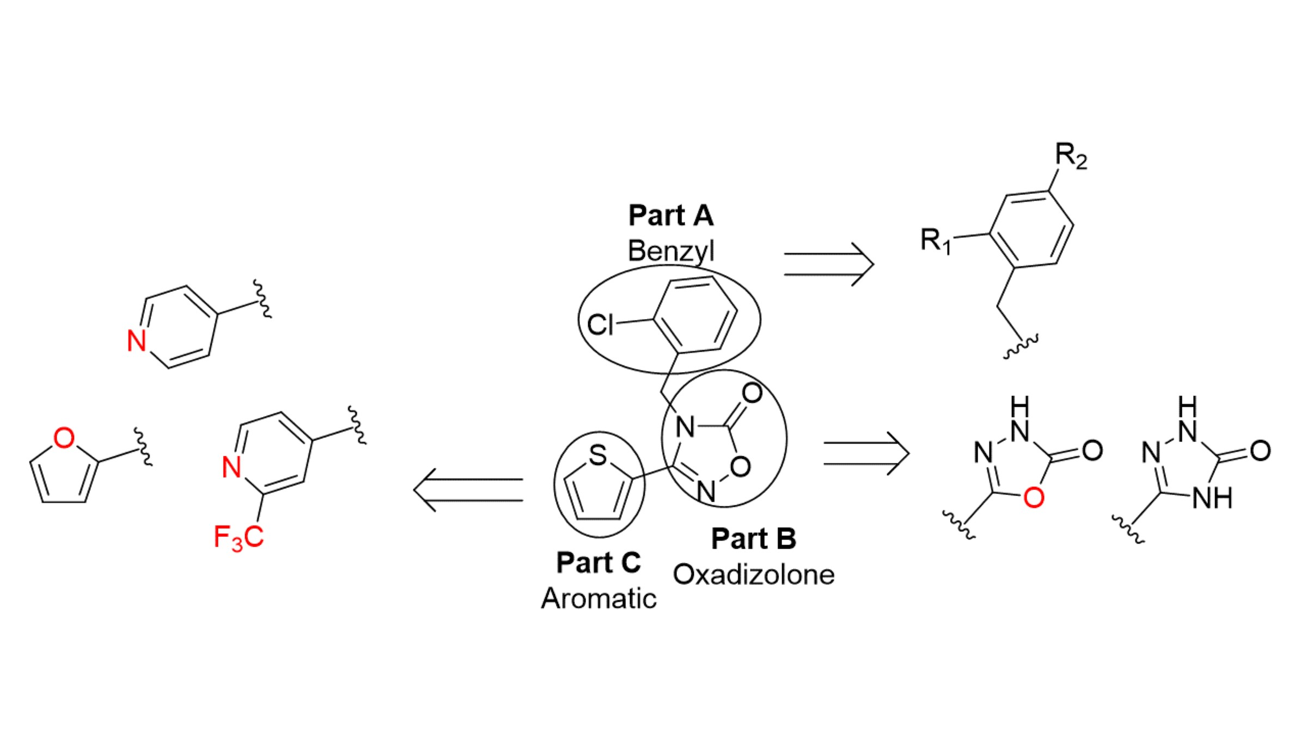

▲ Blueprint of a new candidate drug for Dravet syndrome. A candidate drug with a novel chemical backbone (1,3,4-oxadiazolone) structure was developed that demonstrates superior efficacy compared to existing drugs. This drug is highly potent even at low doses and targets only the target protein. Furthermore, it can be produced in a simple four-step synthesis using inexpensive and readily available materials, making it advantageous for research, development, and production.
The research team also elucidated the mechanism of action of GM-91466.
This drug increased the expression of tryptophan hydroxylase 2 (TPH2), an enzyme that produces the neurotransmitter serotonin, resulting in a tangible increase in serotonin levels.
Serotonin plays a crucial role in regulating mood, sleep, and pain, as well as maintaining the balance of signals between nerve cells. Restoring this balance is particularly important in conditions like Dravet syndrome, where neural circuits are overexcited.
While some existing medications directly stimulate serotonin receptors, GM-91466 differentiates itself by increasing serotonin production itself, leveraging the body's natural regulatory system. This approach is considered a novel approach that reduces the potential for side effects.
* Tryptophan Hydroxylase 2 (TPH2): An enzyme that produces serotonin, it uses the amino acid tryptophan as a starting point. When TPH2 is sufficiently activated, more serotonin is produced, helping to restore the balance of brain neural signals.
Furthermore, GM-91466 has been shown to effectively reach the brain through the bloodstream when administered intravenously, and has also demonstrated stable efficacy when administered orally. Preclinical safety assessments (cardiotoxicity, genotoxicity, and short-term repeated-dose toxicity) conducted prior to human clinical trials showed no significant abnormalities, increasing the potential for future clinical development.
Professor Jin Hee Ahn explained, "'GM-91466' is a small molecule candidate with a novel mechanism that can effectively regulate neural circuit hyperexcitation caused by SCN1A gene dysfunction, the root cause of Dravet syndrome." He added, "By increasing the serotonin-producing enzyme and restoring the balance of brain neural signals, we demonstrated that it can reduce seizures in a way that differs from existing drugs."
He continued, "This study presents a new strategy for the treatment of refractory pediatric epilepsy, opening up the possibility of expanding beyond Dravet syndrome to various neurological disorders with similar mechanisms."
This research, co-led by Professor Jin Hee Ahn of the Department of Chemistry at GIST and Dr. Myung Ae Bae and Dr. Ki Young Kim of the Korea Research Institute of Chemical Technology, and conducted by doctoral student Dong Gun Kim of the Department of Chemistry at GIST, was supported by the Basic Research Program of the Ministry of Science and ICT and the National Research Foundation of Korea, and the Healthcare Technology Development Program of the Ministry of Health and Welfare and the Korea Health Industry Development Institute.
The results of this research were published online on January 23, 2026, in the Journal of Medicinal Chemistry, an international academic journal in the field of medicinal chemistry.
Meanwhile, GIST stated that this research achievement considered both academic significance and potential industrial applications, and that technology transfer inquiries can be made through the Technology Commercialization Office (hgmoon@gist.ac.kr).

