GIST develops miniaturizable, high-power laser-based ultra-intense neutron source: Applicable to explosives and security screening, and expected to be utilized in nuclear fusion (artificial sun) research
- Professor Woosuk Bang's team in the Department of Physics and Photon Science simultaneously achieved world-leading neutron production and stable energy characteristics using electrons accelerated by a 150-terawatt (TW) laser
- This university laboratory-scale device demonstrates potential applications in security screening and non-destructive testing, including the detection of explosives and hazardous materials... This research is expected to have academic and industrial applications. The research was published in the international journal Cell Reports Physical Science


▲ (From left) Professor Woosuk Bang of the Department of Physics and Photon Science and Hyeong-il Kim, a combined master's and doctoral student
The Gwangju Institute of Science and Technology (GIST, President Kichul Lim) announced that a research team led by Professor Woosuk Bang of the Department of Physics and Photon Science has developed an ultra-high-intensity (high-flux*) neutron source with stable energy characteristics using electrons accelerated by a high-power laser. Based on this technology, they have demonstrated its potential applications in security screening, including the identification of explosives.
* high flux: A physics term referring to a state in which the density of particles emitted or passing through a unit of time and area is extremely high. When used in radiography or non-destructive testing, it is a key indicator that dramatically improves the clarity of internal penetration and inspection speed.
Neutrons* are attracting attention as a next-generation precision security screening technology, as they can easily penetrate thick metals that are difficult for X-rays to penetrate. They can also be used to distinguish organic compounds such as hydrogen (H), carbon (C), and nitrogen (N) within materials.
* neutrons: One of the fundamental components of atoms, they are uncharged particles that form the atomic nucleus. Because they carry no charge, they penetrate relatively deeply into matter and interact with it in a different way than X-rays, making them useful in a variety of fields, including material analysis, non-destructive testing, and security screening.
In particular, "laser-based neutron sources" are devices that generate neutrons and can be implemented without the need for large facilities such as large accelerators or nuclear reactors, making them advantageous for equipment miniaturization and field application.
However, until now, technological limitations have plagued the ability to simultaneously secure sufficient neutron production and a stable energy distribution necessary for precise inspection.
To overcome these technical limitations, the research team systematically verified the neutron production and energy characteristics by conducting laser-based neutron generation experiments in parallel with computer simulations and comparing and analyzing the results.
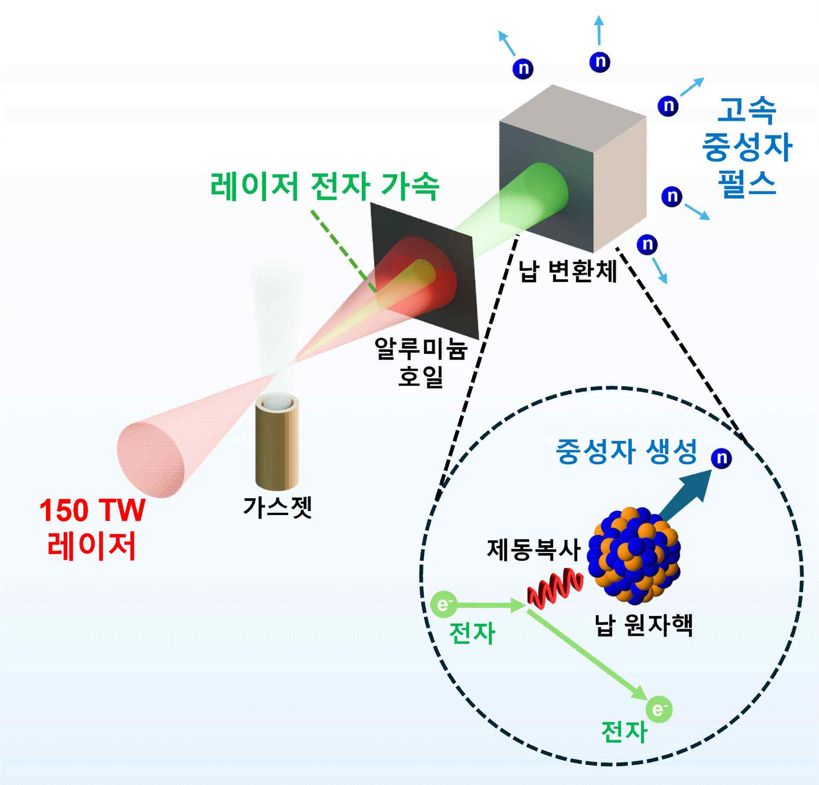

▲ Overview of the laser-based neutron generation experiment. The experimental process is illustrated step-by-step, where electrons accelerated by a high-power laser are incident on a lead converter to generate neutrons.
The neutrons produced by the research team rapidly accelerating electrons with a high-power laser and colliding them with the lead converter exhibited the characteristic of being emitted in a very short time at various energy levels. This characteristic proved to be highly advantageous for neutron transmission imaging and precision material analysis.
Through these results, the research team confirmed the feasibility of a high-yield neutron source even at the scale of a university laboratory. They also secured the neutron characteristics and stable operating conditions necessary for neutron-based security screening technology.
The research team successfully generated approximately 30 million neutrons with a single laser pulse by irradiating a lead converter* with a high-energy electron beam accelerated by a 150-terawatt (TW) high-power laser at GIST.
* terawatt (TW): A unit of power, with 1 TW equaling 1 trillion watts (1,000,000,000,000 W).
* converter: A target material where accelerated, high-energy electrons collide to generate neutrons. This utilizes the principle that electrons interact with matter (nuclear reactions) to release a large number of neutrons.
This figure is close to the world's highest among laboratory-scale laser-based neutron sources, demonstrating that such high neutron yields can be achieved even with compact equipment.
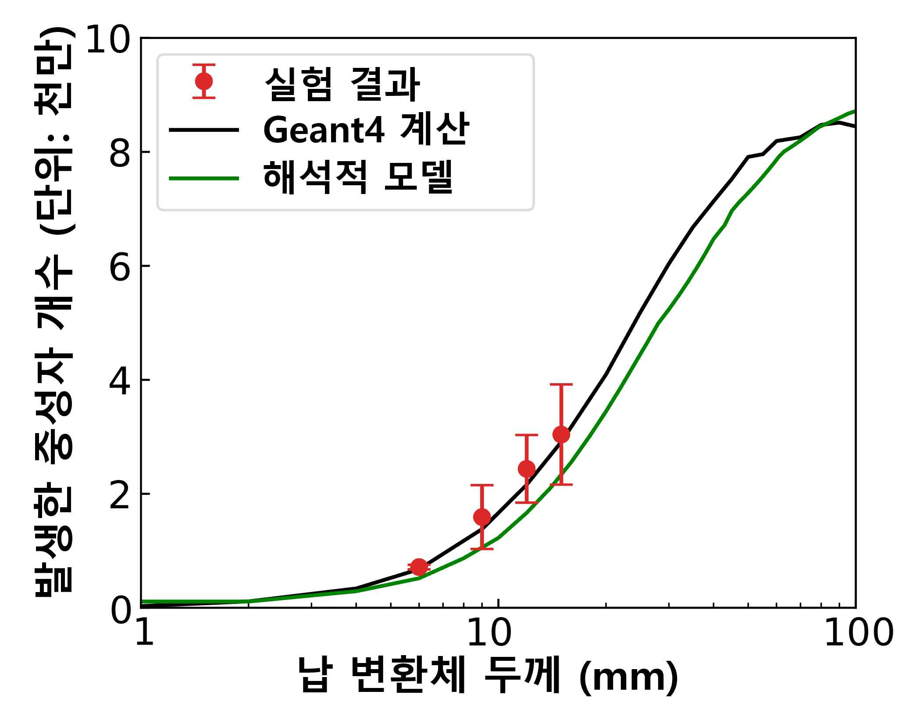

▲ A graph comparing neutron production according to lead converter thickness. This graph compares neutron production according to lead converter thickness with experimental results, Geant4 calculations, and an analytical model, demonstrating consistent trends between the experimental and calculated results.
Furthermore, the research team demonstrated through simulations that optimizing the thickness and material of the converter could produce up to 160 million neutrons, more than five times the current output. This achievement significantly enhances the potential for field application of neutron-based imaging and detection technology in the future.
Furthermore, this study confirmed the stability of the neutron energy distribution, showing that it remains largely unchanged even when the energy of the laser-accelerated electron beam or converter conditions change. This is a significant result that demonstrates the potential for significantly improving energy fluctuations, a limitation of laser-based neutron sources.
Based on these characteristics, the research team demonstrated through simulations that the neutrons generated in this study can be used to identify explosives.
This achievement demonstrates that even laboratory-scale laser equipment can simultaneously achieve near-world-class neutron production and stable energy characteristics, laying the foundation for future field applications such as airport security screening and industrial non-destructive testing.
Professor Woosuk Bang stated, "This research alleviates concerns about the instability of laser-based neutron sources and demonstrates that this technology can be expanded beyond the laboratory to practical applications in imaging and detection."
Meanwhile, this achievement is also noteworthy as it is related to neutron research at the nuclear fusion (artificial sun) research facility recently selected as a construction site in Naju, South Jeolla Province.
The laser-based neutron source in this study is expected to serve as an effective testing platform in the process of verifying detection and measurement technologies for precise measurement of neutrons emitted from the artificial sun.
This research, supervised by Professor Woosuk Bang of the Department of Physics and Photon Science at GIST and led by Hyeong-il Kim, a combined master's and doctoral student, was supported by the National Research Foundation of Korea's Mid-Career Researcher Support Program.
The results of this research were published on February 26th in Cell Reports Physical Science (IF 7.3), an international academic journal covering materials, physics, and energy and a sister publication of the world-renowned academic journal Cell.
Meanwhile, GIST stated that the results of this research were considered in terms of both academic significance and industrial applicability, and that discussions regarding technology transfer can be conducted through the Technology Commercialization Center (hgmoon@gist.ac.kr).

