A joint research team from GIST, the University of Michigan, and the State University of New York has developed a robotic technology that helps patients with amputated arms find customized prosthetic limbs
- A joint Korean-American research team led by Professor Jiyeon Kang of the Department of AI Convergence has developed "I-PEDLE," a robot-based experience system that supports personalized prosthetic hand design... The cable-driven design reduces weight and enables precise wrist functions in various directions
- This system shifts the prosthetic hand selection method from relying on sensory and experience to one based on actual movement data, enabling pre-experience and selection of the optimal prosthetic hand... The study was published in the international journal IEEE Robotics and Automation Letters


▲ (From left) Professor Jiyeon Kang of the Department of AI Convergence (corresponding author), PhD student Souvik Poddar of the State University of New York at Buffalo (first author), Professor Eleonora M. Botta (co-author), and Professor Deanna H. Gates of the University of Michigan (co-author)
For those who have lost an arm due to accident or illness and require prosthetic limbs, an international research team led by Korean researchers has developed technology that allows users to experience and select customized prosthetic limbs using a robot. This technology is expected to enable lighter and more efficient design of customized prosthetics.
The Gwangju Institute of Science and Technology (GIST, President Kichul Lim) announced that a joint Korea-US research team led by Professor Jiyeon Kang of the Department of AI Convergence has developed a robot-based prosthetic experience system, "I-PEDLE (Intelligent Prosthesis Emulator for Daily Living Enhancement)," which supports the design of personalized upper limb prosthetics by considering movement from the shoulder to the hand. This system features a structure that allows free movement in various directions.
This technology allows users to experience various prosthetic limb movements through a robot, and, based on the resulting data, it proposes a customized prosthetic configuration tailored to the individual.
High-functioning prosthetic technology for patients with upper limb amputations is continuously developing, but actual user satisfaction is still low due to limitations such as weight burden, complex control methods, and high cost.
In particular, many commercially available prosthetic hands lack active wrist function, which can lead to excessive shoulder and elbow movements to compensate. Repeated movements can potentially lead to musculoskeletal pain in the long term.
To address this issue, robotic prosthetic hands capable of precise wrist movements and multidirectional movement are being developed. However, despite their high cost, clear standards for custom design and an objective evaluation system have yet to be established.
The research team developed the I-PEDLE, a robotic prosthetic arm experience system that utilizes cable drive to achieve lightweight, three-directional wrist movement.
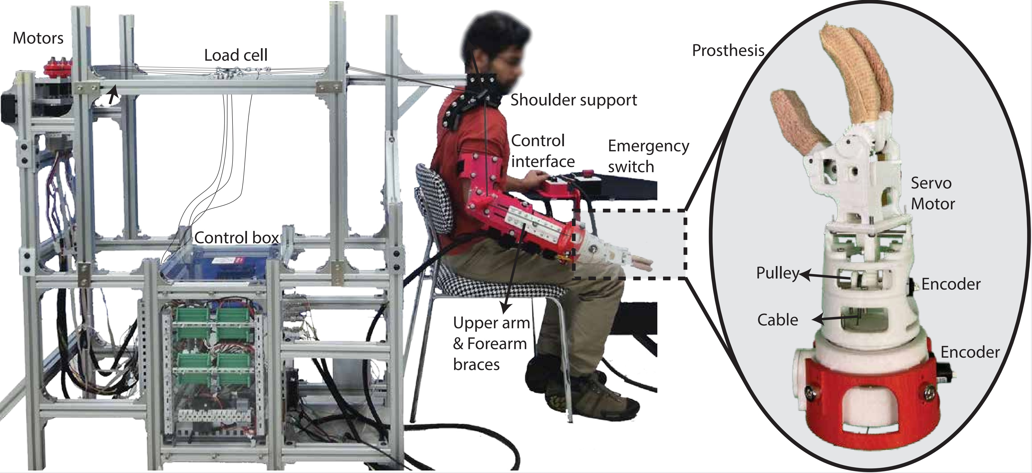

▲ System configuration of the I-PEDLE upper limb prosthetic emulator. Diagram explaining the control module and sensors. By integrating the brace and cable drive structure, it achieves both a lightweight wearable design and high-precision drive performance.
By externally positioning the cable motors, the prosthetic's weight is minimized. This enables precise wrist movements essential for practical use, including: ▴ inward and outward rotation of the wrist ▴ natural wrist angle adjustments ▴ grasping and holding objects.
When healthy participants were asked to perform everyday movements, specific wrist movement combinations were found to be effective in reducing unnecessary movements involving other joints, such as excessive shoulder rotation or lifting, required to use the prosthetic hand.
Furthermore, the research team verified the performance by implementing various wrist functional conditions in the same environment and collecting and analyzing sensor data to capture joint movements occurring during the movement process and movements that utilize other joints more extensively to compensate for deficiencies.
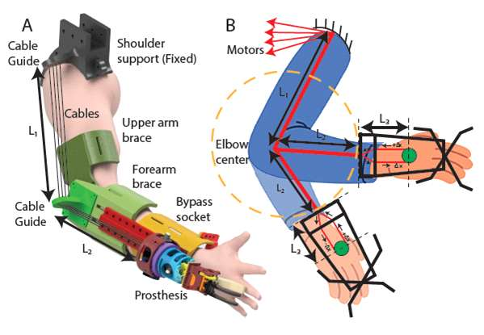

▲ Schematic diagram of the structural design and transmission principle of the cable-driven I-PEDLE upper limb prosthetic system. The diagram shows the upper arm and forearm braces, the cable-driven structure, and the transmission mechanism that maintains a constant cable length throughout the entire range of joint movement.
This allows for quantitative evaluation of shoulder and elbow movements that vary with movement, shifting the prosthetic hand selection process from relying solely on user experience to a more data-driven, rational decision-making process.
Furthermore, the ability to compare various wrist configurations on a single platform is expected to serve as an evaluation and verification system for future customized prosthetic hand designs.
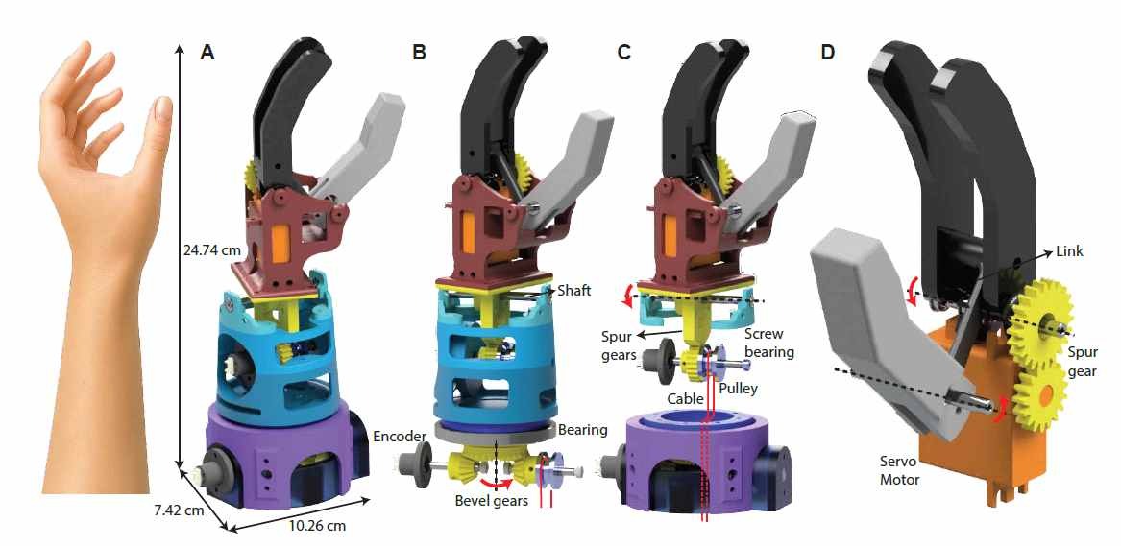

▲ Mechanical design and operation mechanism of the cable-driven I-PEDLE multi-degree-of-freedom prosthetic hand. This process, along with the assembled system geometry, demonstrates precise wrist movements, including ▴ inward and outward wrist rotation, ▴ natural wrist angular movements, and ▴ grasping and gripping functions.
Professor Jiyeon Kang stated, "This study is significant in that it presents a robot-based platform capable of quantitatively evaluating prosthetic wrist design using user-centered metrics. It will serve as a crucial foundation for the future development of personalized prosthetic hand design and human-robot interaction-based rehabilitation technologies."
Future research will expand to include validating the system on actual upper limb amputees and developing a personalized prosthetic hand design algorithm using a human-in-the-loop approach that reflects user feedback in real time to find the optimal design.
This research, led by Professor Jiyeon Kang of the Department of AI Convergence at GIST and jointly conducted by researchers at the University of Michigan and the State University of New York at Buffalo, was supported by the Disability and Rehabilitation Engineering program of the National Science Foundation (NSF), the Biomedical Technology Development Program of the Ministry of Science and ICT (MSIT) and the National Research Foundation of Korea (NRF), and the Individual Basic Research Program.
The research results — A Robotic Emulator for User-Driven Design of Multi-DOF Transradial Prostheses — were published online on February 13, 2026, in the international robotics journal IEEE Robotics and Automation Letters.
Meanwhile, GIST stated that this research achievement considered both academic significance and industrial applicability, and that technology transfer-related discussions can be conducted through the Technology Commercialization Office (hgmoon@gist.ac.kr).

