GIST solves lithium metal battery challenge with 2-minute process... A step ahead to next-generation electric vehicle battery development: 24x improved lithium mobility, over 900 hours of stable operation, and 98.2% capacity retained after 480 high-speed ​​charges and discharges
- Professor KwangSup Eom's team from the Department of Materials Science and Engineering developed a lithium metal battery cathode interface in just two minutes using an electrochemical process that repeatedly applies short electrical signals, suppressing dendrite formation
- The team demonstrated both high-speed charging stability and long lifespan, suggesting the potential for commercialization of high-energy batteries for next-generation electric vehicles and energy storage systems (ESS)... The study was published in the international journal Energy Storage Materials


▲ (From left) Professor KwangSup Eom and doctoral student Changhyeon Lee from the Department of Materials Science and Engineering
The Gwangju Institute of Science and Technology (GIST, President Kichul Lim) announced that a research team led by Professor KwangSup Eom from the Department of Materials Science and Engineering and the Research Institute for Solar and Sustainable Energies has developed a technology that forms a surface (interface) that allows lithium transport and stability in lithium metal battery anodes in just two minutes. This process involves repeatedly applying short electrical signals (electrochemical pulse deposition) to precisely refine the electrode surface.
The key to this research is the introduction of tiny amounts of tin (Sn) onto the copper surface that conducts current in the battery anode, forming a nanowire precursor (SCN)* structure much thinner than a human hair. This demonstrated the ability to create a stable interface that allows lithium metal to accumulate evenly without clumping together in a single, fast and simple process.
* lithium metal battery (LMB): A next-generation battery that uses lithium metal as the anode instead of graphite. Based on a theoretical capacity approximately 10 times higher than that of graphite, LMB can achieve more than twice the energy density. With theoretical performance expectations of 1,200 Wh/L and 400-500 Wh/kg, it is attracting attention as a next-generation electric vehicle battery.
* nanowire precursor (SCN, Sn-doped Cu nanowire): This nanowire structure is a tin (Sn)-doped copper nanowire and is an interface design technology that induces the formation of a stable solid-electrolyte interface.
For electric vehicles (EVs) and energy storage systems (ESS), it is crucial to store electricity and use it safely and reliably when needed. Currently, commercial lithium-ion batteries are primarily used in these systems. Send feedback
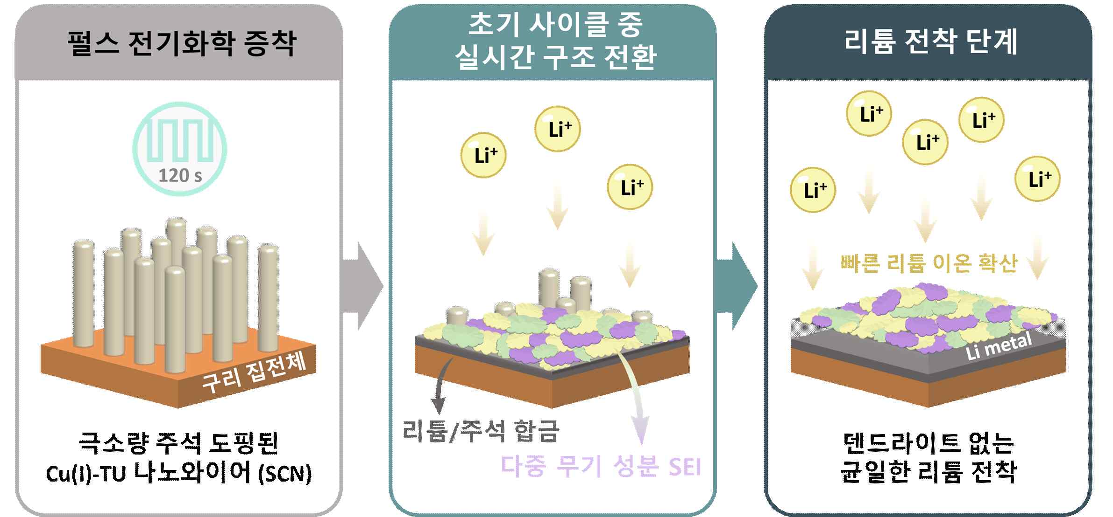

▲ Schematic diagram of the lithium electrodeposition step. This depicts the process by which lithium/tin alloying and a multi-inorganic SEI are formed in real time during the initial cycle on an SCN current collector manufactured by pulsed electrochemical deposition, resulting in uniform lithium ion diffusion and dendrite-free lithium deposition.
Lithium-ion batteries offer the advantage of storing a significant amount of energy relative to their size and weight. However, the structural limitations of the graphite anode* limit the amount of energy they can store. Consequently, interest is growing in next-generation high-energy battery technologies that surpass conventional lithium-ion batteries.
* anode: An electrode that stores and releases lithium ions during charge and discharge, it is a key component that determines the battery's energy density and lifespan.
The research team focused on "lithium metal batteries," which use lithium metal as the anode instead of graphite. Lithium metal batteries theoretically have a very high energy storage capacity, making them a promising technology for next-generation high-energy batteries.
However, if lithium ions do not move evenly along the interface during the charge/discharge process, lithium can accumulate on one side of the anode surface, leading to the growth of spiky crystal structures called "dendrites."
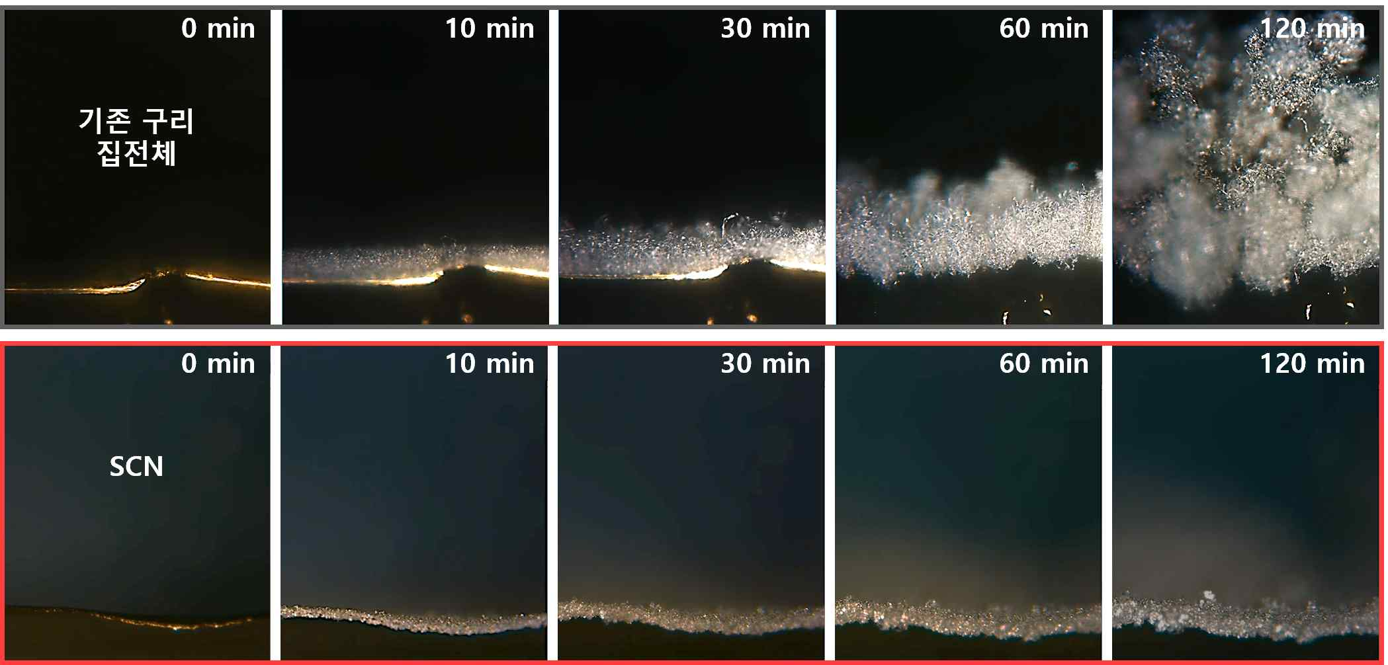

▲ Real-time lithium electrodeposition behavior analysis using in situ optical microscopy. Compared to conventional copper current collectors, the new electrodeposition method demonstrated a lithium ion diffusion rate approximately 24 times faster, effectively suppressing lithium dendrite growth even during high-capacity lithium electrodeposition. (Top) Compared to conventional copper current collectors, (Bottom) pulsed electrochemical electrodeposition-derived SCN current collectors effectively suppressed lithium dendrite growth.
As dendrites grow, the electrode interface becomes unstable, rapidly reducing battery performance and lifespan. Therefore, for practical use of lithium metal batteries, new electrode and interface design technologies are needed that can control the rapid and uniform movement of lithium ions.
* dendrites: Dendritic structures that grow as the solid electrolyte interphase (SEI) that accumulates on the surface of the anode during the charging and discharging process of a lithium battery is repeatedly destroyed. Continuous growth leads to increased internal resistance and heat generation, reducing battery life and stability.
The research team employed a precise design strategy that minimized side effects while preserving only essential functions. By introducing only atomic-level amounts of tin (Sn), they successfully created an anode interface that allowed lithium to adhere well without excessive material mixing or deformation.
As a result, they were able to induce even accumulation of lithium metal rather than agglomeration, effectively suppressing electrode structural deformation and performance degradation.
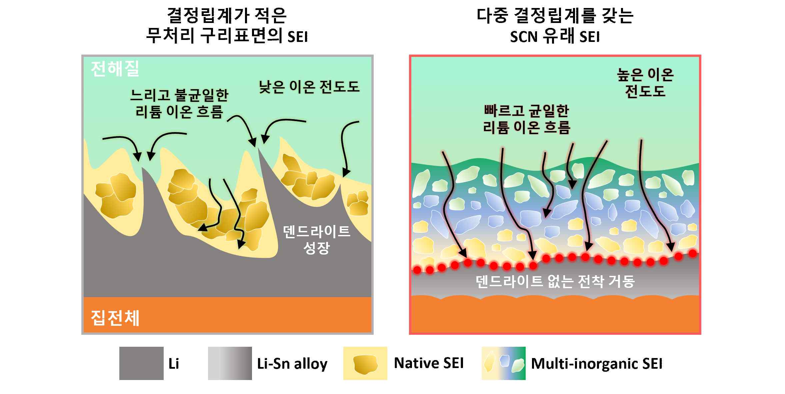

▲ Schematic comparison of a native solid electrolyte interface (SEI) formed on an untreated copper (Cu) surface with low grain boundary density and a solid electrolyte interface (SEI) derived from SCN with multiple grain boundaries. The SEI formed from the nanowire precursor (SCN) exhibits high ionic conductivity, leading to uniform lithium ion transport, effectively suppressing dendrite growth and achieving stable lithium deposition.
In particular, the nanostructured interface, much finer than a human hair, naturally transforms into a protective solid electrolyte interface (SEI)* during the initial charge, forming a pathway for rapid and stable lithium ion transport.
* solid electrolyte interphase (SEI): An organic-inorganic composite solid film formed on the surface of the anode during the initial charge of a battery due to the decomposition of the electrolyte. It prevents direct contact between the electrolyte and the electrode, inhibiting electrolyte decomposition and maintaining ionic conductivity.
The research team precisely designed the cathode interface structure to enable lithium ion movement approximately 24 times faster than conventional copper interfaces. As a result, they were able to effectively suppress the uneven lithium deposition and dendrite growth, long-standing issues in lithium metal batteries.
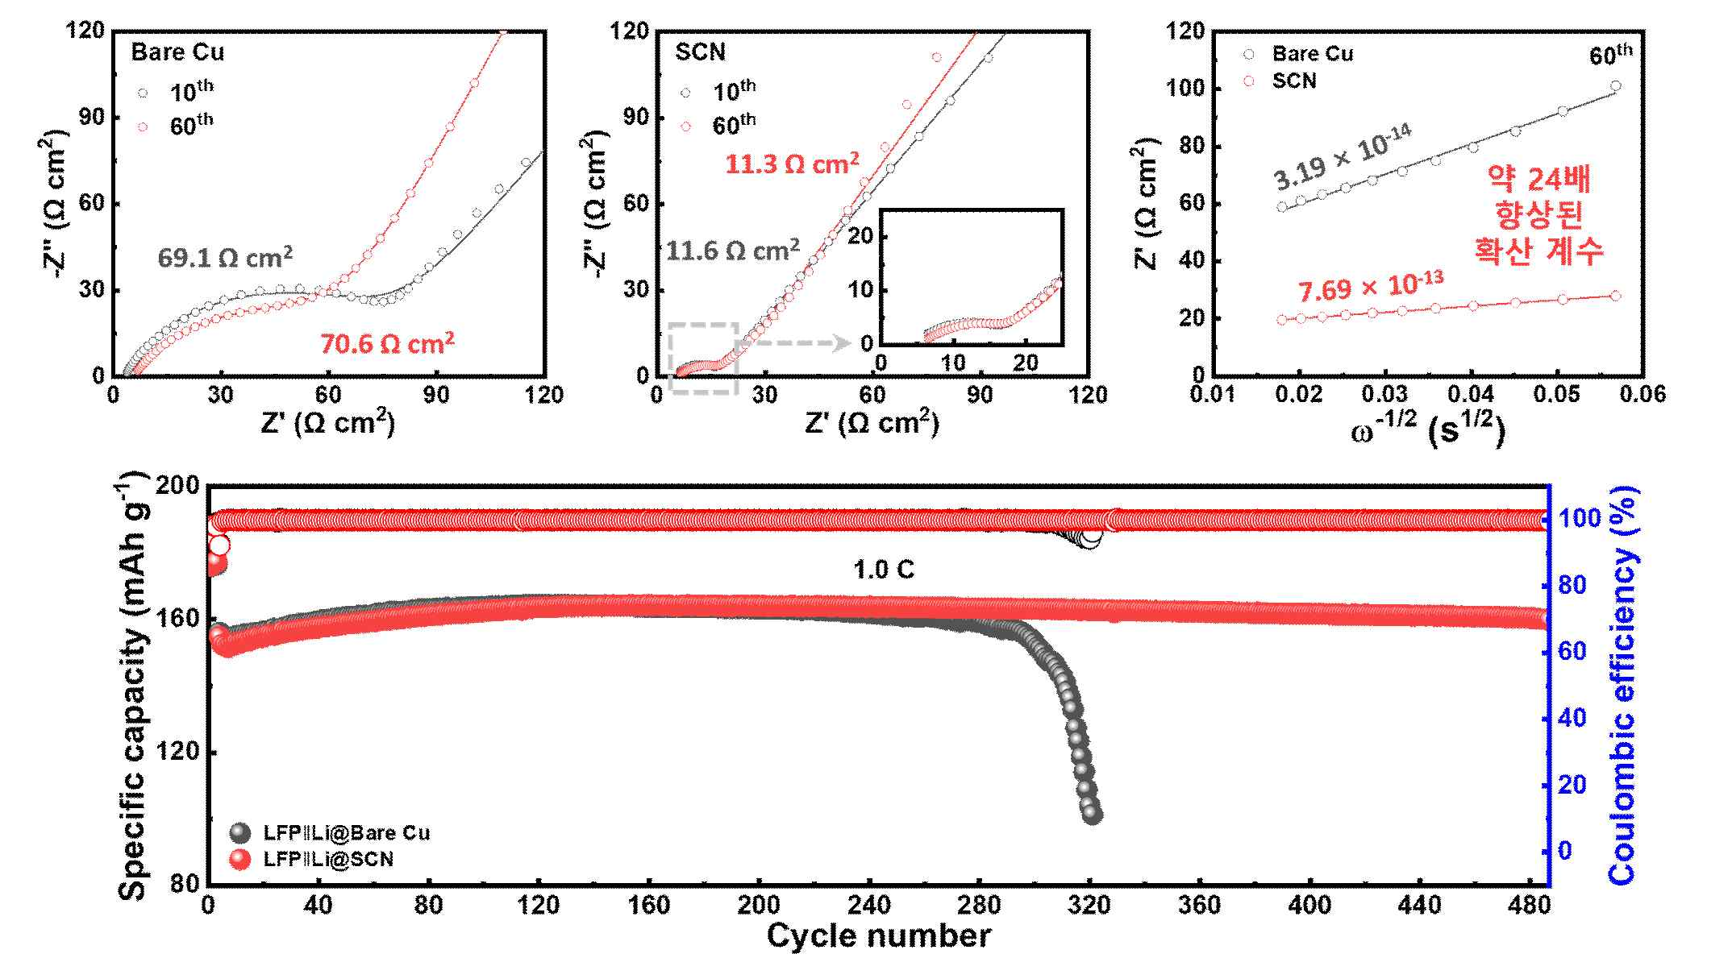

▲ (Top) Comparison of the electrochemical properties of the solid electrolyte interface (SEI) formed on an untreated copper (bare Cu) current collector and a nanowire precursor (SCN) current collector. The SEI formed on the SCN current collector exhibited lower interfacial resistance and faster lithium ion migration both initially (10 cycles) and after long-term cycling (60 cycles). (Bottom) Long-term charge/discharge test results at 1.0C. Compared to the untreated copper current collector, the battery using the SCN current collector maintained a higher specific capacity and stable Coulombic efficiency, demonstrating excellent cycle stability.
The battery using this structure (nanowire interface structure) operated stably for over 900 hours. In an actual battery test using a lithium iron phosphate (LFP)* cathode, it retained 98.2% of its initial capacity after 480 cycles under high-rate conditions (1.0C), with charge/discharge occurring within approximately one hour.
This demonstrates the potential for both fast charging and long battery life, making it highly applicable to industrial applications such as electric vehicles and energy storage systems.
* lithium iron phosphate (LFP): One of the most widely used cathode materials for electric vehicles and energy storage systems, LFP-based full-cell performance verification is a key indicator of the technology's commercial viability.


▲ Professor KwangSup Eom and PhD student Changhyeon Lee of the Department of Materials Science and Engineering conduct an experiment.
Professor KwangSup Eom stated, "This study is significant in that it demonstrates that dendrite formation, a major challenge in the commercialization of lithium metal batteries, can be effectively addressed solely through the design of the electrochemical interface of the lithium anode." He continued, "This simple process, which can be implemented in less than two minutes, simultaneously ensures fast charging and long cycle life, making it a practical technology that can be immediately applied to existing battery manufacturing processes."
He added, "We anticipate that this research will also contribute to accelerating the commercialization of lithium metal batteries, which can store more than twice as much energy as existing lithium-ion batteries."
This research, supervised by Professor KwangSup Eom (corresponding author) of the Department of Materials Science and Engineering at GIST and conducted by doctoral student Changhyeon Lee (first author), was supported by the Mid-Career Researcher Support Program and the Future Radiation Technology Advancement Program of the Ministry of Science and ICT and the National Research Foundation of Korea.
The research results — Construction of Heterostructured Multi-Grain Solid Electrolyte Interphase with Trace Alloying for Fast Li ion Transfer and Dendrite-Free Lithium Metal Batteries — were published online in the international journal Energy Storage Materials on January 29, 2026.
Meanwhile, GIST stated that this research achievement considered both academic significance and industrial applicability, and that technology transfer-related discussions can be conducted through the Technology Commercialization Center (hgmoon@gist.ac.kr).

