"Even with the same material, 'crystal orientation' increases performance by three times" GIST developed a photoelectrode that increases the efficiency of producing high-value-added compounds by leaving the material unchanged and only changing the atomic arrangement
- Professor Sanghan Lee's team from the Department of Materials Science and Engineering has significantly improved the photoelectrochemical performance of bismuth vanadate (BiVO₄) photoelectrodes by controlling the crystal orientation alone, improving the conversion efficiency of biodiesel byproducts (glycerol) into high-value-added chemical feedstocks
- Photoelectrodes with specific crystal orientations have been shown to increase photocurrent and product productivity by up to three times, suggesting new photoelectrode design criteria that enhance performance without altering chemical composition... Published in the international journal Materials Horizons


▲ (From left) Professor Sanghan Lee from the Department of Materials Science and Engineering, master's student Minjoo Lee, and doctoral student Jun Beom Hwang
Photoelectrochemical technology, which utilizes solar energy to drive chemical reactions, is attracting attention as a next-generation technology that not only reduces carbon emissions and generates eco-friendly energy, but also transforms industrial byproducts and waste into high-value-added compounds.
In particular, technology for converting glycerol, a large amount generated during the biodiesel manufacturing process, into a useful chemical feedstock is crucial for resource recycling and eco-friendly industries.
Amidst this trend, a team of Korean researchers has used a novel approach to demonstrate that even the same photoelectrode material can significantly vary in reaction performance depending on the orientation of its crystals. This has presented new design criteria for solar energy-based chemical feedstock conversion technology.
* biodiesel: An eco-friendly fuel made from renewable resources such as vegetable oil and waste cooking oil. Glycerol is produced as a byproduct during the production process.
The Gwangju Institute of Science and Technology (GIST, President Kichul Lim) announced that a research team led by Professor Sanghan Lee from the Department of Materials Science and Engineering has developed a bismuth vanadate* (BiVO₄)-based photoelectrode with precisely controlled crystallographic orientation*, thereby dramatically increasing the efficiency of the glycerol oxidation reaction and the productivity of high value-added compounds.
Glycerol is a large byproduct generated during the biodiesel production process. Efficient oxidation can convert it into a high-value compound useful in the cosmetics, pharmaceutical, and chemical industries.
* photoelectrode: A material that absorbs light to generate electrons and holes, which are then transferred to initiate a chemical reaction.
* crystallographic orientation: The direction in which atoms are arranged within a crystalline material. This orientation can affect the material's electrical and chemical properties.
* bismuth vanadate (BiVO₄): Due to its excellent light absorption and charge transfer properties, it has attracted attention as a metal oxide-based photoelectrode material. It is considered a promising material for water splitting and waste conversion using photoelectrochemical reactions.
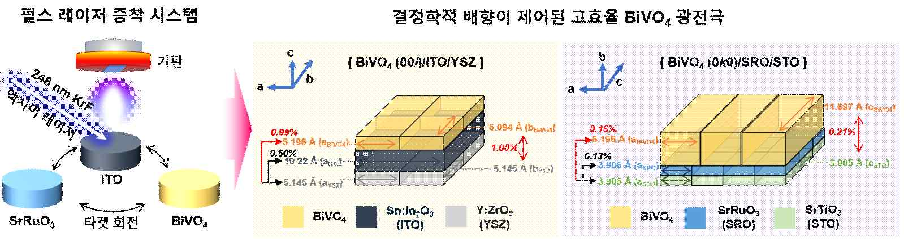

▲ Schematic diagram of a high-efficiency BiVO₄ photoelectrode fabricated with controlled crystallographic orientation using pulsed laser deposition. The research team fabricated BiVO₄ photoelectrodes with different crystallographic orientations on YSZ and STO substrates, which have uniform crystal structures and consistent orientations, using pulsed laser deposition (PLD).
The team precisely fabricated bismuth vanadate (BiVO₄) thin-film photoelectrodes with different crystallographic orientations on single-crystal substrates with uniformly aligned crystals using pulsed laser deposition (PLD)*. They then compared and analyzed their photoelectrochemical performance and glycerol oxidation characteristics under identical conditions.
As a result, bismuth vanadate (BiVO₄) photoelectrodes with crystals aligned in a specific orientation exhibited significantly improved charge transfer efficiency compared to photoelectrodes with different orientations, and they also exhibited distinct performance differences in actual glycerol oxidation.
Among these, photoelectrodes with crystals aligned in the (0k0)* direction exhibited superior performance compared to photoelectrodes with the (00l)* orientation.
* pulsed laser deposition (PLD): This technique uses a high-energy laser to vaporize a target material and then form a high-quality thin film on a substrate.
* (0k0), (00l): Crystallographic notation indicating the orientation of the crystal planes where atoms are exposed in a crystalline material, affecting surface reactivity and charge transfer characteristics.
In an actual glycerol oxidation reaction experiment, the photoelectrode with the superior crystal orientation (0k0) recorded a photocurrent density of 2.51 mA per photoelectrode area, approximately 2.4 times higher than the photoelectrode with the other crystal orientation (00l).
Furthermore, the production rate of high-value-added chemicals such as glyceric acid, glycolic acid, and formic acid was also confirmed to be 81.4 mmol·m⁻²·h⁻¹, up to 3.2 times higher than the photoelectrode with the relatively low performance (00l).
This indicates that the electrons and holes generated within the photoelectrode were more efficiently utilized for the reaction. This experimental result demonstrates that reaction performance can vary significantly depending on the crystal orientation, even for the same material.
To analyze the cause of the performance improvement, the research team meticulously investigated charge transfer characteristics and recombination behavior. As a result, it was confirmed that the photoelectrode with the superior crystal orientation (0k0) exhibited significantly improved characteristics in which charges remained separated without recombination.
By controlling the crystallographic orientation, the internal paths for charge transfer were formed more efficiently. This allowed the generated charges to participate in the glycerol oxidation reaction without loss, simultaneously improving the photoelectrode's reaction performance and product productivity.
* crystallographic orientation: This refers to the specific direction in which atoms are arranged within a crystalline material. Even for materials with the same chemical composition, the charge transfer path, surface reactivity characteristics, and electrical and chemical properties can vary significantly depending on the crystallographic orientation.
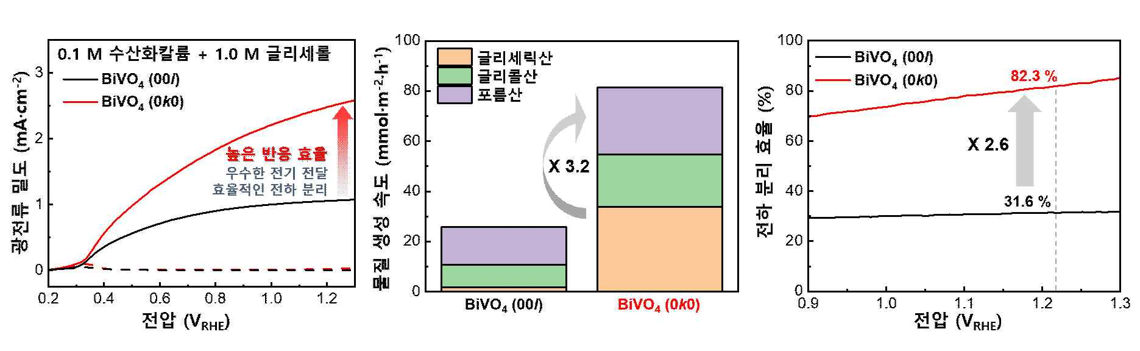

▲ Comparison of the photoelectrochemical performance of BiVO₄ photoelectrodes according to crystallographic orientation. The BiVO₄ photoelectrode with the crystallographic orientation controlled to (0k0) exhibited a higher photocurrent density than that with the (00l) orientation, and the production rate of high value-added compounds such as glyceric acid, glycolic acid, and formic acid in the glycerol oxidation reaction was enhanced by approximately 3.2 times. The cause of the performance improvement was analyzed and the charge separation efficiency of the (0k0)-oriented photoelectrode was found to be approximately 2.6 times superior, indicating that the crystallographic orientation control facilitates electrical conduction and effective charge transfer, thereby simultaneously improving the reaction performance and product productivity of the photoelectrode.
The greatest significance of this study lies in demonstrating that photoelectrochemical reaction performance can be dramatically improved solely by employing the fundamental design element of crystallographic orientation, without altering the chemical composition or complex structure of the photoelectrode.
The research team anticipates that this achievement will significantly expand the potential for future solar energy-based eco-friendly chemical raw material production technologies, as well as the practical application of waste recycling and carbon-reducing chemical processes.
Professor Sanghan Lee stated, "This study is the first in the world to systematically elucidate how photoelectrochemical glycerol oxidation performance varies depending on the crystallographic orientation of the photoelectrode. It is significant in that it presents new design criteria for solar energy-based technologies that convert waste into high-value-added compounds."
This research, supervised by Professor Sanghan Lee of the Department of Materials Science and Engineering at GIST and conducted by master's students Minjoo Lee and doctoral student Jun Beom Hwang, was supported by the Individual Basic Research Program (Mid-career Researcher) and the Future Hydrogen Source Technology Development Program of the Ministry of Science and ICT and the National Research Foundation of Korea.
The research results — Orientation-engineered epitaxial BiVO₄ thin films for efficient photoelectrochemical glycerol valorization — were published online in the international journal Materials Horizons on January 13, 2026.
Meanwhile, GIST stated that this research achievement considered both academic significance and industrial applicability, and that technology transfer-related discussions can be conducted through the Technology Commercialization Center (hgmoon@gist.ac.kr).

