"We are using AI to find promising candidates, rather than just experimenting with them one by one" GIST successfully predicted and experimentally verified energy storage materials using AI
- Professor Youngjune Park's team from the Department of Environment and Energy Engineering analyzed molecular structure and physical properties using AI-based deep learning to identify candidate materials for gas hydrate formation... They proposed a data-driven material exploration strategy, moving beyond the traditional trial-and-error approach
- The team confirmed the potential for energy gas storage at lower pressures and higher temperatures, promising expansion into next-generation energy storage, transportation, and carbon-neutral technologies... The study was published in the international journal njp Computational Materials


▲ (From left) Professor Youngjune Park and doctoral student Yusung Ok of the Department of Environment and Energy Engineering
The Gwangju Institute of Science and Technology (GIST, President Kichul Lim) announced that a research team led by Professor Youngjune Park of the Department of Environment and Energy Engineering has successfully used artificial intelligence (AI) to identify a new material that can more easily create and stably maintain "gas hydrate," a solid ice-like storage medium for energy gases like natural gas. The team then successfully verified this through experiments.
This research is significant in that it departs from the traditional method of manually testing each material to determine which one would be effective. Instead, AI analyzes the relationship between molecular structure and thermodynamic properties to identify promising candidates, which are then verified through actual experiments.
Gas hydrate is a solid material where water forms an ice-like structure under low temperature and high pressure, trapping energy gases like methane, hydrogen, and carbon dioxide.
Gas hydrate has been attracting attention as a next-generation energy storage and transportation technology due to its ability to store large quantities of energy gases in a small volume. However, the extremely cold and high-pressure conditions required for practical application have hindered its practical application.
To overcome these limitations, substances (thermodynamic promoters*) that facilitate hydrate formation and long-term retention have been proposed. However, until now, the effectiveness of each substance had to be individually confirmed through experiments, and the complex relationship between molecular structure and stability made predictive design difficult.
* thermodynamic promoter: An organic compound that incorporates the water structure during gas hydrate formation and helps maintain hydrate stability even at lower pressures or higher temperatures.
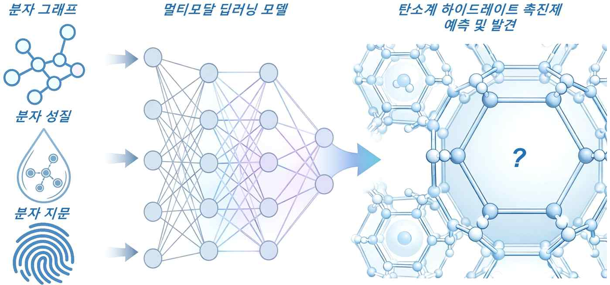

▲ Schematic diagram of an AI-based accelerated discovery of carbon-based hydrate promoters. This study proposes a data-driven exploration process that predicts and selects carbon-based hydrate promoters through multimodal deep learning, which integrates molecular structure, physical properties, and molecular fingerprint information, and leads to experimental validation.
To address these challenges, the research team developed an AI prediction model that simultaneously learns the shape and properties of molecules (SMILES* and molecular graphs) and various physicochemical information about experimental conditions (multimodal deep learning).
This model is designed to precisely predict the conditions under which gas hydrates are formed stably by considering the shape of the molecule, how atoms are connected, and how conditions such as temperature and concentration change.
* SMILES: This data represents the structure of a molecule in a computer-understandable format, allowing AI to learn the overall shape and characteristics of the molecule.
* molecular graph: This data represents a molecule in a simplified form, using dots and lines, to help AI easily understand how atoms are connected.
* multimodal deep learning: This AI technique simultaneously learns different types of information to perform comprehensive predictions.
Of particular note is that this AI model was able to predict gas hydrate stability for a new class of molecules that were not included in existing experimental data.
AI analysis revealed that ethylene sulfite*, a cyclic organic molecule containing sulfur (S), which has rarely been explored in previous studies, is an effective agent for gas hydrate formation.
* ethylene sulfite: A cyclic organic compound with a five-membered ring structure containing sulfur (S), it fits well within the gas hydrate structure, facilitating stable hydrate formation even at lower pressures and higher temperatures.
The research team synthesized this AI-proposed compound and applied it to gas hydrate formation experiments and structural analysis.
As a result, the AI ​​predictions and experimental results closely matched each other, within approximately 1 MPa (megapascal), confirming that stable hydrate formation was possible even under conditions approximately 12 Kelvin (a unit of absolute temperature) more relaxed than conventional methane hydrate*. This achievement demonstrates the potential for storing and transporting energy gases at lower pressures and higher temperatures.
* methane hydrate: A solid material containing methane gas trapped within a water matrix, it is attracting attention as a technology capable of storing energy gas at high densities.
The research team expects this achievement to be utilized in the development of next-generation energy storage and transportation materials and the advancement of carbon-neutral technologies.
Professor Youngjune Park stated, "This research is significant in that it goes beyond simply assisting experiments with AI. It first suggests promising materials and verifies their effectiveness through actual experiments." He added, "This will serve as an opportunity to expand data-driven design strategies not only for gas hydrate but also across the entire development of energy and environmental materials."
He added, "We anticipate that this will lead to improved energy gas storage efficiency and, in the future, to the design of materials that support carbon neutrality and a circular economy."
This research, supervised by Professor Youngjune Park (corresponding author) of the Department of Environment and Energy Engineering at GIST and conducted by PhD candidate Yusung Ok (first author), was supported by the Individual Basic Research Program (Mid-Career Researcher Support Program) and the Leading Research Center Support Program of the Ministry of Science and ICT and the National Research Foundation of Korea.
The results of the research — Data-driven discovery of methane hydrate promoters — were published online in the international journal npj Computational Materials on January 29, 2026.
Meanwhile, GIST stated that this research achievement considered both academic significance and industrial applicability, and that technology transfer inquiries can be made through the Technology Commercialization Center (hgmoon@gist.ac.kr).

