"The principle of enzymes that perform difficult chemical reactions with a single oxygen source" GIST has discovered the world's first enzyme reaction mechanism that utilizes oxygen without auxiliary substances
- Professor Jungwook Kim's team in the Department of Chemistry has elucidated the structure and function of TrhO, a tRNA-modifying enzyme that prevents errors during protein synthesis... The team has uncovered how it operates without metal ions or coenzymes, previously considered essential for oxygen reactions
- The team has confirmed the enzyme-tRNA bond structure for the first time using cryo-electron microscopy, laying the foundation for designing new enzymes for eco-friendly, low-cost chemical reactions... The study was published in the international journal Nature Chemical Biology


▲ (From left) Professor Jungwook Kim of the Department of Chemistry, and PhD student Kiroo Shin
The Gwangju Institute of Science and Technology (GIST, President Kichul Lim) announced that a research team led by Professor Jungwook Kim of the Department of Chemistry has discovered a novel enzymatic reaction mechanism that directly utilizes oxygen to precisely produce proteins in living organisms.
This research provides the first molecular-level explanation of how cells prevent errors during protein synthesis. It also demonstrates that enzymes can directly utilize oxygen without complex auxiliary components such as metal ions or organic coenzymes.
This discovery expands our understanding of existing enzymatic reactions and suggests the potential for designing novel biocatalysts that could enable low-cost and eco-friendly hydroxylation reactions (reactions that modify the properties of molecules by binding oxygen).
The genetic information in DNA, the blueprint for life, is transcribed into RNA, which is then translated into proteins.
Proteins are key components that form the structure of cells and carry out life processes. Even a single error can lead to cellular dysfunction or disease.
Transfer RNA (tRNA) plays a crucial role in preventing these errors. tRNA accurately reads the genetic code, codons*, and transfers amino acids, the building blocks of proteins, thereby ensuring protein synthesis in the correct order.
* codon: A three-base genetic code present in mRNA that specifies which amino acids will be used to create a protein. During translation, each codon corresponds to a specific amino acid, and tRNA recognizes this to ensure accurate protein synthesis.
To enhance the accuracy of protein synthesis, cells undergo a process called "tRNA modification," chemically modifying specific components (bases) of tRNA.
In particular, the wobble site* of tRNA is a key site that allows a single tRNA to recognize multiple codons. Subtle chemical modifications at this site play a crucial role in maintaining translation accuracy.
* wobble position: The 34th base of tRNA, which pairs with the third base of an mRNA codon. While the first and second bases of a codon form standard bonds, such as A–U and C–G, the third base allows for looser, non-standard bonds, allowing a single tRNA to recognize multiple codons.
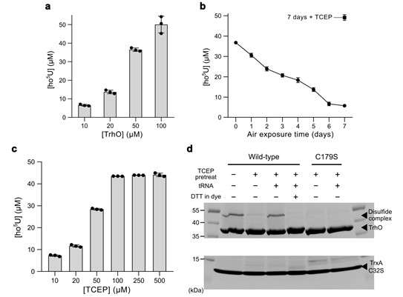

▲ TrhO activity experiments under various conditions. Figure (a) shows that product production increases when TrhO is reacted with a substrate at increasing concentrations in the absence of a reducing agent. Figure (b) shows that when TrhO is exposed to air for 7 days, reactivity decreases with prolonged exposure. This decrease is restored when TCEP, a reducing agent, is added. Figure (c) shows that reactivity increases with increasing concentration of TCEP. Figure (d) shows that point mutations in TrxA, a protein capable of reducing oxidized proteins, are introduced into the experiment, enabling binding to TrhO. TrhO exposed to air and after reaction with substrate tRNA formed a bond with the TrxA C32S mutant, but did not form a bond when the catalytic cysteine ​​was mutated (C179S).
The TrhO enzyme helps accurately decode the genetic code by introducing a hydroxyl group (–OH) to the uridine base located in the tRNA wobble site.
However, how TrhO activates molecular oxygen and transfers it to the target uridine remained unknown.
Enzymes that utilize oxygen typically rely on metal ions such as iron or copper, or organic cofactors like FAD or NAD to facilitate the reaction. However, it was not known whether TrhO utilizes cofactors in the reaction, leaving the mechanism of the reaction a crucial unsolved question.
* uridine: A basic component of RNA, it consists of the base uracil and the ribose sugar. In RNA, uracil replaces thymine in DNA, and uridine is directly involved in the transmission and decoding of genetic information. In tRNA, uridine is chemically modified to enhance codon recognition accuracy and ensure error-free protein synthesis.
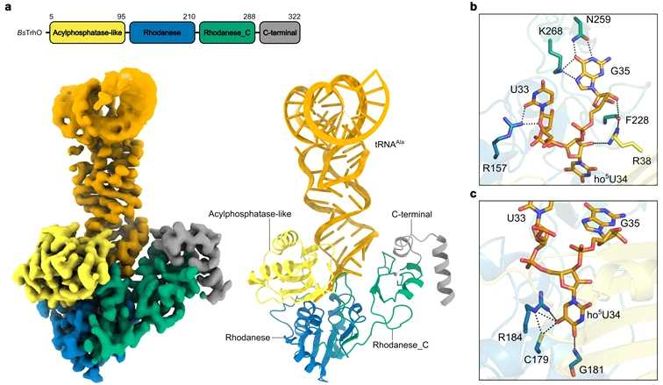

▲ Structure of the Bacillus subtilis TrhO enzyme and substrate tRNA complex elucidated by the research team. The top of Figure (a) shows the protein domains, color-coded by domain. Below are the electron density map (left) and atomic model (right) of the TrhO-tRNA complex reconstructed using cryo-electron microscopy. Each region is colored according to the domain designation. Figure (b) shows the interaction between the protein and uridine at position 33 and guanosine at position 35 of the anticodon ring, while Figure (c) shows the interaction between the protein and hydroxyuridine at position 34. The dotted lines indicate hydrogen bonds.
To elucidate the mechanism of this reaction, it is crucial to determine the structure of the enzyme when actually bound to its target.
However, the previously reported structures of TrhO were in a non-reactive state, leaving unknown how it functions when bound to tRNA.
In particular, the enzyme is smaller than TrhO found in other organisms, limiting the ability to interpret how it recognizes and modifies its target.
To overcome these limitations, the research team utilized cryo-electron microscopy (cryo-EM)* to elucidate the structure of the TrhO enzyme in its active state, bound to tRNA.
Through this, they were able to confirm for the first time how TrhO recognizes tRNA and how a partial structural modification of tRNA positions the uridine at the precise location where the reaction occurs, positioning it at the enzyme's reaction center.
* Cryo-EM: This cutting-edge research equipment allows for the analysis of the structures of biomolecules such as proteins and nucleic acids at the atomic level by rapidly cooling samples to extremely low temperatures. Because it allows observation of the natural state of the molecule without crystallization, it is particularly useful for elucidating the structure of the complex between the enzyme and substrate.
Analysis of the structure of the TrhO–tRNA complex revealed that the uridine at the core of the tRNA is precisely positioned at the reaction center of the TrhO enzyme and closely interacts with the cysteine ​​amino acid that directly initiates the reaction. This structural evidence supports the hypothesis that the cysteine ​​serves as a key catalyst in initiating the oxygen-mediated hydroxylation reaction.
Following experiments, the research team confirmed that the TrhO enzyme can perform this hydroxylation reaction without the need for metal ions or other auxiliary substances. Indeed, purification and analysis of the enzyme revealed no organic coenzymes that aid in the reaction, and the zinc ion also shown in the structure did not affect the enzyme's operation.
* cysteine: One of the basic building blocks of proteins, it contains a sulfur (S) atom, making it particularly susceptible to chemical reactions. In the TrhO enzyme, this cysteine ​​plays a key role in initiating the reaction with oxygen, attaching the oxygen component to the uridine.
In particular, the research team verified the operating principle of the TrhO enzyme through experiments that altered the properties of a single cysteine ​​amino acid (C179) that initiates the reaction within the enzyme.
The results confirmed that the enzyme temporarily halted activity when the cysteine ​​bound to oxygen during the reaction, but then recovered its function when it returned to its original state. This experimental evidence demonstrates that the hydroxylation reaction of TrhO begins directly at this cysteine.
Based on these results, the research team proposed a completely new hydroxylation mechanism in which cysteine ​​reacts directly with molecular oxygen, briefly undergoes an intermediate state, and then transfers the oxygen to uridine located at the wobble site. This is fundamentally different from existing enzymes that rely on metal ions or other auxiliary substances to utilize oxygen.
* point mutation: A mutation that replaces one amino acid in a protein. This mutation allows for the selective identification of the function of a specific amino acid, helping to identify key components in enzymatic reactions.
* thiohydroperoxy: A reactive intermediate temporarily formed during an enzymatic reaction when cysteine ​​containing sulfur (S) combines with molecular oxygen. It acts as a stepping stone for transferring the oxygen atom to the substrate. In the TrhO enzyme, this intermediate transfers the hydroxyl group to uridine, enabling the enzyme to utilize oxygen without the need for a coenzyme.
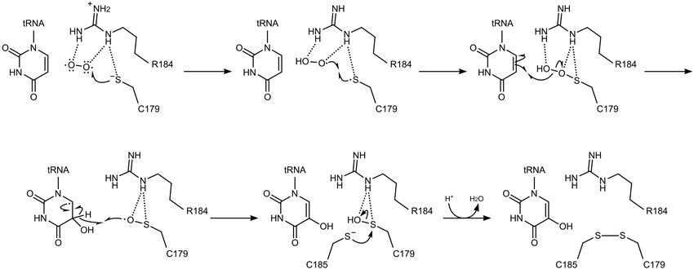

▲ The uridine hydroxylation mechanism of TrhO proposed by the research team. Based on the experimental results obtained in this study, the reaction equation for the hydroxylation reaction occurring in wobble uridine was reconstructed.
Professor Jungwook Kim stated, "This study elucidates the principle that a single enzyme can perform the oxygen introduction reaction ('aromatic ring'), a structure that is chemically very difficult to react with using molecular oxygen, without the aid of any other auxiliary substances." He added, "We anticipate that utilizing the properties of this enzyme will simplify complex and costly existing chemical processes, realize low-cost, high-efficiency hydroxylation reactions, and expand the technology to design and improve practical enzymes."
This research was supervised by Professor Jungwook Kim of the Department of Chemistry at GIST and conducted by a doctoral student named Kiroo Shin. The research was supported by the Ministry of Science and ICT (MSIT) and the National Research Foundation of Korea (NRF) through the Global Leading Research Center (IRC) program, the Mid-Career Researcher Support Program, and the MSIT Advanced Bio Large-Scale Equipment Joint Utilization System Establishment Project.
The research results — Unconventional monooxygenation by the O₂-dependent tRNA wobble uridine hydroxylase TrhO — were published online in the international journal Nature Chemical Biology on January 19, 2026.
Meanwhile, GIST stated that this research achievement considered both academic significance and industrial applicability, and that technology transfer-related discussions can be conducted through the Technology Commercialization Center (hgmoon@gist.ac.kr).

