"For the first time, the reason why cancer patients lose muscle has been revealed" A research team led by Professor Darren Williams and Research Professor Da-Woon Jung has identified the core cause of cancer cachexia, which lowers cancer patient survival rates
- Professor Darren Williams's team in the Department of Life Sciences has discovered for the first time in the world that signaling between cancer cells and cancer-associated fibroblasts (CAFs) causes muscle wasting... A specific protein (CXCL5) directly induces muscle atrophy
- Blocking CXCL5 alleviates weight loss and muscle strength decline with clinical validity proven through patient-derived cell, animal experiments, and patient tumor tissue analysis... Published in the international journal Journal of Biomedical Science


▲ (From left) Professor Darren Williams of the Department of Life Sciences, Research Professor Da-Woon Jung, and Drs. Jun-Hyeong Kim, Hyun-Jun Kim, and Seon-Wook Kim
A Korean research team has identified the key mechanism that causes "cancer cachexia," a fatal complication that significantly reduces the survival rate of cancer patients.
The Gwangju Institute of Science and Technology (GIST, President Kichul Lim) announced that a research team led by Professor Darren R. Williams and Research Professor Da-Woon Jung of the Department of Life Sciences has identified, for the first time in the world, a previously unreported intercellular signaling pathway that causes cancer cachexia and proposed a therapeutic strategy to block it.
Cancer cachexia is a disease characterized by persistent muscle and weight loss due to a disruption in the overall metabolic balance caused by cancer. It occurs in approximately 80% of patients with advanced cancer and is a serious complication associated with 20-30% of all cancer deaths.
Unlike simple malnutrition, cachexia is characterized by a persistent decline in physical strength and immune function, leading to decreased cancer treatment effectiveness and a lower survival rate. Despite this clinical significance, no drug or clear therapeutic target has been established to fundamentally treat cancer cachexia.
To overcome these limitations, the research team focused on the "tumor microenvironment" surrounding cancer. The tumor microenvironment is a complex tissue environment formed through the interaction of various cells, including cancer cells, immune cells, vascular cells, and fibroblasts.
Among these, cancer-associated fibroblasts (CAFs), which are normal fibroblasts transformed by cancer, are known to act as facilitators of cancer growth, metastasis, and immune evasion. However, the process by which CAFs induce cancer cachexia, particularly muscle wasting, and the specific mechanisms by which they function have remained unclear.
The research team discovered that the secretion of a specific protein, CXCL5, significantly increases during signaling between cancer cells and CAFs, and for the first time, identified CXCL5 as a key factor directly inducing muscle wasting.
While CAFs have been primarily studied as cells involved in cancer growth, metastasis, and immune evasion, this study is the first to demonstrate at the molecular level that CXCL5 secreted by CAFs is a key factor in cancer cachexia.
* chemokines: A type of signaling protein secreted by cells that regulates the movement and function of other cells. They are primarily involved in directing immune cells to sites of inflammation or damage, playing a crucial role in the body's immune response and inflammation control.
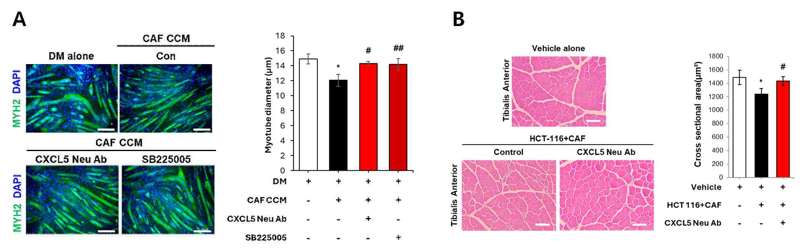

▲ Validation of the efficacy of CAF-derived CXCL5 in treating cancer cachexia in cell and animal models. Figure (A) shows changes in myotube diameter after CXCL5-neutralizing antibodies and receptor inhibitors were administered to atrophic myotubes treated with CAF culture medium (CAF CCM) derived from colorectal cancer patients. The treatment effectively restored myotube diameter to normal levels. Figure (B) shows changes in muscle tissue cross-sectional area after administering CXCL5-neutralizing antibodies to a mouse model transplanted with cancer cells and CAFs. Significant muscle recovery was observed in the neutralizing antibody-treated group compared to the control group.
The research team demonstrated the clinical relevance of their findings through experiments reflecting actual patient settings.
In experiments using cancer-associated fibroblasts (CAF) isolated directly from colorectal cancer patients, they confirmed that the conditioned medium secreted by CAFs activated by the cancer cell culture medium induces muscle cell atrophy.
Further analysis revealed that among the various signaling molecules, CXCL5 was the most significantly increased, and muscle atrophy was induced even when CXCL5 alone was used.
Conversely, using antibodies blocking CXCL5 or drugs that inhibit related pathways effectively suppressed muscle atrophy.
These results demonstrate that cancer-associated fibroblasts (CAFs) isolated from patients induce muscle wasting through CXCL5 even in the context of actual cancer cachexia. Furthermore, blocking this signal suppresses muscle atrophy, suggesting potential as a future therapeutic strategy.
The research team also demonstrated the therapeutic potential of CXCL5 blockade through animal experiments and molecular analysis.
In a mouse model that mimicked the human cancer environment as closely as possible by co-transplanting patient-derived CAFs with cancer cells, blocking CXCL5 significantly reduced weight loss and muscle atrophy. Muscle function was also restored in tests assessing muscle strength, such as the hanging test. These results demonstrate that CXCL5 is not simply a laboratory marker, but a key factor in inducing cancer cachexia under conditions similar to those experienced by actual patients. Blocking it can alleviate weight loss and muscle weakness.
Analyzing gene expression changes revealed that blocking CXCL5 reactivated a signaling pathway (PI3K–AKT–MyoG signaling) crucial for muscle growth and maintenance. Furthermore, the structures supporting muscle tissue were restored to normal, suppressing muscle atrophy. Through this analysis, the research team identified a novel cachexia-causing pathway (cancer cell–CAF–CXCL5) in which cancer cells and cancer-associated fibroblasts (CAFs) induce muscle wasting via CXCL5, suggesting this pathway as a promising therapeutic target.
The research team further validated these findings through analysis of patient tumor tissue.
Analysis of patient tumor tissue provided by Chonnam National University Hwasun Hospital (Director Jeong-jun Min) revealed that CXCL5 protein, along with vimentin*, which represents cancer-associated fibroblasts (CAFs), was strongly expressed in the tissue surrounding cancer cells.
In contrast, CXCL5 expression was barely observed in normal colon tissue, demonstrating that CAFs are the primary source of CXCL5 in patient tumor tissue.
* vimentin: An intermediate filament protein that supports the intracellular structure, vimentin is primarily expressed in mesenchymal cells such as fibroblasts. In normal conditions, it contributes to cell shape maintenance and mechanical stability. However, in cancer tissue, it serves as a representative marker for identifying cancer-associated fibroblasts (CAFs). It is associated with epithelial-to-mesenchymal transition (EMT), playing a crucial role in cancer malignancy processes, including cancer cell invasion and metastasis and tumor microenvironment formation.
This study is significant in that it goes beyond laboratory cell experiments and comprehensively analyzes patient-derived cells, animal experiments, and actual patient tumor tissue, elucidating the process by which cancer and surrounding cells induce muscle wasting in a manner closely resembling the actual patient situation.
Notably, by confirming that blocking CXCL5 with an antibody effectively reduced muscle atrophy, it suggests a novel treatment strategy for fundamentally alleviating cancer cachexia and the potential for future drug development.
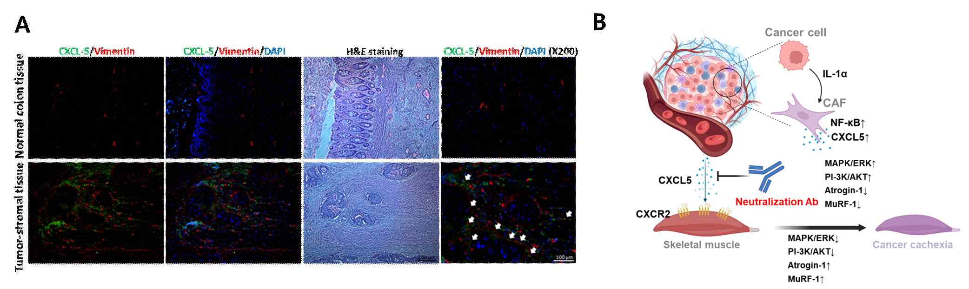

▲ Clinical validation through analysis of colorectal cancer patient tissue (A) and schematic diagram of cancer cachexia treatment mechanism (B). Figure (A) shows immunofluorescence staining of colorectal cancer tumor tissue, demonstrating strong expression of CXCL5 (green) in cancer-associated fibroblasts (CAFs, red) present in the stroma surrounding cancer cells, demonstrating clinical relevance. Figure (B) schematically illustrates the overall mechanism by which cancer-activated CAFs secrete CXCL5, which induces muscle wasting via the CXCR2 receptor on muscle cells, and the therapeutic strategy for blocking this process using a CXCL5-neutralizing antibody.
Professor Darren Williams stated, "This study is significant in that it clinically demonstrates, through analysis of patient-derived cancer-associated fibroblasts (CAFs) and actual tumor tissue, that CXCL5 is a key factor in inducing muscle wasting in the tumor microenvironment."
Research Professor Da-Woon Jung stated, "We are currently developing drugs that inhibit CXCL5 expression, which we anticipate will prevent rapid muscle loss and improve the survival rates of cancer patients." She added, "In the future, combination therapies with immunotherapies and other agents could further enhance the effectiveness of cancer treatment."
This research, supervised by Professor Darren Williams of the Department of Life Sciences at GIST and participated by Research Professors Da-Woon Jung and Drs. Jun-Hyeong Kim, Hyun-Jun Kim, and Seon-Wook Kim, was supported by the Mid-Career Researcher Support Program of the Ministry of Science and ICT and the National Research Foundation of Korea, and the Leading Software Core Technology Development Program of the Ministry of Science and ICT and the National IT Industry Promotion Agency.
The results of the research — CXCL5 neutralization mitigates cancer cachexia by disrupting CAF-cancer cell crosstalk — were published online in the international journal Journal of Biomedical Science on December 15, 2025, and related domestic and international patents have been filed.
Meanwhile, GIST stated that this research achievement considered both academic significance and industrial applicability, and that technology transfer inquiries can be made through the Technology Commercialization Center (hgmoon@gist.ac.kr).

