"Cancer creates its own acidic environment," Professor Jeong-Seok Nam's team explains, elucidating the mechanism that promotes colon cancer metastasis and malignancy
- Professor Jeong-Seok Nam's team from the Department of Life Sciences has uncovered the molecular mechanism that creates a favorable environment for cancer cell growth... The team has identified the key role of the dysedherin protein in driving tumor acidification, a world first
- Experimental confirmation that acidic environments accelerate cancer cell growth, migration, and metastasis, suggesting a novel treatment strategy targeting dysedherin for colon cancer... The research was published in the international journal Signal Transduction and Targeted Therapy
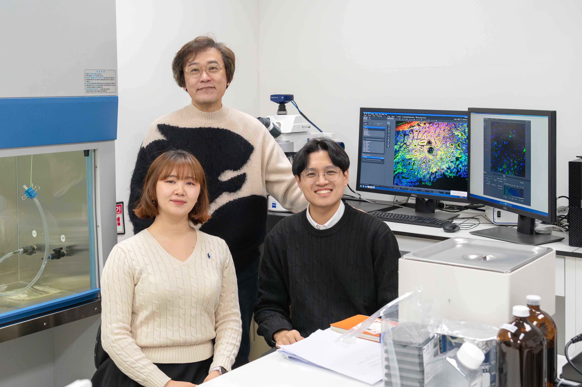

▲ (From left) GIST Department of Life Sciences master's and doctoral program student Hyeon-Ji Yun, Professor Jeong-Seok Nam, and Dr. Choong-Jae Lee
The Gwangju Institute of Science and Technology (GIST, President Kichul Lim) announced that a research team led by Professor Jeong-Seok Nam of the Department of Life Sciences has elucidated how an "acidic tumor environment" that promotes the metastasis and malignancy of colorectal cancer is created, and identified "dysadherin" as the key protein driving this process.
This study elucidates, at the molecular level, the mechanism by which cancer creates an environment conducive to its own growth, suggesting the potential for new treatment strategies.
Colorectal cancer has a high incidence and mortality rate worldwide. Many patients are diagnosed at an advanced stage, making treatment difficult with poor prognosis.
Recently, active research is being conducted to identify the causes of cancer not only in genetic abnormalities but also in the environment surrounding cancer cells, namely the tumor microenvironment. The tumor microenvironment encompasses not only cellular components surrounding cancer cells, such as immune cells and fibroblasts, but also physical and chemical conditions such as oxygen deficiency, nutrient deficiency, and an acidic environment.
In particular, it is known that when the area around a tumor becomes acidic, the attack function of immune cells is weakened, and cancer cells become more likely to invade surrounding tissues or spread to other organs.
However, how this acidic environment is created and maintained remains unclear.
The research team focused on dysedherin, a membrane protein involved in cancer progression and metastasis.
Dysedherin is rarely expressed in normal tissues, but is highly expressed in various cancers. Previous research has shown that this protein plays a crucial role in the development and progression of colon cancer.
In this study, through single-cell data analysis of colon cancer patients and experiments in mouse tumor models, the research team confirmed that tumors with high dysedherin expression experienced a more acidic environment, significantly increasing cancer aggressiveness and the risk of recurrence.
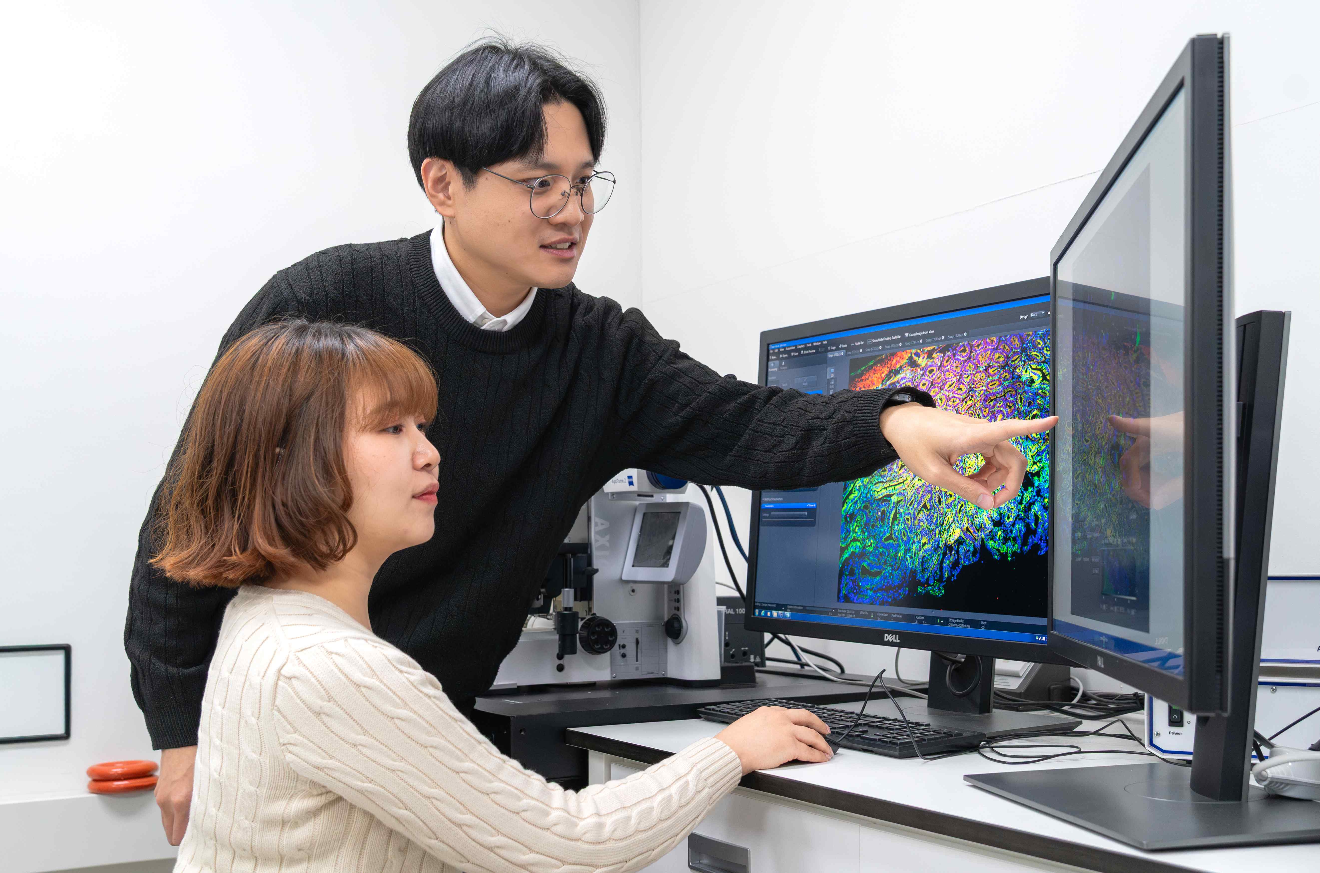

▲ Professor Jeong-Seok Nam's research team from the Department of Life Sciences: student Hyeon-Ji Yun and Dr. Choong-Jae Lee, discuss the results of their research.
Even in the same acidic environment, cancer cells with high levels of dysedherin grew faster, migrated more readily, and had a significantly greater ability to invade other tissues. This suggests that dysedherin acts as a "switch" that promotes cancer cell malignancy in an acidic environment.
Through this study, the research team has for the first time identified the specific process by which dysedherin alters the properties of cancer cells. Analysis revealed that dysedherin activates signaling pathways within cancer cells, increasing the production of a protein called carbonic anhydrase-9 (CA9)*.
The research team discovered that CA9 expels acidic substances accumulated within cancer cells, maintaining relative stability within the cancer cells while making the surrounding tumor environment more acidic.
* carbonic anhydrase-9 (CA9): An enzyme protein that catalyzes the conversion of carbon dioxide and water into bicarbonate and hydrogen ions. Its expression is characterized by increased expression in hypoxic and acidic environments. In cancer cells, it releases accumulated acid from within the cell, stabilizing intracellular pH and further acidifying the surrounding tumor environment. This promotes cancer cell survival, growth, invasion, and metastasis.
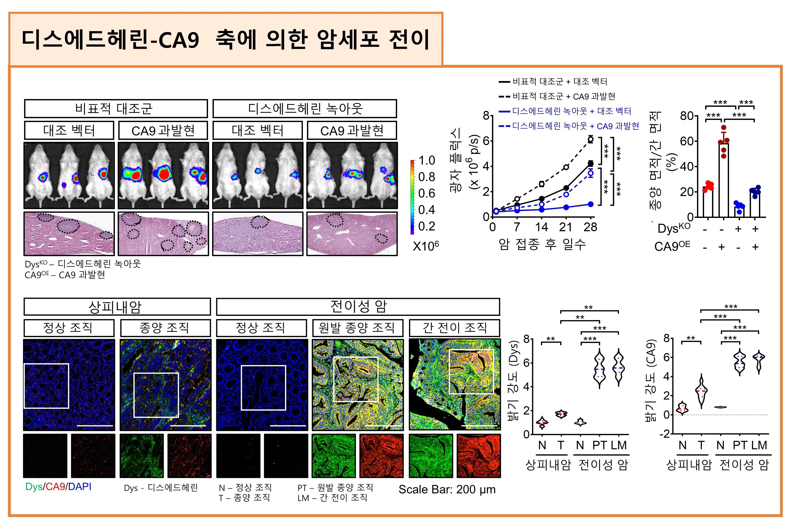

▲ Identification of the mechanism of cancer metastasis mediated by the dysedherin-CA9 axis. The dysedherin-CA9 axis-induced increase in colon cancer metastasis was confirmed in mouse models and human tissues. Higher dysedherin-CA9 expression was associated with greater liver metastasis.
In other words, cancer cells use dysedherin and CA9 to create a favorable environment for themselves while simultaneously transforming the surrounding environment into one that is increasingly conducive to cancer growth.
This acidic environment alters the energy metabolism of cancer cells, reduces the anti-cancer function of immune cells (T cells), and activates fibroblasts that promote cancer growth, reorganizing the entire tumor in a way that favors cancer cells.
Furthermore, the research team developed a peptide that inhibits dysedherin function and applied it to colon cancer cells. The result was a marked decrease in the cancer cells' ability to create an acidic environment, leading to a marked inhibition of cancer cell growth and proliferation.
This experimentally demonstrated that dysedherin regulates tumor acidification through the FAK–STAT3–CA9* signaling pathway, demonstrating that therapeutic strategies targeting dysedherin can indeed suppress cancer malignancy.
* FAK–STAT3–CA9 signaling pathway: A representative molecular signaling axis that promotes cancer cell survival and metastasis. When FAK (focal adhesion kinase), a signaling protein involved in cell adhesion and migration, is activated, the transcriptional regulator STAT3 (signal transducer and activator of transcription 3) is activated in a chain reaction, which increases the expression of CA9, an enzyme protein involved in adaptation to acidic environments.
This study is significant in that it reveals that dysedherin is not simply a signal indicating cancer progression, but rather plays a key role in further malignancy of colon cancer by simultaneously altering both the properties of cancer cells and the tumor microenvironment.
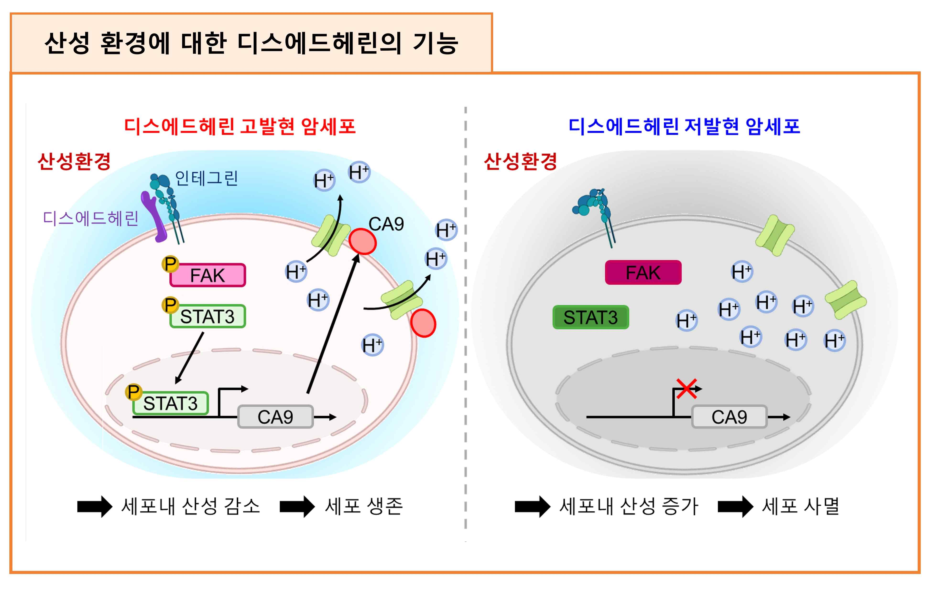

▲ Schematic diagram of the dysedherin-CA9 function in the malignant process of colon cancer. Schematic diagram illustrating the mechanism by which the dysedherin-CA9 axis enables colon cancer cells to survive in acidic environments. The FAK-STAT3-CA9 axis regulates intracellular pH, allowing cells to survive in acidic environments.
Professor Jeong-Seok Nam stated, "This study elucidates at the molecular level how cancer cells alter their surrounding environment to their advantage, including the specific signaling pathways involved. We anticipate that this will lead to the development of new therapeutic strategies to control tumor malignancy and metastasis."
This study was led by Professor Jeong-Seok Nam, with Dr. Choong-Jae Lee and PhD student Hyeon-Ji Yun as co-first authors. The research was supported by the Ministry of Science and ICT and the National Research Foundation of Korea's Mid-Career Researcher Support Program, the Biomedical Technology Development Program, the Global Leading Research Center Support Program (IRC), and the GIST Research Institute (GRI) Research Program.
The results of the study — The dysadherin/carbonic anhydrase 9 axis shapes an acidic tumor microenvironment to promote colorectal cancer progression — were published on January 15, 2026, in the prestigious Nature affiliated international journal on biomedical science and molecular signaling, Signal Transduction and Targeted Therapy.
Meanwhile, GIST stated that this research achievement considered both academic significance and industrial applicability, and that technology transfer inquiries can be made through the Technology Commercialization Center (hgmoon@gist.ac.kr).

