"Performance remains the same even when made large" A joint research team led by Senior Researcher Hongkyu Kang and Kangwon National University has developed a core technology for large-area solar cells that surpasses commercialization limits
- A research team led by Assistant Director Hongkyu Kang of the Research Institute for Solar and Sustainable Energies has implemented a simple process that directly controls the interface during the early stages of electron transport layer formation... This has structurally improved performance loss caused by uneven thin film formation over large areas
- High efficiency (22.56%) and long-term stability (over 500 hours) in a 24.8 cm² large-area module have been achieved, suggesting the potential for commercialization using a printing-based mass production process. Published in the international journal Small
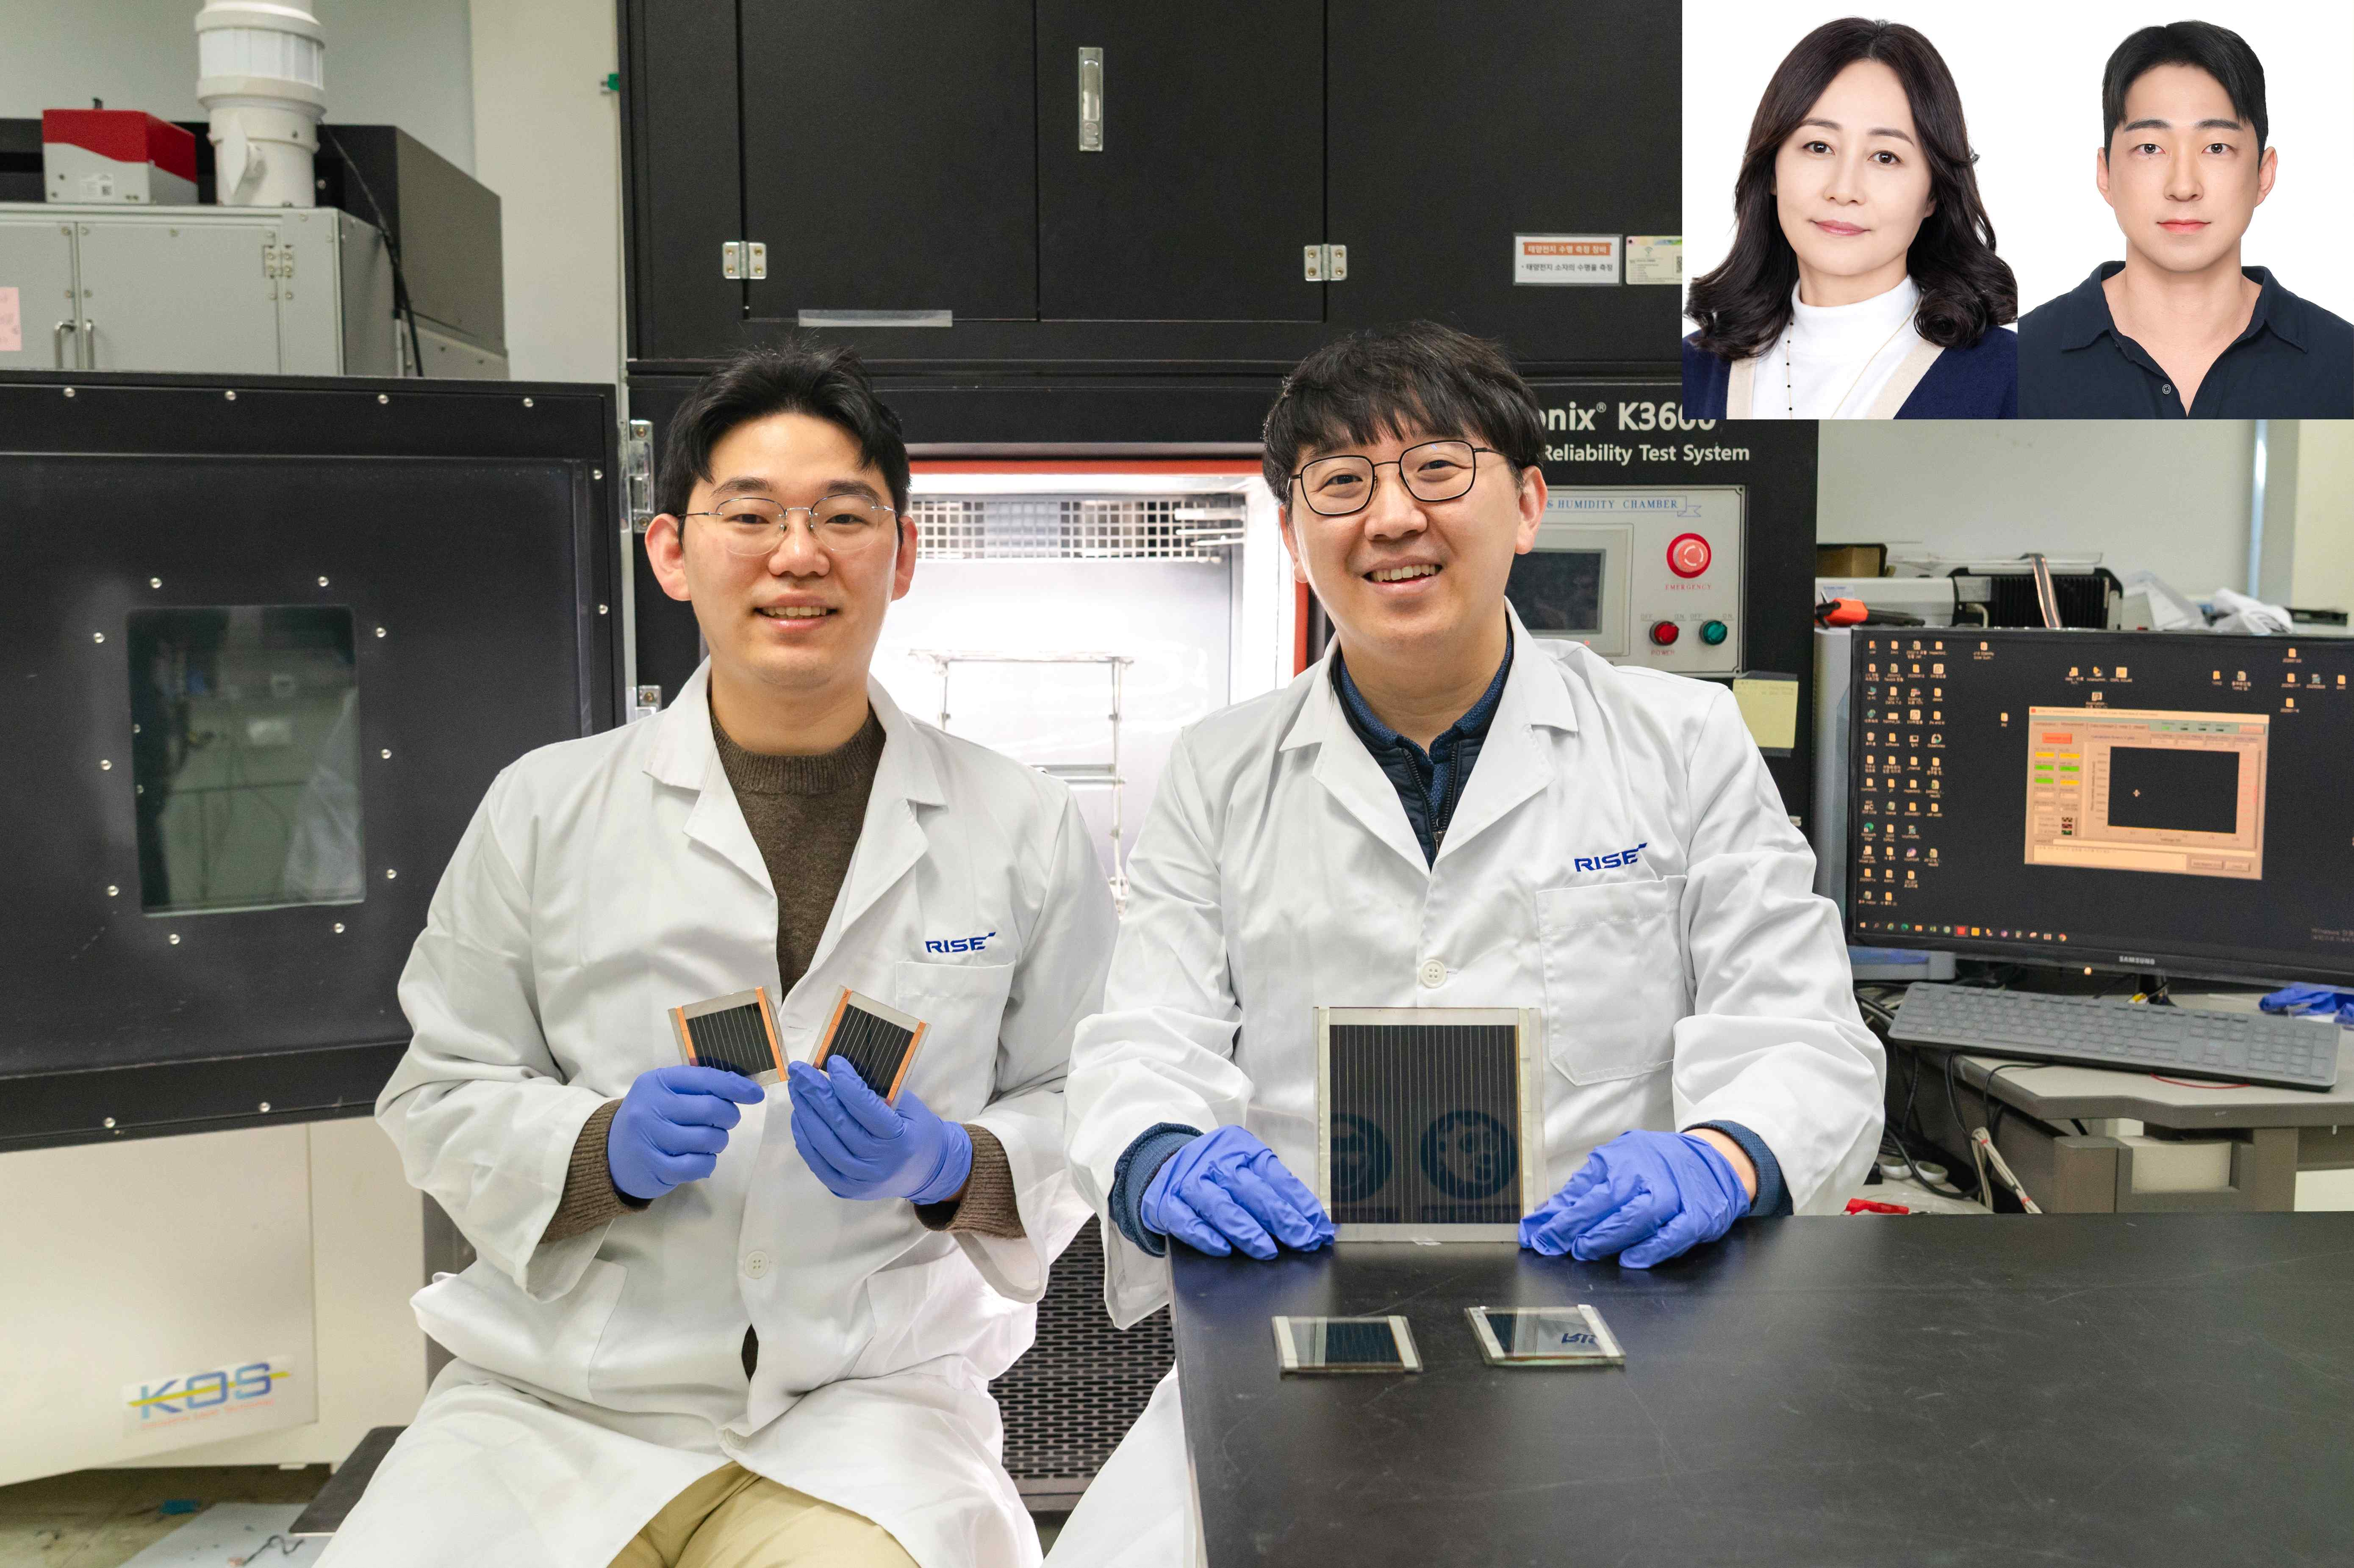

▲ (From left) GIST Research Institute for Solar and Sustainable Energies Researcher Sangcho Kim and Assistant Director Hongkyu Kang, (from top left) Kangwon National University Professor Mee-Yi Ryu and Dr. Il-Wook Cho
A Korean research team has developed a core technology for next-generation materials-based perovskite solar cells that maintains efficiency and stability even when fabricated on large surfaces for commercialization.
The Gwangju Institute of Science and Technology (GIST, President Kichul Lim) announced that a research team led by Assistant Director Hongkyu Kang of the Research Institute for Solar and Sustainable Energies, in collaboration with researchers at Kangwon National University, has developed an interface engineering technique that precisely controls the properties between the internal layers of perovskite solar cells.
The application of this technology resulted in a high power conversion efficiency of 22.56% for a large-area module, approximately one-quarter the size of an A4 sheet of paper (24.8 cm²), and demonstrated stability, maintaining approximately 94% of initial performance after over 500 hours of use.
Perovskite solar cells are attracting attention as next-generation solar cells due to their lighter weight and simpler manufacturing process compared to conventional silicon solar cells. However, commercialization has been hampered by the rapid deterioration in performance and lifespan as the size increases.
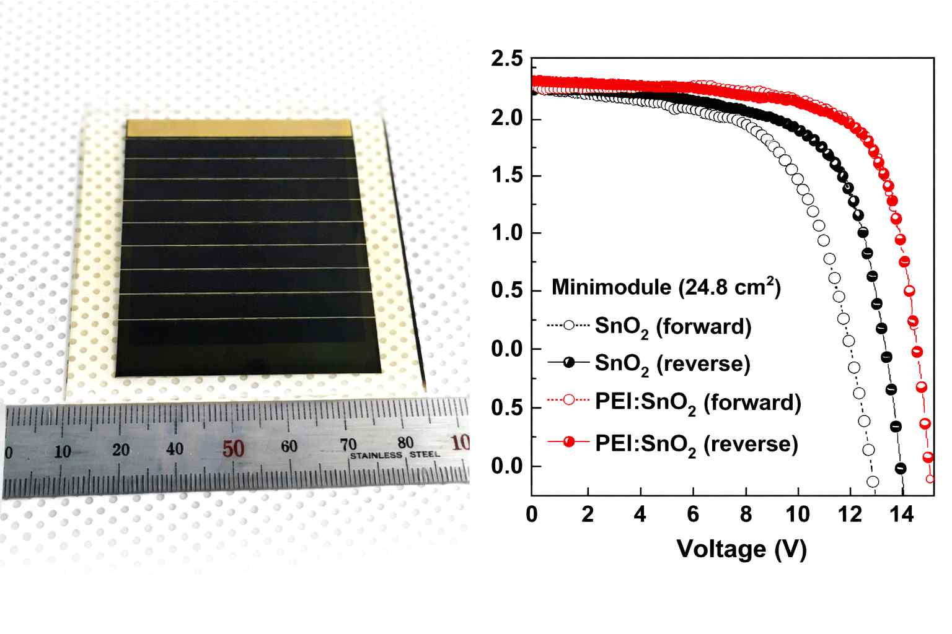
▲ Perovskite module photo and efficiency graph: Photograph of a 24.8 cm² perovskite solar cell module fabricated using PEI-modified SnO₂, along with an efficiency graph before and after modification.
As the solar cell area increases, it becomes more difficult to form the internal thin film uniformly. This increases electron transport losses, leading to both reduced efficiency and stability.
The research team focused on the interfacial properties of the electron transport layer*, which is responsible for electron transport within the solar cell, as the core cause of these problems.
SnO₂, a widely used electron transport layer, is advantageous for electron transport, but its poor surface wetting results in an uneven film formed on top, and microscopic defects can cause electrons to disappear midway.
* electron transport layer: This layer helps ensure that electrons generated by light within the solar cell are transported to the electrode without loss and can be used as electricity. This layer acts as a conduit for electrons, and the characteristics of this layer significantly affect the efficiency and stability of the solar cell, affecting the speed and degree of electron loss.
* tin oxide (SnO₂): An oxide semiconductor material composed of tin (Sn) and oxygen (O₂), it facilitates fast and stable electron transport. Due to its high chemical stability and transparency, it is widely used as an electron transport layer in perovskite solar cells and plays a crucial role in the electron extraction efficiency and lifespan of solar cells.
The research team introduced a simple process method that mixes the polymer "PEI (polyethyleneimine)*" with tin oxide (SnO₂) in the initial stage of electron transport layer formation, solving two problems at once.
The polymer PEI fills in microscopic defects on the tin oxide (SnO₂) surface, reducing electron loss and improving the electrical environment at the interface, facilitating smooth electron transport. This lowers the electron transport barrier within the solar cell, simultaneously improving the efficiency and stability of the entire solar cell.
* PEI (polyethyleneimine): A polymer containing amine functional groups that possesses the property of highly bonding to surfaces. In perovskite solar cells, it binds to microscopic defects on the electron transport layer surface, reducing electron loss and forming electric dipoles at the interface, facilitating electron transport. This enhances both the efficiency and stability of solar cells.
The most significant feature of this research is that it simultaneously achieved the ability to uniformly form thin films (surface wettability) and control electron transport characteristics through a single, simple process.
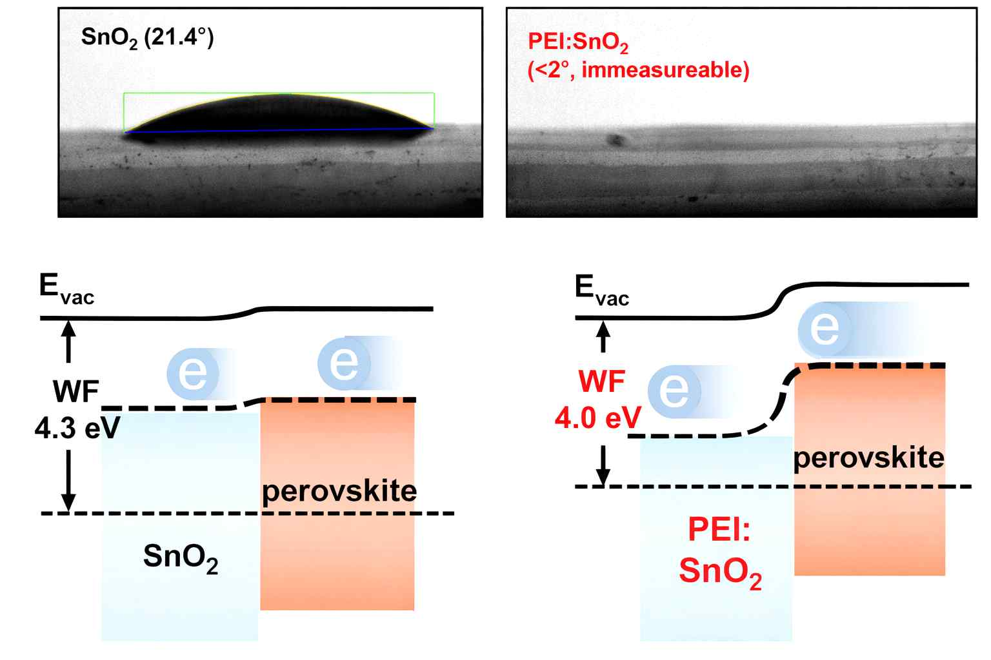

▲ Wettability and interface electron transport phenomena of unmodified and modified SnO₂. Figure: Contact angle measurements for perovskite solvent on the SnO₂ surface using a contact angle meter. In the case of modified SnO₂, the improved wettability allowed the solvent to spread rapidly across the surface, making contact angle measurements impossible. Furthermore, they confirmed that the work function change through modification improved charge transport characteristics at the interface.
By directly controlling the interface during the initial stages of forming the tin oxide (SnO₂) electron transport layer, the research team achieved uniform thin films with minimal quality variation, even over large areas, without additional processing. This approach is particularly advantageous in solar cell manufacturing processes suitable for mass production, such as printing methods that form thin films similar to inkjet printing.
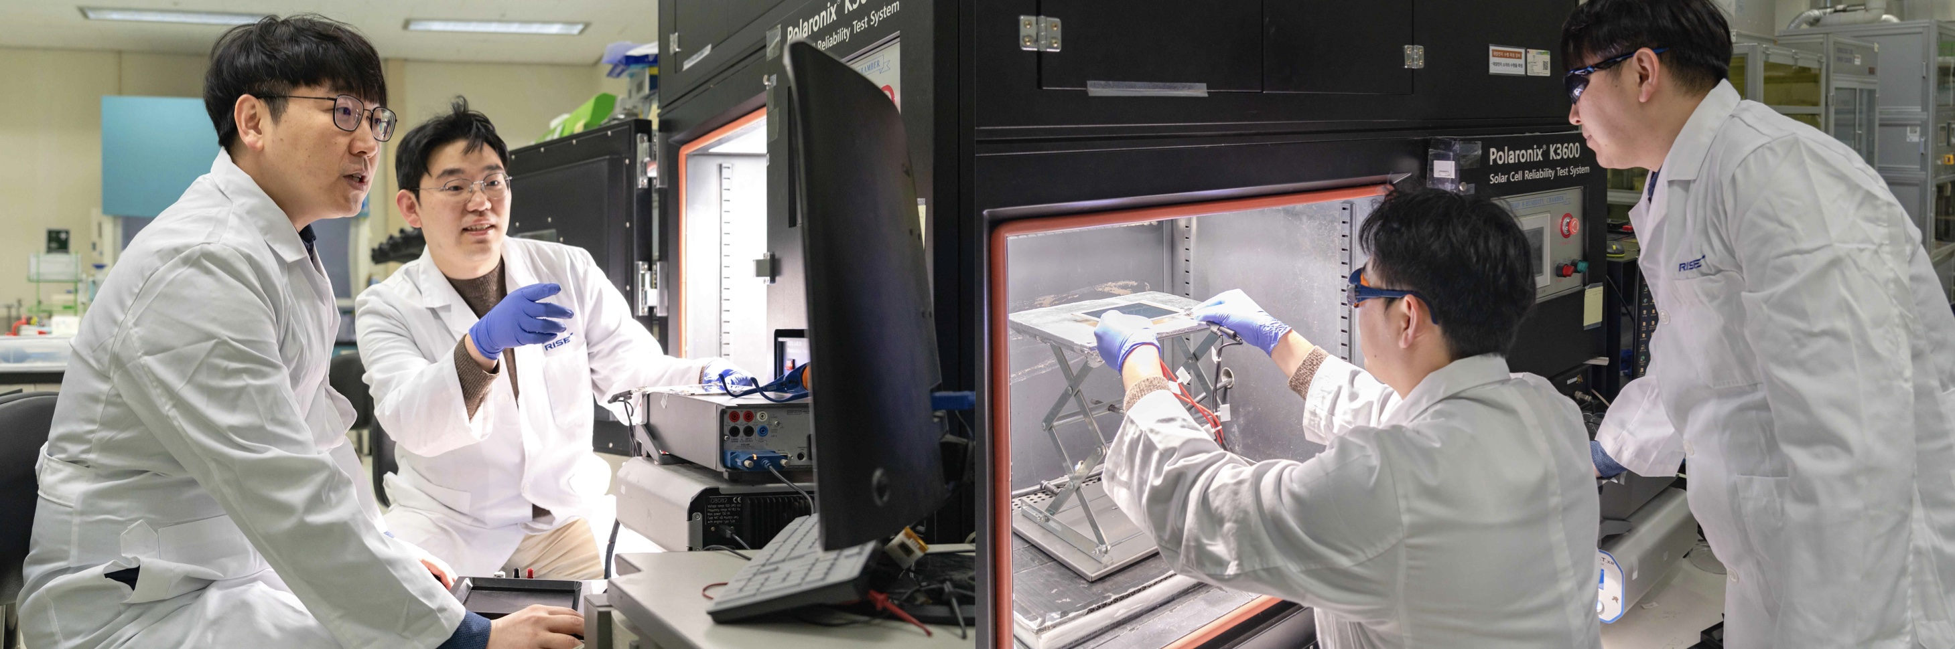
▲ (Left) Researchers discussing performance data for a large-area perovskite solar cell module. (Right) Experimental scene using a solar simulator to measure the photoelectric conversion efficiency of a large-area perovskite solar cell module.
As a result, high efficiency and stability were consistently maintained not only in small-area cells but also in large-area solar cell modules, significantly increasing the potential for mass production and commercialization.
This effectively reduces the uneven film formation, which has been a problem with increasing solar cell area, and the loss of electrons (non-luminescent recombination*) caused by electrons disappearing from microscopic gaps or imperfect junctions within the film or between layers, preventing them from being used as electricity.
* non-luminescent recombination: Electrons and holes generated by light should move to the electrode to generate electricity, but instead, they recombine at defects or interfaces within the device, dissipating energy without generating light or electricity. The more this process occurs, the fewer electrons are actually utilized within the solar cell, lowering power generation efficiency and compromising device stability.
Hongkyu Kang, Assistant Director of the GIST Research Institute for Solar and Sustainable Energies, said, "This research is significant in that it simultaneously addresses wettability and film uniformity, key challenges in large-area perovskite solar cells, through a simple process." He added, "By simultaneously securing high energy conversion efficiency and long-term stability, we expect this research to contribute to accelerating the commercialization of perovskite-based large-area solar cells."
This research was supported by the Basic Research Program of the Ministry of Education and the National Research Foundation of Korea, the Industrial Technology Development Program of the Ministry of Trade, Industry and Energy, the Regional Innovation-Oriented University Support System (RISE) Program of the Ministry of Education and Gangwon Special Self-Governing Province, and the GIST Future-Leading Specialized Research Project.
The results of the research — Dual-Function Interface Engineering of SnO₂ Electron Transport Layers: Wettability Enhancement and Work Function Tuning for Efficient and Stable Perovskite Solar Cells and Minimodules — were published online in the international journal Small on December 19, 2025.
Meanwhile, GIST stated that the results of this research were considered in consideration of both academic significance and industrial applicability, and that discussions regarding technology transfer can be conducted through the Technology Commercialization Center (hgmoon@gist.ac.kr).

