"Discerning well-made semiconductors at a glance without breaking them" Professor Hyunseob Lim's research team develops next-generation, non-destructive semiconductor quality inspection technology
- Professor Hyunseob Lim's research team in the Department of Chemistry has developed a non-destructive analysis technology that determines single crystals without damaging the sample... Using low-energy electron diffraction (LEED), it overcomes the limitations of conventional destructive analysis and can be applied to wafer processing
- This technology, which allows for a single crystal quality assessment of the entire wafer at a glance, much like an X-ray, is expected to be a key technology for improving yields in next-generation two-dimensional semiconductor mass production... Published in the international journal Nano Letters
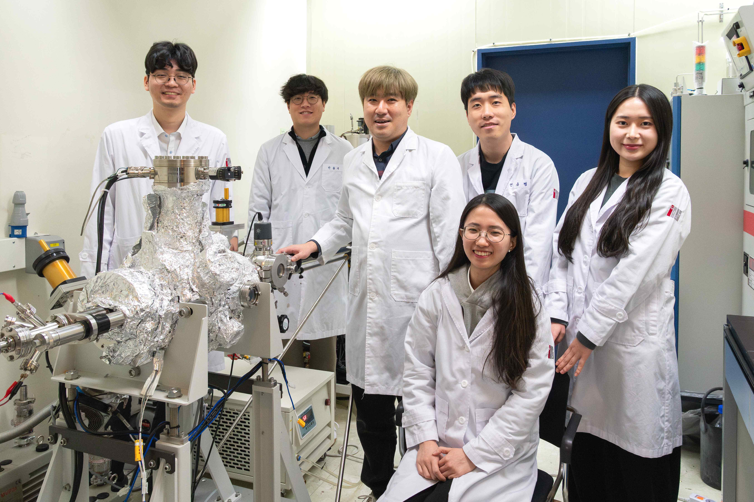

▲ (From left) Dohoon Kim, a student in the combined master's and doctoral program in the Department of Chemistry, Dr. Chaehyeon Ahn, Professor Hyunseob Lim, master's students Joonbyeong Jeon, Hyeeree Joo, and Joohee Oh, a student in the combined master's and doctoral program (sitting in a chair)
The Gwangju Institute of Science and Technology (GIST, President Kichul Lim) announced that a research team led by Professor Hyunseob Lim of the Department of Chemistry has developed a non-destructive analysis technique that can accurately determine whether next-generation semiconductor materials have been properly synthesized without damaging the sample.
Silicon (Si), currently the mainstay material in the semiconductor industry, faces physical limitations, such as the difficulty of maintaining performance and efficiency as chips become smaller. Furthermore, increased power consumption hinders performance improvements. Consequently, two-dimensional semiconductor materials capable of exhibiting superior electrical and optical properties even at a single atomic layer thickness are attracting attention as key alternatives for the "post-silicon" era.
Among these, molybdenum disulfide (MoS₂)* is a representative two-dimensional semiconductor material with an ultra-thin film structure, one atomic layer thick—much thinner than a sheet of paper—unlike conventional three-dimensional semiconductors, which are as thick as silicon. However, in order to utilize this as an actual semiconductor chip, it is most important to maintain a ‘perfect single crystal’ state in which all atoms are aligned in one direction even when synthesized on a large area.
* molybdenum disulfide (MoS₂): A representative two-dimensional semiconductor material composed of molybdenum (Mo) and sulfur (S), it exhibits excellent electrical and optical properties despite its extremely thin structure, measuring only one atomic layer thick. It is attracting attention as a key next-generation semiconductor material that will overcome the physical limitations of silicon. When "single crystal growth" occurs, where all crystals are aligned in a single direction, electron movement becomes smoother, significantly improving device performance and energy efficiency.
The problem is that while synthesized samples may appear to be perfectly aligned, or "single crystals," with atoms neatly aligned, they often contain "false crystals" (domains) where the atomic arrangement is flipped 180 degrees.
The coexistence of these crystals disrupts electron flow at the interface, drastically degrading semiconductor performance and reducing device reliability. Therefore, for the commercialization of next-generation two-dimensional semiconductors, an evaluation technology capable of accurately verifying single crystal integrity is essential.
However, most existing analysis techniques involve cutting or damaging the sample, limiting their application to the "wafer process," which involves processing thin, disc-shaped materials to create semiconductor chips without damage.
To overcome these limitations, the research team focused on the 'Low-Energy Electron Diffraction (LEED)*' technique.
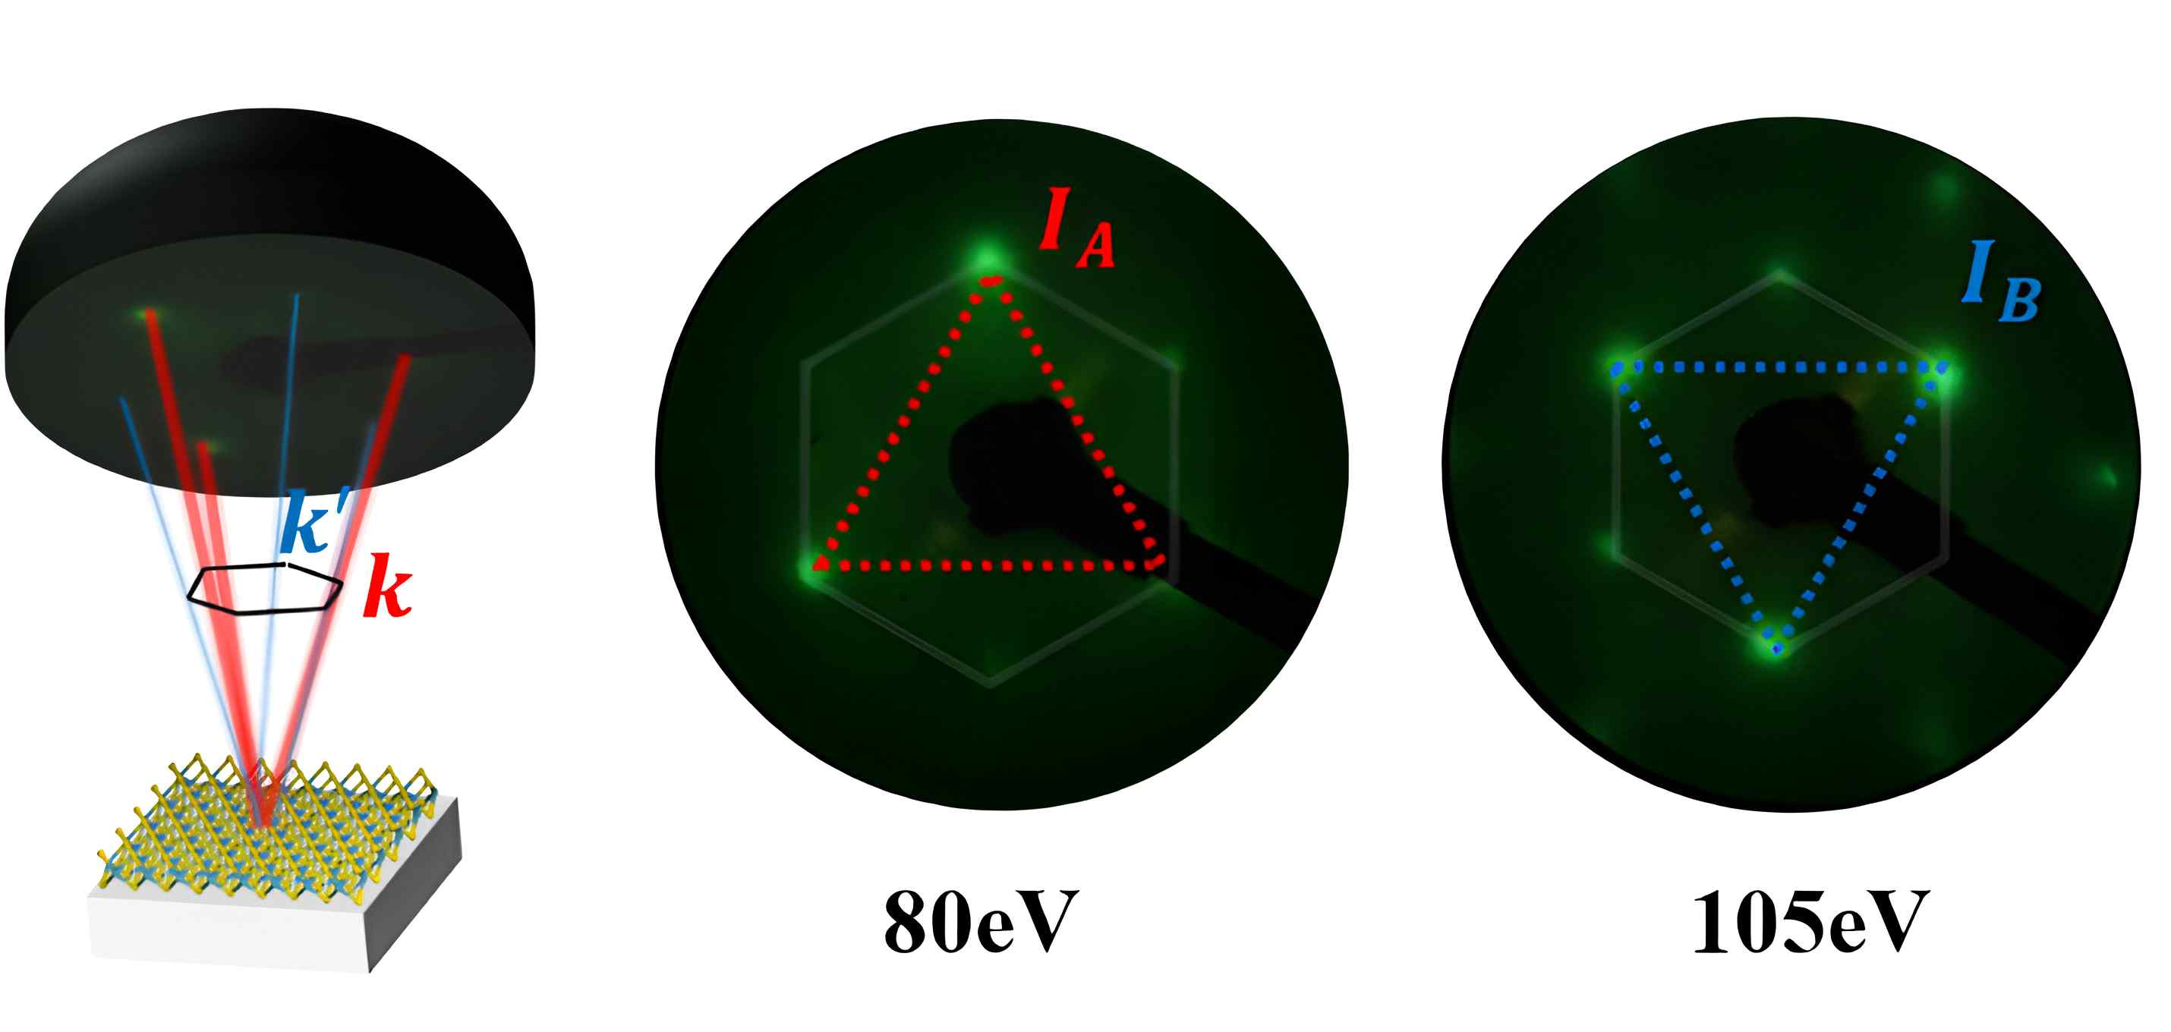

▲ Non-destructive single crystal quality verification: By varying the electron beam energy and measuring the change in brightness of the diffraction pattern spots, the team can determine whether and to what extent "twin crystals" with flipped atomic arrangements are present.
By gradually varying the electron beam energy and precisely analyzing the intensity changes in the diffraction pattern (the change in the intensity of the diffraction signal) generated by the electrons striking the atomic arrangements, the team was able to clearly distinguish between a "true single crystal" with all crystals aligned in one direction and a sample containing crystals with a mixed orientation, all without destroying the sample.
This study is particularly significant in that it establishes a reliable single-crystal identification method that goes beyond simple image observation by presenting a method (new electron diffraction analysis criteria) that quantitatively assesses the degree of crystal alignment by considering both the structural characteristics of a single-layer two-dimensional semiconductor and the multiple electron scattering effect.
*low-Energy Electron Diffraction (LEED): This analytical technique uses a low-energy electron beam to illuminate the surface of a material and analyzes the diffraction pattern of electrons caused by atomic arrangements to determine the surface crystal structure and arrangement. Because electrons are sensitive to the outermost atomic layer of a material, LEED is particularly suitable for assessing the crystallinity of ultra-thin materials, such as two-dimensional semiconductors that are one atomic layer thick.
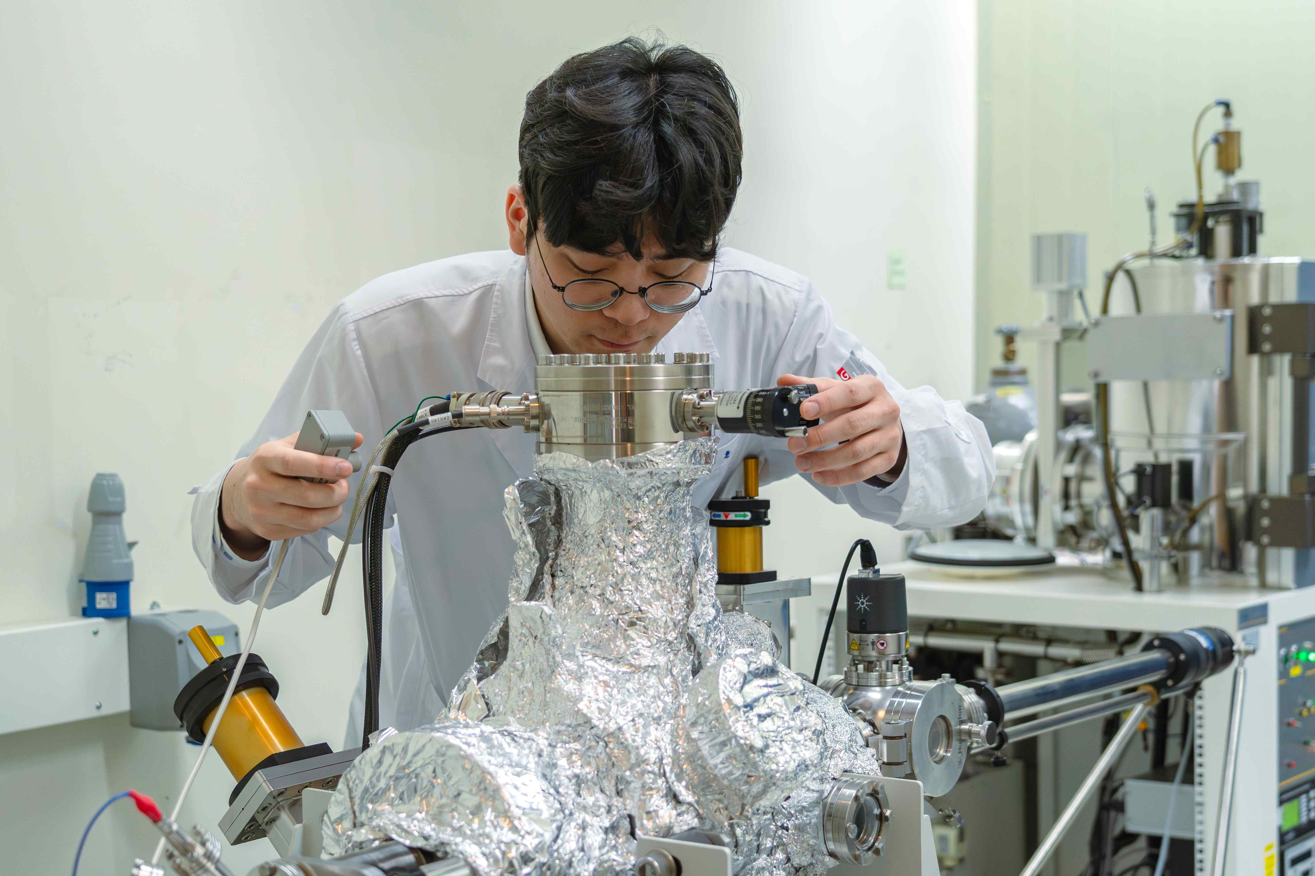

▲ Professor Hyunseob Lim's student, Dohoon Kim (first author) from the Department of Chemistry, uses low-energy electron diffraction (LEED) analysis to determine whether a semiconductor material has been properly synthesized without damaging the sample.
This achievement is noteworthy not only for presenting a new analysis technique but is also noteworthy for demonstrating its potential for industrial application.
No matter how excellent a semiconductor material is developed, mass production is impossible without a technology capable of quickly and accurately inspecting it. The research team's analysis method, which allows for a single-crystal quality assessment of the entire wafer at a glance, much like an X-ray, is expected to be a key technology for dramatically increasing the yield, or percentage of good products, during the mass production of next-generation two-dimensional semiconductors.
Furthermore, this technology can be applied not only to molybdenum disulfide (MoS₂) but also to various two-dimensional semiconductors and structures (van der Waals heterojunctions) made by layering different ultra-thin materials. Therefore, it has great potential to become a standard quality control technology for the entire next-generation semiconductor process.
Professor Hyunseob Lim stated, "For next-generation semiconductor materials that surpass silicon to be applied in real-world industrial settings, large-scale synthesis technology and reliable evaluation technology to verify it are essential." He added, "The non-destructive analysis method developed this time will serve as a crucial bridge, connecting two-dimensional semiconductor research, which has remained confined to the laboratory, to wafer processing in industrial settings."
This research was conducted by Dohoon Kim, a combined master's and doctoral student, under the supervision of Professor Lim Hyunseob Lim of the Department of Chemistry at GIST. It was supported by the Basic Research Program of the Ministry of Science and ICT (MSIT) and the National Research Foundation of Korea (NRF), and the InnoCORE program of the MSIT.
The results of this research — Revisiting Dynamical Theory To Elucidate Friedel’s Law Breaking in Low-Energy Electron Diffraction as Strong Evidence of Unidirectional Growth of Monolayer 2H Mo S₂ — were published online in the international journal Nano Letters on January 8, 2026.
Meanwhile, GIST stated that the results of this research were considered in consideration of both academic significance and industrial applicability, and that discussions regarding technology transfer can be conducted through the Technology Commercialization Center (hgmoon@gist.ac.kr).

