“When I enlarged the hole, electricity started flowing much better” GIST has overcome the limitations of fuel cell performance with a vertical electrode structure that applies the principle of fruit freeze-drying

- Professor Chanho Pak's team in the Department of Chemistry and Professor Seung-Hyeon Moon's team in the Department of Environment and Energy Engineering jointly developed a high-performance, integrated membrane-electrode assembly (MEA) that applies the porous structure of freeze-dried fruit to fuel cell electrode design.

- Simultaneously improving output and stability without increasing the amount of platinum catalyst used, suggesting potential applications in mobile fuel cells requiring high output and durability... Published in the international journal 《Chemical Engineering Journal》



▲ (From left) Professor Chanho Pak of the Department of Chemistry at GIST, Dr. Hyeon-Seung Jung, Visiting Distinguished Professor Seung-Hyeon Moon of the Department of Environment and Energy Engineering, Dr. Jae-Hun Kim of POSCO Holdings, and master's student Seung Tae Lee of GIST

The Gwangju Institute of Science and Technology (GIST, President Kichul Lim) announced that a joint research team consisting of Professor Chanho Pak of the Department of Chemistry, Visiting Distinguished Professor Seung-Hyeon Moon of the Department of Environment and Energy Engineering, and Dr. Jae-Hun Kim of POSCO Holdings has developed a novel membrane-electrode assembly (MEA) structure* that can simultaneously enhance the output and stability of fuel cell electrodes by applying a porous structure with numerous internal pores, like freeze-dried fruit, to the design of fuel cell electrodes.

The key to this research is that by continuously combining a porous catalyst layer produced using freeze-drying technology and an electrolyte membrane into a single structure, the researchers expanded the "three-phase interface*," a key space for fuel cell reactions, from a flat surface to a three-dimensional structure. This simultaneously improves gas diffusion and reaction efficiency, significantly increasing its potential as a mobile fuel cell technology.

* membrane electrode assembly (MEA): A core component of a polymer electrolyte membrane fuel cell, the MEA combines the electrolyte membrane and the anode and cathode electrodes into a single structure. The membrane is centered on the electrolyte membrane, with catalyst-coated electrode layers arranged on either side. Electricity is generated through the electrochemical reaction of hydrogen and oxygen. During this process, ion transport, electron transfer, and gas diffusion occur simultaneously, determining the performance and lifespan of the fuel cell.

* triple-phase boundary (TPB): The local point where the oxygen reduction reaction (ORR) actually occurs in a fuel cell. It refers to the point where three phases—electrons moving across the solid electrode, hydrogen ions flowing through the electrolyte, and oxygen gas—meet. Oxygen and hydrogen ions combine at the platinum catalyst distributed at this triple-phase boundary to produce water.

Polymer electrolyte membrane fuel cells (PEMFCs)* are an eco-friendly energy conversion technology that generates electricity from hydrogen and emits only water instead of exhaust gas. They are widely used in medium- to large-scale transportation vehicles, including hydrogen electric vehicles.

However, a significant challenge in PEMFCs is reducing the amount of platinum catalyst used while simultaneously ensuring high output and long-term stability. In particular, the triple-phase boundary, where the actual reaction occurs, is limited to the thin, two-dimensional interface between the catalyst layer and the electrolyte membrane in conventional thin-film catalyst layers. This limits gas diffusion and ion transport, as well as interfacial bonding stability.

The three-phase interface (TPI) is where electrons, hydrogen ions, and oxygen meet. It primarily forms between the catalyst layer, where electricity is generated, and the electrolyte membrane, which facilitates the flow of hydrogen ions. Its effective surface area and structure determine fuel cell performance. Therefore, ensuring a wide and stable contact area between the TPI and the electrolyte membrane has been a key challenge in the design of high-performance membrane-electrode assemblies (MEAs).

* polymer electrolyte membrane fuel cell (PEMFC): A type of fuel cell that uses hydrogen as fuel to generate electricity. It is characterized by the use of a polymer membrane as its electrolyte. Hydrogen ions generated from hydrogen pass through the electrolyte membrane, and electrons move through an external circuit to generate electricity. This eco-friendly energy conversion device emits only water and heat. Due to its low operating temperature and fast startup characteristics, PEMFCs are widely used in hydrogen electric vehicles and portable power sources.

To address these issues, the research team introduced a novel electrode manufacturing method that combines the freeze-casting* process, which encourages ice growth in one direction, with the freeze-drying* process. As the ice crystals grow in a specific direction, vertically aligned pores are created within the crystal, resembling a honeycomb. This structure facilitates gas movement within the catalyst layer, maximizing gas diffusion.

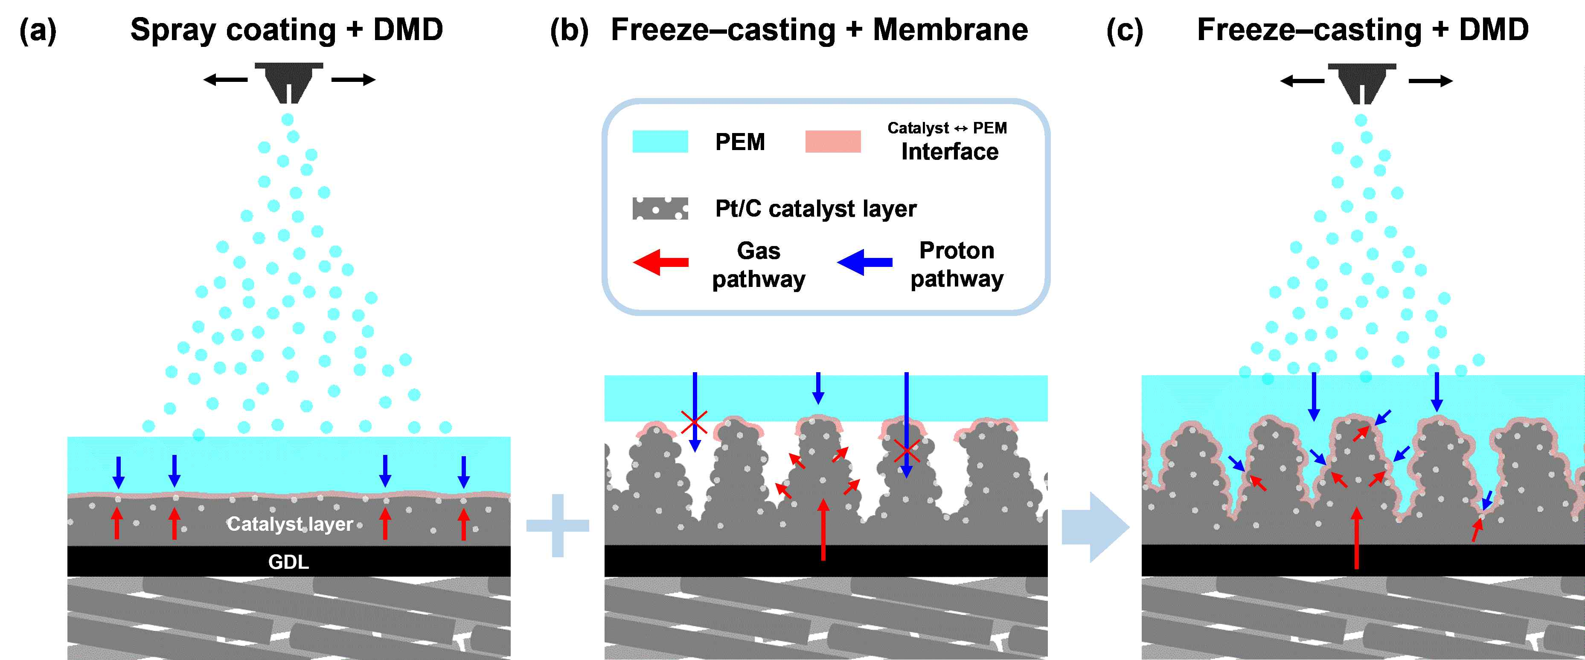

▲ Schematic of an integrated membrane-electrode assembly utilizing a combination of freeze-casting and direct membrane deposition (DMD) techniques: (a) DMD applied to a conventional catalyst layer; (b) a conventional electrolyte membrane attached to a freeze-cast catalyst layer; and (c) the structure of an integrated membrane-electrode assembly with DMD incorporated into the freeze-cast catalyst layer. The diffusion paths of gas (red) and hydrogen ions (blue) can be compared with the interface between the catalyst layer and the electrolyte membrane (red region). In the case of the integrated membrane-electrode assembly, a three-dimensional interface is formed, ensuring a larger effective contact area.

Specifically, when the electrode, immediately after coating the catalyst layer, is placed on a cold plate, ice crystals grow vertically from the bottom upward (freeze casting). Subsequent freeze-drying results in the sublimation of the ice, forming a honeycomb-like, aligned porous structure with a hollow interior, reminiscent of a freeze-dried fruit.

The catalyst layer fabricated using this method is approximately 30 micrometers (μm) thick, forming nearly straight gas transport channels within it. The porosity increased to approximately 49%, and the pore volume increased to 0.27 milliliter/gram (mL/g), securing more than twice the pores of conventional spray-type catalyst layers. This structure plays a direct role in enhancing reaction efficiency by facilitating oxygen diffusion and water release.

* freeze-casting: A technique that forms a structure by freezing the solvent prior to freeze-drying. One side is cooled to a low temperature, while the other side is maintained at a constant temperature, inducing a specific direction of water freezing. When the catalyst ink is frozen using freeze-casting, the ice crystals grow in one direction, forming an aligned internal pore structure.

* freeze-drying: A drying method that lowers the temperature below the freezing point of the solvent (below 0°C for water) to solidify the liquid, then sublimates and removes the solid solvent under vacuum. In this study, freeze-drying was applied to prevent the internal porous structure from collapsing after the catalyst layer coating.

Furthermore, instead of the conventional method of attaching the completed electrolyte membrane to the electrode, the research team applied a "direct electrolyte membrane deposition*" technique, which forms a membrane by directly depositing the electrolyte polymer onto the catalyst layer.

This method allows the electrolyte polymer to penetrate deep into the porous catalyst layer, forming a three-dimensional interlocking structure between the membrane and electrodes (3D interlocking). This results in enhanced interfacial adhesion and improved electron and hydrogen ion transport pathways.

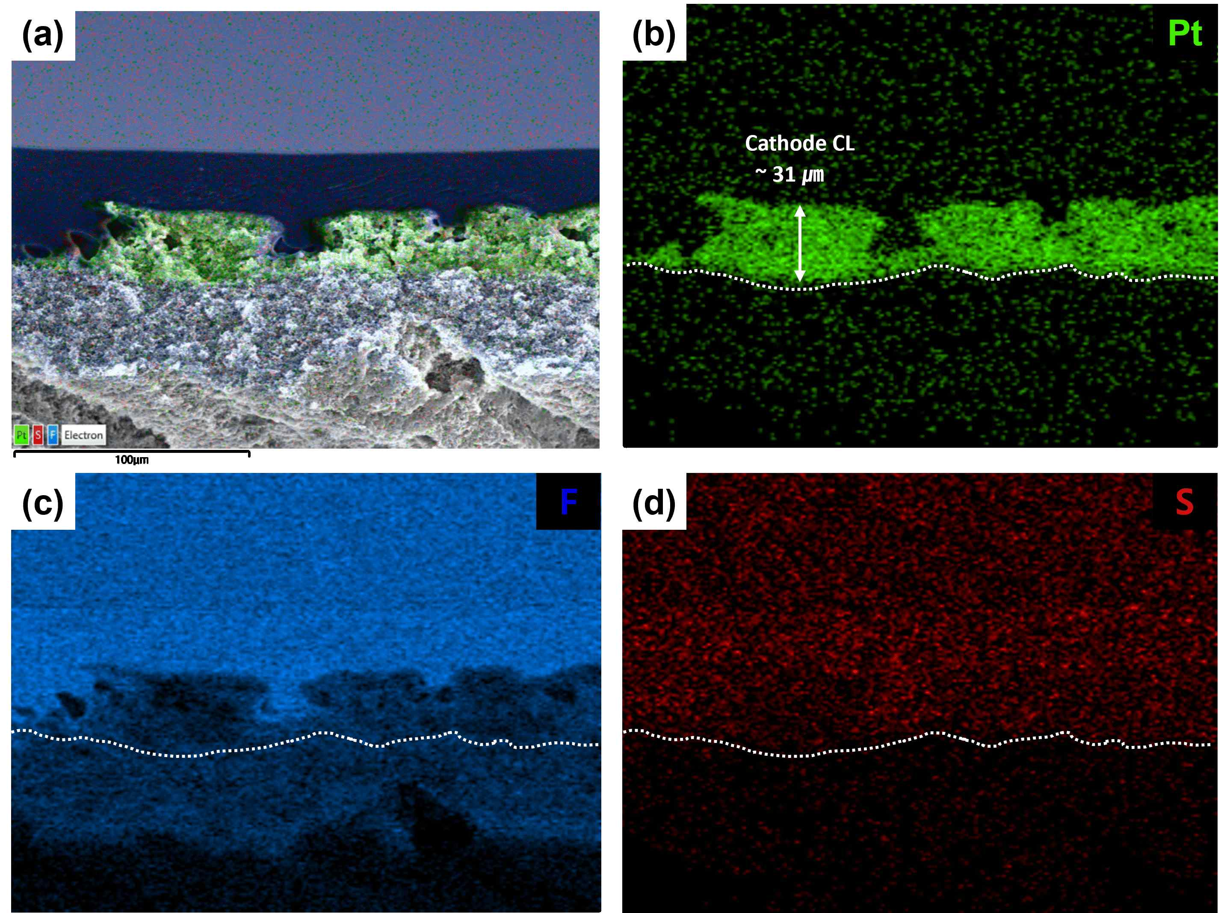

▲ Scanning electron microscope (SEM) cross-sectional and elemental distribution images of the integrated membrane-electrode assembly: (a) total elements, (b) platinum distribution, (c) fluorine distribution, (d) sulfur distribution. The interlocking structure of the electrolyte membrane and catalyst layer is observed in (a), and this is further confirmed by analysis of the platinum distribution in (b). Furthermore, comparison with the fluorine (F) distribution in the electrolyte polymer confirms that the electrolyte penetrates deep into the catalyst layer, facilitating the transport of hydrogen ions.

Electrochemical analysis results showed that the expansion of the three-phase interface from a planar to a three-dimensional structure facilitated both the flow of electricity and the transport of hydrogen ions (reduced hydrogen ion diffusion resistance and charge transfer resistance). This resulted in increased fuel cell reaction efficiency and improved overall performance.

* direct membrane deposition (DMD): One method for creating a membrane-electrode assembly with an electrolyte membrane attached to the catalyst layer. Conventional methods produce membrane-electrode assemblies by assembling a completed commercial electrolyte membrane with a catalyst layer and pressing it together. However, DMD dissolves the electrolyte membrane polymer in alcohol and sprays it directly onto the catalyst layer, ensuring even adhesion at the interface between the catalyst layer and the electrolyte membrane, thereby forming a membrane-electrode assembly.

Performance evaluation results showed that the integrated membrane-electrode assembly developed by the research team achieved a maximum power density of approximately 1.62 watts (W) per square centimeter (cm²) under conditions of 80°C, 100% relative humidity, and an oxygen supply. This represents a 10% improvement over existing membrane-electrode assembly structures, meaning more electricity can be generated from the same area. This demonstrates a significant improvement in fuel cell efficiency.

Notably, this performance improvement was achieved solely through electrode microstructure and membrane-electrode interface design, without increasing the amount of platinum catalyst used, making it highly valuable for industrial applications.

Excellent durability evaluation results were also observed. In accelerated degradation tests involving repeated humidification and drying, the reduction in the electrode's catalytic reaction area (electrochemically active area) was limited to approximately 35%, demonstrating stable performance over extended periods of use compared to conventional structures.

Notably, the rate of performance degradation (reduction in active area) remained moderate even after 500 cycles and up to 2,000 cycles, confirming that the three-dimensional interlocked membrane-electrode structure contributes to improved interfacial stability and long-term durability.

The integrated membrane-electrode assembly developed in this study features high porosity and large pore volume, which enhance gas diffusion, while also achieving high output and excellent durability through optimization that reduces proton diffusion resistance and charge transfer resistance.

These structural and electrochemical advantages are expected to significantly expand the potential for future applications in high-performance applications, including medium- and large-scale mobile fuel cell systems for electric vehicles and trucks.

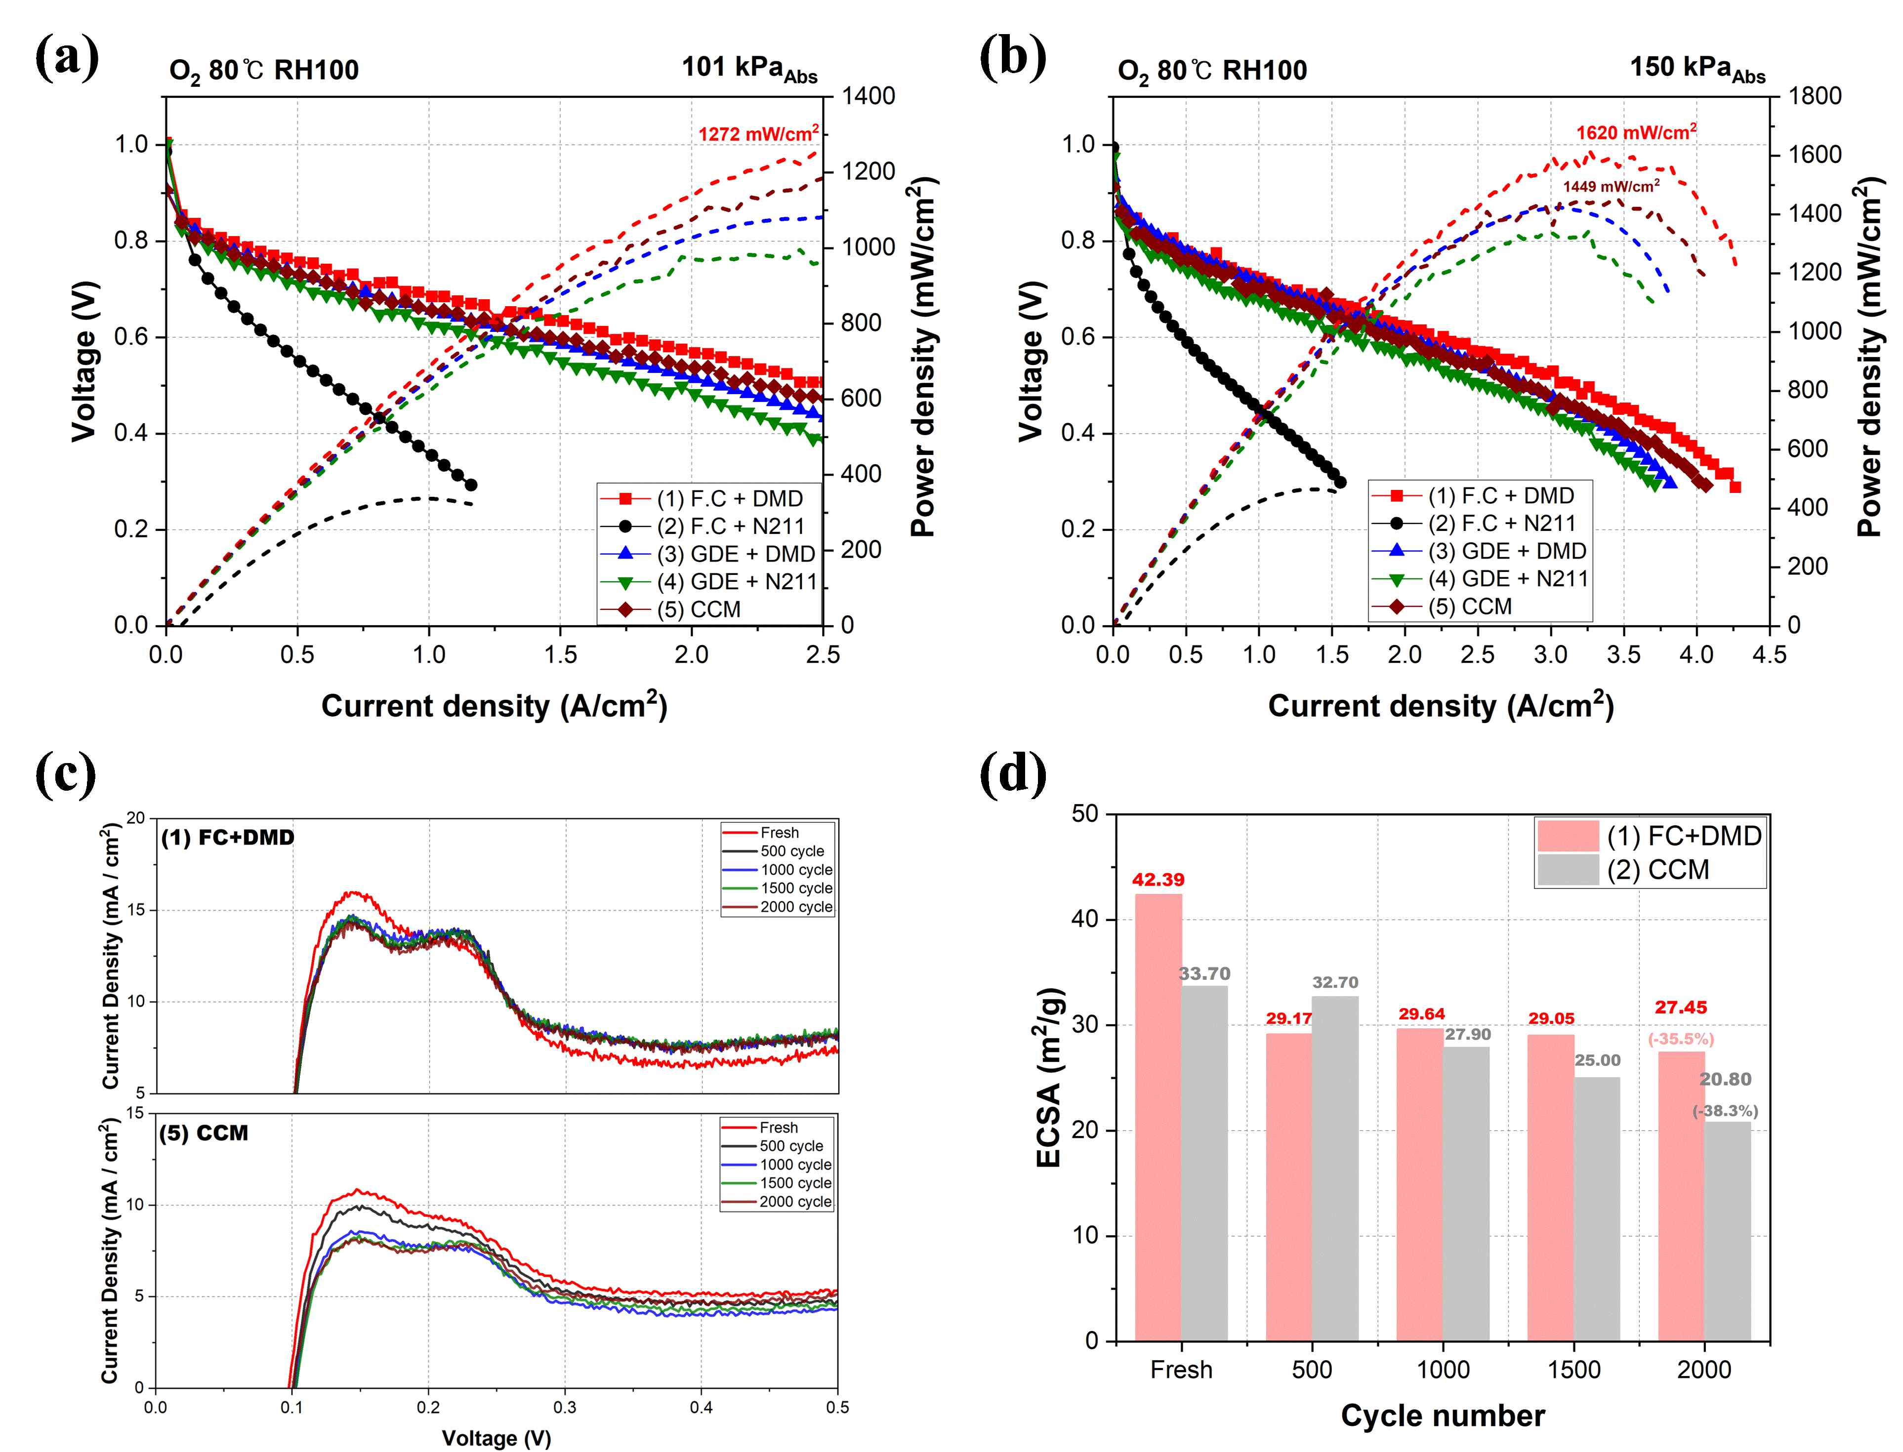

▲ Comparison of unit cell evaluation results by membrane-electrode assembly structure: (a) under atmospheric oxygen conditions, (b) under pressurized oxygen conditions, (c) electrochemical active area graph measurements after accelerated degradation durability evaluation, and (d) graph comparing electrochemical active area changes by accelerated degradation durability cycle. (b) According to the results, the proposed FC+DMD structure achieved a power density of 1,620 mW/cm², approximately 11.8% higher than the conventional CCM (1,449 mW/cm²). The active area reduction rate after the accelerated degradation test was also -35.5%, which was smaller than the -38.3% decrease for the CCM, confirming improved durability.

Professor Chanho Pak explained, "By combining freeze-casting and direct membrane deposition into an integrated structure, we were able to simultaneously optimize the transport pathways of gas, electrons, and hydrogen ions." He added, "This research is significant because it suggests a new electrode and membrane manufacturing process that can simultaneously improve the performance and stability of fuel cells that convert clean hydrogen into electricity. This research provides a direction for future electrode structure development."

This research, led by Professor Chanho Pak of the Department of Chemistry at GIST, was conducted by Visiting Distinguished Professor Seung-Hyeon Moon of the Department of Environment and Energy Engineering, Dr. Jae-Hun Kim of POSCO Holdings, and Dr. Hyeon-Seung Jung of the GIST Research Institute for Solar and Sustainable Energies. The research was supported by a research project from the Korea Institute of Energy Technology Evaluation and Planning (KETEP) and POSCO Holdings.

The results — Integrated MEA for polymer electrolyte membrane fuel cells enabled by freeze–casting and direct membrane deposition — were published online in the international journal Chemical Engineering Journal on December 16, 2025.

Meanwhile, GIST stated that the results of this research were considered in consideration of both academic significance and industrial applicability, and that discussions regarding technology transfer can be conducted through the Technology Commercialization Center (hgmoon@gist.ac.kr).



