"The reason liver cancer grows back even after treatment lies in a single protein" GIST presents a new breakthrough in liver cancer treatment, uncovering the hidden causes of recurrence and treatment resistance

- Professor Jeong-Seok Nam's team from the Department of Life Sciences identified "dysadherin," a key factor that simultaneously induces drug resistance and immune evasion in liver cancer... They confirmed that cancer stem cell formation and immune suppression are linked through a single signaling pathway

- Patient data and animal experiments confirmed a link between dysadherin and tumor progression and recurrence, demonstrating that dysadherin inhibition reduces tumor growth and metastasis and restores immunity... The study was published in the international journal 《Signal Transduction and Targeted Therapy》



▲ (From left) Professor Jeong-Seok Nam of the Department of Life Sciences at GIST, Professor Hyung-Sik Kim of Pusan ​​National University, Tae-Young Jang, a student in the combined master's and doctoral program at GIST, and So-El Jeon, a student in the combined master's and doctoral program at GIST

The Gwangju Institute of Science and Technology (GIST, President Kichul Lim) announced that a research team led by Professor Professor Jeong-Seok Nam of the Department of Life Sciences has identified the protein "dysadherin," a key factor in inducing both drug resistance and immune evasion in liver cancer, and has also suggested the possibility of a therapeutic strategy targeting it.

This study is significant in that it uncovers the common mechanisms of recurrence and treatment resistance, two of the greatest challenges in liver cancer treatment.

Liver cancer has one of the highest mortality rates worldwide. It frequently relapses after treatment and often has a limited response to existing chemotherapy or immunotherapy.

Notably, cancer stem cells* exist within tumor tissues that survive chemotherapy and regenerate tumors. The tumor microenvironment creates an immunosuppressive state that blocks immune cell attacks, reducing treatment effectiveness.

However, the process by which cancer stem cell formation and immune evasion occur simultaneously has remained unclear. Unraveling this link could lead to the discovery of new therapeutic targets to overcome drug resistance, metastasis, and recurrence.

Against this backdrop, the research team focused on dysedherin. Dysedherin is a glycoprotein present in the cell membrane and has long been known to be involved in cancer progression and metastasis. Previous clinical studies have shown that dysedherin is highly expressed in various cancer cells, while rarely observed in normal cells.

* cancer stem cells: A small subset of cancer cells possess the ability to replicate and differentiate into various cancer cells, similar to stem cells. They are known to survive chemotherapy and are a major cause of cancer recurrence and metastasis.

Using clinical patient data analysis, mouse tumor models, and humanized mouse models*, the research team confirmed that dysedherin expression in liver cancer accelerates cancer progression, increases aggressiveness, and significantly increases the risk of recurrence.

Furthermore, the mechanism by which dysedherin simultaneously promotes cancer stem cell formation and immune evasion in liver cancer was elucidated, and preclinical studies in laboratory animals demonstrated that blocking this signal effectively inhibited tumor growth.

* humanized mouse model: This experimental animal model is created by transplanting human hematopoietic stem cells into immunodeficient mice to create a human-like immune system. Because it can mimic the human immune response, it is widely used to evaluate the efficacy of immunotherapy.

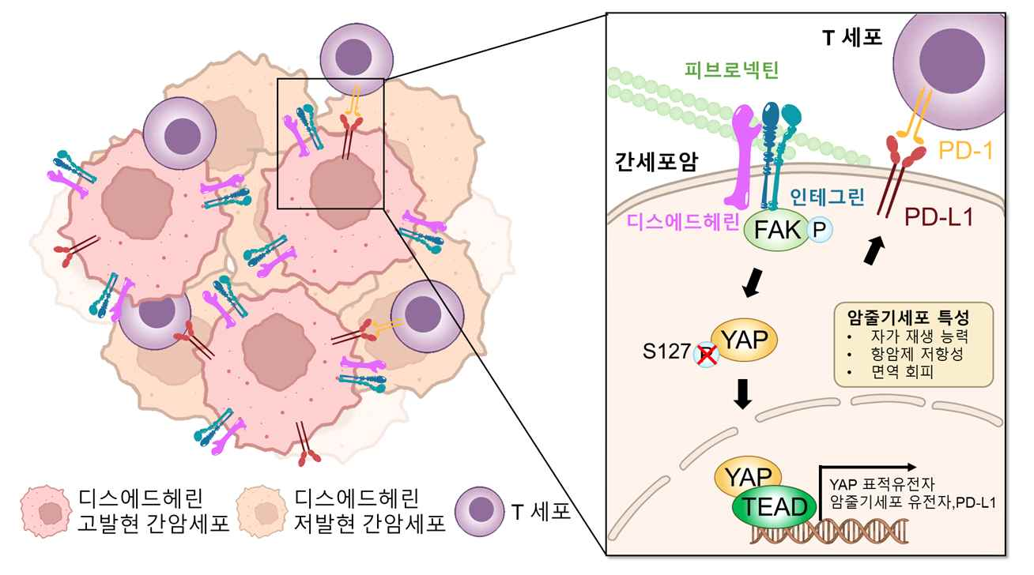

▲ 1 Schematic diagram of dysedherin-induced liver cancer malignancy and immune evasion. The study elucidated the mechanism by which dysedherin simultaneously increases cancer stem cell genes and the immune evasion protein (PD-L1) through signaling pathways (FAK/VAP/TEAD).

An analysis of genomic data from liver cancer patients revealed that patients with high dysedherin expression were at a higher risk of tumor progression and had a poorer prognosis.

Specifically, the higher the expression of dysedherin, the higher the amount of OCT4* protein, which is closely related to the aggressiveness of liver cancer cells, and the stronger the activation of YAP* signaling, which regulates cell growth and proliferation.

This suggests that dysedherin plays a critical role in transforming liver cancer cells into more aggressive and treatment-resistant states. This trend was also confirmed in analysis of actual patient data, showing that high dysedherin expression was associated with faster cancer progression and lower survival rates.

* OCT4 (octamer-binding transcription factor 4): A key transcription factor that maintains stem cell self-renewal and pluripotency. When its expression is increased in cancer, it is known to enhance cancer stem cell characteristics, promoting proliferation, recurrence, metastasis, and drug resistance.

* YAP (yes-associated protein): A key protein in the Hippo signaling pathway, which regulates cell proliferation and apoptosis. It plays a role in regulating various cellular functions, including the division, differentiation, and migration of stem cells and cancer cells.

The research team also suggested the possibility of a new therapeutic strategy targeting dysedherin. Transplanting liver cancer cells with dysedherin suppressed into a humanized mouse model, they observed a reduction in cancer stem cell characteristics and the reactivation of previously dysfunctional immune cells, significantly reducing tumor growth and spread to other organs (metastasis).

Furthermore, administering a dysedherin-inhibiting peptide to tumor model mice significantly reduced cancer stem cell characteristics, tumor growth, and metastasis, demonstrating the potential for therapeutic strategies targeting dysedherin to lead to real-world therapeutic effects.

This study identified dysedherin as a key regulator linking cancer stem cell characteristics, immune evasion, and chemotherapy resistance in liver cancer.

The research team discovered that dysedherin activates an intracellular signaling pathway called the FAK–YAP signaling axis*, increasing the production of genes associated with cancer stem cells (such as OCT4) and a molecule that evades immune cell attack (PD-L1).

Furthermore, preclinical models have shown that inhibiting dysedherin or the FAK–YAP signaling pathway not only reduces tumor growth and metastasis, but also restores the immune environment surrounding the tumor to a more normal state.

* FAK–YAP signaling axis: This signaling pathway involves the activation of FAK (focal adhesion kinase), which is activated during cell adhesion, inducing the activation of YAP (yes-associated protein), which translocates to the nucleus. This pathway, in turn, increases the expression of genes associated with cancer stemness, invasion/metastasis, and drug resistance. Overactivation of this signaling axis in tumors increases the malignancy of the cancer, making it a promising therapeutic target.

Professor Jeong-Seok Nam stated, "This study is significant in that it reveals that drug resistance and immune evasion, two of the greatest challenges in liver cancer treatment, are closely linked through the dysedherin-YAP signaling axis." He continued, "Since we have confirmed that inhibitory strategies targeting dysedherin alleviate tumor growth, metastasis, and the immunosuppressive microenvironment, we anticipate that future therapeutic development will offer new therapeutic possibilities for patients with advanced liver cancer who do not respond to existing treatments."

This study, led by Professor Jeong-Seok Nam of GIST and Professor Hyung-Sik Kim of Pusan ​​National University School of Dentistry as co-corresponding authors and co-first authors by GIST doctoral students Tae-Young Jang and So-El Jeon, was supported by the Ministry of Science and ICT and the National Research Foundation of Korea through the Mid-career Researcher Support Program, the Biomedical Technology Development Program, the Advanced Research Center Support Program (IRC), and the GIST-Chonnam National University Hospital Joint Research Program.

The research results — Dysadherin/YAP axis fuels stem plasticity and immune escape in liver cancer — were published online on December 29, 2025, in the international journal 《Signal Transduction and Targeted Therapy》, a Nature-affiliated journal specializing in biomedical science and molecular signaling.

Meanwhile, GIST stated that this research achievement considered both academic significance and potential industrial applications, and that technology transfer-related discussions can be conducted through the Technology Commercialization Center (hgmoon@gist.ac.kr).



