GIST has implemented weather forecasting with significantly improved accuracy using AI technology that reads the atmosphere in 3D: Temperature and precipitation forecast errors reduced by up to 31%, improving accuracy even for long-term forecasts one month out

- An international joint research team led by Professor Jin-Ho Yoon of the School of Environment and Energy Engineering has significantly improved the accuracy of regional weather changes by subdividing the existing numerical forecasting area (120 km) into 23 km zones

- AI learns temporal, spatial, and topographic information simultaneously to correct structural errors in existing models. This model operates with minimal computational resources, ensuring practicality and scalability... Published in the international journal 《Geoscientific Model Development》



▲ (From left) Professor Jin-Ho Yoon of GIST, postdoctoral researcher Jihun Ryu of Utah State University, and master's student Hisu Kim of GIST

The Gwangju Institute of Science and Technology (GIST, President Kichul Lim) announced that an international joint research team led by Professor Jin-Ho Yoon of the School of Environment and Energy Engineering has developed a new method that utilizes artificial intelligence (AI) technology to forecast weather conditions in the western United States up to a month in advance (32 days) with far greater detail and accuracy than existing methods.

The validation of this method in the western United States, where complex mountainous, coastal, and inland terrain complicates forecasting, is considered to open up new possibilities for high-resolution forecasting technology in the era of climate crisis.

The research team focused on addressing the issue of the existing numerical weather forecast (NWP) model*, used by the Korea Meteorological Administration and the European Centre for Medium-Range Weather Forecasts (ECMWF), which provides information in widely spaced forecast zones at intervals of approximately 120 km (1.5 degrees Celsius), failing to adequately reflect regional characteristics.

The western United States, in particular, is known for its significant elevation differences and the alternating influence of air masses flowing in from the ocean and descending from the inland (active air mass exchange between the ocean and the inland). This makes actual weather conditions significantly variable depending on the terrain, making it difficult to predict.

* numerical weather prediction (NWP) models: These models represent the physical and dynamic processes of the atmosphere in mathematical equations and calculate these equations using high-speed computers to predict future weather conditions. Using observed data such as temperature, pressure, wind, and humidity as initial values, these models simulate atmospheric changes over time and serve as a core foundation for modern weather forecasting.

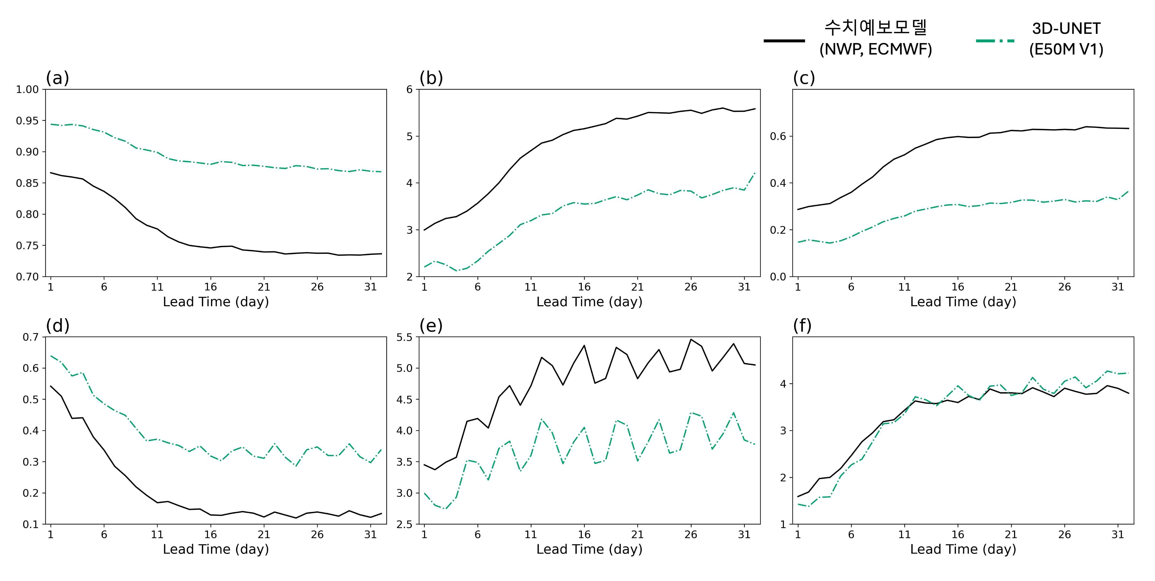

▲ Comparison of 32-day forecast performance for the Western United States. (a)–(c) represent temperature, (d)–(f) represent precipitation. (a) and (d) represent correlation coefficients, (b) and (e) represent root mean square error (RMSE), and (c) and (f) represent comprehensive indicators of variance and correlation coefficient. Compared to existing numerical weather forecasts (NWP, ECMWF), the 3D U-Net-based model (E50M V1) exhibited higher correlation coefficients and lower forecast errors (RMSE) for both temperature and precipitation, demonstrating significant improvements in mid-term forecast performance.

To address this issue, the research team developed a "3D U-Net*-based AI forecast postprocessing model" designed to learn how weather patterns persist and change over time.

This model analyzes the time interval from today to the target date (forecast lead time*) as a single continuous flow. Based on relatively accurate ultra-short-term and mid-term (1-10 days) forecasts*, it naturally extends the accuracy to extended mid-term* (10-32 days) forecasts.

In other words, it goes beyond simply correcting the information provided by existing numerical forecasts to simultaneously reflect temporal, spatial, and topographic characteristics, producing more realistic results.

* U-Net: A deep learning-based convolutional neural network (CNN) structure developed for medical image analysis. It features a U-shaped connection between the encoder (reduction path) and decoder (expansion path). It is highly effective in extracting features while preserving detailed spatial information from the image and performing precise pixel-level segmentation based on these features. It is currently widely used in various fields, including medical imaging, satellite imagery, life sciences, and autonomous driving.

* forecast lead time: This refers to the time interval between the time a forecast is issued and the actual forecasted time. For example, a "12-hour forecast" predicts weather conditions 12 hours ahead of the forecast's release time. This is a key concept in assessing the forecast's temporal scope and accuracy.

* ultra-short-term forecast: This refers to a forecast predicting weather conditions within the next 36 hours. It allows for rapid assessment of short-term weather changes, such as temperature, precipitation, and wind speed, and is therefore useful for disaster response, field operations, and real-time decision-making.

* medium-term forecast: This refers to a forecast predicting weather changes from 36 hours to a week in advance. It allows for a broader timeframe than short-term forecasts, allowing for the understanding of weather trends, making it useful for planning daily life and industrial activities.

* extended medium-range: This refers to the forecast scope covering weather forecasts from one week to one month. It is used to identify weather trends over a longer timeframe than short- and medium-range forecasts, assisting in mid- to long-term decision-making in areas such as agriculture, energy demand management, and scheduling.

The AI ​​model developed by the research team was trained to generate high-resolution information at a resolution of approximately 23 km (0.25 degrees Celsius) based on forecast data from the European Centre for Medium-Range Weather Forecasts (ECMWF). It also features the ability to correct for structural errors that recurring in numerical weather forecasts.

This technology subdivides the previously broad forecast area, typically spaced approximately 120 km apart, into much finer-grained areas, typically 23 km in size. This allows for forecasts down to smaller areas and allows for more precise reflection of weather variations across terrain, such as mountains, coasts, and inland areas. This advanced method goes beyond simply increasing resolution; it meticulously adjusts forecast errors to reduce discrepancies with actual weather patterns.

Performance evaluation results showed that the new model demonstrated a marked improvement in its consistency with actual weather changes.

For temperature, the correlation coefficient*, which indicates how well the model accurately matches weather patterns, increased by 0.12 compared to the previous model, and for precipitation, it also increased by 0.18. A correlation coefficient closer to 1 indicates a greater agreement with actual weather changes. Furthermore, the prediction error (RMSE*) decreased by approximately 31% for temperature and 22% for precipitation, demonstrating a significant improvement in overall accuracy compared to existing numerical weather forecasts.

In particular, the new model accurately reproduced patterns that were difficult to capture with existing forecast models, such as subtle temperature fluctuations in mountainous terrain, concentrated precipitation areas along the coast, and localized changes frequently occurring in inland agricultural areas. This demonstrates that AI-based correction technology can effectively complement the structural limitations of existing numerical weather forecasts in regions with significant topographical influence and complex interactions between the ocean and the atmosphere.

* pattern correlation: This indicator evaluates how accurately a model reproduces the spatial distribution of a variable. It expresses the spatial pattern similarity between observed and predicted values ​​in the form of a correlation coefficient. A value closer to 1 indicates a more accurate simulation of the spatial distribution.

* root mean square error (RMSE): This indicator is calculated by squaring the difference between the observed and predicted values, averaging the squares, and then taking the square root. It is a representative evaluation metric indicating the magnitude of the error in a prediction model. A lower value indicates higher model prediction accuracy.

The research team additionally analyzed the case of record-breaking rainfall in California, USA, in 2023. The results showed that while the new model more accurately captured the location and distribution of rain, it tended to slightly underpredict the actual amount of rain (absolute precipitation).

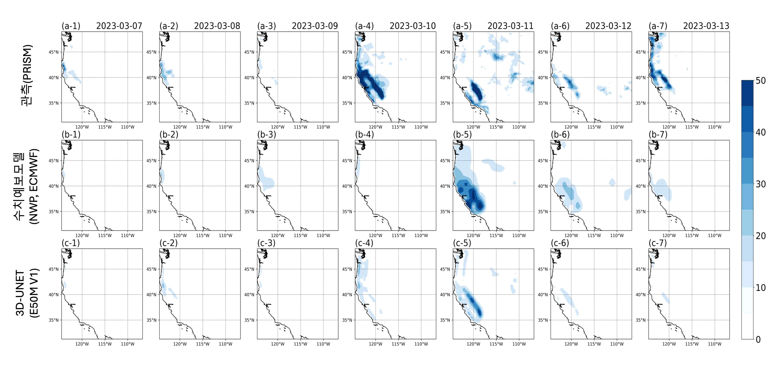

▲ Comparison of extreme precipitation events in the western United States from March 7 to 13, 2023, forecasted on March 6, 2023. Compared to observations (PRISM),

the 3D U-Net model (E50M V1) more accurately reproduces precipitation locations and paths than existing numerical forecasts (NWP, ECMWF) and better captures the spatial distribution of extreme precipitation.

This is a known limitation even in the latest AI-based weather forecast models developed overseas, suggesting that accurately predicting precipitation magnitude (amount) remains an unresolved challenge.

Notably, this study achieved high forecast performance by combining multiple forecast results (ensemble mean*) and using only a few key pieces of information, without adding dozens of complex inputs or utilizing the results of multiple models in detail.

This approach reduces the model's memory footprint and significantly shortens computation time, enabling stable operation even on standard GPU environments rather than expensive equipment. In other words, it is considered a realistic and efficient alternative for improving forecasting capabilities before building a large-scale AI weather forecasting system.

Furthermore, with additional training, it is highly scalable enough to be applied to any region worldwide, offering significant potential for industrial and academic applications.

* ensemble mean: This method averages multiple predictions (ensembles) generated by numerical weather forecasting models with different initial conditions, resulting in less variability, more stability, and higher reliability than a single forecast.

Professor Jin-Ho Yoon emphasized, "With the growing importance of forecasting due to climate change, 'postprocessing technology'—which uses AI to further refine the results generated by existing models to enhance accuracy—will be a powerful solution to address the limitations of numerical weather forecasting." He added, "As seen in the case of the western United States, where topography and regional characteristics are complex, AI can play a crucial role in implementing high-resolution regional forecasts."

He continued, "This technology will be of great help in responding to climate disasters such as wildfires, floods, and droughts, as it increases forecast accuracy, reduces computational burden, and enhances operational efficiency."

This research, led by Professor Jin-Ho Yoon of the School of Environment and Energy Engineering at GIST and postdoctoral researcher Jihun Ryu of Utah State University, involved GIST master's student Hisu Kim and Professor Shih-Yu (Simon) Wang of Kasetsart University in Thailand. The research was supported by the National Research Foundation of Korea's "AI-based Future Climate Technology Development Source Research Project" and the Korea Meteorological Administration's "Drought Specific Weather Center."

The results of the research — Increasing resolution and accuracy in sub-seasonal forecasting through 3D U-Net: the western US — were published online in the international journal 《Geoscientific Model Development》 on January 5, 2026.

Meanwhile, GIST stated that the results of this research were considered in consideration of both academic significance and industrial applicability, and that discussions regarding technology transfer can be conducted through the Technology Commercialization Center (hgmoon@gist.ac.kr).



