Beyond observing nanostructures, GIST research team presents an AI-based electron microscope analysis platform that predicts material performance

- Professor Eunji Lee's team from the Department of Materials Science and Engineering has overcome limitations in analyzing complex self-assembled structures of soft materials vulnerable to electron beams... Using AI technology, they have automated everything from structure recognition to analysis of changes over time

- This image-based integrated analysis strategy, which expands electron microscopes from simple observation devices to prediction and design platforms, is expected to accelerate the development of next-generation functional materials... Published in the international journal 《NPG Asia Materials》

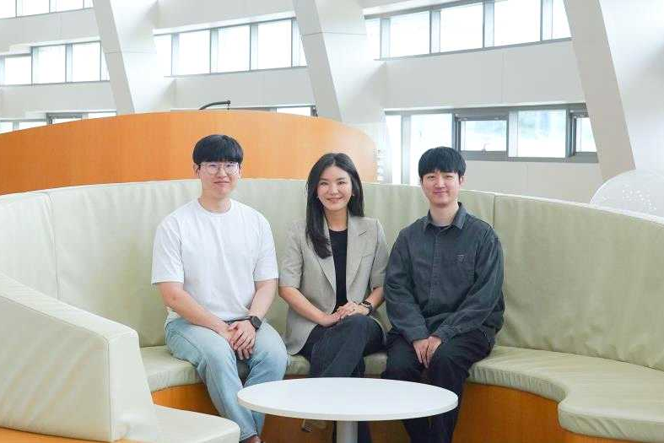

▲ (From left) GIST Department of Materials Science and Engineering Ph.D. candidate Junyeon Yoon (first author), Professor Eunji Lee, and Dr. Jun Ho Hwang

The Gwangju Institute of Science and Technology (GIST, President Kichul Lim) announced that a research team led by Professor Eunji Lee of the Department of Materials Science and Engineering has presented a new analytical paradigm that extends the ability to "observe" the complex self-assembled structures of "soft matter" such as organic polymers and biomaterials by incorporating artificial intelligence (AI) into transmission electron microscopy (TEM) analysis. This approach expands the analysis paradigm from "observation" to "automatic analysis and prediction."

This study is noteworthy for its approach to the complex self-assembled structures of soft matter, previously difficult to analyze due to their sensitivity to electron beams. By integrating multiple electron microscopy techniques with AI, the system automates structure recognition, 3D reconstruction, and temporal analysis, and even enables property prediction.

* transmission electron microscope (TEM): This device uses an electron beam to pass through a sample, converting the generated signal into an image to observe nano- and atomic-level microstructures. By utilizing the differences in electrons passing through extremely thin samples, it can analyze internal structures, crystallinity, and defects. It also allows for the simultaneous identification of structure and composition, making it a key tool in materials science and nanotechnology.

* self-assembled structures: This refers to the phenomenon or result of molecules, ions, nanoparticles, etc. spontaneously assembling themselves to form regular arrangements or structures without complex external processing or manipulation. It determines the properties and functions of probabilistic materials and is a key concept in the design of nanomaterials, biomedicine, energy, and electronic materials.

Soft materials encompass a wide range of materials, from biomaterials like proteins and cell membranes to synthetic materials like polymers and liquid crystals. Their self-assembly, where molecules assemble to form fine nanostructures, has made them a key component of diverse advanced industries.

These self-assembled structures are a key factor in determining the performance of materials used in next-generation vaccines (mRNA vaccine carriers), drug delivery systems, and next-generation energy storage materials. However, their extremely small and complex structures have hindered accurate observation and understanding.

In particular, soft materials are primarily composed of light elements like carbon, hydrogen, and oxygen, making their structural outlines unclear in electron microscope images and prone to deformation or damage by electron beams. Consequently, conventional electron microscope analysis alone has made it difficult to precisely understand the unique nanostructures and self-assembly processes of soft materials.

To overcome these limitations, the research team combined deep learning-based AI technology with different electron microscopy techniques, including cryo-TEM, electron tomography (ET), and real-time liquid phase electron microscopy (LP-TEM).

This integrated analysis strategy enabled ▲ the automated recognition of complex nanostructures; ▲ 3D reconstruction of nanostructures based on multiple 2D electron microscopy images; and ▲ dynamic analysis of self-assembly processes over time. Furthermore, it enabled the prediction of material properties based on structural information, enabling the prediction of material performance.

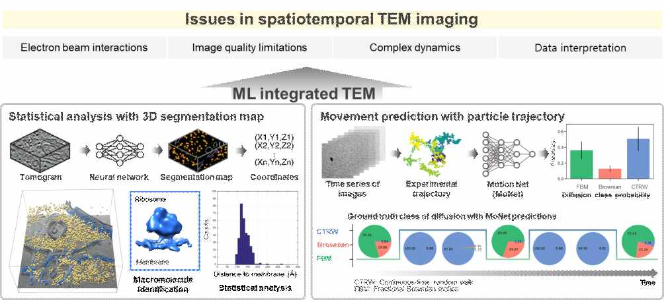

▲ Overcoming spatiotemporal limitations and precise analysis of soft matter analysis using AI-integrated electron microscopy technology: (Top) Key challenges encountered when spatiotemporally imaging electron beam-sensitive soft matter. (Bottom left) Schematic diagram demonstrating the automatic identification and statistical analysis of macromolecules, such as ribosomes, within complex structures using deep learning-based 3D recognition technology. (Bottom right) Schematic diagram showing a technique for tracking and predicting the movement trajectories of nanoparticles in liquid-phase transmission electron microscope images using a deep learning model.

In this process, cryogenic electron microscopy played a role in capturing the original nanostructure of the soft material with minimal damage, and electron tomography was used to reconstruct this structure in three dimensions. Real-time liquid electron microscopy observed self-assembly in solution in real time, enabling analysis of the structure formation and evolution over time.

The research team applied AI to this process to automatically process and interpret vast amounts of high-dimensional electron microscopy data. This analysis system goes beyond simple image observation to identify correlations between structure and properties and predict future structural changes.

This achievement expands the use of electron microscopy from a "viewing tool" to an "understanding and prediction tool," suggesting a new direction for soft matter research overall.

This study holds significant academic significance in that it combines AI with electron microscopy analysis to more systematically understand the self-assembly mechanisms of soft materials and suggests the possibility of advancing to "image-based material design," which predicts material properties based on image data.

The research team plans to further develop the AI-based automated analysis system and apply it to research on functional soft materials that operate reliably even in extreme environments, thereby expanding into the biomedical and energy fields.

Professor Eunji Lee stated, "This study is significant in that it establishes an analysis system that can observe the self-assembly process of soft materials sensitive to electron beams in real time, precisely analyze this process using AI, and predict material properties." She added, "It suggests a new research direction that can expand beyond conventional image observation to data-driven material design."

PhD candidate Junyeon Yoon (first author) explained, "We focused on analyzing vast amounts of high-dimensional transmission electron microscopy (TEM) data with AI to identify correlations between nanostructures and material properties. This study demonstrates that AI can be a key tool in 'material informatics,' predicting material properties from electron microscopy images and suggesting optimal material designs."

This research, conducted by Ph.D. candidate Junyeon Yoon (first author) under the supervision of Professor Eunji Lee (corresponding author) of the Department of Materials Science and Engineering at GIST, with Dr. Jun Ho Hwang of the GIST-InnoCORE Research Group participating as a co-author, was supported by the Ministry of Science and ICT and the National Research Foundation of Korea through the Mid-Career Researcher Support Program, the Nano and Materials Technology Development Program, and the GIST-InnoCORE Project. The results of the research — Dive into soft matter imaging: artificial intelligence-integrated electron microscopy — were published online in the international academic journal 《NPG Asia Materials》 on December 23, 2025.

Meanwhile, GIST stated that the results of this research were considered in consideration of both academic significance and industrial applicability, and that discussions regarding technology transfer can be conducted through the Technology Commercialization Center (hgmoon@gist.ac.kr).



