GIST & Kyung Hee University has demonstrated the world's first experimental demonstration of the Liefschitz phase transition in a topological semimetal: Laying the foundation for next-generation quantum material design by directly capturing changes in electronic structure

- A joint research team from GIST and Kyung Hee University directly observed phase changes in electronic structure by controlling the thickness of a topological semimetal film... The Lifshitz phase transition was experimentally demonstrated through a change in plasma frequency that decreased to a minimum and then increased again

- A new experimental paradigm for measuring and diagnosing the electronic structure of quantum materials was presented... The study was published in the international journal 《Materials Today Physics》



▲ (From left) Professor Jong Seok Lee and Dr. Min Seop Kim of the Department of Physics and Photon Science at GIST

The Gwangju Institute of Science and Technology (GIST, President Kichul Lim) announced that a research team led by Professor Jong Seok Lee of the Department of Physics and Photon Science, in collaboration with Professor Emeritus Suk-Ho Choi of Kyung Hee University, has experimentally elucidated the physical principles of the Lifshitz phase transition, a phenomenon that occurs in a topological semimetal, a material with a unique electronic structure in which electrons move very rapidly like massless particles.

The Lifshitz phase transition is a quantum phase transition phenomenon in which the phase of the Fermi surface changes due to changes in the electronic band structure. While previously predicted theoretically, direct observation in real materials has been extremely difficult.

This research experimentally demonstrated this phenomenon using the plasma frequency, a key indicator of the collective behavior of electrons, as a key indicator. It is significant in that it presents a new measurement paradigm for quantum materials research.

The research team precisely controlled the thickness of a bismuth-antimony alloy thin film (Bi₀.₉₆Sb₀.₀₄ thin film)* with topological semimetal properties in nanometer (nm) units, and analyzed the plasma frequency change reflecting the collective behavior of electrons through terahertz (THz) band optical measurements.

As a result, they successfully directly observed a critical phenomenon where the plasma frequency changes abruptly and the electronic phase transitions abruptly at a film thickness of approximately 10 nanometers (nm; 1 nm is one billionth of a meter).

This is interpreted as an experimental capture of the moment when topological properties fundamentally change amidst continuous changes in the electronic structure.

* Bismuth-antimony alloy thin film (Bi₀.₉₆Sb₀.₀₄ thin film): This thin film, a nanometer-thick sample of an alloy containing approximately 4% antimony (Sb) mixed with bismuth (Bi), is known as a representative topological semimetal material. This composition forms a Dirac semimetal electronic structure where the conduction and valence bands intersect, and the electronic behavior and topological properties change sensitively depending on the film thickness and strain conditions. Thanks to these characteristics, Bi₀.₉₆Sb₀.₀₄ thin films serve as a key experimental platform for studying quantum phenomena such as topological transitions, Lifschitz phase transitions, and dimensional effects.

A "topological semimetal" is a quantum material with a unique electronic structure where the conduction band and valence band* intersect at a specific point or line, and this intersection is stably protected by the material's symmetry. This allows electrons to behave like massless Dirac or Weyl fermions, exhibiting unique physical properties distinct from those of conventional metals or semiconductors.

Dirac or Weyl fermions are states in topological semimetals that behave like new particles, characterized by following the physical laws of high-speed particles like light. Dirac fermions are electronic states that exist when the electron structure remains unified, while Weyl fermions are states where this structure is disrupted, causing electrons to split into two states with different properties, like "left-handed" and "right-handed" states (chirality).

These properties have led to the emergence of topological semimetals as key materials for next-generation technologies, including ultra-fast, low-power electronic devices, spintronics, and quantum computing.

* conduction band and valence band: The conduction band is the energy band responsible for electrical conduction, where electrons can move freely. The valence band is the energy band where electrons are bound to atoms and remain relatively stable. Depending on the relationship between these two bands, a material is classified as a metal, semiconductor, insulator, or topological material. In topological semimetals, the conduction and valence bands intersect at specific points or lines, exhibiting unique electronic properties.

The Liefschitz phase transition is a quantum phase transition phenomenon in which the Fermi surface's "topology" changes due to changes in electronic band structure, without any change in the material's crystal structure or symmetry. This phenomenon is a core concept with broad implications, extending from topological materials to superconductors, magnetism, and even high-energy physics and astrophysics.

Although it has been theoretically predicted that the plasma frequency will have a minimum value at a critical point with a rapid change in electron concentration, there have been limitations in directly confirming this in actual materials.

* topology: A concept referring to the intrinsic structural properties of an object that remain unchanged even with slight changes in size or shape. In physics, it refers to the characteristics of an electronic structure that persist despite external stimuli or continuous deformation, such as the connection or cross-linking structure of electronic energy bands. These topological properties, combined with the symmetry of a material, create unique electronic states and serve as the fundamental principles for the unique physical phenomena observed in topological materials, such as topological semimetals and topological insulators.

The research team used molecular beam epitaxy (MBE) technology* to grow bismuth-antimony alloy thin films ranging from 3 to 300 nm in thickness on a gallium arsenide (GaAs) substrate, at the atomic level.

The team then precisely measured the dynamics and optical conductivity of free electrons using terahertz (THz)-band optical measurement techniques, such as helical-dependent terahertz emission spectroscopy and transmission terahertz time-resolved spectroscopy.

* molecular beam epitaxy (MBE): This is a thin film growth technique that precisely grows materials, one atomic layer at a time, by supplying elements to a substrate in the form of molecular or atomic beams in an ultra-high vacuum environment. The precise control of the supply amount and growth rate of each element allows for atomic-level control of composition, thickness, and crystal structure. It also allows for the production of high-quality single-crystal thin films with virtually no impurities. Therefore, it is widely used in fundamental research on the properties of semiconductors, topological materials, and quantum materials, as well as in the development of next-generation electronic and optical devices.

As a result, when the film thickness is reduced to approximately 10 nm or less, the "circular photoelectric effect*" is observed, in which the intensity of emitted terahertz waves varies depending on the direction of circular polarization (left or right).

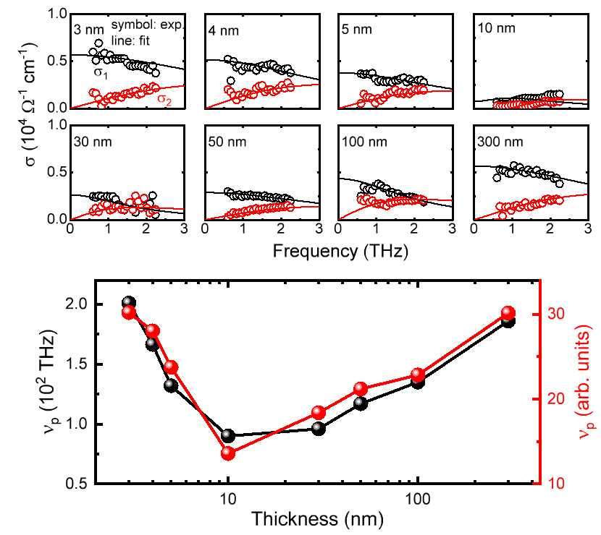

▲ Experimental elucidation of the principle of the Lifschitz phase transition by measuring the terahertz band photoconductivity spectrum (top) and plasma frequency changes (bottom) depending on the film thickness. At the critical thickness of 10 nm, the plasma frequency reaches its minimum.

This is interpreted as a clear topological signal indicating the transition from a Dirac semimetal state to a Weyl semimetal state*.

* circular photogalvanic effect (CPGE): This refers to the phenomenon in which the magnitude and direction of current change depending on the direction of rotation (left or right) of the light when irradiating a material with circularly polarized light. This effect occurs in an asymmetric electronic structure where electron spin and motion are strongly coupled, and is known as a representative characteristic signal in Weyl semimetals with broken inversion symmetry.

* Dirac semimetal state and Weyl semimetal state: These refer to the electronic structures of topological semimetals, distinguished by the way the conduction and valence bands intersect. In the Dirac semimetal state, the two bands intersect at a single point, and electrons behave like massless Dirac fermions, maintaining both time-reversal and inversion symmetry. In contrast, the Weyl semimetal state occurs when one of these symmetries is broken, causing a single Dirac point to split into two Weyl points with different properties. The electrons behave like Weyl fermions with handedness (chirality), exhibiting unique topological phenomena such as the circular photoelectric effect.

Of particular note is the change in plasma frequency. Experimental results showed a distinct change: the plasma frequency gradually decreased with decreasing film thickness, reaching a minimum at 10 nm, and then increasing again.

This is consistent with the fact that the charge density, Fermi level, and optical and electrical conductivities all exhibit minimum values ​​at the same critical thickness, providing decisive evidence for the actual occurrence of the Lifshitz phase transition, which alters the electronic structure.

These results demonstrate the world's first optical experiment to demonstrate the direct connection between the Lifshitz phase transition and plasma oscillations in topological semimetals, previously predicted only in theoretical studies.

Professor Jong Seok Lee stated, "This study is the first to experimentally confirm the Lifschitz phase transition in topological metals, which are attracting attention as next-generation quantum materials following graphene, without external stimulation." He added, "By demonstrating that the physical quantity of plasma vibration is directly linked to changes in the topological electronic structure, it presents a new approach for measuring, diagnosing, and controlling quantum materials."

He emphasized, "This will serve as a new standard for non-destructive diagnosis of the state of quantum materials, precise control of electronic structure through thickness, strain, and external stimulation, and potentially lead to practical device design."

This research, led by Professor Jong Seok Lee of the Department of Physics and Photon Science at GIST and conducted by Dr. Min Seop Kim, was supported by the research team of Professor Emeritus Suk-Ho Choi of the Department of Applied Physics at Kyung Hee University, along with researchers from the Australian National University and Sungkyunkwan University. The research was supported by the Ministry of Science and ICT and the National Research Foundation of Korea's Mid-Career Researcher Support Program.

The research results — Experimental manifestation of topological lifshitz transition by observing thickness-dependent shift of plasma frequency in topological semimetals — were published online on December 9, 2025, in the international academic journal Mat 《Materials Today Physics》.

Meanwhile, GIST stated that the results of this research were considered in consideration of both academic significance and industrial applicability, and that discussions regarding technology transfer can be conducted through the Technology Commercialization Center (hgmoon@gist.ac.kr).



