GIST develops a low-cost, high-performance air pollution detection sensor, improving detection performance 100-fold without the need for precious metal catalysts

- Professor Sanghan Lee's team in the Department of Materials Science and Engineering improved nitrogen dioxide (NO₂) sensitivity by 100-fold by controlling oxygen pores on the sensor surface using only sulfur (S), without precious metals, enabling precise detection of even ultra-trace pollutants

- High selectivity with little reaction to other gases... Low-cost, mass-producible, it can be used in a variety of fields, including urban air quality monitoring, hazardous gas detection at industrial sites, and air purifiers

- Published in 《Sensors and Actuators B: Chemical》, a top 1.9% international academic journal in the field of "Instrumentation and Measurement"



▲ (From left) Professor Sanghan Lee and Dr. Jun-Cheol Park of the Department of Materials Science and Engineering at GIST, Professor Myoung Hwan Oh of the Department of Energy Engineering at KENTECH, and Dr. Seungkyu Kim of the Korea Institute of Energy Technology

There is a growing need for more accurate monitoring of nitrogen dioxide (NO₂), a major cause of air pollution. Nitrogen dioxide, generated from vehicle exhaust and industrial activities, impacts health and the environment, and technologies capable of precisely detecting it are considered a key element in urban air quality management.

The Gwangju Institute of Science and Technology (GIST, President Kichul Lim) announced that a research team led by Professor Sanghan Lee of the Department of Materials Science and Engineering has successfully developed a new gas sensor technology capable of highly sensitively detecting nitrogen dioxide without the use of expensive precious metals such as platinum or gold.

This research overcomes the limitations of existing methods for improving sensor performance, proposing a new solution that can improve performance while reducing costs.

Typically, metal oxide gas sensors measure the concentration of harmful gases by detecting the electrical changes that occur when specific gases in the air react with the sensor surface. The widely used tungsten oxide (WO₃) sensor, while structurally stable, suffers from slow response and low sensitivity.

To compensate for this, a method of adding a substance that facilitates the reaction, i.e. a “catalyst,” to the sensor surface has been utilized, and precious metals such as gold (Au), platinum (Pt), and palladium (Pd) have been mainly used. However, the high price and unstable supply of these precious metal catalysts have acted as obstacles to commercialization.

To address these issues, the research team utilized sulfur (S), an inexpensive and naturally abundant element, to develop a novel catalyst structure that enhances the sensor surface's gas-responsiveness.

Introducing sulfur (S) to tungsten oxide (WO₃) maintains the basic crystal structure while increasing the number of microscopic voids on the sensor surface, allowing nitrogen dioxide (NO₂) to more readily attach and then release more quickly after the reaction. This allows the sensor to rapidly detect even very small amounts of NO₂ and resume measurements within a short time. This characteristic not only reduces manufacturing costs but also facilitates mass production and sensor miniaturization.

By introducing sulfur (S) to the tungsten oxide (WO₃) surface, the research team successfully significantly increased the number of "oxygen vacancies*," which play a crucial role in gas reactions. As oxygen vacancies increase, the sensor surface becomes more sensitive to gases, enabling rapid detection of even very small amounts of nitrogen dioxide. Furthermore, the sensor surface returns to its original state much more quickly after the reaction.

* oxygen vacancies: These are empty spaces created by the removal of oxygen atoms from the metal oxide crystal structure. They enhance electron mobility and surface reactivity, allowing gas molecules to more readily adsorb and react with the surface. This enhances sensor sensitivity and is a key factor in determining the performance of metal oxide-based gas sensors.

Using various analytical techniques, including electron energy loss spectroscopy (EELS), X-ray photoelectron spectroscopy (XPS), and infrared spectroscopy (IR), the research team precisely determined how the sulfur (S)-based catalyst design actually changes the sensor surface properties.

As a result, the application of sulfur (S) to tungsten oxide (WO₃) significantly increased the number of oxygen vacancies, demonstrating experimentally that this structural change leads to improved sensor performance.

In actual sensor testing, this sensor was able to measure nitrogen dioxide (NO₂) at a concentration of 5 ppm, equivalent to approximately 5 per million air molecules, at 150°C. It demonstrated approximately 100 times improved response performance (response value 5.6 → 578) compared to previous models. Furthermore, the lowest concentration the sensor can distinguish (limit of detection (LOD)*) was 50 ppb, equivalent to approximately 50 per billion air molecules, enabling the detection of even very small amounts of pollutants.

This performance is comparable to, or even superior to, tungsten oxide (WO₃) sensors using precious metal catalysts such as gold (Au), platinum (Pt), and palladium (Pd).

* limit of detection (LOD): This refers to the lowest concentration that a sensor or analytical device can reliably distinguish. That is, the measurement signal is the minimum concentration at which the presence of an actual substance can be confirmed beyond background noise, and the lower the value, the higher the sensitivity performance that can detect even very small amounts.

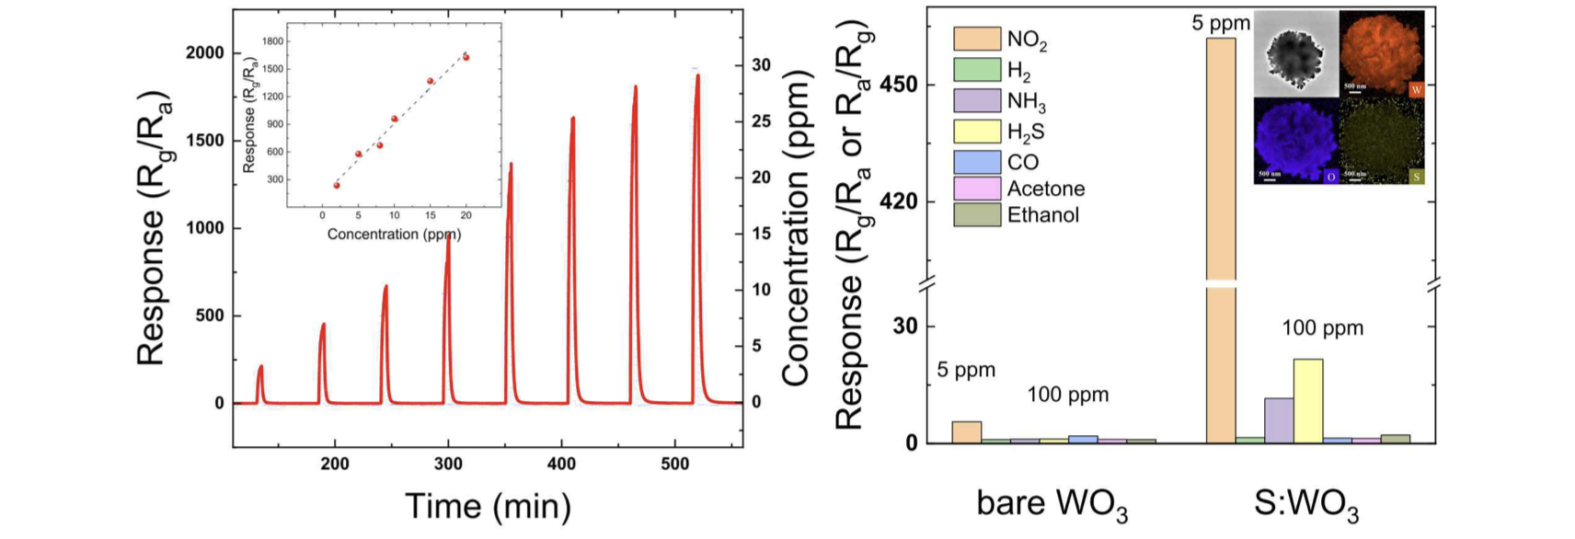

▲ Gas detection characteristics evaluation. Sulfur-doped tungsten oxide sensors theoretically exhibit an extremely low nitrogen dioxide detection limit of approximately 50 ppb, demonstrating exceptional sensitivity to nitrogen dioxide compared to other toxic gases present in the atmosphere.

Furthermore, sulfur (S)-based tungsten oxide (WO₃) sensors demonstrate rapid recovery after reaction and a clear target detection.

Recovery is rapid, returning to the initial state in approximately two minutes after exposure to nitrogen dioxide (NO₂), making them suitable for continuous measurement. Furthermore, they exhibit minimal response to other gases that can coexist in real-world environments, such as acetone, ethanol, carbon monoxide (CO), hydrogen sulfide (H₂S), and ammonia (NH₃), while being sensitive only to nitrogen dioxide, significantly enhancing measurement reliability.

Furthermore, they are less affected by humidity changes and operate reliably in a variety of environments, even at high temperatures.

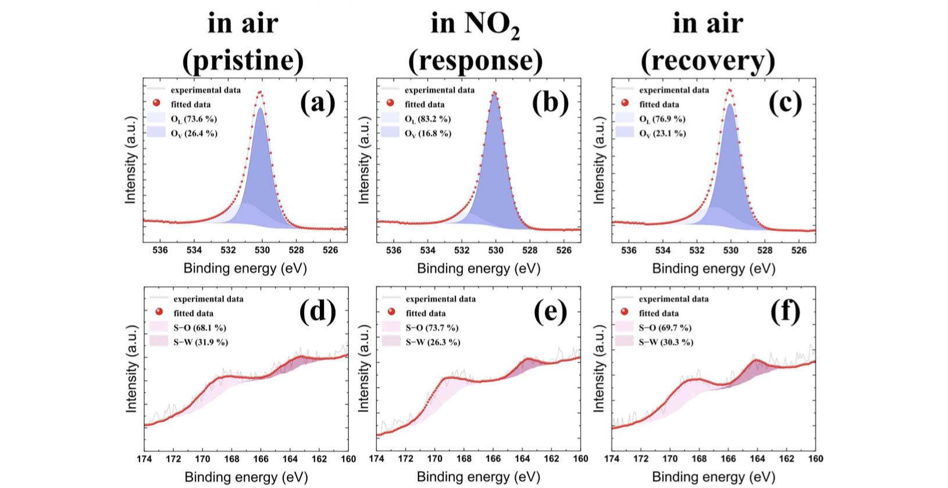

▲ Improved nitrogen dioxide detection performance. The tungsten oxide-based nitrogen dioxide sensor developed by the research team added sulfur to its surface, creating more oxygen pores. This significantly increases the active area where reactions can occur when nitrogen dioxide is adsorbed on the sensor. This resulted in significantly higher detection reactivity compared to previous models.

The research team anticipates that this technology will find wide-ranging applications, ranging from equipment for continuous urban air quality monitoring, to hazardous gas detection systems in industrial settings, sensors for air purifiers and ventilators, and wearable environmental monitoring devices.

Professor Sanghan Lee stated, "The proposed sulfur (S)-based sensor surface modification method is not limited to tungsten oxide (WO₃), but is a universal technology applicable to various metal oxide gas sensors." He added, "It can maintain performance while reducing costs, which will accelerate the practical commercialization of air pollution monitoring devices."

This research, led by Professor Sanghan Lee of GIST and co-authored by Professor Myoung Hwan Oh of the Department of Energy Engineering at the Korea Institute of Energy Technology (KENTECH), was conducted in collaboration with Dr. Jun-Cheol Park of the Department of Materials Science and Engineering at GIST and Dr. Seungkyu Kim of the Korea Institute of Energy Technology. The research was supported by the GIST-MIT Joint Research Project and the GIST Future-Leading Specialized Research Project.

The research results — Non−noble metal catalyst embedded WO₃ microspheres for enhancement of NO2 gas sensing — were published online in the international journal 《Sensors and Actuators B: Chemical》, which ranks in the top 1.9% of the "Instrument & Instrumentation" category according to the Journal Citation Reports (JCR), a global academic journal evaluation index. The paper is scheduled to appear in the print edition (Volume 447) to be published on January 15, 2026.

Meanwhile, GIST stated that this research achievement considered both academic significance and industrial applicability, and that technology transfer inquiries can be made through the Technology Commercialization Center (hgmoon@gist.ac.kr).



