“Self-driving cars now indicate who, when, and where they will yield” GIST develops communication technology enabling autonomous vehicles to inform road users about 'who, when, and where they will stop'

- Professor SeungJun Kim's team from the Department of AI Convergence conducted a multi-user VR traffic experiment involving pedestrians, cyclists, and drivers, overcoming the limitations of existing studies focusing solely on pedestrians... This study suggests interface design directions that reflect real-world road conditions

- Signals indicating ‘whom’ to yield to show the highest performance, and safety and trust significantly improve as more contextual information (Whom / When / Where) is provided... Presented at the international academic conference "UbiComp 2025"



▲ (From left) GIST Professor SeungJun Kim, Ph.D. student Yumin Kang, master's student Jeongju Park, University of Washington Ph.D. student Seokhyun Hwang, GIST Ph.D. students Minwoo Seong and Gwangbin Kim

The Gwangju Institute of Science and Technology (GIST, President Kichul Lim) announced that a research team led by Professor SeungJun Kim of the Department of AI Convergence has developed a new "external human-machine interface (eHMI) technology" to help autonomous vehicles communicate more safely and clearly with road users.

This research is significant in that it overcomes the limitations of most previous studies that assumed "pedestrians alone" situations and verifies the effectiveness of eHMI by recreating a real-world road environment where pedestrians, cyclists, and drivers coexist in virtual reality (VR).

The full-scale introduction of autonomous vehicles will bring about significant changes for all road users, including pedestrians, cyclists, and drivers.

Previously, drivers could communicate with pedestrians through nonverbal cues like eye contact and hand gestures, but in the era of fully autonomous driving, these cues will no longer be effective. Therefore, technology that enables autonomous vehicles to clearly communicate their intentions and actions to those around them (eHMI) is essential.

However, most research to date has focused on one-on-one situations between autonomous vehicles and pedestrians. In environments where multiple users move simultaneously, as on actual roads, it has been consistently pointed out that it remains unclear to whom (the target), when (the timing), and where (the location) the autonomous vehicle should deliver its message. This ambiguity can lead to misunderstandings and risks.

To address these practical challenges, the research team proposed a "context-based eHMI" design direction to enable clear and safe communication even in complex road conditions.

The research team conducted an experiment to compare the effectiveness of five types of external signals (eHMI) for autonomous vehicles: ▴ "No signal (No eHMI)"; ▴ "Basic signal (No Context)" that simply indicates a yielding intent with a mouth symbol; ▴ "Target information (Whom)" that indicates who is yielding; ▴ "Time information (When)" that indicates when to stop; and ▴ "Location information (Where)" that indicates where to stop.

All signals adopted a unique color and symbol system to avoid confusion with international standard traffic signals, and were designed to be displayed identically on the front, sides, and rear of the vehicle.

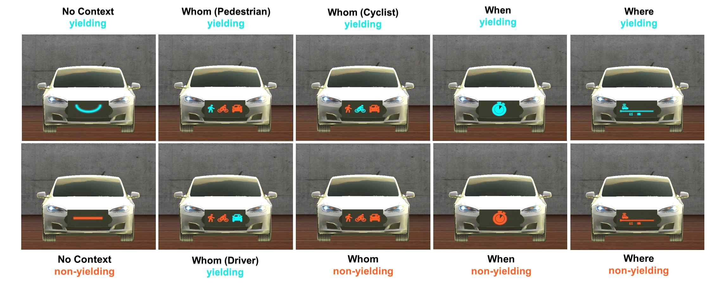

▲ Visual representation of each type of autonomous vehicle external interface (eHMI). The "No eHMI" condition represents the complete absence of any signal, while the "No Context" eHMI simply indicates the intent to yield with a symbol (a mouth shape). The "Who" eHMI provides messages by targeting specific targets, such as pedestrians, cyclists, and drivers, while the "When" and "Where" eHMIs convey temporal and spatial information, respectively. All visualizations depict the vehicle front-end interface from the perspective of road users.

A total of 42 participants, including pedestrians, cyclists, and drivers, participated in the experiment.

The research team ▴ applied head-mounted VR headsets (HMDs) to pedestrians, ▴ stationary indoor bicycle trainers (bicycle trainers) that replicate actual pedaling and speed changes to cyclists, and ▴ vehicle simulators that simulate real-world driving conditions to drivers. This ensured that all participants simultaneously interacted with the autonomous vehicle in the same virtual road environment.

The results showed that the "Target Information (Whom)" signal led to the fastest and most stable decision-making, demonstrating the best performance across all indicators. When it was clearly indicated to whom to yield, pedestrians, cyclists, and drivers were all able to make decisions and act in a shorter time, and subjective evaluations of safety, reliability, and clarity were also the highest.

Conversely, the absence of any signal ('No eHMI') showed the lowest performance across all metrics, and the 'basic signal' ('No Context'), which simply indicated a willingness to yield, was limited in reducing confusion.

The 'When' and 'Where' signals also demonstrated higher reliability and stability than the context-free signal ('No eHMI').

Notably, neither signal resulted in a single behavioral error due to misinterpretation, clearly demonstrating that contextual information directly impacts decision-making stability. Furthermore, an analysis of biosignals (EDA), which uses electrodermal response to assess tension and anxiety levels, revealed a tendency for participants' psychological tension to decrease when the 'Whom' signal was provided.

Participant interviews also revealed a clear preference for the 'Whom' signal.

Many participants commented that the signals were "the easiest to understand and most reliable because they clearly indicate the intended purpose." Others felt the simple symbol-based signals ("No Context") were "confusing" because they differed from existing traffic signal systems.

Some participants suggested the need for methods to enhance the intuitiveness of visual information, such as "color coding," which conveys meaning through color alone. For example, some suggested that clearly distinguishing situations such as "safe," "caution," and "stop" with color, or providing flashing signals or simple audio notifications, could further enhance the comprehension of eHMIs.

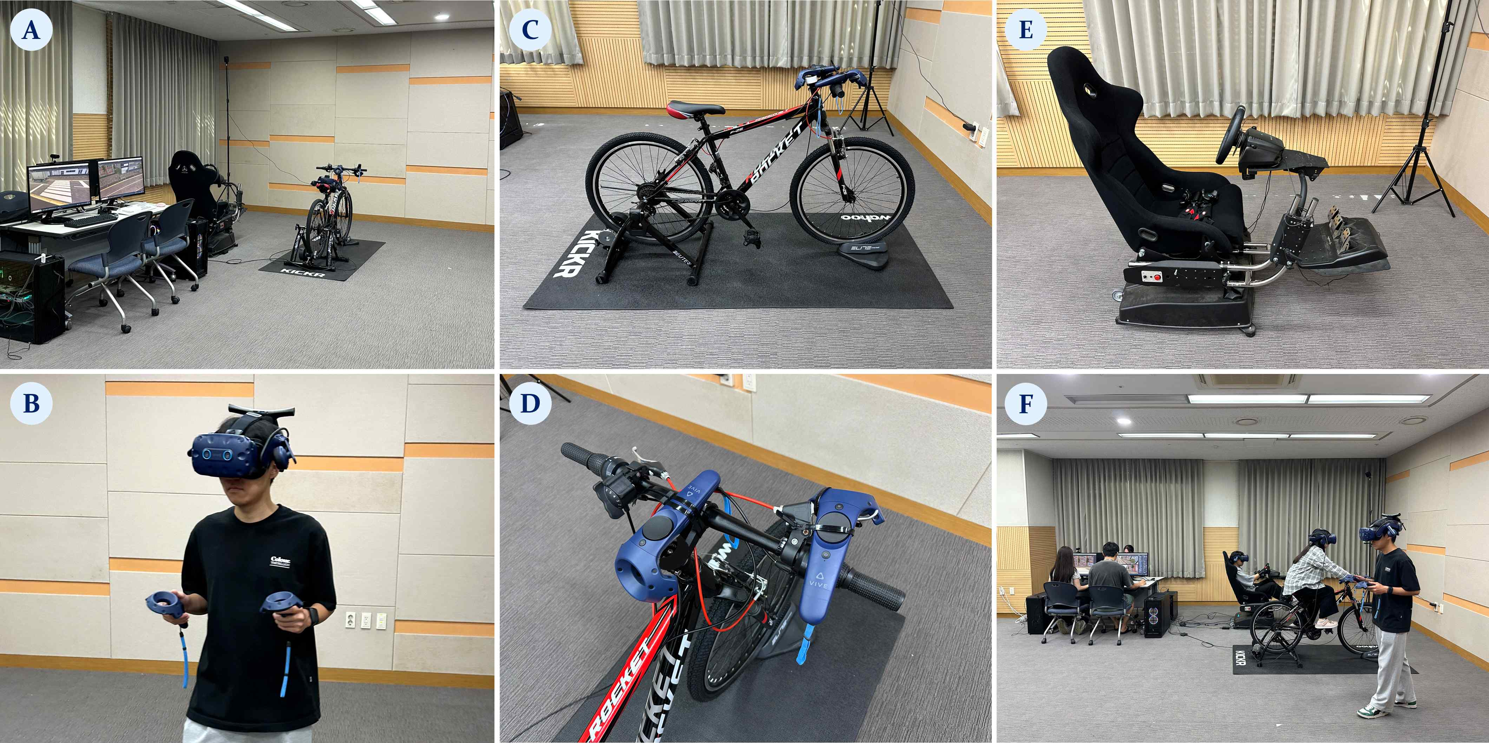

[Figure 2] Experimental environment configuration of the VR-based multi-user evaluation platform. (A) Overview of the entire experimental platform. (B) Pedestrians wore wireless HMDs to secure a large interaction space. (C) Cyclists recreated their driving positions in the VR environment and (D) controlled direction and speed using a VR controller. (E) Drivers participated in the experiment in a realistic driving environment using a driving simulator. (F) A photo taken during the experiment, showing the real-time interaction of the participants.

First author Yumin Kang, a doctoral student, stated, "Real roads are populated not only by pedestrians but also by cyclists and drivers." She added, "This study is significant in that it suggests a new direction for interface design that can reduce misunderstandings and risks between autonomous vehicles and road users in such realistic environments."

Professor SeungJun Kim, who led the research, stated, "This is a rare worldwide case where a real-world road environment with multiple traffic entities simultaneously was implemented in VR and the effectiveness of eHMI was verified." He emphasized, "Clearly communicating not only that autonomous vehicles are yielding, but also to whom, when, and where they are yielding will be key to future traffic safety."

Based on the newly developed multi-user VR traffic simulation platform, the research team plans to expand its research scope to include the advancement of AI-based autonomous driving technology, the design of smart intersections, and the development of safety systems to protect vulnerable road users.

This research was supported by the National Research Foundation of Korea (NRF) grants "Development of an Actuated XR System Based on Soft Robotics and Sensory Intelligence for Embodiment of Reality and Virtuality" and the "GIST-MIT Physical AI Research Center: Research on Core HCI Technologies and XR Utilization Technologies for Physical AI." It was conducted as part of the GIST-MIT joint research project, "HCI+AI Convergence Research for Human-Centered Physical Systems Design."

The results of this research — You're the One Whom I'm Talking To: The Role of Contextual External Human-Machine Interfaces in Multi-Road User Conflict Scenarios — were published in September in the ACM Journal of Interactive, Mobile, Wearable and Ubiquitous Technologies (IMWUT), a journal covering cutting-edge research in ubiquitous and wearable computing. The findings were also presented on October 15th at the ACM International Joint Conference on Pervasive and Ubiquitous Computing (UbiComp) 2025, a leading international conference in the field of ubiquitous computing.

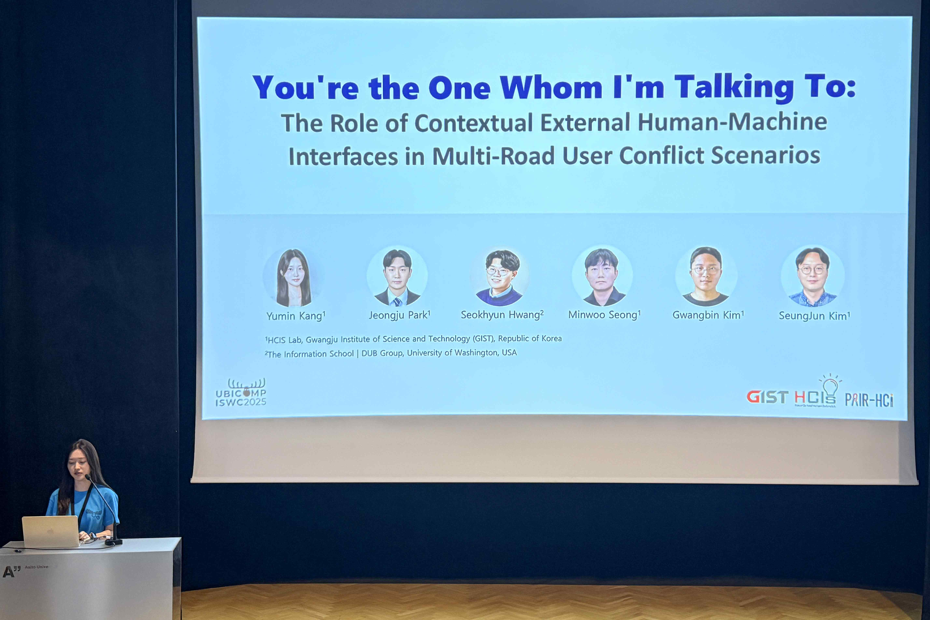

▲ The research team is presenting the results of their research on a multi-user autonomous vehicle interface at the UbiComp 2025 conference.

Meanwhile, GIST stated that this research achievement considered both academic significance and industrial applicability, and that technology transfer-related discussions can be conducted through the Technology Commercialization Center (hgmoon@gist.ac.kr).



