"We captured particle signals that were too numerous to read" GIST research team has become the first in the world to identify deuterium sensitivity, a key element in nuclear fusion (artificial sun) research

- Professor Woosuk Bang's team in the Department of Physics and Photon Science developed a "multi-scan reconstruction technique" that restores even "saturated signals" where the incoming particle count exceeds the measurement limit... The team has confirmed the world's first absolute sensitivity for deuterium ions in the 5-200 keV range

- By overcoming structural limitations with existing measurement equipment alone, the team has significantly expanded the potential for precise diagnosis of high-intensity particle environments, such as nuclear fusion, accelerators, and radiation measurement... Published in the international journal 《Radiation Physics and Chemistry》



▲ (From left) Professor Woosuk Bang and student Hyeong-il Kim of the Department of Physics and Photon Science at GIST

The Gwangju Institute of Science and Technology (GIST, President Kichul Lim) announced that a research team led by Professor Woosuk Bang of the Department of Physics and Photon Science has successfully overcome the limitations of existing particle detection equipment and achieved the world's first measurement of the absolute sensitivity of deuterium ions*, a key fuel for nuclear fusion, a promising future clean energy source, in the energy range (5-200 kiloelectron volts (keV)*) where nuclear fusion reactions actually occur.

Absolute sensitivity refers to the intensity of the actual signal left on a detector by a single particle. Knowing this allows for reliable measurement of the number of incident particles and radiation dose, even in high-intensity radiation environments where numerous particles are simultaneously incident.

This achievement is also directly related to the artificial sun (nuclear fusion) research facility, for which Naju City, South Jeolla Province, was recently selected as the preferred bidder. Highly reliable absolute sensitivity data is essential for accurately measuring the high-energy deuterium and tritium particles generated within a nuclear fusion device.

* keV: A unit representing the energy of particles or radiation. 1 keV represents the energy gained by a deuterium ion when it passes through a voltage difference of 1,000 volts. keV is also often used to express the temperature of nuclear fusion plasma, with 10 keV corresponding to approximately 100 million degrees Celsius.

* deuteron: Deuterium, which accounts for only about 0.015% of natural hydrogen, is a special type of hydrogen with one proton and one neutron. When deuterium loses an electron and becomes positively charged, it is called a deuterium ion. Heavier than regular hydrogen ions, it interacts with matter differently and plays a crucial role in nuclear fusion research, plasma physics, and accelerator experiments.

Deuterium ions are crucial for nuclear fusion, plasma, and accelerator research. However, detector saturation has prevented detection of absolute sensitivity data in the key energy range essential for nuclear fusion (several keV to hundreds of keV).

This achievement marks the first measurement of key data previously unavailable worldwide, laying the foundation for accurate particle measurement in diverse fields, including nuclear fusion, accelerators, and radiation measurement.

Imaging plates (IPs)* are widely used as high-sensitivity detectors in various particle and radiation experiments. However, they have structural limitations: when a large number of particles are simultaneously input, the signal exceeds the scanner's measurable limits, leading to "complete saturation," rendering actual data unreadable.

Deuterium ions, in particular, are easily saturated due to their high particle density in accelerators. This has prevented accurate absolute response data from being reported worldwide.

* imaging plates: Reusable, high-sensitivity radiation and particle detectors that store signals generated when radiation or particles are incident on matter and then reconstruct them using a scanner.

The research team recently discovered a "universal decay characteristic," which indicates that the signal decays at a specific rate when a saturated imaging plate is scanned repeatedly.

They demonstrated that this characteristic remains constant regardless of particle energy or initial signal intensity. Based on this, they developed a "multi-scan reconstruction*" algorithm that accurately reconstructs the saturated signal by inversely calculating it using a non-saturated reference sample.

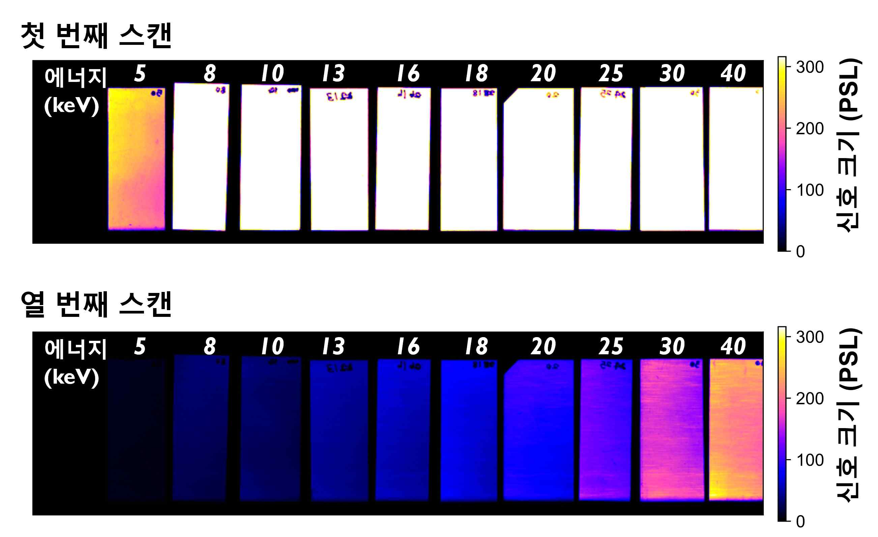

▲ Results of repeated scans of an imaging plate irradiated with deuterium at various energies (5-40 keV). Initially, the signals are saturated and indistinguishable. However, with each subsequent scan, the saturation gradually resolves, revealing the signal.

This method allows the recovery of saturated signals that were previously unreadable by conventional scanners, overcoming the structural limitations of existing detectors and opening the way for imaging plates to accurately measure signals ranging from weak to extremely strong.

* multi-scan reconstruction: This analysis technique accurately reconstructs the original signal values ​​through repeated scans when exposed to strong radiation signals exceeding the detector's measurable limits. This method exploits the characteristic that the signal recorded on the imaging plate decays at a constant rate with each scan, allowing the intensities of the initial signals, which could not be directly measured, to be mathematically calculated.

The research team conducted an experiment by irradiating an imaging plate with a single-energy (5-200 keV) deuterium ion beam generated by the Korea Atomic Energy Research Institute (KAERI) Proton Accelerator (KOMAC).

The signal reconstructed through repeated scans showed a very high degree of agreement with theoretical model predictions. This provided the first absolute deuterium response data in the previously unavailable 5-200 keV range.

Furthermore, it seamlessly connected to previously acquired data at higher energies, resulting in a complete response calibration curve.

The "multi-scan reconstruction technology" developed by the research team has significant practicality and impact, as it can resolve saturation issues while using existing equipment (scanners and imaging plates).

This technology has laid the foundation for applications not only in nuclear fusion but also in various fields requiring precise radiation dose measurement, such as high-dose radiation therapy and medical imaging diagnostics.

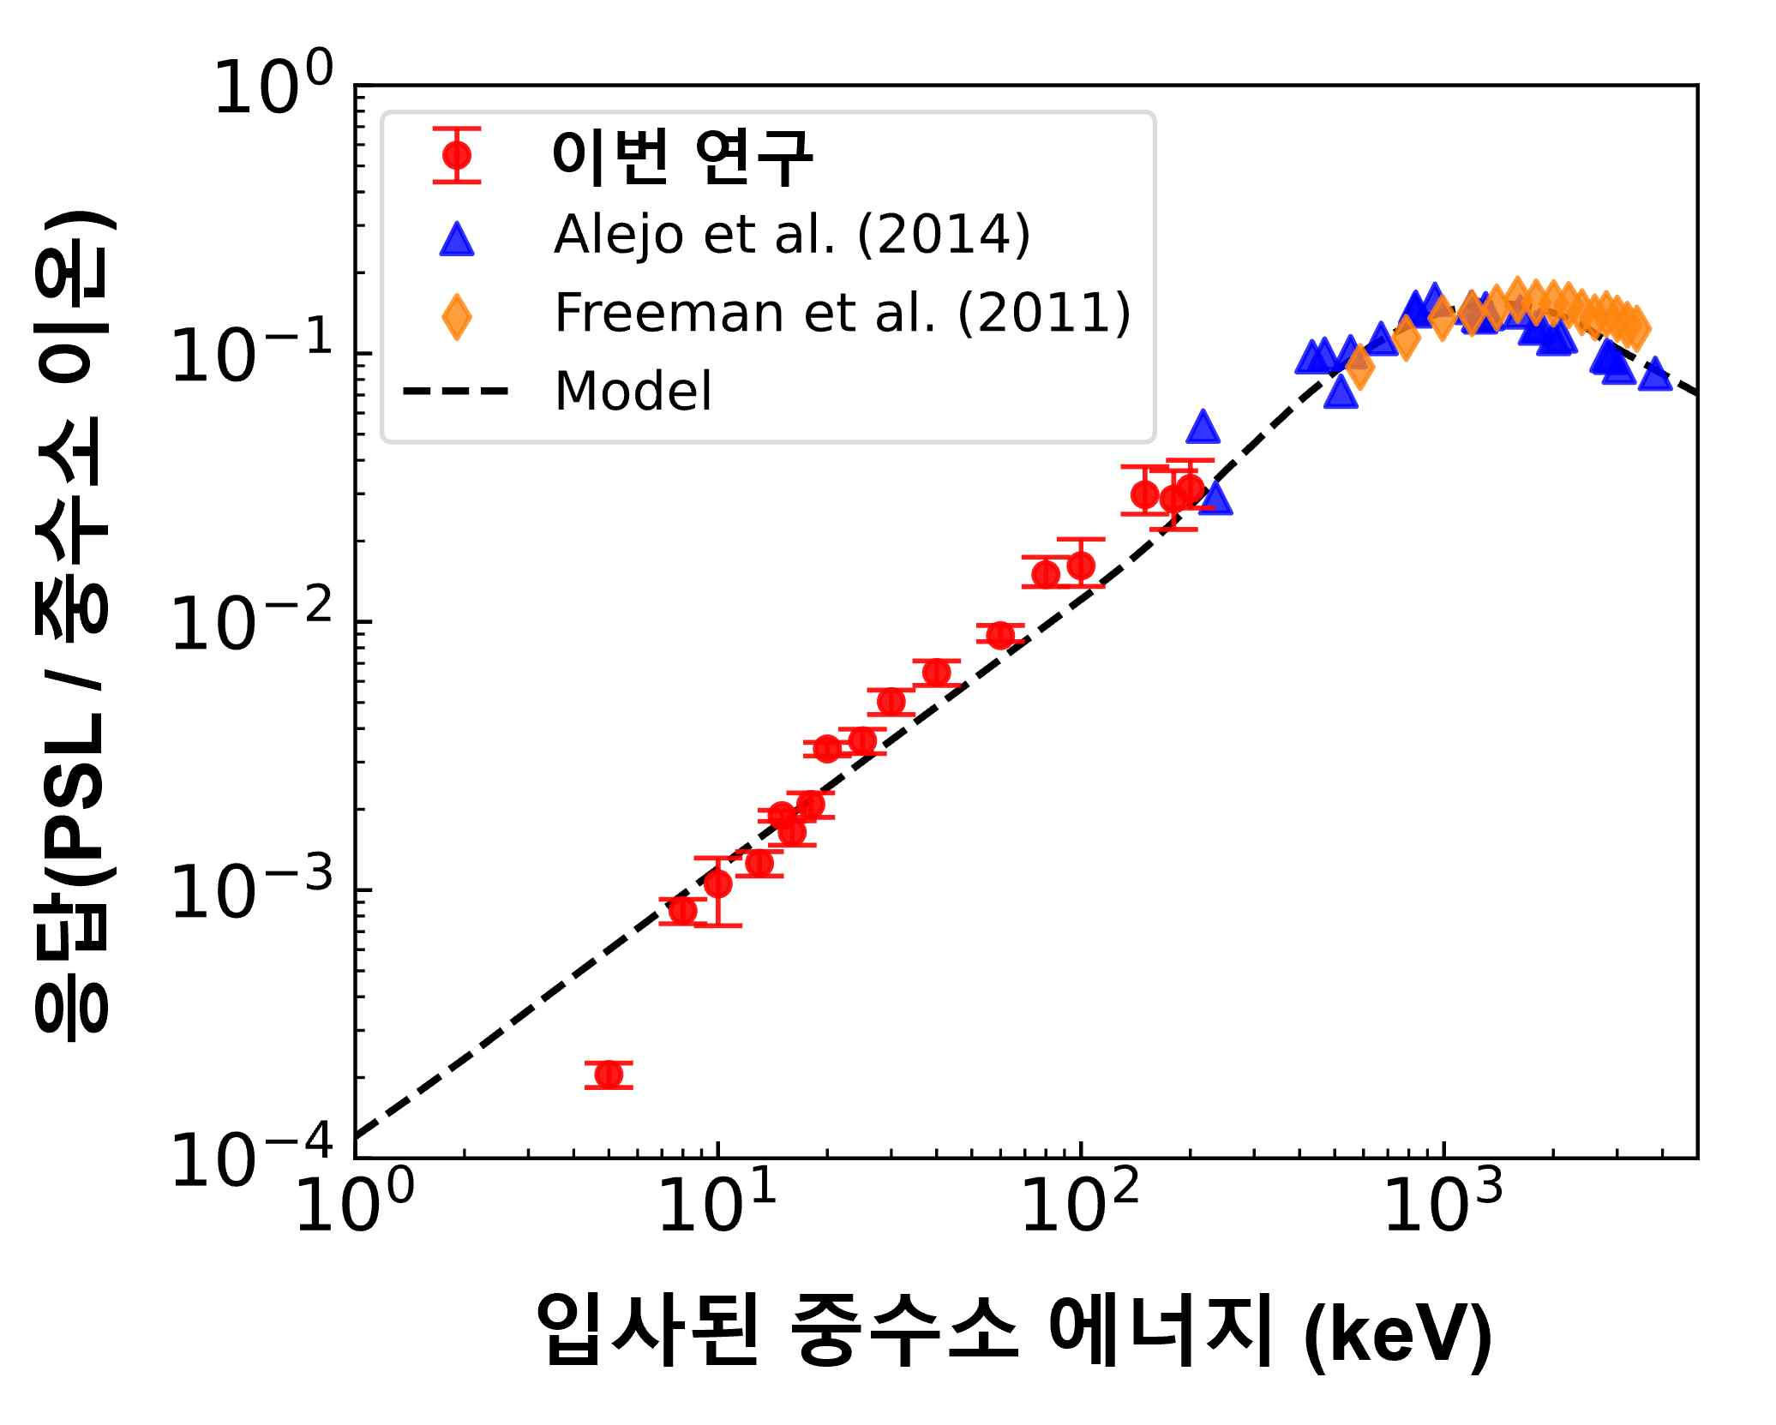

▲ Absolute response of the imaging plate according to deuterium energy. The absolute response of deuterium in the 5–200 keV range (red dots) measured in this study is consistently consistent with previous high-energy measurements and also closely matches the predictions of the theoretical model (black dotted line).

Professor Woosuk Bang stated, "This technology presents a new diagnostic technique that can accurately read signals even in extreme experimental environments where a large number of particles are simultaneously released." He added, "The absolute response data obtained from this study can be immediately utilized in international nuclear fusion and accelerator experiments and will contribute broadly to various particle experimental research."

This research, supervised by Professor Woosuk Bang of the Department of Physics and Photon Science at GIST and led by Hyeong-il Kim, a combined master's and doctoral student, was supported by the National Research Foundation of Korea's Mid-Career Researcher Support Program. The research results — Overcoming imaging plate saturation with a multi-scan reconstruction technique for high-flux deuteron diagnostics — were published online on November 24, 2025, in 《Radiation Physics and Chemistry》, an international academic journal ranked in the top 6.1% of nuclear science journals according to the Journal Citation Reports (JCR), a global academic journal evaluation index.

Meanwhile, GIST stated that this research achievement considered both academic significance and industrial applicability, and that technology transfer-related discussions can be conducted through the Technology Commercialization Center (hgmoon@gist.ac.kr).



