"Walk through vast virtual worlds without the constraints of real space" GIST developed 'ReD Shoes,' overcoming the limitations of virtual reality walking

- Professor SeungJun Kim's team from the Department of AI Convergence has combined tactile feedback on the soles of the feet with VR walking guidance technology (redirected walking)... Providing the experience of freely walking in a spacious virtual space even in confined spaces

- The system, which utilizes foot tilting to enhance immersion and stability while minimizing dizziness and discomfort, is expected to be utilized in various industries, including gaming, military training, and rehabilitation therapy... The research was published in the international journal Virtual Reality



▲ (From left to right) Professor SeungJun Kim of the GIST Department of AI Convergence, researcher Aya Ataya, postdoctoral fellow Ahmed Elsharkawy, researcher Jieun Lee, researcher Seokhyun Hwang, and PhD candidate Minwoo Seong

The Gwangju Institute of Science and Technology (GIST, President Kichul Lim) announced that Professor SeungJun Kim's research team in the Department of AI Convergence has developed "Red Shoes", a robotic walking interface that helps users walk naturally across much larger spaces in a virtual reality (VR) environment.

The name "ReD Shoes" is derived from the 1948 British film "The Red Shoes." In the film, the protagonist, upon putting on a pair of red shoes, experiences an immersive experience, as if he were endlessly led by the shoes into a new world. Inspired by this iconic scene, the research team named the interface "Red Shoes" to symbolize an interface that allows users to seamlessly immerse themselves in a virtual space without being conscious of the limitations of the real world.

VR technology is being utilized in diverse fields such as education, training, and gaming. However, it has limitations: users find it difficult to walk freely in confined spaces. To address this, redirected walking (RDW) technology was developed, which finely manipulates the visual information in a virtual environment to guide the user's walking path.

However, existing RDW technologies suffer from motion sickness and a sense of disorientation due to a misalignment between vision and body balance, reducing both immersion and walking stability.

* redirected walking (RDW): This technology subtly manipulates the user's actual walking direction, allowing them to freely explore a much wider virtual space within a confined real space. The VR system tracks the user's gaze and movements, applying subtle turns and curves to their walking. This allows the user to feel as if they are moving straight through the virtual space, while actually moving safely within the confined space.

To address this issue, the research team developed "Red Shoes," a walking interface that utilizes "tilt-tactile feedback" delivered to the soles of the feet to reduce sensory mismatch.

This allows for precise coordination of visual, vestibular, and proprioceptive sensations during VR walking, creating a natural and stable experience, reminiscent of walking in a wide virtual space, even in a confined real space.

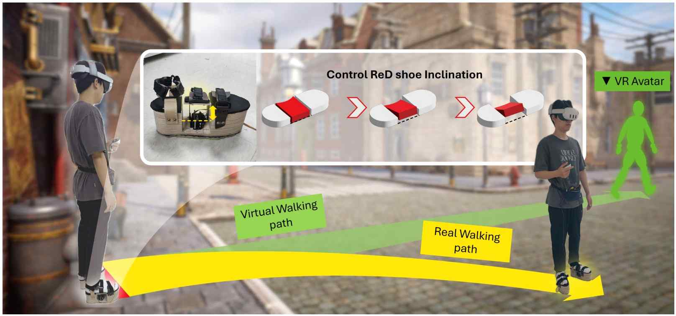

▲ Conceptual diagram of ReD Shoes. The bottom of the shoe slightly tilts, aligning visual, tactile, and vestibular senses. This prevents the user from perceiving that they are actually moving in a curved path, even when walking in a straight line.

The shoe's core component is a small tilting module located at the arch of the foot. This tilts the sole of the shoe up to 1.5 cm to the left and right, naturally guiding the user's direction of travel. This process simultaneously coordinates tactile and vestibular senses*, enhancing both immersion and walking stability.

"ReD Shoes" are modularly constructed with separate upper, middle, and lower sections. Despite their wood-based structure, they are lightweight at 0.9 kg. It's comfortable to wear for long periods of time and easy to maintain.

* vestibular sense: This sense, detected by the vestibular system in the ear, allows us to recognize body position, movement, and orientation in space. This allows us to maintain balance when walking or running, and to maintain stable posture when turning our head or moving our body. It's also commonly referred to as the sense of balance or equilibrium.

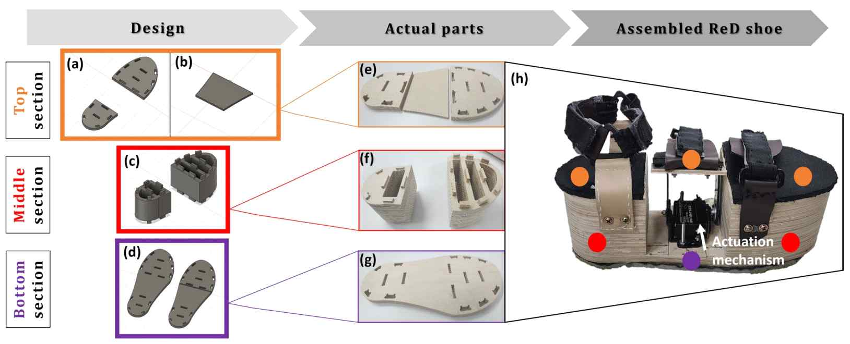

▲ Structure of ReD Shoes. Designed with a one-degree-of-freedom (1-DOF) module that tilts the midfoot, it achieves stable, lightweight performance.

The research team conducted experiments on 30 subjects and found that a 1cm incline condition resulted in the highest level of immersion and walking stability. This condition provided approximately 43.6% wider walking range than the previous model while minimizing discomfort and motion sickness.

Conversely, a high incline stimulus of 1.5cm or more actually reduced walking stability and induced motion sickness, highlighting the importance of "optimal stimulus* settings," which precisely adjust the stimulus intensity in VR walking interfaces.

* detection threshold (DT): This value represents the minimum intensity or change required to recognize a sensory stimulus. It is used in various sensory experiments, including visual, auditory, and tactile. For example, in tactile research, DT is measured as the minimum intensity of vibration or pressure applied to the palm, allowing for evaluation of sensory sensitivity, device performance, and the recognizability of a stimulus. A lower DT indicates greater sensory sensitivity, while a higher DT indicates greater difficulty in detecting stimuli.

* optimal stimulus: This refers to the physical or sensory stimulus set to provide the most immersive and comfortable experience for users in a VR environment.

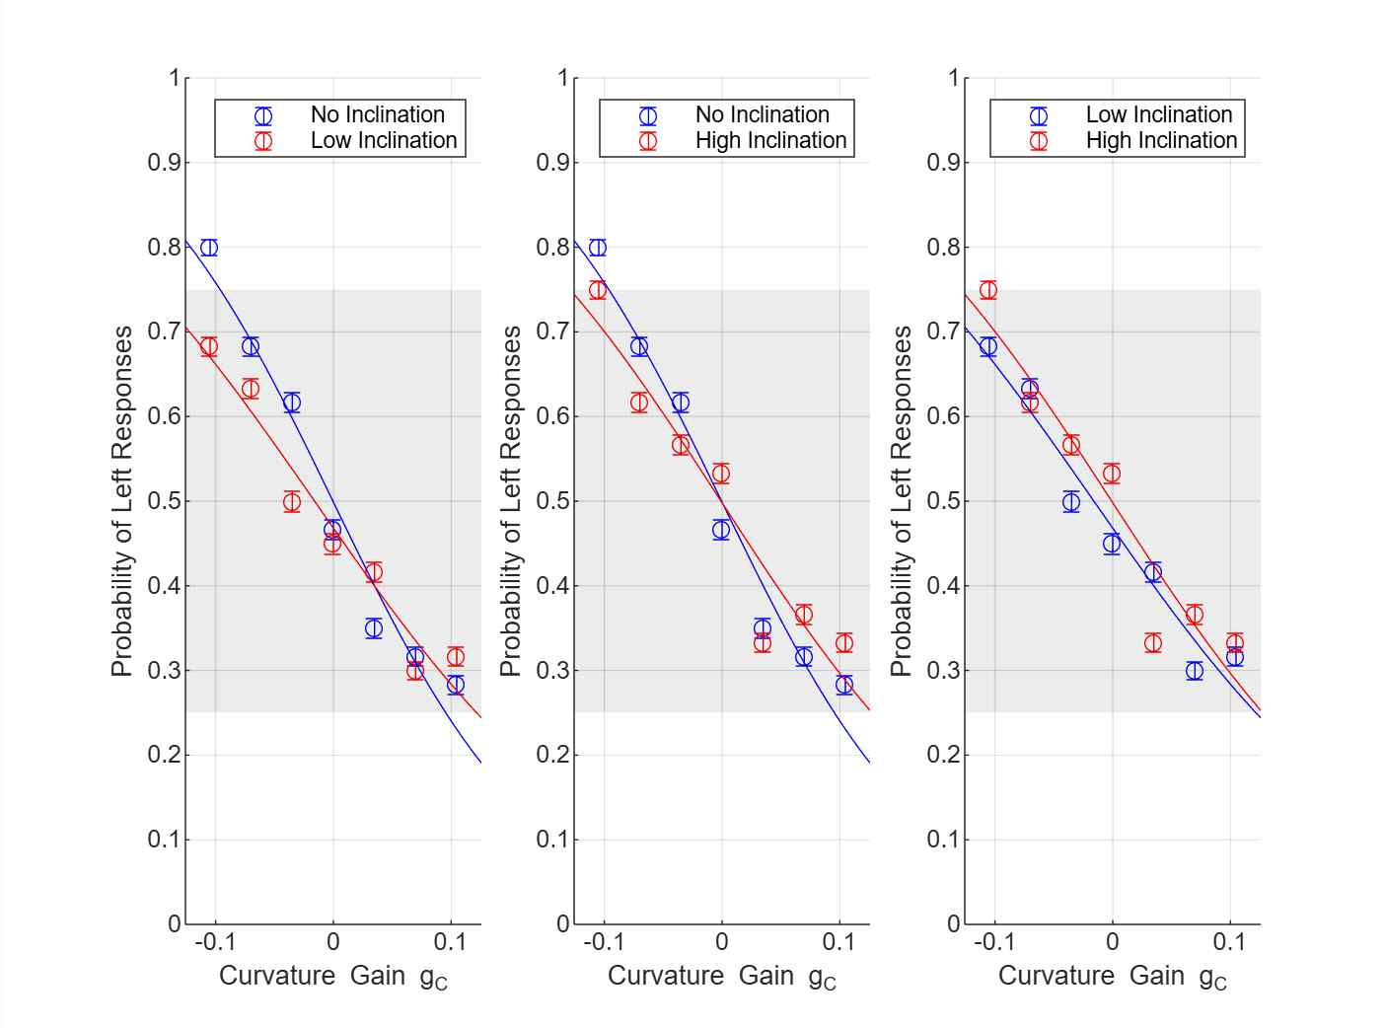

▲ User Study Results. The Low Inclination condition significantly expanded the Detection Threshold, providing the highest level of immersion and stability.

The research team plans to develop an AI-based adaptive interface that utilizes an adjustable frame that adapts to the shape of the foot and a customized insole (inner shoe sole) that compensates for the distribution of pressure on the sole of the foot. Furthermore, the team plans to develop a real-time analysis of the user's walking pattern to provide the optimal incline.

Professor SeungJun Kim stated, "'ReD Shoes' is not just a simple VR walking assistance tool; it demonstrates the potential of a new form of walking interface that combines the human sensory system with robotic control." He added, "In the future, with lightweight design and customization, it could be utilized in various industries, including gaming and the metaverse, as well as military and medical training and rehabilitation."

This research was conducted by researcher Aya Ataya, postdoctoral fellow Ahmed Elsharkawy, researcher Jieun Lee, researcher Seokhyun Hwang, and PhD candidate Minwoo Seong of the Human-Centered Intelligent Systems Laboratory under the supervision of Professor SeungJun Kim of the Department of AI Convergence. This research was supported by the National Research Foundation of Korea (NRF)'s Academic Research Support Program (Post-Doc. Growth-oriented Joint Research), the Mid-career Researcher Support Program, and the Overseas Excellent Research Institute Collaboration Hub Establishment Program.

The research results [ReD shoes: actuated footwear for multisensory redirected walking in virtual reality] were published online in the international journal 《Virtual Reality》 on September 18, 2025.

Meanwhile, GIST stated that this research achievement considered both academic significance and industrial applicability, and that technology transfer-related discussions can be conducted through the Technology Commercialization Center (hgmoon@gist.ac.kr).



