"Accelerate and soar, decelerate and plunge" GIST develops VR technology that simulates the sensation of flying in a moving car

- Professor SeungJun Kim's team from the Department of AI Convergence developed a "gravity-inertia reorientation" technique that converts a vehicle's acceleration and deceleration into the sensation of ascent and descent in VR... By applying the principle of the human "gravity illusion," the team realized the sensation of flight and descent without the need for actual vertical movement

- High levels of realism and immersion were demonstrated even in urban driving, and autonomous vehicles are expected to expand into mobile content such as entertainment, education, and tourism... Presented at "IEEE ISMAR 2025," the most prestigious international conference in the VR and AR field



▲ (From top left) GIST Department of AI Convergence Professor SeungJun Kim, master's student Bocheon Gim, PhD students Seongjun Kang, Dohyeon Yeo, and Gwangbin Kim, and master's students Juwon Um and Jeongju Park

The Gwangju Institute of Science and Technology (GIST, President Kichul Lim) announced that a research team led by Professor SeungJun Kim of the Department of AI Convergence has developed virtual reality (VR) technology that utilizes the acceleration and deceleration of a vehicle to create the sensation of "up and down" motion, similar to riding an airplane, within the vehicle.

This technology, when applied to a regular vehicle, will enable the experience of flying, and is expected to create diverse and novel content in the entertainment, education, and tourism sectors in the era of autonomous driving.

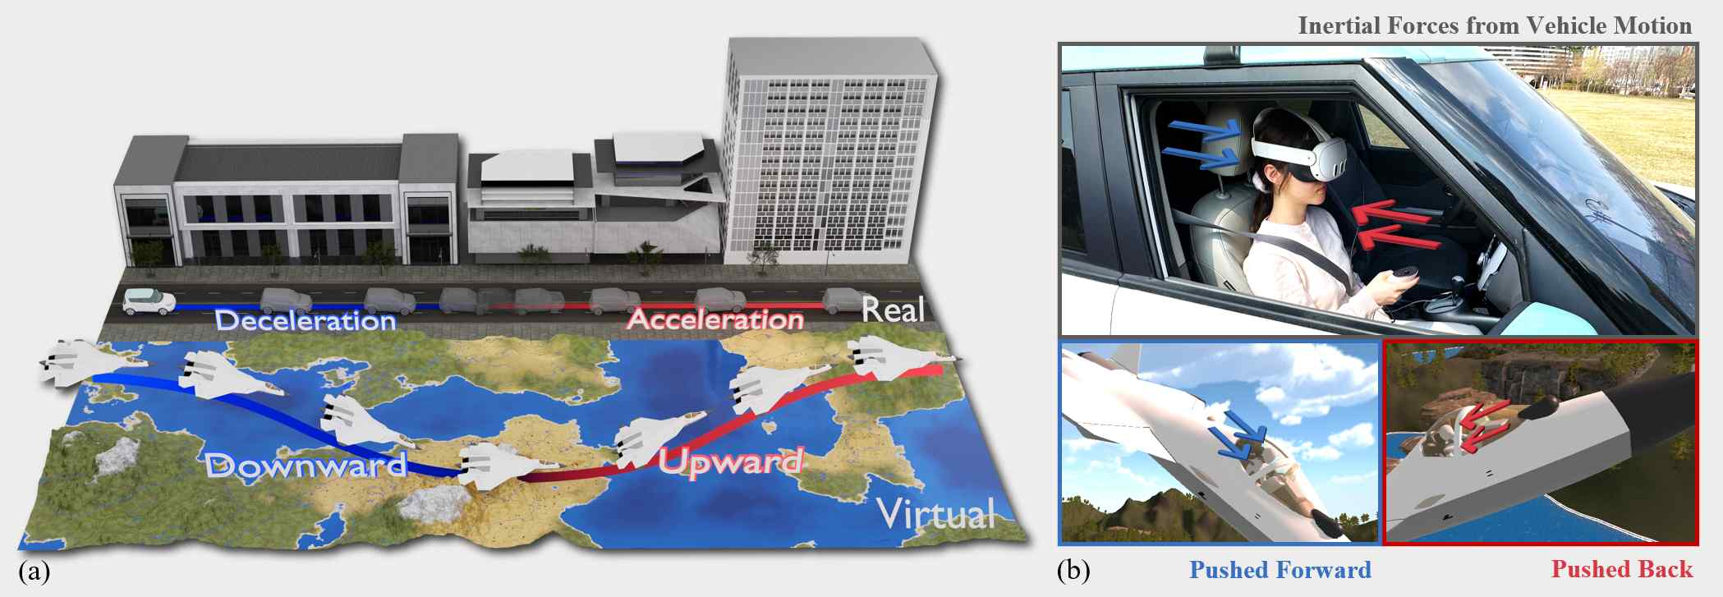

▲ Overview of the Defying Gravity principle. The virtual aircraft ascends when the vehicle accelerates, and descends when it decelerates. The image illustrates the direction of inertial force acting on the user's body and the process of redirecting this force into upward and downward movements in virtual reality.

Previous in-car VR technologies often directly reflected the vehicle's position and acceleration data, providing only a horizontally oriented experience.

While this approach helped reduce motion sickness, it had limitations in replicating the sensation of up-and-down movement, as seen in airplanes, submarines, and roller coasters.

To address these limitations, the research team developed a new technique called "Gravitoinertial Retargeting."

This technology reinterprets the sensation of the body leaning back when the vehicle accelerates and being thrown forward when it decelerates, as upward and downward movements in VR. This technique is designed to create the sensation of the user ascending and descending rapidly, even though they are actually driving on the road.

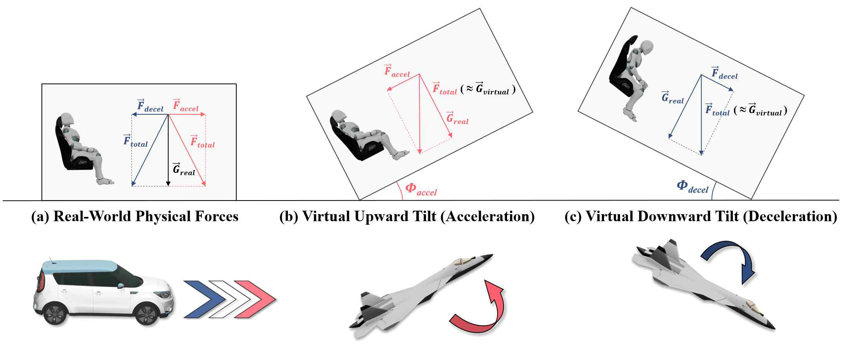

▲ Explanation of the Gravitoinertial Retargeting principle applied to movement in VR. This system principle illustrates how forces generated during acceleration (red) and deceleration (blue) are combined with actual gravity to create a new composite force. This composite force is applied to match the direction of gravity in the virtual reality, creating a sensation of rising during acceleration and falling during deceleration.

For example, rapid acceleration naturally induces a sensation of rising, while rapid deceleration naturally induces a sensation of falling. This applies the principle of the "gravity illusion*," a cognitive psychological characteristic experienced by pilots and drivers, where humans have difficulty distinguishing between gravity and acceleration.

* somatogravic illusion: This refers to a sensory illusion caused by a person's inability to clearly distinguish between gravity and acceleration. For example, when an airplane or car accelerates rapidly, the body feels pushed backwards, but the brain misinterprets this as upward movement. Similarly, when a car decelerates rapidly, the body feels thrown forward, but the brain perceives it as downward movement. This phenomenon occurs when the human vestibular system, vision, and somatosensory systems confuse gravity and inertial acceleration, and is a key principle used in pilot training and the design of immersive VR technology.

The research team verified the technology's effectiveness through two phases of experimentation.

In the first phase of the experiment, the actual vehicle acceleration was converted to various ratios to determine the intensity of the vertical movement that participants perceived most realistically. The results showed that vertical movement approximately twice as exaggerated as theoretically calculated was perceived as most realistic.

In the second phase, participants experienced a VR flight simulation while driving in an actual city. When the vehicle's movement and the "optimal vertical translation value*" were precisely synchronized, participants experienced a high level of immersion and enjoyment, and their motion sickness levels remained stable. In contrast, arbitrary vertical translations not synchronized with the vehicle's movement caused discomfort and motion sickness.

* optimal vertical translation value: This refers to the ratio of vertical movement adjusted to convert the vehicle's actual acceleration and deceleration into ascent and descent in VR to provide the most realistic and immersive experience for users.

Professor SeungJun Kim stated, "This research is significant in that it transcends the limitations of in-vehicle VR, which was previously limited to horizontal movement, enabling multidimensional experiences such as flight, ascent, and descent without actual vertical movement." He added, "In the era of commercialization of autonomous vehicles, its application will expand into diverse fields such as entertainment, education and training, and theme park-style experiences."

He added, "We plan to further develop this VR experience, reflecting even the vehicle's left and right tilt, to create a VR experience that closely resembles a full flight simulation on the road."

This research, supervised by Professor SeungJun Kim of the Department of AI Convergence at GIST and led by master's student Bocheon Gim, was supported by the National Research Foundation of Korea's "Development of an Actuated XR System Based on Soft Robotics and Sensory Intelligence for Embodiment of Reality and Virtuality" and the GIST-MIT Physical AI Research Center. It was also conducted as part of the joint research project between GIST and the Massachusetts Institute of Technology (MIT), "HCI+AI Convergence Research for Human-Centered Physical Systems Design."

The research results — Defying Gravity: Towards Gravitoinertial Retargeting of Acceleration for Virtual Vertical Motion in In-Car VR — were presented on October 11th at the IEEE ISMAR (International Symposium on Mixed and Augmented Reality) 2025, the most prestigious international academic conference in the fields of human-computer interaction and virtual/augmented reality.

Meanwhile, GIST stated that this research achievement considered both academic significance and industrial applicability, and that technology transfer-related discussions can be conducted through the Technology Commercialization Center (hgmoon@gist.ac.kr).



