"Awakening the dormant 'attack instinct' of immune cells and destroying cancer" GIST has developed a new anticancer agent, "77c," that blocks cancer cell immune evasion: Drug optimization, mechanism elucidation, and preclinical efficacy verification completed

- Professor Yong-Chul Kim of the Department of Life Sciences and Professor Hansoo Park of the Department of Biomedical Science and Engineering developed "77c," a novel anticancer drug candidate with a novel mechanism that overcomes the limitations of immunotherapy... It is the world's first to target TPST2, an enzyme that induces immune evasion in cancer cells

- Inhibits tumor growth by enhancing immune cell recognition and attack power... Potent synergistic effects confirmed when combined with existing immunotherapy (anti-PD-1). Published in the international journal "Journal of Medicinal Chemistry"



▲ (From left) Professor Yong-Chul Kim of the Department of Life Sciences at GIST, Hansoo Park of the Department of Biomedical Science and Engineering, Dr. Soo Bin Park of the Department of Life Sciences, and Dr. Hyun Kim of the Department of Biomedical Science and Engineering

Korea researchers have developed a new anticancer drug candidate with a novel mechanism that could overcome the limitations of immunotherapy.

The Gwangju Institute of Science and Technology (GIST, President Kichul Lim) announced that a research team led by Professor Professor Yong-Chul Kim of the Department of Life Sciences and Professor Hansoo Park of the Department of Biomedical Science and Engineering has developed a novel small-molecule compound, "77c," that targets the enzyme "TPST2*," which is involved in the immune evasion mechanism of cancer cells.

The research team demonstrated that this compound could serve as a novel immunotherapy strategy, helping immune cells more effectively recognize and attack cancer cells.

* TPST2 (Tyrosylprotein Sulfotransferase 2): An enzyme that alters the properties of proteins by adding a chemical compound called a "sulfate group." This enzyme is known to help cancer cells evade immune cell attacks.

Immunotherapy* is a treatment that induces the body's immune cells to directly attack cancer cells. Compared to conventional chemotherapy, it has attracted attention for its fewer side effects and greater survival rate improvement. However, for some cancer types, the response rate remains limited to 15-40%, limiting its effectiveness for a significant number of patients.

This is because cancer cells develop various mechanisms to evade or suppress immune cell attacks. To overcome this, the development of "immunosensitizers*" is attracting global attention as a new approach. Immune sensitizers block cancer cells' immune evasion, allowing immune cells to more effectively recognize and attack them. They are expected to be a new treatment strategy that increases the response rates of existing immunotherapy drugs.

* immune checkpoint inhibitors: These drugs prevent cancer cells from using the immune system's inhibitory signals (such as PD-1) to evade attack, thereby inducing T cells to re-attack cancer cells.

Based on the role of the TPST2 enzyme in cancer cell immune evasion, the research team developed a small molecule compound, "77c," that significantly enhances the T cell* immune response against tumors by inhibiting its activity.

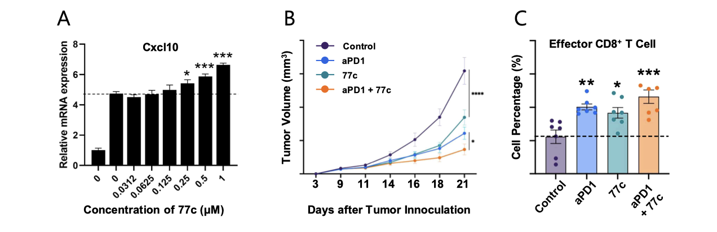
▲ Immune activation and anticancer effects of the TPST2 inhibitor 77c. Figure (A) shows increased Cxcl10 gene expression in response to interferon gamma (IFN-γ) stimulation after treatment with the TPST2 inhibitor 77c in mouse colon cancer cells (MC38). IFN-γ signaling was enhanced in a dose-dependent manner after inhibitor treatment. Figure (B) shows changes in tumor growth in the MC38 tumor-implanted mouse model after single or combined administration of anti-PD-1 antibody and 77c. Tumor growth inhibition was most pronounced in the combination group (aPD1 + 77c). Figure (C) analyzes the proportion of intratumoral CD8+ T cells, demonstrating a significant increase in CD8+ T cell infiltration and activation in the 77c monotherapy and anti-PD-1 combination groups.

TPST2 is known to act on the interferon gamma (IFN-γ) signaling pathway, weakening the immune response in the tumor microenvironment (TME). The research team used a TPST2 inhibitor to enhance tumor recognition by immune cells, thereby inducing a more aggressive immune attack on cancer cells.

* T cells: A key cell of the immune system, they directly recognize and attack infected or cancerous cells. CD8+ T cells, in particular, play a key role in eliminating cancer cells and are attracting attention as a key target for immunotherapy.

* IFN-γ (Interferon-gamma): An immune signaling molecule secreted by T cells and NK cells, it enhances the anti-cancer immune response by promoting immune cell activation and cancer cell elimination.

* tumor microenvironment (TME): A complex cellular environment surrounding cancer cells, comprised of blood vessels, immune cells, fibroblasts, signaling molecules, and the extracellular matrix. This microenvironment has a significant impact on cancer growth and metastasis, drug resistance, and immune evasion, and in particular, it plays a role in suppressing the function of immune cells, helping cancer cells avoid immune attack.

The research team, leveraging the extensive compound database held by the Korea Chemical Bank (KCB), screened and validated numerous candidates capable of inhibiting TPST2 enzyme activity. Through this process, they developed the final candidate, 77c, which targets TPST2.

Experimental results showed that 77c effectively inhibited TPST2 enzyme activity. In cell experiments using mouse colon cancer cells (MC38), treatment with 77c reduced TPST2 activity, enhanced interferon gamma (IFN-γ) signaling, and increased the expression of the immune signaling protein Cxcl10*. This confirmed that cancer cells transitioned into an "immune activation state," making them more vulnerable to immune cell attack.

* Cxcl10 (C-X-C motif chemokine ligand 10): A protein involved in signaling between immune cells, Cxcl10 plays a role in recruiting immune cells to cancer cells or inflammatory sites in the body. It is primarily produced by interferon gamma (IFN-γ) and enhances the immune response by promoting the activation of T cells and natural killer cells (NK cells). In cancer research, higher Cxcl10 expression is used as an indicator of immune cell infiltration into tumors and active anticancer responses.

Candidate 77c also demonstrated remarkable anticancer effects in an experimental mouse tumor model implanted with human colon cancer cells (mouse colon cancer cell transplantation tumor model).

When administered alone, it inhibited tumor growth by 54%, with no adverse effects such as weight loss observed. Notably, when administered in combination with a widely used immunotherapy (anti-PD-1 antibody*), the tumor growth inhibition rate increased to approximately 80%, demonstrating a clear synergistic effect between the two drugs.

Furthermore, 77c administration resulted in increased infiltration of immune cells, including CD8+ T cells, which directly attack cancer cells, into the tumor tissue. Furthermore, the activity of cells responsible for the anticancer immune response, such as CD8+ T cells* and NK cells, which remember the cancer and can attack it again, was found to increase throughout the entire immune system. In other words, 77c enhanced the overall "attack power" of immune cells, allowing them to more effectively eliminate cancer cells.

* Anti-PD-1 antibody (anti-PD-1 antibody): This immunotherapy drug blocks the function of PD-1, an immunosuppressive protein on T cells, thereby inducing immune cells to attack cancer cells again.

* CD8⁺ T cells: These are cytotoxic T lymphocytes that directly recognize and eliminate infected or cancerous cells within the body's immune system. They are so named because they possess the CD8 protein on their surface. CD8⁺ T cells are "killer cells" that directly kill cancer cells. They are the primary target of immunotherapy and serve as a key indicator of the activity of the anticancer immune response.

To confirm the results obtained from cell experiments at the molecular level, the research team conducted protein structural analysis and molecular dynamics (MD) simulations.

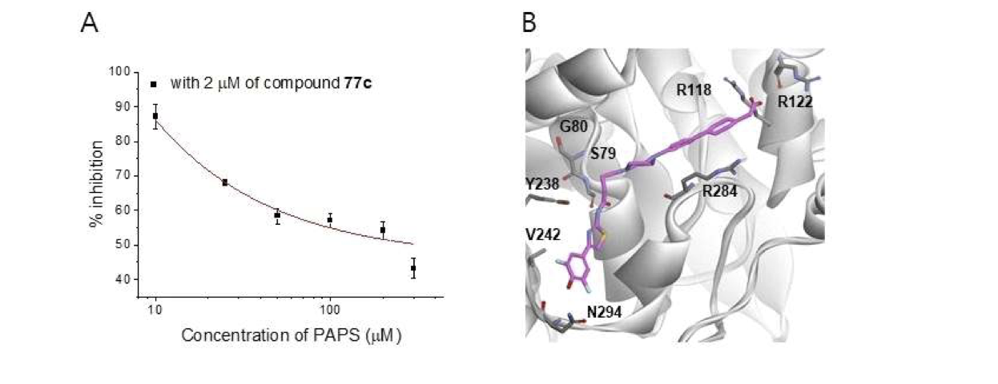
▲ Enzyme inhibition properties and binding structure prediction of TPST2 inhibitor 77c. Figure (A) shows the inhibition profile measured by varying the substrate (PAPS) concentration in the TPST2 enzyme reaction, demonstrating that 77c is a competitive inhibitor of PAPS. Figure (B) shows the predicted 77c–TPST2 binding structure, based on docking and molecular dynamics simulations of the TPST2 protein.

The results revealed that 77c stably binds to the key binding site of the TPST2 enzyme, blocking its action. This provides molecular evidence that 77c directly inhibits TPST2, supporting the immunostimulatory effects observed in the experiment, the research team explained.

Professor Yong-Chul Kim stated, "This study has revealed for the first time that TPST2 is a novel target for immunotherapy that can be controlled with drugs. By inhibiting TPST2, we can propose a new therapeutic approach that overcomes the limitations of existing immunotherapy."

He added, "We hope that this achievement will expand the scope of immunotherapy and provide effective treatment options to more patients."

This research, led by Dr. Soo Bin Park of the Department of Life Sciences and Dr. Hyun Kim of the Department of Biomedical Science and Engineering, under the joint supervision of Professor Yong-Chul Kim of the Department of Life Sciences and Professor Hansoo Park of the Department of Biomedical Science and Engineering at GIST, was supported by the Korea Drug Development Fund (KDDF) ​​and the National Research Foundation of Korea's Global Research Center (IRC) program.

The results of this study, Discovery of (4-Phenyl-cyclohexyl)acetate-Derived Tyrosylprotein Sulfotransferase 2 (TPST2) Inhibitors with Potent Anti-Tumor Activity for Immuno-Oncology Applications, were published online on October 30th in the Journal of Medicinal Chemistry, an international academic journal published by the American Chemical Society (ACS).

Meanwhile, GIST stated that the results of this research were considered in consideration of both academic significance and industrial applicability, and that discussions regarding technology transfer can be conducted through the Technology Commercialization Center (hgmoon@gist.ac.kr).



