GIST and Kyungpook National University have developed AI semiconductor technology that enables brain-like learning using a single component: Accelerating the implementation of ultra-low-power, high-performance neuromorphic AI semiconductors without complex circuitry

- A joint research team led by Professor Dong-Ho Kang of the Department of Semiconductor Engineering at GIST and Professor Byung Chul Jang of Kyungpook National University has implemented a "bidirectional synapse" that controls both positive and negative current directions in a single device by mimicking the signal processing principles of the human brain

- Achieving 95% facial recognition accuracy through precise signal intensity control using both electricity and light, a 20% improvement in learning accuracy compared to existing technologies… Published in the international journal 《Advanced Functional Materials》



▲ Professor Dong-Ho Kang of the Department of Semiconductor Engineering at GIST (corresponding author), Professor Byung Chul Jang of the School of Electronic and Electrical Engineering at Kyungpook National University (corresponding author), GIST student Hyejin Yoon (first author) and researcher Soeun Park (first author), and Kyungpook National University student Yeong Kwon Kim (first author)

The Gwangju Institute of Science and Technology (GIST, President Kichul Lim) announced that a joint research team led by Professor Professor Dong-Ho Kang of the Department of Semiconductor Engineering and Professor Professor Byung Chul Jang of the School of Electronic and Electrical Engineering at Kyungpook National University has developed an "optoelectronic artificial synapse" that can control both positive and negative current directions in a single device using light and voltage, based on the operating principles of "synapses," the connections between brain nerve cells (neurons) where signals are exchanged.

This research marks the first example of a bidirectional artificial synapse implemented using a single device, fundamentally overcoming the structural limitations of existing hardware neural networks. This technology is a key enabler for accelerating the implementation of highly integrated, low-power artificial intelligence (AI) semiconductors (neuromorphic chips) and is expected to be widely utilized in real-time AI processing systems based on on-chip learning*, such as image recognition and pattern analysis.

* on-chip learning: This refers to a technology that simultaneously performs data learning and computation within an AI semiconductor (neuromorphic chip). By processing data storage and computation within a single chip, computational speeds can be increased and power consumption can be significantly reduced.

Neuromorphic semiconductors are next-generation AI chips that mimic the human brain's neural network, processing and learning information in parallel.

Unlike conventional computers, which have separate memory and computational units, synaptic elements simultaneously perform memory storage and computation, enabling high-speed, low-power computing.

In particular, neuromorphic systems based on spiking neural networks (SNNs) utilize the time intervals between electrical signals exchanged by neurons in the brain as learning cues, implementing a brain-like computational structure that simultaneously performs learning and inference.

However, most neuromorphic devices developed to date can only control current in one direction (unipolarity), making it difficult to freely change the strength (weight) of the signal transmitted by the synapse in either positive or negative directions.

For this reason, implementing a single synaptic function required a "dual-synapse" structure, connecting two devices as a pair. This resulted in complex circuits, increased power consumption, and reduced integration, significantly hindering the implementation of large-scale neuromorphic chips.

Furthermore, neuromorphic devices developed to date have had a limited dynamic range (dynamic range) for finely controlling information due to their unipolar nature, which allows current to be controlled in only one direction. Consequently, their ability to solve problems through learning has been limited to the level of existing software-based artificial neural networks.

To overcome these structural limitations, the research team combined two new materials—rhenium disulfide (ReS₂, n-type) and tungsten diselenide (WSe₂, p-type)—in a thin layer called a two-dimensional semiconductor. This structure, a pn junction structure, was created to control the direction of current flow. Beneath this, an insulating layer (hexagonal boron nitride, h-BN*) was partially oxidized through oxygen treatment (plasma processing). This resulted in the creation of an optoelectronic synapse device capable of precise current control.

This insulating layer (h-BN layer) possesses the property of temporarily storing or releasing current (charge trapping), implementing a "pseudo-doping" effect that stores or releases electrons in response to external voltage or light stimulation. This allows for stable and precise control of synaptic weights in the positive (+) or negative (-) direction.

* Rhenium disulfide (ReS₂, n-type) and tungsten diselenide (WSe₂, p-type): These two-dimensional semiconductor materials are used in next-generation electronic and optoelectronic devices. ReS₂ exhibits n-type characteristics, with electrons as the primary carrier, while WSe₂ exhibits p-type characteristics, with holes as the primary carrier. Combining the two materials to form a pn junction allows for controlling the movement of electrons and holes based on current flow and voltage, and is utilized to induce the photovoltaic effect (the phenomenon of converting light into an electrical signal).

* hexagonal boron nitride (h-BN): A two-dimensional (2D) layered material in which boron (B) and nitrogen (N) atoms are arranged in a hexagonal honeycomb structure. Structurally, it is similar to graphene, but it is an insulator and conducts little current. In particular, h-BN partially oxidized through oxygen plasma treatment forms defects that can store or release electrons, playing a key role in implementing a weight control function (virtual doping effect) in artificial synaptic devices.

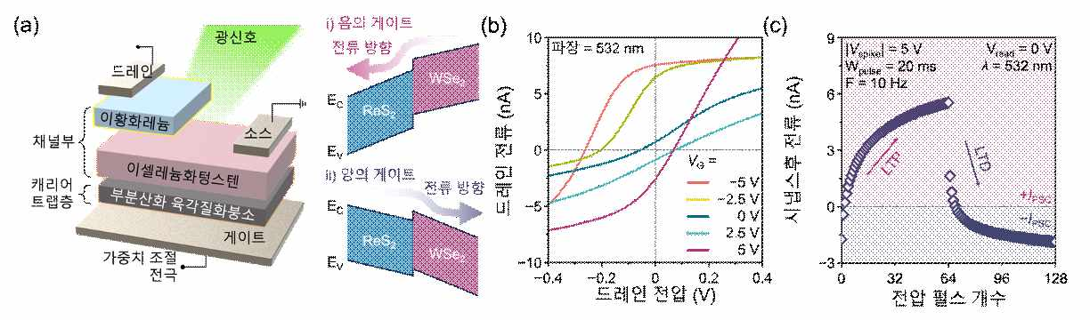

▲ Optoelectronic artificial synaptic device. (a) Structure of the artificial synaptic device. (b) Photocurrent reversal phenomenon according to gate voltage. (c) Bidirectional synaptic characteristics.

The completed optoelectronic synaptic device can freely control the direction and intensity of synaptic current by simultaneously utilizing voltage and light. A momentary application of a positive voltage increases the current from negative to positive, while a momentary application of a negative voltage decreases it from positive to negative, demonstrating bidirectional synaptic plasticity*.

Furthermore, when exposed to light, tiny particles, namely electrons and holes, that generate current within the semiconductor are generated, strengthening the current flow. Blocking the light or changing the voltage direction reverses the current flow. This method, utilizing both electricity and light (an electrical-optical hybrid control mechanism), allows for precise control of the intensity of synaptic signals.

This allows for bidirectional control and repetitive learning, strengthening or weakening synaptic signals with just a single device, enabling the learning and memory processes similar to those of brain neurons without the need for complex circuitry.

* bidirectional synaptic plasticity: This refers to the property that allows the electrical current strength (conductance) of an artificial synapse to be controlled in both positive (+) and negative (-) directions depending on the direction of the electrical stimulus, i.e., the polarity of the voltage. This ability to freely strengthen or weaken the signal strength transmitted by a synapse physically embodies the plasticity that occurs during the learning and memory processes of the human brain.

Simulation results showed that an AI neural network utilizing the device developed by the research team achieved 95% accuracy in facial recognition, a performance improvement of over 20% over a conventional unipolar device-based neural network (less than 75%).

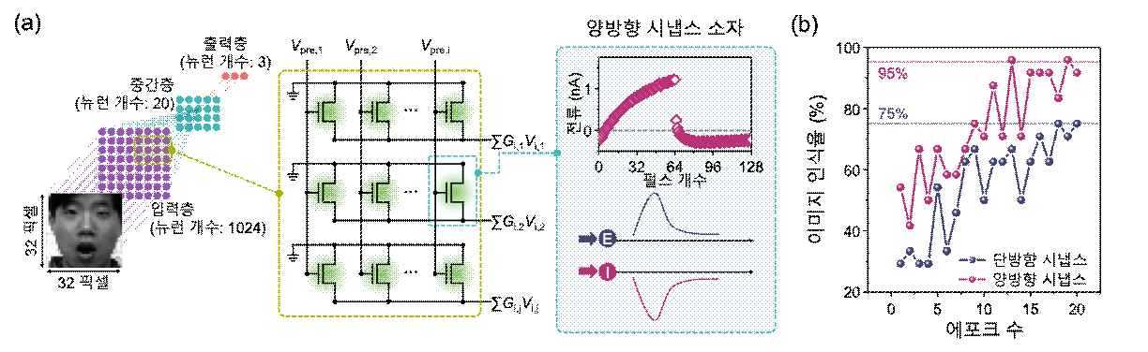

▲ Artificial neural network-based facial recognition simulation. (a) Artificial neural network configuration and circuit schematic for facial recognition. (b) Facial image recognition rates based on unidirectional and bidirectional synapses.

The research team expects this technology to be a core technology for implementing energy-efficient neuromorphic hardware and a foundational technology that can significantly improve the computational efficiency of next-generation AI semiconductors.

Professor Dong-Ho Kang of GIST stated, "This study, which implemented bidirectional synaptic currents in a single device, is a technological breakthrough that can dramatically improve the energy efficiency of neuromorphic hardware." He added, "It will serve as an important foundation for the development of ultra-low-power, high-performance AI semiconductors capable of real-time learning and adaptation."

This research was supervised by Professor Dong-Ho Kang of GIST and Professor Byung Chul Jang of Kyungpook National University, and conducted by GIST student Hyejin Yoon (then an undergraduate student), GIST researcher Soeun Park, and Kyungpook National University researcher Yeong Kwon Kim. The research was supported by the National Research Foundation of Korea's Excellent Young Researcher Program and the GIST Future-Leading Specialized Research Program. The research results — A Van der Waals Optoelectronic Synapse with Tunable Positive and Negative Post-Synaptic Current for Highly Accurate Spiking Neural Networks — were published online in the international journal 《Advanced Functional Materials》 on November 4, 2025.

Meanwhile, GIST stated that this research achievement considered both academic significance and industrial applicability, and that technology transfer-related discussions can be conducted through the Technology Commercialization Center (hgmoon@gist.ac.kr).



