"Southeast Asia is experiencing a sticky heatwave, Central Asia is experiencing a dry heatwave" GIST identifies two regional types of heatwaves in Asia: The first continent-wide quantitative analysis of the combined effects of temperature and humidity

- An international joint research team led by Professor Jin-Ho Yoon of the Department of Environment and Energy Engineering has revealed regional variations in heatwave patterns across Asia over a 50-year period (1973-2023)... Clearly distinguishing between "wet heatwaves" in monsoon regions and "dry heatwaves" in arid regions

- The regional patterns of heatwaves are the result of a combination of changes in atmospheric moisture balance and anthropogenic factors, highlighting the need for tailored climate response and health policies... The study was published in the international journal 《Climatic Change》



▲ (From left) Professor Jin-Ho Yoon and Dr. Jina Park, Department of Environment and Energy Engineering

With global warming leading to an increase in heat waves around the world, compound heatwaves, in particular, characterized by simultaneous increases in temperature and humidity, are being identified as a major factor, making it difficult for the human body to regulate its temperature and even reducing labor productivity.

Amidst this situation, a study has revealed that distinctly different heatwave patterns are observed across Asia.

The Gwangju Institute of Science and Technology (GIST, President Kichul Lim) conducted a detailed analysis of heatwave phenomena across Asia by climate type by a research team led by Professor Jin-Ho Yoon of the Department of Environment and Energy Engineering, in collaboration with domestic and international researchers. The analysis revealed that "wet heatwaves," combining high temperatures and high humidity, are rapidly increasing in monsoon regions, including the Korean Peninsula, while "dry heatwaves," characterized by low humidity, are intensifying in arid regions such as Central Asia.

This study is the first continental-level analysis to quantitatively examine heat waves across Asia, including the combined effects of temperature and humidity. Using the European Centre for Medium-Range Weather Forecasts (ECMWF)'s high-resolution Atmospheric Reanalysis (ERA5) data, the research team meticulously examined climate data for the Asian summer (June to August) spanning approximately 50 years from 1973 to 2023.

While previous studies simply categorized all of Asia as a single climate zone, this study is significant in that it distinguishes between monsoon and arid regions and quantitatively identifies trends in heat wave types. The research team analyzed changes in "heat stress"*, which is actually felt by the human body, using not only "daily maximum temperature" but also "wet-bulb temperature," which considers both temperature and humidity.

* wet-bulb temperature (WBT): This temperature reflects both air temperature and humidity, and is the perceived temperature, reflecting the heat absorbed by water vapor in the air as it evaporates. It is used in heat stress assessment, heat wave risk, industrial safety, military training, and climate research.

* heat stress: This refers to the strain on the body and brain caused by a loss of body temperature regulation due to high temperatures, high humidity, intense sunlight, and excessive physical activity. Recently, the World Health Organization (WHO) and the World Meteorological Organization (WMO) have warned of the heat stress faced by workers worldwide. Therefore, the definition of heat wave currently used by the Korea Meteorological Administration (KMA) considers wet bulb temperature.

Analysis results show that in monsoon regions (South and Southeast Asia, South China, etc.), the number of "wet heat waves" has increased by an average of 1.95 days per year over the past decade, a rate that is faster than that of regular heat waves. This phenomenon is interpreted as the result of a combination of anthropogenic factors, such as increased water vapor inflow from the ocean, the urban heat island effect due to urbanization, and expanded agricultural irrigation.

Since 2000, particularly in monsoon regions, "wet heat waves," characterized by both high temperatures and humidity, have increased dramatically. In the Indo-Gangetic Plain and South China, rising relative humidity, rather than simply rising temperatures, has been the primary driver of heatwave intensification.

In South China, moisture vapor from the Bay of Bengal and the South China Sea accumulated in the summer atmosphere, leading to a sharp increase in humidity. Furthermore, the westward movement of the Western Pacific Subtropical High (WPSH) further intensified wet heat waves.

These heat waves suppress sweat evaporation, making body temperature regulation difficult and posing a serious threat to labor productivity and health.

Conversely, arid regions such as Central and West Asia have shown an intensification of "dry heat waves," characterized primarily by soaring temperatures due to limited moisture supply. The number of days with dry heat waves has increased by an average of 2.05 days per year over the past decade, and this is attributed to a lack of moisture in the region and weak water vapor convergence.

This region has seen little increase in wet heat waves due to minimal atmospheric moisture inflow, but the frequent occurrence of extremely high temperatures poses a direct threat to agricultural productivity and water resource management.

The research team explained that this difference is not simply due to rising temperatures, but rather to changes in the climate system's "moisture balance." In monsoon regions, rising sea surface temperatures in the adjacent oceans intensify evaporation, and strengthened southwesterly winds and monsoon circulation transport large amounts of ocean moisture to the land, maintaining high humidity. This, combined with anthropogenic factors such as urbanization and expanded irrigation, exacerbates wet heat waves.

In contrast, arid regions experience prominent high temperatures but little moisture inflow, leading to the predominance of "high temperature, dry heat waves."

* moisture balance: This refers to assessing overall moisture changes by calculating the inflow and outflow of moisture within a system or material. In other words, it compares the moisture entering through rainfall and irrigation with the moisture leaving through evaporation and drainage to determine net moisture changes.

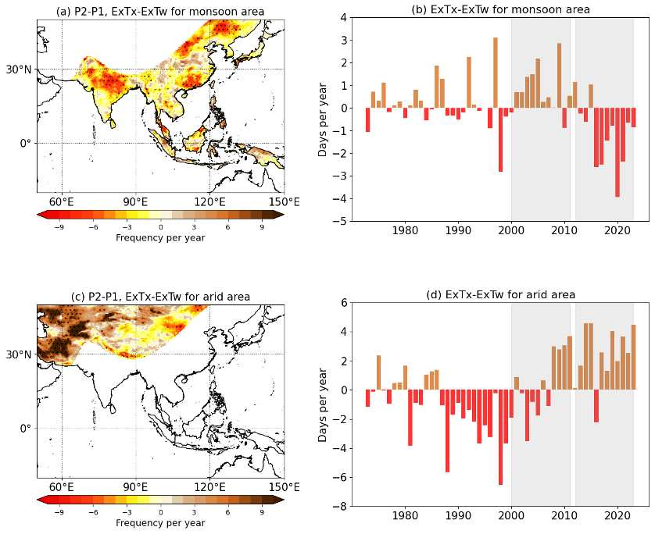

▲ Comparison of temperature-based and wet-bulb temperature-based heatwaves. (a) Spatial distribution of the difference between temperature-based and wet-bulb temperature-based heatwaves in the monsoon region during P1 (2000-2011) and P2 (2012-2023). (c) Time series evolution of the difference between the two heatwave types in the monsoon region. (b) and (d) are identical to (a) and (c), respectively, but represent the results for the dry region. Higher values ​​(brown; >0) indicate more frequent temperature-based heatwaves, while lower values ​​(red; <0) indicate more frequent wet-bulb temperature-based heatwaves. In the monsoon region, increased humidity led to more wet heatwaves (red), while in the dry region, less significant humidity changes led to more severe dry heatwaves (brown).

The research team emphasized that these regionally differentiated heatwave patterns have direct implications for societal response strategies. In monsoon regions, high temperatures and humidity simultaneously increase the risk of exceeding the human body's physiological limits, necessitating strengthened safety nets in the health and labor sectors and policies to protect vulnerable populations.

Conversely, in arid regions, extreme heat events directly impact agricultural productivity and water resource management, necessitating focused climate adaptation strategies.

Even within the Asian continent, regional climate characteristics present distinct risk patterns, necessitating tailored climate response policies rather than a uniform approach, the research team explained.

Professor Jin-Ho Yoon stated, "Even with the same temperature rise, the characteristics of heatwaves vary depending on regional climate characteristics. Heatwave patterns in Asia are highly regionally specific, so we need strategies that differentiate between monsoon and arid regions."

He also warned, "Ignoring this could lead to the emergence of new climate risks across the society and economy in specific regions."

Dr. Jina Park (first author) emphasized, "In regions with high humidity, such as the Indo-Gangetic Plain and South China, heat stress indicators are rising explosively, posing a serious threat to human health." She added, "Climate change responses must consider not only the simple rise in temperature but also the combined effects of humidity."

This study was led by Professor Jin-Ho Yoon and Dr. Jina Park of the Department of Environment and Energy Engineering at GIST, and was a joint research project with Professor Hyungjun Kim of KAIST, Professor Jee-Hoon Jeong of Sejong University, and Dr. Suyeon Moon of the APEC Climate Center. The research was supported by the Ministry of Science and ICT and the National Research Foundation of Korea's Mid-Career Researcher Support Program.

The results of the study, Divergent trends of Tmax-based and Tw-based heat extremes across Asia's climatic divide, were published online in the international journal 《Climatic Change》 on October 14, 2025.



