"The colorful colors of the jewel beetle's shell are realized with just 1 volt" GIST and KAIST have developed a core technology for ultra-low-power, next-generation displays that control color using light direction and voltage

- Professor Hyeon-Ho Jeong's team from the Department of Electrical Engineering and Computer Science at GIST, in collaboration with Professor Young Min Song's team from KAIST, developed a "chiral electrochromic metasurface" that precisely controls color by combining the direction of electricity and light... Published in the international journal 《ACS Nano》

- Achieved near-universal color reproduction and ultra-fast color switching in less than 0.25 seconds. Ultra-low power and non-volatile memory characteristics enable high-efficiency operation... Expected applications include optical memory and security displays



▲ (Clockwise from top left) Professor Hyeon-Ho Jeong of the Department of Electrical Engineering and Computer Science at GIST; Professor Young Min Song of the School of Electrical Engineering at KAIST; researcher Juhwan Kim of the Department of Electrical Engineering and Computer Science at GIST; Dr. Jang-Hwan Han of Heidelberg University in Germany; researcher Gyurin Kim and Dr. Doeun Kim of the Department of Electrical Engineering and Computer Science at GIST

The Gwangju Institute of Science and Technology (GIST, President Kichul Lim) announced that a joint research team led by Professor Hyeon-Ho Jeong from the Department of Electrical Engineering and Computer Science and Professor Young Min Song of the Korea Advanced Institute of Science and Technology (KAIST) have developed a "chiral plasmonic electrochromic metasurface" that can precisely control color depending on electrical stimulation and the direction (polarization) of light.

This research combines a light-responsive helical gold nanostructure with the characteristic of "circular polarization," which emits different colors depending on the direction of light rotation, and an electrochromic polymer (polyaniline) that changes color when a voltage is applied. This allows for control of a wide color range (287 nanometers (nm), which represents most visible colors)—a range previously difficult to achieve with existing technologies—at voltages of less than 1 volt.

* polarization: A state in which the direction of vibration of light waves is consistently aligned. Normal natural light vibrates in multiple directions, but when subjected to specific conditions such as polarizing filters or reflection/refraction, only one component remains, forming polarized light. Utilizing this polarization characteristic can be used to simulate dichroism, a phenomenon in which light absorption or reflection color varies depending on the structural asymmetry (chirality) of a material.

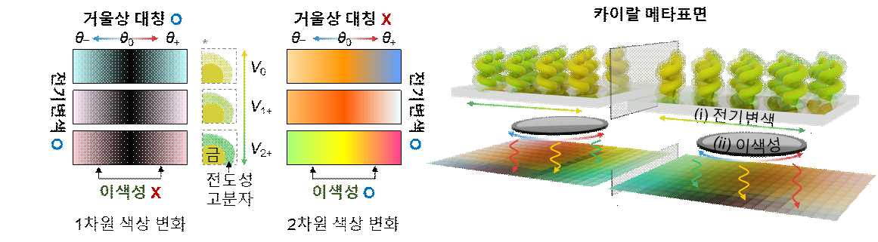

▲ Principles of chiral metasurfaces: (Left) comparison of color changing performance of symmetric and chiral nanostructures (Right) dynamic color implementation mechanism of chiral metasurfaces

Electrochromic devices are a technology that changes color when voltage is applied, and are used in smart windows and low-power displays.

However, existing technologies have limited color variability or require high voltages, making it difficult to achieve a variety of colors within a single pixel.

Inspired by the "chirality" of spiral structures like the shells of jewel beetles, which change color depending on angle, the research team proposed a novel approach that combines "dichroism," which changes color depending on the rotational direction of light (LCP/RCP)*, with electrochromism.

Chirality (mirror-image asymmetry) refers to a structure that does not overlap when reflected in a mirror. Implementing chirality at the nanometer level (nm, approximately one-hundred-millionth of a meter) can produce different colors depending on the polarization direction of light.

* rotational direction (LCP/RCP): This refers to the direction in which the electric field rotates in the circular polarization of light. If the electric field rotates to the left as the light wave propagates, it is called left-hand circular polarization (LCP), and if it rotates to the right, it is called right-hand circular polarization (RCP).

The research team fabricated a gold-based helical nanostructure and uniformly coated it with an electrochromic polymer material (PANI)* to create a chiral electrochromic metasurface whose transmittance changes depending on voltage and polarization.

This metasurface can be easily fabricated on large-area substrates without complex microfabrication, such as exposure processes, demonstrating high industrial scalability. Furthermore, once the color is changed by applying voltage, the electrochromic material exhibits a non-volatile memory effect, maintaining the color for approximately 15 minutes even after power is turned off, due to the memory properties of the electrochromic material.

* electrochromic polymer material (PANI, Polyaniline): A conductive polymer whose color changes reversibly according to electron transfer when voltage is applied. Since the refractive index and absorption rate change depending on the oxidation/reduction state, the color can be controlled with an electrical signal.

The fabricated metasurface boasts a wide color gamut of 287 nanometers, capable of reproducing all colors in the visible spectrum, including primary colors such as red, green, and blue (RGB), and exhibits a fast color transition speed of less than 0.25 seconds.

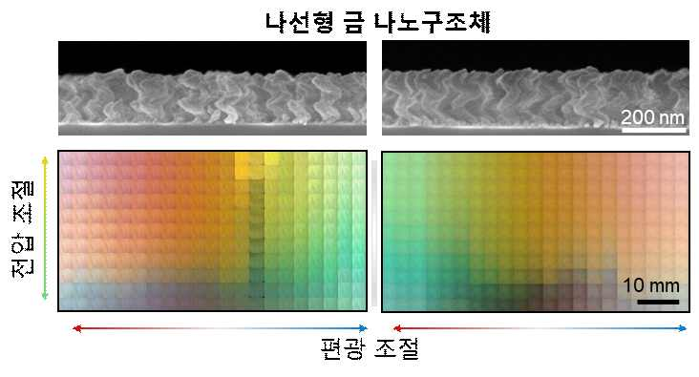

▲ Color performance of the fabricated chiral metasurface: Color changes according to voltage and polarization adjustments. (Left) Left-handed spiral and (Right) Right-handed spiral.

Furthermore, the color changes stably even after over 1,000 cycles of operation, and the device continued to operate without any performance degradation even after one year of operation, demonstrating excellent durability and stability.

Notably, it operates at a low voltage of less than 1 volt and operates at an ultra-low power consumption of approximately 1.3 milliwatts per square centimeter (1.3 mW/cm²), enabling energy-efficient color control across the entire visible spectrum.

The research team extended this metasurface to an optical logic memory device composed of four pixels, realizing 162 color combinations simply by combining voltage and polarization.

This is a ternary optical logic system that goes beyond conventional binary logic, demonstrating its potential for use in next-generation optical-based information processing technologies, such as high-density optical data storage and visual information encryption.

* binary logic represents information by dividing it into two states, 0 and 1, and is the fundamental principle used in most current digital circuits and memory devices. In contrast, ternary logic represents information using three states, 0, 1, and 2, allowing for the storage and processing of more data simultaneously.

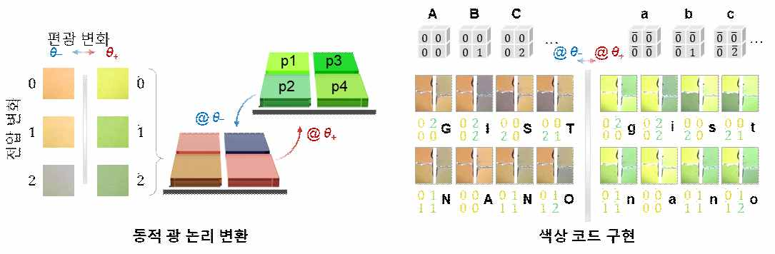

▲ Fabrication of optical logic devices: (Left) Metasurface optical logic based on color changes (Right) Implementation of an optical memory color code composed of 4-pixel devices

Professor Hyeon-Ho Jeong of GIST explained, "This research introduces a new color control method that combines light polarization and electrical stimulation, suggesting a next-generation optical device paradigm with low power consumption and vivid colors." He added, "It can be applied to low-power, high-resolution outdoor displays, optical memory, and security display devices in the future."

Professor Young Min Song of KAIST added, "Polarization-responsive electrochromic devices can become a key component of various light-based technologies, such as AR/VR displays, sensors, and photonic computing."

This research, supervised by Professor Hyeon-Ho Jeong of the Department of Electrical Engineering and Computer Science at GIST and Professor Young Min Song of the School of Electrical Engineering at KAIST, and conducted by researchers Juhwan Kim, Jang-Hwan Han, Gyurin Kim, and Doeun Kim at GIST, was supported by the Ministry of Science and ICT and the National Research Foundation of Korea's Excellent Young Researcher Program, the Future Technology Laboratory Program, and the InnoCORE program, a national research talent development program. The results were published online in the international journal 《ACS Nano》 on October 1, 2025.

Meanwhile, GIST stated that this research achievement considered both academic significance and industrial applicability, and that technology transfer inquiries can be made through the Technology Commercialization Center (hgmoon@gist.ac.kr).



