"100x improved electromagnetic shielding at 1/100 the thickness of a hair" GIST and a joint research team from Seoul National University developed world-class 'ultra-thin, ultra-high-performance electromagnetic shielding film' and published in the international academic journal 《Nature》

- Professor Hanwool Yeon's team from the Department of Materials Science and Engineering at GIST, in collaboration with Professor Young-Chang Joo's research team at Seoul National University, has developed a world-class ultra-thin electromagnetic shielding technology... A heterojunction structure combining metal and MXene has dramatically reduced the thickness of the shielding film

- Achieving electromagnetic shielding performance that is more than 100 times (over 20 dB) improved at a thickness of 1-2 μm, 10 times thinner than existing technologies... Simultaneously achieving lightweight and high performance, the EXIM structure and chrome-aluminum capping layer also ensure environmental stability

- Expected applications include next-generation semiconductor packaging, smart devices, and flexible electronic components



▲ (From left in the back row) GIST Department of Materials Science and Engineering students Moonkyu Lee and Dong-hoon Shin, and Professor Hanwool Yeon (from left in the front row) students Da-Ae Kim, Inhye Jeong, Jiwoon Jeon, Yujin Kim, and Binhyung Lee (Top right) Seoul National University Professor Young-Chang Joo, Dr. Geosan Kang, and student Guhyeon Kwon

The Gwangju Institute of Science and Technology (GIST, President Kichul Lim) announced that a research team led by Professor Hanwool Yeon from the Department of Materials Science and Engineering, in collaboration with Professor Young-Chang Joo of Seoul National University, Professor Myung-Ki Kim of Korea University, and Dr. Sung-soo Lee of the Korea Institute of Science and Technology (KIST), has developed world-class ultra-thin electromagnetic shielding technology.

The research team developed a new heterojunction structure that combines metal and ‘MXene*’ material, and developed materials and process technology that can drastically reduce the thickness of electromagnetic wave shielding films while improving performance by up to 100 times.

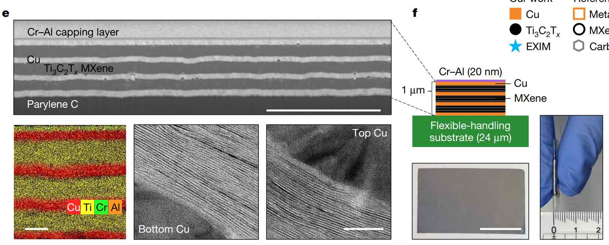

▲ Image of EXIM shielding film. A stack of 2D MXene and 3D metal thin films.

This research is attracting attention as a key technology for the commercialization of ultra-thin, high-performance shielding films. In particular, it fundamentally resolves the long-standing "thickness-performance dilemma" in the development of conformal electromagnetic shielding films (EMF) used in semiconductor packaging. The thinner the film, the lower the shielding performance. This achievement was published online in the world's most prestigious scientific journal, Nature, on October 30, 2025.

* MXene: A two-dimensional ceramic material composed of alternating layers of metal atoms and carbon (or nitrogen) atoms. It boasts both excellent electrical conductivity and mechanical flexibility, attracting attention as a material for next-generation electronic devices and electromagnetic shielding.

* conformal: This refers to a form that evenly and tightly wraps around the surface of a semiconductor chip, conformally conforming to the shape of the chip's surface. It also allows for uniform coating thicknesses, even on chips or packages with complex structures.

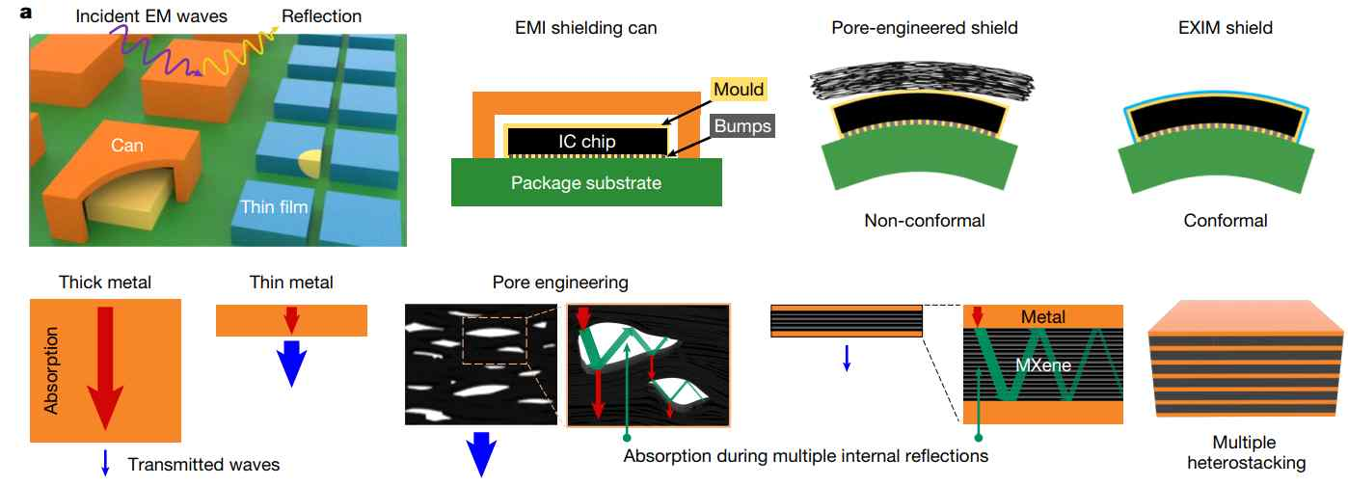

▲ Types of electromagnetic shielding films for semiconductor packaging and conformal EXIM shielding. Metal can-type shielding films offer excellent performance but are thick, heavy, and bulky. Porous shielding films offer excellent performance relative to their thickness, but suffer from various limitations due to the formation of pores. The research team's EXIM shielding film has a laminated structure of metal and MXene thin films, confining electromagnetic waves within the MXene layer to maximize performance even at a thin thickness.

Electromagnetic interference (EMI) generated in electronic devices can cause communication errors, malfunctions, and overheating, reducing device performance and stability.

Accordingly, EMI shielding technology is considered a key element in semiconductor packaging and smart device design. However, existing metal-based shielding films are thick and heavy, making them difficult to apply to modern electronic devices requiring miniaturization and flexibility.

To address these limitations, conformal electromagnetic shielding films were developed, a cutting-edge material essential for making semiconductor packages lighter and thinner.

However, existing shielding films suffer from the "thickness-performance dilemma," whereby electromagnetic shielding performance deteriorates sharply with decreasing thickness, making it difficult to simultaneously achieve both weight reduction and high performance.

Previous research attempts included forming numerous microscopic pores within the shielding film to enhance electromagnetic wave scattering. However, these methods have been difficult to apply to actual semiconductor packaging due to incompatibility with semiconductor processes, such as high temperatures, pore non-uniformity, and limitations caused by increased thickness.

To address this issue, the research team proposed a new "EXIM (Embedded-MXene-in-Metal) shielding film" structure, which utilizes existing semiconductor packaging equipment to stack metal and MXene films without creating pores.

* pores: Microscopic pores within a material, used to scatter and absorb electromagnetic waves or to control the material's density and weight. The more uniform the pore size and distribution, the more stable the electromagnetic shielding performance.

In the new EXIM structure, the metal film acts as a wall to confine electromagnetic waves, while the MXene film within it induces scattering and absorption. This achieves performance over 100 times higher (over 20 decibels (dB), blocking approximately 99% of electromagnetic waves) than existing shielding films, even at a thickness of less than 2 micrometers (μm, approximately 1/50 the thickness of a human hair).

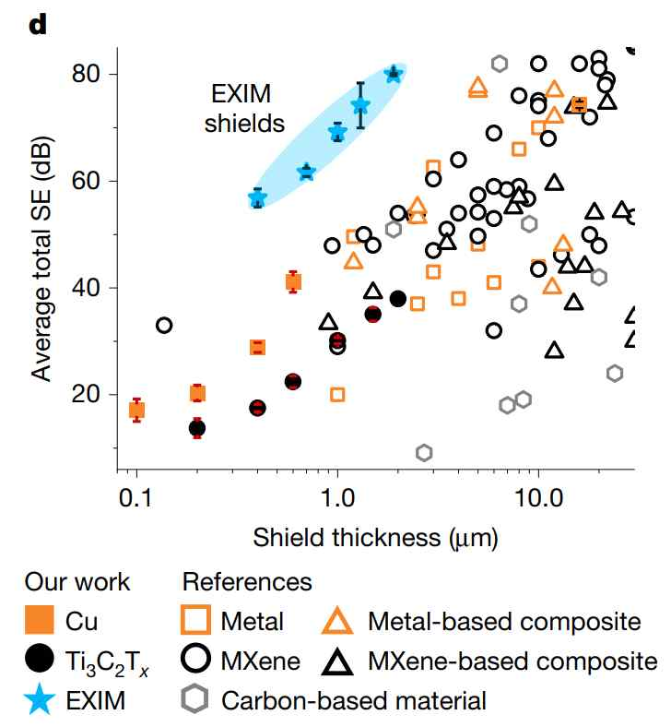

▲ Benchmark for shielding performance and thickness. EXIM shielding films demonstrate over 20 dB (over 100 times) better performance than conventional shielding films.

Furthermore, performance was maintained even when the MXene thickness was reduced from 1 micrometer (μm) to 200 nanometers (nm, approximately 1/500 the thickness of a human hair). Furthermore, inserting only a 4-nanometer-thick organic layer at the metal-MXene interface resulted in a sharp drop in performance. This experimentally demonstrated that the key to shielding performance is the quality of the metal-MXene heterojunction interface.

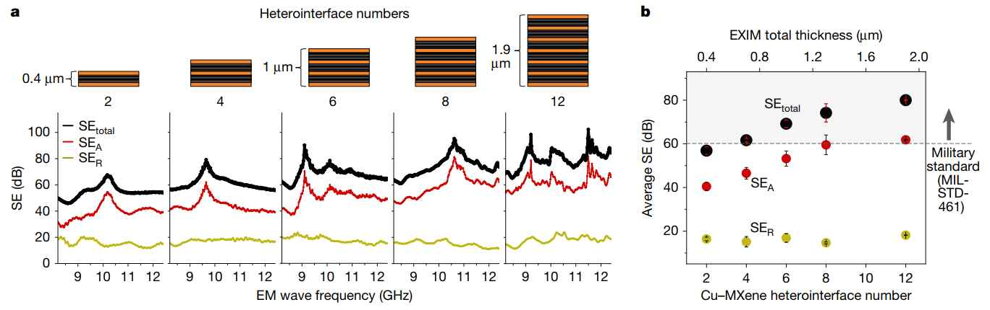

▲ Improved electromagnetic shielding performance based on metal-MXene heterojunctions. Metal-MXene heterojunctions can be formed through multiple heterostacks by controlling the number of interfaces.

The research team also applied a 20-nanometer (nm) thick chromium-aluminum capping layer* to enhance the environmental stability of the EXIM shielding film, ensuring stable performance even in humid environments.

As a result, the EXIM shielding film maintained stable performance for over 48 hours without oxidation or corrosion, even in high-temperature (over 85°C) and high-humidity (85% RH) environments.

* capping layer: A protective layer formed at the top layer to protect internal materials from the external environment or enhance performance. It prevents oxidation, contamination, and moisture penetration, and enhances the durability and stability of the electromagnetic shielding film.

The research team applied this technology to commercial flash drive semiconductor chips and flexible devices, demonstrating both process compatibility and ultra-close adhesion.

For example, applying the ultra-thin film to the IC chip of a USB 3.0 flash drive completely eliminated Bluetooth speaker signal interference. Even in flexible ZnO-based Schottky diodes, current fluctuations due to electromagnetic waves were reduced to less than 1/20th of the original value.

As a result, the EXIM shielding film, with a thickness ranging from 1 to 1.9 micrometers (μm), is much thinner and more flexible than conventional aluminum foil (16 μm thick), yet achieves ultra-high shielding effectiveness of 70 to 80 decibels (dB), exceeding military standards (over 60 dB).

Professor Yeon Han-ul of GIST stated, "This research overcomes the long-standing dilemma of 'thinner thickness leads to lower performance' in electromagnetic shielding materials. This extremely thin and flexible shielding technology, yet boasts outstanding performance, will find wide application in diverse fields, including next-generation semiconductor packaging, smart devices, and flexible electronic devices."

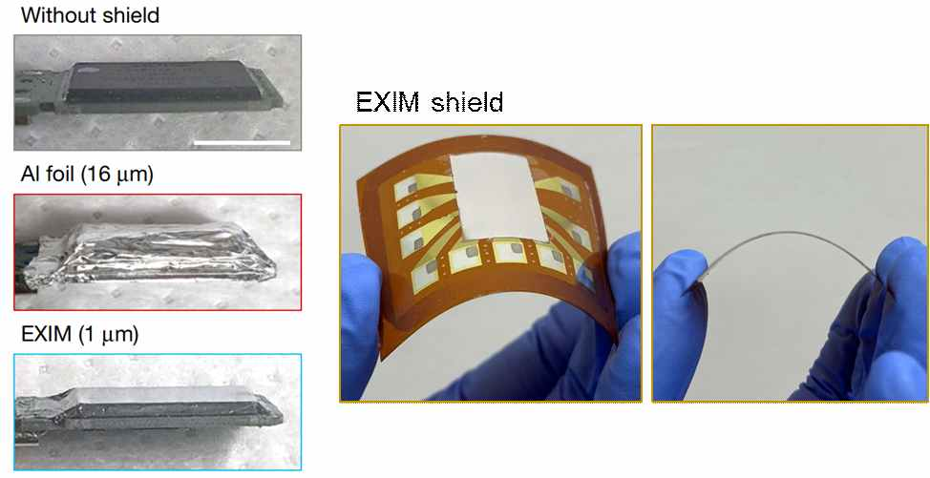

▲ Utilizing EXIM electromagnetic shielding films. Conformally formed on the surface of semiconductor chips and flexible devices.

This research, jointly supervised by Professor Hanwool Yeon of the Department of Materials Science and Engineering at GIST and Professor Young-Chang Joo of Seoul National University, and conducted by Geosan Kang and Guhyeon Kwon, both of Seoul National University, and Jiwoon Jeon, a combined master's and doctoral student at GIST, received support from the Ministry of Science and ICT's 2023 Regional Innovation Mega Project and the 2024 Semiconductor Advanced Packaging Core Technology Development Project.

Meanwhile, GIST stated that the results of this research were considered in consideration of both academic significance and industrial applicability, and that discussions regarding technology transfer can be conducted through the Technology Commercialization Center (hgmoon@gist.ac.kr).



