"Enjoy 4D VR in a moving car…including heat, wind, and seat motion" GIST developed a platform that creates a vivid VR experience using only the vehicle's basic built-in systems

- Professor SeungJun Kim's team from the Department of AI Convergence developed "AttraCar," a vehicle VR platform that synchronizes heat, wind, and seat motion without a separate device... Real-world driving conditions have proven to reduce motion sickness, enhance immersion, and enhance presence

- Real-time responsive wind and seat motion, along with seat heating and cooling that reach target temperatures within 3-4 seconds, ensure optimal immersion and tactile sensations... Presented and won three awards at the international academic conferences "ACM UIST 2025" and "IEEE ISMAR 2025"

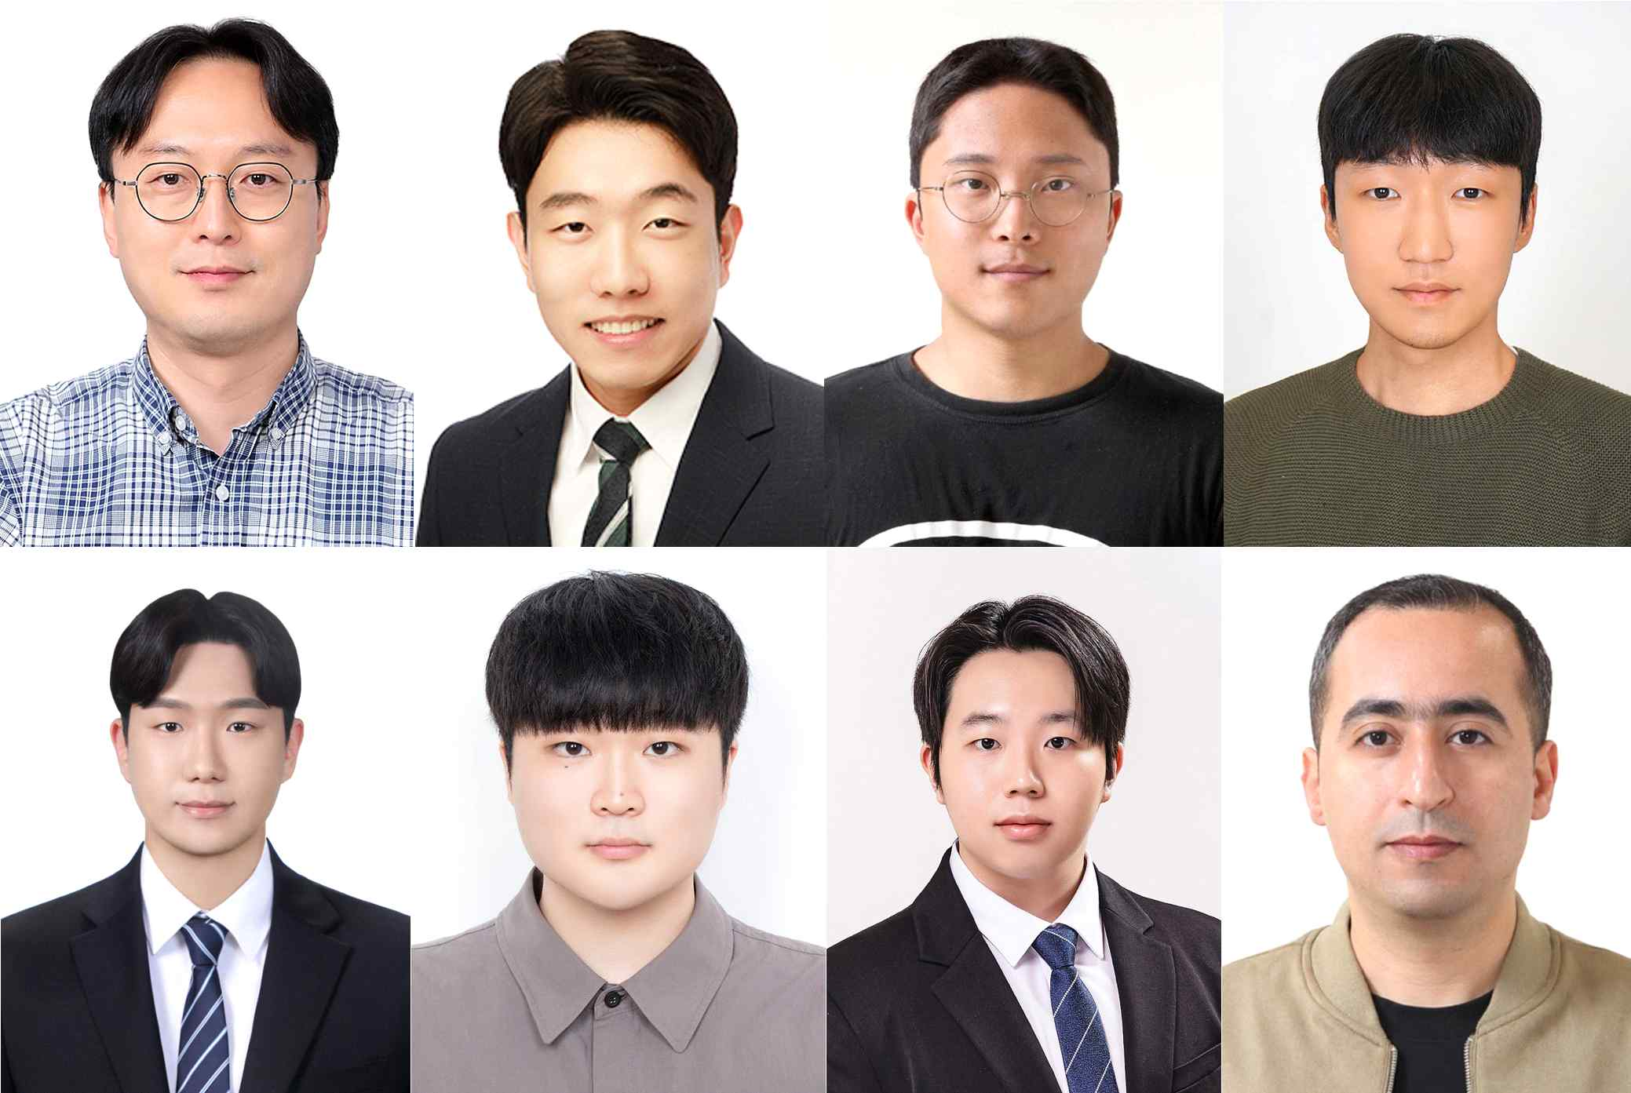

▲ (Clockwise from top left) GIST Department of AI Convergence Professor SeungJun Kim, Ph.D. student Dohyeon Yeo, Ph.D. student Gwangbin Kim, master's student Minwoo Oh, Assistant Research Professor Ahmed Elsharkawy, Ph.D. student Seongjun Kang, master's student Bocheon Gim, and master's student Jeongu Park

The Gwangju Institute of Science and Technology (GIST, President Kichul Lim) announced that Professor SeungJun Kim's research team in the Department of AI Convergence has developed "AttraCar," a vehicle VR platform capable of precisely synchronizing virtual reality (VR) content with heating/cooling, airflow, and seat motion feedback using only the vehicle's built-in systems.

"AttraCar" offers multisensory stimulation without the need for separate wearable or external devices, reducing motion sickness and enhancing immersion and presence.

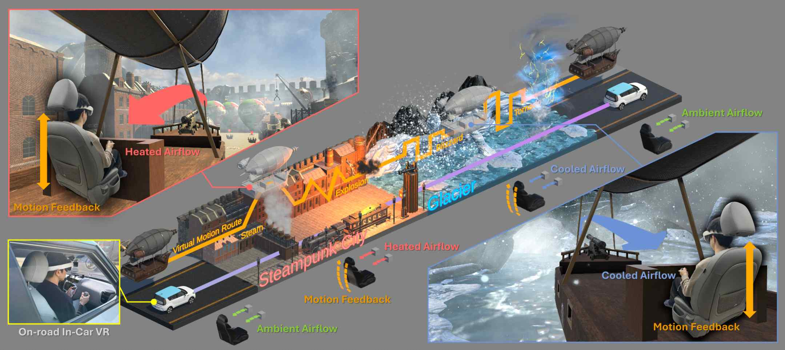

▲ Overview of the 'AttraCar' platform technology. Passengers in the AttraCar wear a VR headset and experience virtual spaces (Steampunk City, Icefield) while experiencing multi-sensory feedback of heat, wind, and motion provided by the in-vehicle system, creating an immersive in-vehicle VR experience.

The research team integrated this platform into the system without modifying the vehicle and verified its effectiveness in an on-road environment. This established the foundation for a safe and reliable in-vehicle VR user experience, even while driving.

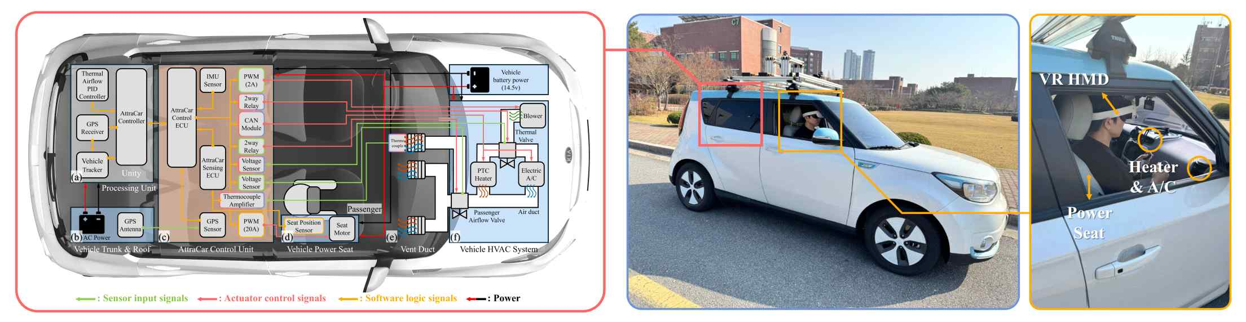

▲ AttraCar system configuration. Heat, wind, and motion feedback are synchronized with the VR scenario through the vehicle's HVAC (air conditioning) system and power seat control. (Left) AttraCar control system architecture. (Right) AttraCar platform and passenger.

To verify the feasibility of the in-vehicle system as a multi-sensory feedback device, the research team experimentally identified the "perceptual thresholds*" for wind speed, temperature (heating/cooling), and seat motion.

As a result, users clearly perceived changes in wind speeds of approximately 0.34 m/s, seat motion of approximately 1.75 mm/s, and differences in heating and cooling temperatures of approximately 7.2°C and 4.4°C, respectively. Based on this data, the research team designed stimulus intensities for each situation and applied them to actual driving scenarios.

* just noticeable difference (JND): This refers to the minimum amount of change required for the human senses to first detect a difference between two stimuli. Simply put, it represents the "limit beyond which a difference can be perceived" at a given stimulus intensity, and is applied across various sensory domains, including vision, hearing, and touch.

Next, the research team conducted an experiment comparing user responses under six conditions combining wind conditions (none/room temperature/hot air) and seat motion conditions (none/present) in an actual driving environment.

As a result, motion sickness (SSQ) was significantly reduced when wind and seat motion stimuli were provided together, while presence (IPQ) and haptic experience (HX) were significantly improved. The greatest interaction effect was observed in the "hot wind + seat motion" condition.

* The study assessed users' perceived responses using three indicators: motion sickness (SSQ, Simulator Sickness Questionnaire), presence (IPQ, Igroup Presence Questionnaire), and haptic experience (HX, Haptic Experience). The SSQ is a questionnaire that quantitatively measures the degree of motion sickness experienced in a simulator or virtual environment, while the IPQ assesses the user's sense of immersion and presence within the environment. The HX is an indicator that reflects the user's tactile experience in response to haptic stimulation. Through these three assessments, we can comprehensively analyze the impact of various stimuli in a driving environment on user immersion and comfort.

The "AttraCar" platform has also proven its commercial viability in terms of technical perfection. The average delay from input of wind and seat motion signals to response is only about 60 milliseconds (ms, 0.06 seconds), and the target heating and cooling temperatures are measured at approximately 4.3 and 3.6 seconds, respectively, seamlessly synchronizing with on-screen events.

Furthermore, the system was integrated while maintaining the existing vehicle control method, meeting safety standards and demonstrating stable operation in actual vehicles.

Professor SeungJun Kim stated, "With the system already built into the vehicle, we can now provide multi-sensory feedback to passengers, enabling a more immersive and vivid VR experience even inside the vehicle." He added, "This study systematically demonstrates the potential of in-vehicle VR technology and its enhanced user experience."

This research, supervised by Professor SeungJun Kim of the Department of AI Convergence at GIST and led by Ph.D. candidate Dohyeon Yeo as the first author, was supported by the National Research Foundation of Korea's Mid-career Researcher Support Program and the Overseas Research Institute Collaboration Hub Establishment Project, as well as the University ICT Research Center (ITRC) of the National IT Industry Promotion Agency (NIPA).

The results of this research were presented earlier this month at the ACM UIST (The ACM Symposium on User Interface Software & Technology) 2025, the most prestigious international academic conference in the field of human-computer interaction, and the IEEE ISMAR (International Symposium on Mixed and Augmented Reality) 2025, a leading international academic conference in computer engineering.

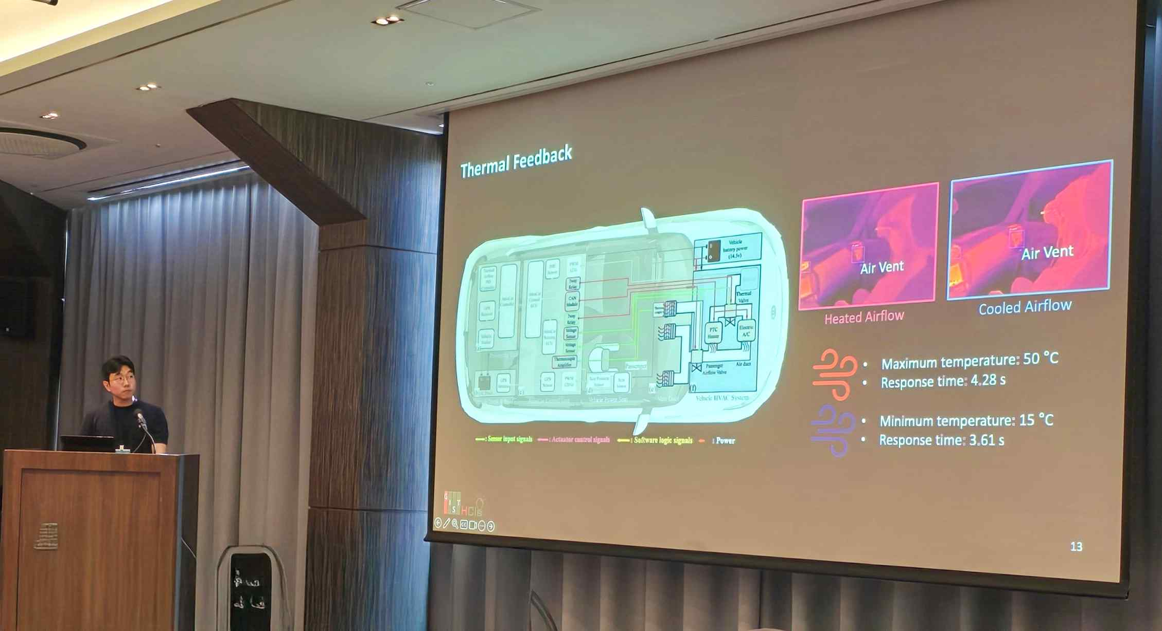

▲ Professor SeungJun Kim's research team presents the results of their "AttraCar" research at the ACM UIST 2025.

In particular, at ‘ACM UIST 2025’, it won both the ‘People’s Choice Best Demo Award’ and the ‘Jury’s Choice Demo Honorable Mention’ in the technology demonstration category, and also won the ‘Best Demonstration Award’ at ‘IEEE ISMAR 2025’, receiving international recognition for its technological prowess and practicality.

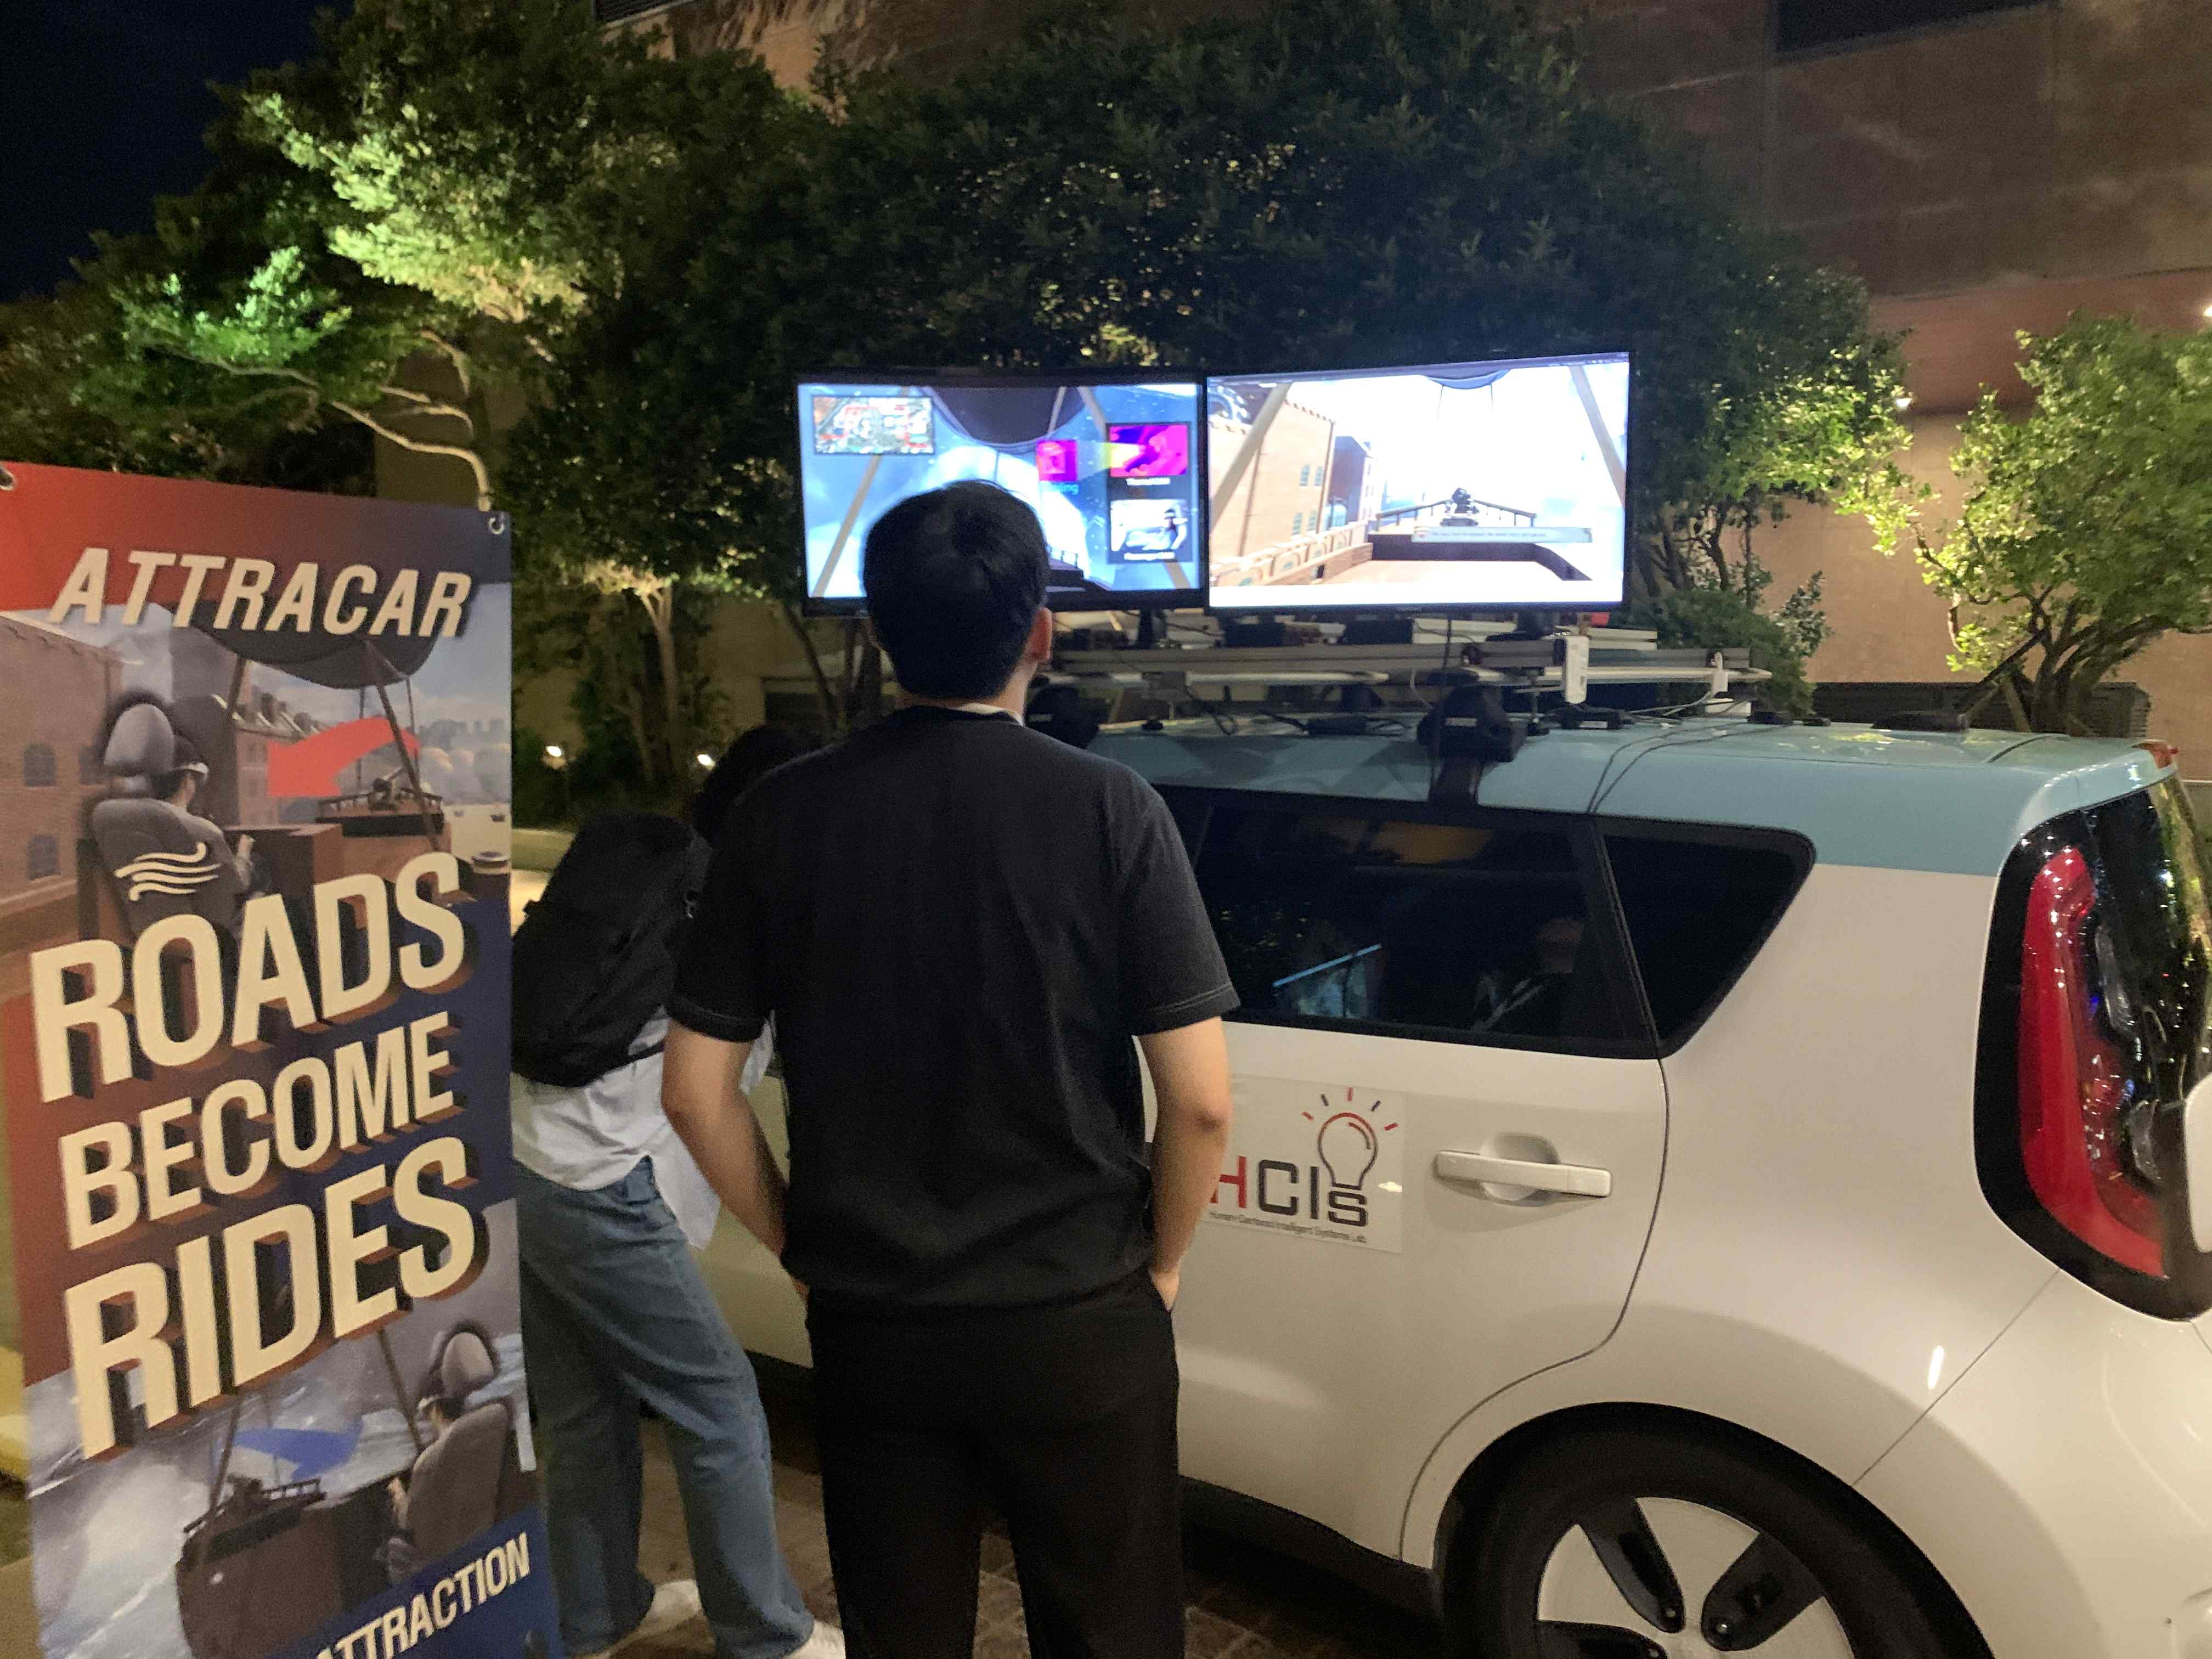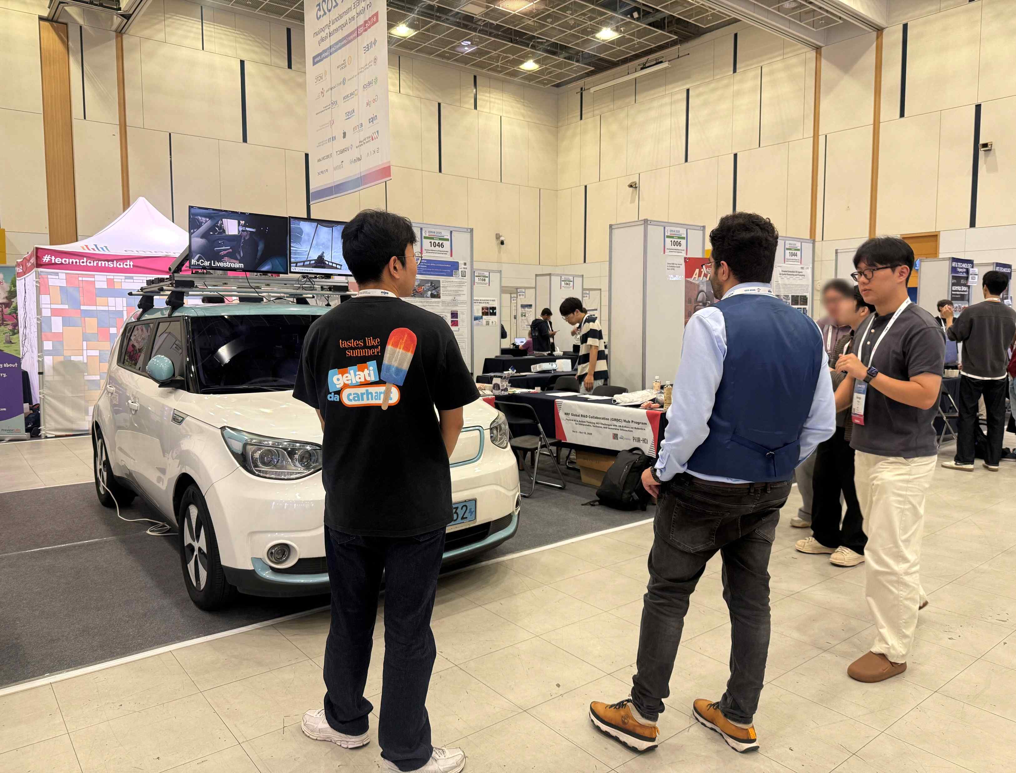

▲ Professor SeungJun Kim's research team is demonstrating and explaining the "AttraCar" research at "IEEE ISMAR 2025."

Meanwhile, GIST stated that this research achievement considered both academic significance and industrial applicability, and that technology transfer-related discussions can be conducted through the Technology Commercialization Center (hgmoon@gist.ac.kr).



