"Acute renal failure no longer becomes chronic" GIST and Chonnam National University have developed the world's first nanomedicine technology that prevents acute renal failure from becoming chronic

- Professor Jae Young Lee's team from the School of Materials Science and Engineering, in collaboration with Professor Soo Wan Kim's team from Chonnam National University College of Medicine, developed an "intelligent nanoplatform" that releases drugs only in response to reactive oxygen species in the damaged area... The platform demonstrated a pathological transition from acute renal failure to chronic renal failure

- The combination of hyaluronic acid (HA) and reduced graphene (rGO) enabled selective targeting of damaged areas and enhanced in vivo stability... Cell and animal model experiments demonstrated inhibitory effects on inflammation, fibrosis, and cell death. Published in the international journal «Theranostics»



▲ (From left) Professor Jae Young Lee from the Department of Materials Science and Engineering at GIST, Professor Soo Wan Kim of the Department of Internal Medicine at Chonnam National University Medical School, Professor Sang Heon Suh of the Department of Internal Medicine at Chonnam National University Medical School, and Ph.D. student Seungjun Lee of the Department of Materials Science and Engineering at GIST

The Gwangju Institute of Science and Technology (GIST, President Kichul Lim) announced that a joint research team led by Professor Professor Jae Young Lee from the Department of Materials Science and Engineering and Professor Soo Wan Kim at Chonnam National University Medical School has developed a novel treatment technology that fundamentally blocks the progression of acute kidney injury into chronic kidney disease (CKD).

This study is noteworthy for presenting a therapeutic strategy that can inhibit the pathological process that causes acute kidney injury (AKI) to progress to chronic kidney disease (CKD). It is expected to be a groundbreaking achievement that could open new treatment options for patients at high risk for kidney damage due to surgery, contrast agents, sepsis, and other conditions.

Acute kidney failure (AKI) is a disease characterized by rapid decline in kidney function due to various causes, including blood flow obstruction, sepsis, and toxic substances. Even after recovery, many patients experience the "AKI-to-CKD transition," a phenomenon in which kidney damage progresses to chronic kidney disease (CKD).

This process involves excessive production of reactive oxygen species (ROS) within kidney tissue, triggering a chain reaction of cell damage → inflammation → and fibrosis. If chronic renal failure progresses, dialysis or kidney transplantation is ultimately required, but to date, there has been no clear treatment to prevent this.

Furthermore, there was a critical need for targeted and responsive nanomedicine technology, as there was a lack of treatments that effectively control reactive oxygen species and act only on damaged areas.

To address this issue, the research team developed a graphene-based intelligent nanomedicine platform that can effectively remove excess reactive oxygen species generated in renal injury while selectively delivering antifibrotic drugs to the damaged area.

This platform is designed to selectively target damaged kidney areas by combining hyaluronic acid (HA) with reduced graphene. Furthermore, paricalcitol, an antifibrotic drug from the vitamin D derivative family, was loaded onto the platform, ensuring drug release only in the oxidative environment of the damaged area.

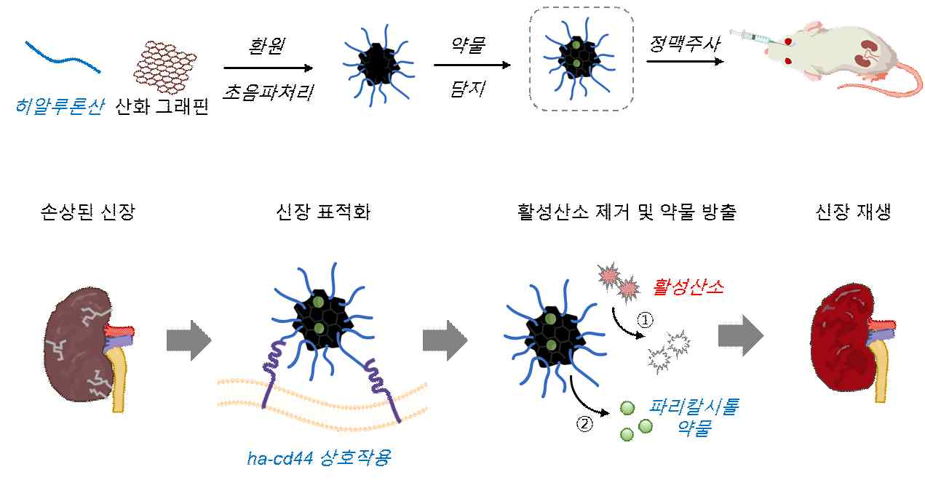

▲ A Schematic diagram of paricalcitol-loaded reduced hyaluronic acid-conjugated reduced graphene oxide nanoparticles (P/HA/rGO) for the treatment of ischemia-reperfusion renal injury. (A) Synthesis process of P/HA/rGO: Synthesized via reduction and high-power sonication, then loaded with paricalcitol and intravenously injected into rats with acute kidney injury. (B) Multifunctional therapeutic properties of P/HA/rGO: Inhibition of the pathological progression of acute kidney injury through specific targeting of damaged kidneys via HA-CD44 interaction, scavenging of reactive oxygen species, and reactive oxygen-responsive drug release.

This 'P/HA/rGO nanomedicine, created by combining anti-fibrotic drugs (P), hyaluronic acid (HA), and reduced graphene oxide (rGO), implements an 'active oxygen-responsive drug release mechanism' that releases the drug only in lesion areas with high levels of active oxygen. It is characterized by acting selectively only on the damaged kidney tissue without affecting normal tissue.

Furthermore, the combination of hyaluronic acid significantly enhances in vivo stability and blood retention time, enabling sustained and precise therapeutic effects.

The research team systematically verified the platform's ▲ drug delivery efficiency ▲ reactive oxygen scavenging ability ▲ tissue targeting ▲ therapeutic effect through cell-level experiments and renal ischemia/ reperfusion (IR)* injury animal model experiments.

* renal ischemia-reperfusion injury: Renal ischemia-reperfusion injury refers to acute renal damage that occurs when blood flow to the kidney is temporarily interrupted and then restored. It is a common cause of kidney transplantation and emergency surgery.

Experimental results showed that the nanocomposite exhibited a drug loading efficiency of 93%, and 26% of the drug was released over 30 days in the presence of reactive oxygen species, demonstrating a release efficiency approximately 2.7 times higher than that under normal conditions.

This demonstrated the ability to precisely control drug release by responding to excessive accumulation of reactive oxygen species at the site of injury, allowing for only the necessary time.

In cell experiments, the hyaluronic acid (HA)/reduced graphene (rGO) composite (HA/rGO) significantly reduced renal cell damage in an environment where excessive reactive oxygen species accumulate and damage cells. It also demonstrated high antioxidant protection, maintaining cell viability of over 70% even in an environment with 1 millimolar (mM) * hydrogen peroxide.

In an animal model, a nanocomposite (P/HA/rGO)* combining an antifibrotic drug (P), hyaluronic acid (HA), and reduced graphene (rGO) accumulated only in damaged kidneys through selective interactions between the CD44 receptor on the cell surface and hyaluronic acid (HA) (CD44-HA*), significantly reducing blood levels of kidney damage markers (NGAL, cystatin C). Inflammation, fibrosis, and apoptosis were also effectively suppressed.

* 1 millimole (mM): 0.001 mole (mol) of solute dissolved in 1 liter (L) of solution. One mole represents approximately 6.022 × 10²³ particles (atoms, molecules, ions, etc.), and therefore, 1 millimole represents 1/1000 of this number of particles. In experiments, the unit of mM is used when dealing with very low concentrations of drugs or chemicals.

* nanocomposite (P/HA/rGO): This composite can be designed as a targeted nanomedicine platform that selectively releases drugs only at the site of injury. Antifibrotic drug (P) - A treatment that inhibits "fibrosis," the excessive formation of fibrous tissue in areas such as the kidneys, liver, and lungs, alleviating tissue damage and reducing inflammation. / Hyaluronic acid (HA) - A natural polysaccharide found in the human body. It selectively binds to the CD44 receptor on the cell surface, enabling targeted drug delivery to specific sites such as damaged tissues or cancer cells. / Reduced graphene (rGO) - A nanomaterial made by reducing graphene oxide (GO). Its large surface area and excellent electrochemical stability make it ideal for drug delivery, biosensors, and photothermal therapy.

* CD44-HA: This refers to the selective binding of the CD44 receptor on the cell surface to hyaluronic acid (HA). CD44 is involved in cell growth, migration, and signaling, and is particularly highly expressed in cancer cells and damaged tissues.

* renal damage markers: NGAL (Neutrophil Gelatinase-Associated Lipocalin) and Cystatin C, biomolecules used to assess the degree of renal function impairment, are used.

As a result, the study successfully blocked the pathological transition from acute renal failure to chronic renal failure, including renal tubular damage, inflammation, and fibrosis that occur after renal ischemiareperfusion injury. This demonstrates the potential of an integrated nanomedicine treatment strategy that transcends the limitations of existing treatments.

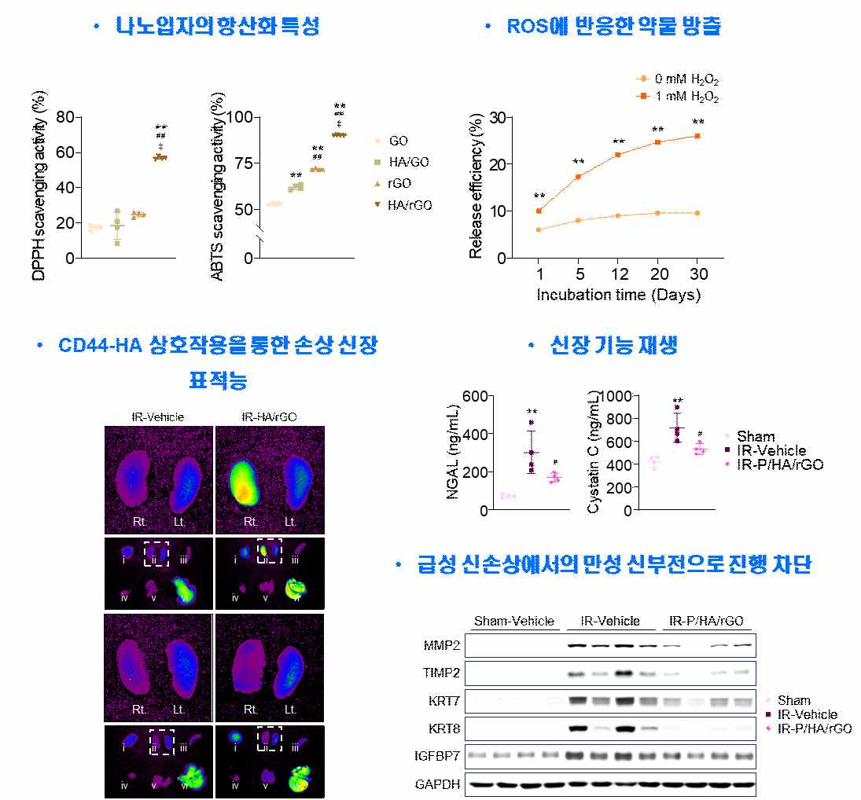

▲ Antioxidant properties, drug release capacity, renal targeting ability, and renal therapeutic efficacy in animal models of nanoparticles. The fabricated nanoparticles were confirmed to exhibit increased antioxidant activity against DPPH and ABTS radicals. They also exhibited drug release properties in response to oxidative stress. Application to animal models of kidney injury demonstrated targeted kidney function, regenerated kidney function (recovery of renal function assessment indicators), and inhibited the progression of chronic renal failure in acute kidney injury.

Professor Jaeyoung Lee of the Department of Materials Science and Engineering at GIST stated, "This study presents an intelligent nanomedicine platform that responds to reactive oxygen species and delivers drugs specifically to the damaged area." He added, "In future clinical trials, this approach could be applied to various kidney diseases, including diabetic nephropathy, as well as renal failure."

Professor Soowan Kim of Chonnam National University College of Medicine emphasized, "This treatment strategy simultaneously suppresses cell damage (oxidative stress) and fibrosis caused by reactive oxygen species, a major cause of kidney disease, and will overcome the limitations of existing treatments."

This study, supervised by Professor Jae Young Lee from the Department of Materials Science and Engineering at GIST and Professor Soo Wan Kim of the Department of Internal Medicine at Chonnam National University Medical School, and participated by researchers Seungjun Lee, Junghyun Kim, and Sehyeon Park of the Department of Materials Science and Engineering at GIST, and Researchers Sang Heon Suh and Seong Kwon Ma of Chonnam National University, was supported by the National Research Foundation of Korea's Regional Innovation Leading Research Center (RLRC) project, mid-career research project, mid-career follow-up research project, and GIST-Chonnam National University Hospital joint research project.

The research results were published online in the international journal «Theranostics» on October 23, 2025.

Meanwhile, GIST stated that this research achievement considered both academic significance and industrial applicability, and that technology transfer-related discussions can be conducted through the Technology Commercialization Center (hgmoon@gist.ac.kr).



