GIST successfully produced high-value, eco-friendly D-mannitol from discarded sugarcane byproducts

- Professor Inchan Kwon's team from the Department of Materials Science and Engineering has developed an eco-friendly bioconversion technology that converts molasses from sugarcane refining into D-mannitol using only an enzymatic reaction... The D-gluconolactone produced during the reaction can also be utilized as a value-added compound

- The technology demonstrates high conversion efficiency (92-95%) and enzyme stability, improving reaction speed and selectivity compared to existing microbial fermentation methods... Minimizing byproducts ensures economic and environmental benefits. The research was published in the international journal 《Industrial Crops and Products》

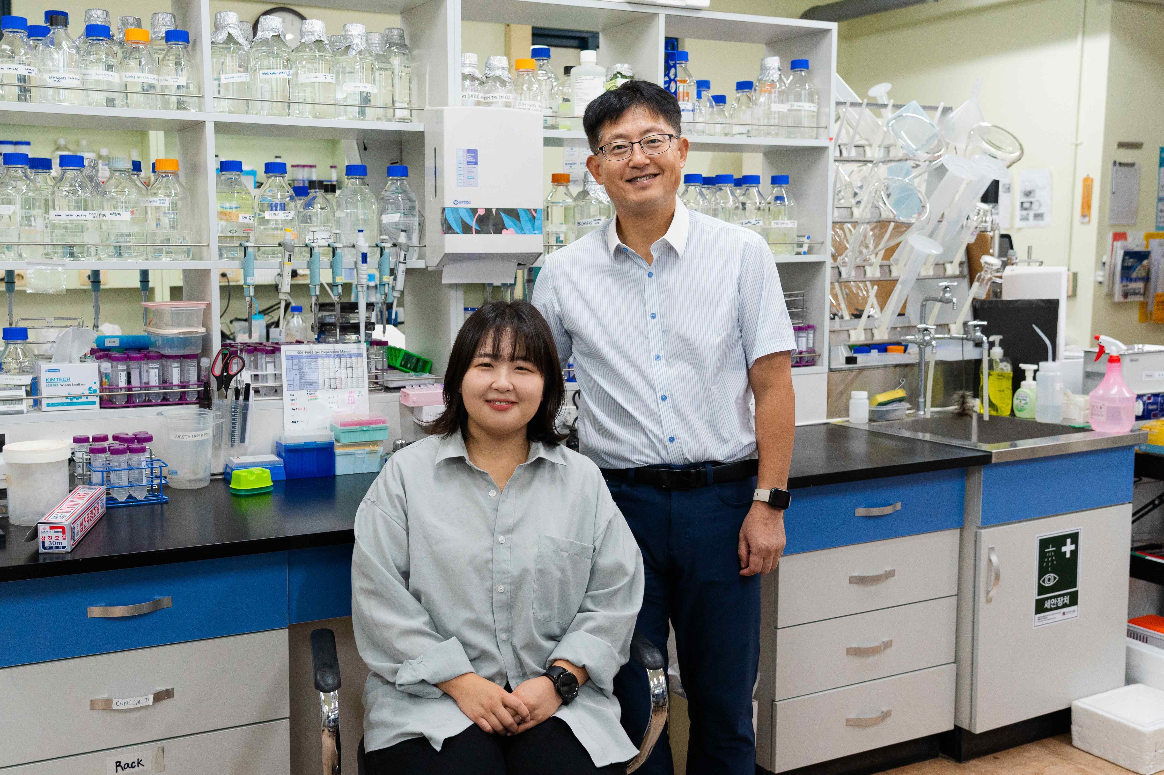

▲ (From left) GIST Department of Materials Science and Engineering student Hyeonseon Bak and Professor Inchan Kwon

The Gwangju Institute of Science and Technology (GIST, President Kichul Lim) announced that a research team led by Professor Inchan Kwon of the Department of Materials Science and Engineering has developed an eco-friendly bioconversion technology that converts molasses, a byproduct of sugarcane refining, into the high-value-added substance D-mannitol through an enzymatic reaction alone.

D-mannitol is a natural sugar alcohol and a high-value-added functional substance used as a sweetener, stabilizer, and therapeutic agent in various industries, including food, pharmaceuticals, and cosmetics.

This research is expected to contribute to achieving a net-zero environmental impact and enhancing industrial competitiveness by upcycling discarded agricultural byproducts into new resources.

▲ Enzymatic conversion of molasses, a byproduct of sugar refining, into mannitol. Molasses, a byproduct of sugarcane production and refining, is converted into mannitol, a low-calorie sweetener and pharmaceutical, through a triple enzymatic reaction involving invertase, MDH, and GDH.

The sugar industry produces a vast amount of byproducts every year. Molasses, produced during the processing of sugarcane or sugar beets, is a viscous byproduct containing sugar, glucose, fructose, and minerals. However, most of it has been used solely as livestock feed or a low-cost ethanol feedstock, preventing its use in high-value-added applications.

Technologies that convert these byproducts into new resources are attracting attention as a key strategy for simultaneously addressing environmental issues and enhancing industrial competitiveness.

In particular, molasses, due to its high sugar content, has significant potential for recycling as a biochemical raw material. The production of D-mannitol using molasses could be a prime example of repurposing a waste byproduct into an industrial resource.

Previous research focused on producing D-mannitol from molasses primarily through microbial fermentation. However, some fructose was consumed for microbial growth and maintenance, resulting in low conversion rates and the production of unwanted byproducts such as lactic acid and ethanol.

In reality, the efficiency of existing fermentation methods remained at 60-90% of the theoretical maximum (100%). Therefore, the research team designed a new "three-step enzymatic reaction system" that converts molasses to D-mannitol solely through enzymatic reactions, without chemical treatment.

This system utilizes three enzymes—invertase*, mannitol reductase (MDH)*, and glucose reductase (GDH)*—that act as natural catalysts, inducing a chain reaction of sucrose → glucose/fructose → D-mannitol.

* invertase: An enzyme that breaks down sucrose into glucose and fructose.

* mannitol dehydrogenase (MDH): An enzyme that catalyzes the oxidation-reduction reaction between fructose and mannitol.

* glucose dehydrogenase (GDH): An enzyme that oxidizes glucose and produces the cofactor NADH.

The research team designed a self-sufficient system that eliminates the need for additional external cofactors by allowing glucose reductase (GDH) to regenerate the cofactor (NADH) consumed during the reaction in real time by oxidizing glucose.

First, invertase breaks down sucrose, abundant in molasses, into glucose and fructose. These decomposed monosaccharides become available as raw materials for other enzymatic reactions in subsequent steps.

Next, mannitol reductase (MDH) performs the key reaction of directly converting fructose into D-mannitol. To sustain this reaction, a cofactor (NADH), which acts as the enzyme's "fuel," is essential.

The third enzyme, glucose reductase (GDH), plays a crucial role here. GDH oxidizes glucose in molasses, naturally regenerating the cofactor (NADH), which then enables mannitol reductase (MDH) to continuously convert fructose into mannitol.

This chain reaction system, in which the three enzymes act in cascade, allows for the efficient utilization of the diverse sugar components in molasses. As a result, eco-friendly and economical bioconversion is possible without the use of expensive chemicals or complex pre-processing of raw materials.

* cofactor (NADH): A molecule that acts as a "chemical fuel" to facilitate the smooth operation of the enzymatic reaction. Its official name is Nicotinamide Adenine Dinucleotide (reduced form), and it serves as an energy carrier and reaction accelerator required for enzyme activity.

The research team constructed two types of enzyme reaction systems and compared their performance.

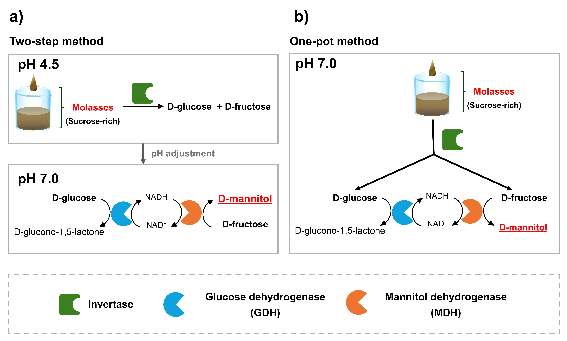

▲ Two methods for optimizing the triple enzyme complex reaction. To efficiently utilize enzymes with different optimal activity conditions, a two-step process was developed to minimize enzyme usage and a one-pot process for process simplification.

First, in a two-step process where each enzyme's optimal operating conditions were applied step-by-step, 137 mM of D-mannitol was produced, achieving a conversion efficiency of approximately 92%.

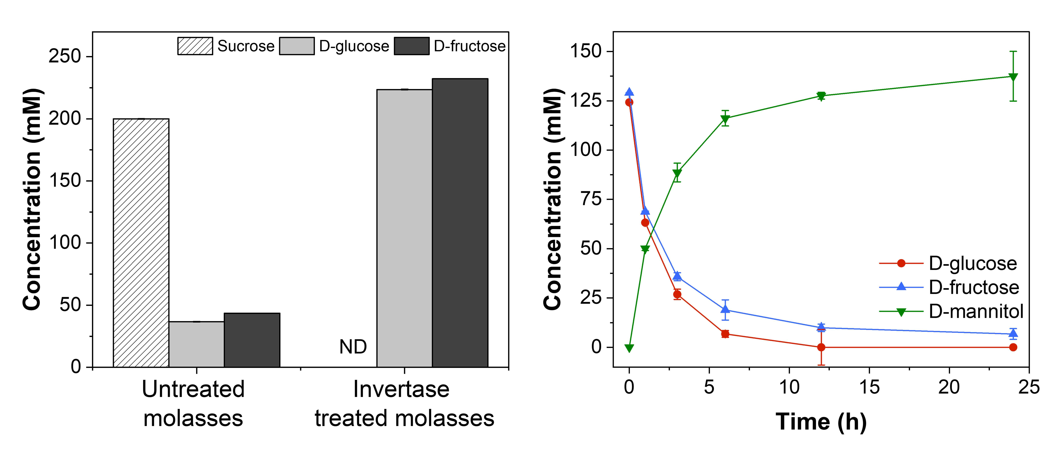

▲ Time-dependent mannitol production using the two-step method.

Conversely, in a one-pot process where all enzymes were mixed and reacted simultaneously, 123 mM of D-mannitol was produced, achieving a high efficiency of approximately 95%.

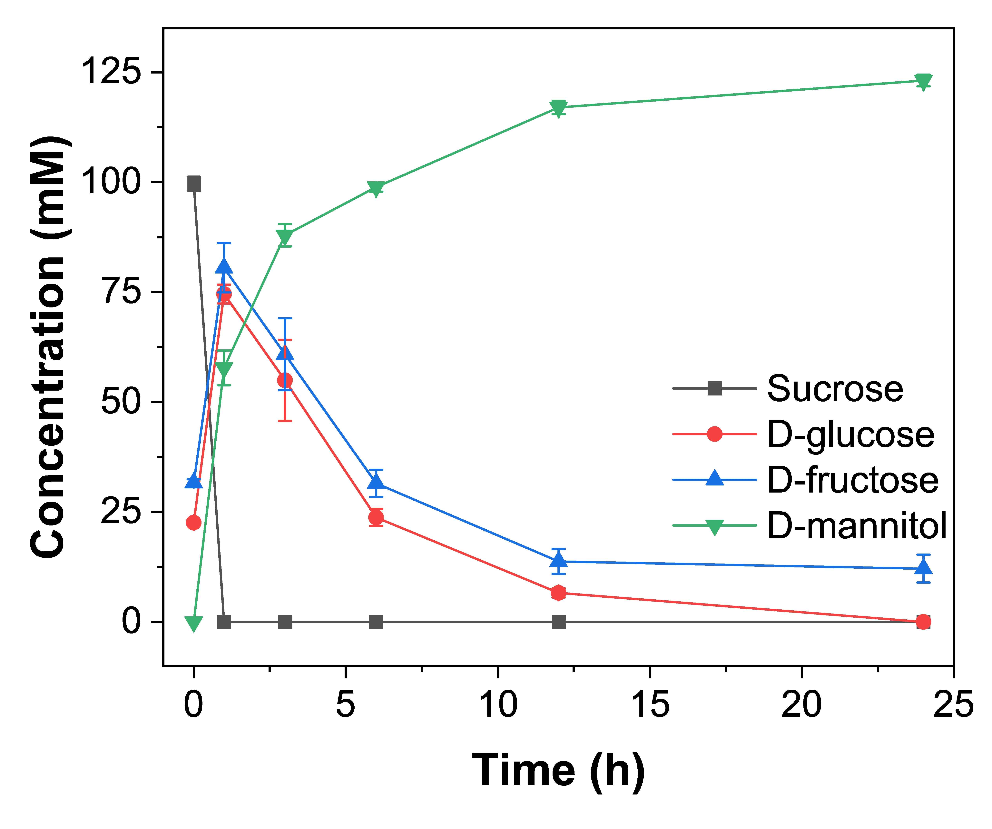

▲ Mannitol production using the one-pot method.

Notably, the enzymes exhibited stable activity even in the presence of various molasses components, and the reaction proceeded smoothly without additional treatment processes such as impurity removal or dilution, demonstrating that this enzyme system can convert molasses as a raw material.

* mM: Abbreviation for millimolar concentration, meaning that 137 millimoles (mmol) of a substance are dissolved in 1 liter (L) of solution.

Furthermore, they confirmed that D-gluconolactone, produced by glucose oxidation during the reaction process, can be utilized as another value-added compound.

This demonstrated the technological advantage of simultaneously producing two high-value compounds in a single process.

The enzyme-based technology developed by the research team boasts higher reaction speed and selectivity than existing microbial fermentation-based production methods, and produces virtually no unnecessary byproducts, making it a sustainable biomanufacturing technology that ensures process simplicity, economic feasibility, and environmental friendliness.

Professor Inchan Kwon stated, "This research demonstrates an upcycling technology that can produce high-value-added compounds from discarded industrial byproducts, ensuring both environmental friendliness and economic feasibility." He added, "We anticipate that this technology will be expanded into a sustainable biomanufacturing process in various industries, including food, pharmaceuticals, and energy."

This research, supervised by Professor Inchan Kwon from the Department of Materials Science and Engineering at GIST and conducted by integrated student Hyeonseon Bak, was supported by the National Research Foundation of Korea's Leading Research Center Program and the PhD Research Grant Program. The results were published online in the international journal 《Industrial Crops and Products》 on September 30, 2025.

Meanwhile, GIST stated that this research achievement considered both academic significance and industrial applicability, and that technology transfer inquiries can be made through the Technology Commercialization Center (hgmoon@gist.ac.kr).



