GIST "AI Solves High-Dimensional Physics Problems Through Computational Methods Instead of Experiments" GIST develops AI learning technology that reliably solves high-dimensional physics problems: The paper was selected as a "Spotlight" paper in the top 3.5% of NeurIPS 2025, the world's most prestigious AI conference

- Professor Euiseok Hwang's team from the Department of Electrical Engineering and Computer Science developed the "Adaptive Sampling Framework (LAS)" to address learning instability in physical information neural networks (PINNs). The AI ​​explores areas of high error and complex sections, enhancing learning efficiency and stability.

- Compared to existing techniques, the solution achieves accuracy and stability in high-dimensional partial differential equation problems ranging from 1 to 8 dimensions. It can be applied to diverse engineering fields such as fluid dynamics, heat transfer, transportation, and power grids. It is also expected to contribute to reducing simulation costs in industrial settings.



▲ (From left) Professor Euiseok Hwang from the Department of Electrical Engineering and Computer Science, Ph.D. student Giup Seo, and Master's student Minseok Jeong

The Gwangju Institute of Science and Technology (GIST, President Kichul Lim) announced that Professor Euiseok Hwang's research team in the Department of Electrical Engineering and Computer Science has developed a novel adaptive sampling technique to address the instability that arises in the learning of physical information neural networks (PINNs) that solve partial differential equations (PDEs).

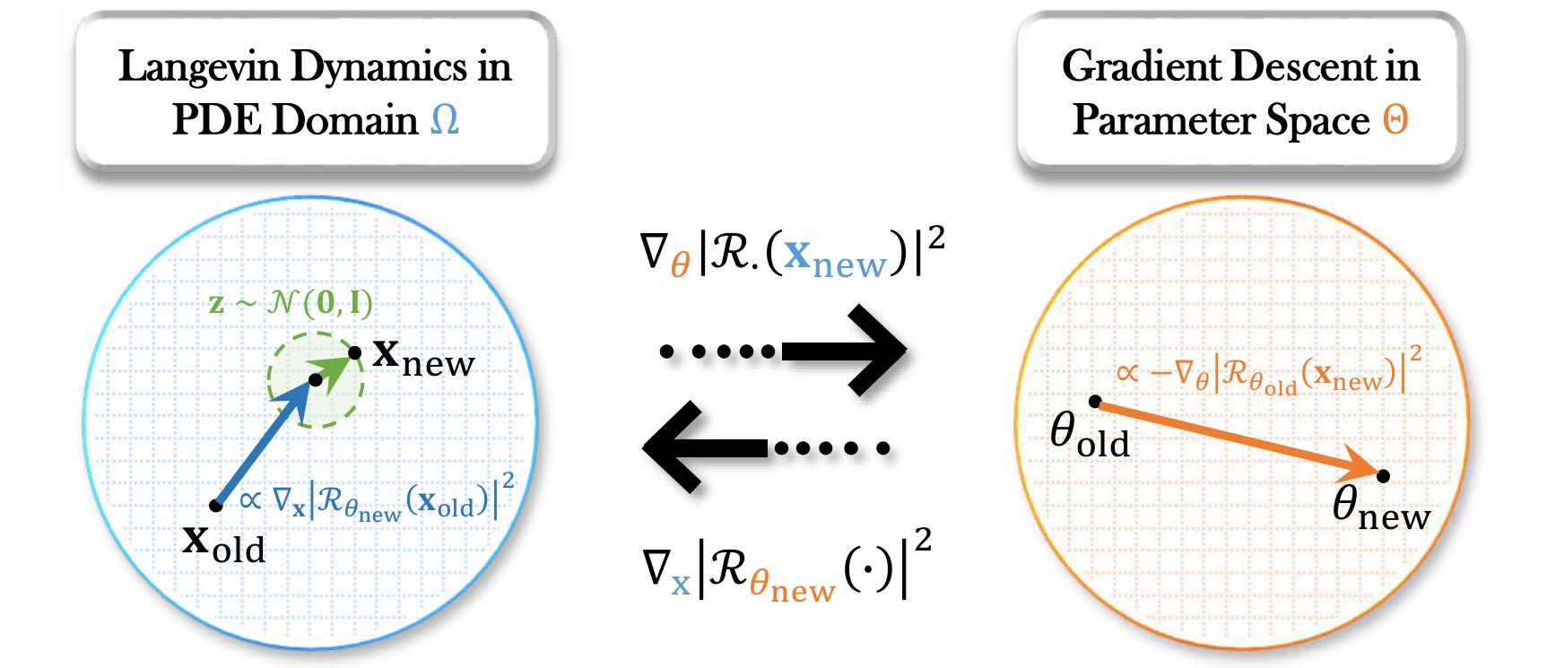

▲ LAS Framework Structure: (Explained from left to right in the figure) On one axis, collocation points are updated based on Langevin dynamics, while on the other axis, neural network parameters are learned using gradient descent.

This research achievement is characterized by improved accuracy and stability while reducing computational costs compared to existing methods, and is expected to be widely applied to various scientific and engineering problems.

* partial differential equation (PDE): An equation that includes functions of multiple variables and their rates of change (differentiation). It mathematically represents various physical phenomena, such as temperature, pressure, fluid flow, and electromagnetic fields, that vary over time and space.

* physics-informed neural network (PINN): This technique directly incorporates the laws of physics into deep learning neural networks. Beyond simply learning data, it incorporates initial conditions, boundary conditions, and physical constraints expressed as differential equations into the loss function to obtain a solution.

Physical information neural networks (PINs) are attracting attention as a next-generation analytical method that directly incorporates physical laws into the neural network learning process, reducing data collection costs and increasing computational efficiency compared to existing numerical methods (e.g., finite difference method, finite element method, etc.).

However, existing residual (error)*-based sampling techniques have the disadvantage of focusing only on certain sections of a partial differential equation when the error increases during the learning process, leading to biased learning. This leads to unstable learning, and even small changes in the learning rate can lead to significant variations in results.

* finite difference method (FDM) and finite element method (FEM): Both are representative methods for numerically solving partial differential equations (PDEs) or continuum problems (modeling physical quantities defined in continuous space and time).

* residual: The difference between the predicted value and the conditions that must actually be satisfied. For example, when solving a partial differential equation using a physical information neural network (PINN), the solution produced by the network is not perfectly valid when substituted into the equation, resulting in an error. This error is known as the residual. A larger residual indicates a poorer satisfaction of the equation, so the learning process optimizes the neural network to reduce the residual.

To address this issue, the research team proposed a new "Langevin Adaptive Sampling (LAS)" framework based on "Langevin dynamics (LD)".

Langevin dynamics is a mathematical model originally used in physics and statistical mechanics to describe the random motion of particles (Brownian motion). Its characteristic is that particles move not simply randomly, but in a manner that combines energy landscapes and probabilistic factors.

The research team applied this principle to the learning process, guiding the artificial intelligence (AI) to more frequently explore areas with high error rates or complex boundary conditions. That is, while AI explores multiple sections as if taking a random walk, it increases its own learning efficiency by looking more frequently at areas with large errors or important parts.

The core of the Adaptive Sampling Framework (LAS) is that, instead of directly estimating the residual-based probability distribution, it dynamically adjusts the sampling process by injecting noise (a constant stochastic factor) into the residual gradient information. This allows the AI ​​to prefer "flat" residual regions over "sharp" residual regions* where errors change rapidly, significantly enhancing learning stability.

As a result, LAS maintained consistent performance even with varying learning rates and model structures, and even demonstrated a more stable approach to finding a solution than existing methods for high-dimensional partial differential equation problems.

* sharp (high curvature) residual regions: These refer to regions where the error between the model's predicted value and the actual observed value, i.e., the residual, varies rapidly spatially.

The research team also demonstrated the high performance of LAS through various experiments.

For one-dimensional partial differential equation problems, such as waves or chemical reactions, LAS achieved significantly smaller errors than existing methods, and consistently and stably converged results during the learning process.

For more complex 4-8D heat transfer equation problems, existing methods were unstable and failed to learn properly, while LAS was the only method that consistently found solutions.

Furthermore, while existing methods became unstable even when the neural network structure was made more complex or the learning rate was adjusted rapidly, LAS maintained stability and accuracy even under a wide range of conditions. It also boasted superior computational efficiency, producing faster and more accurate results at a similar cost to existing methods.

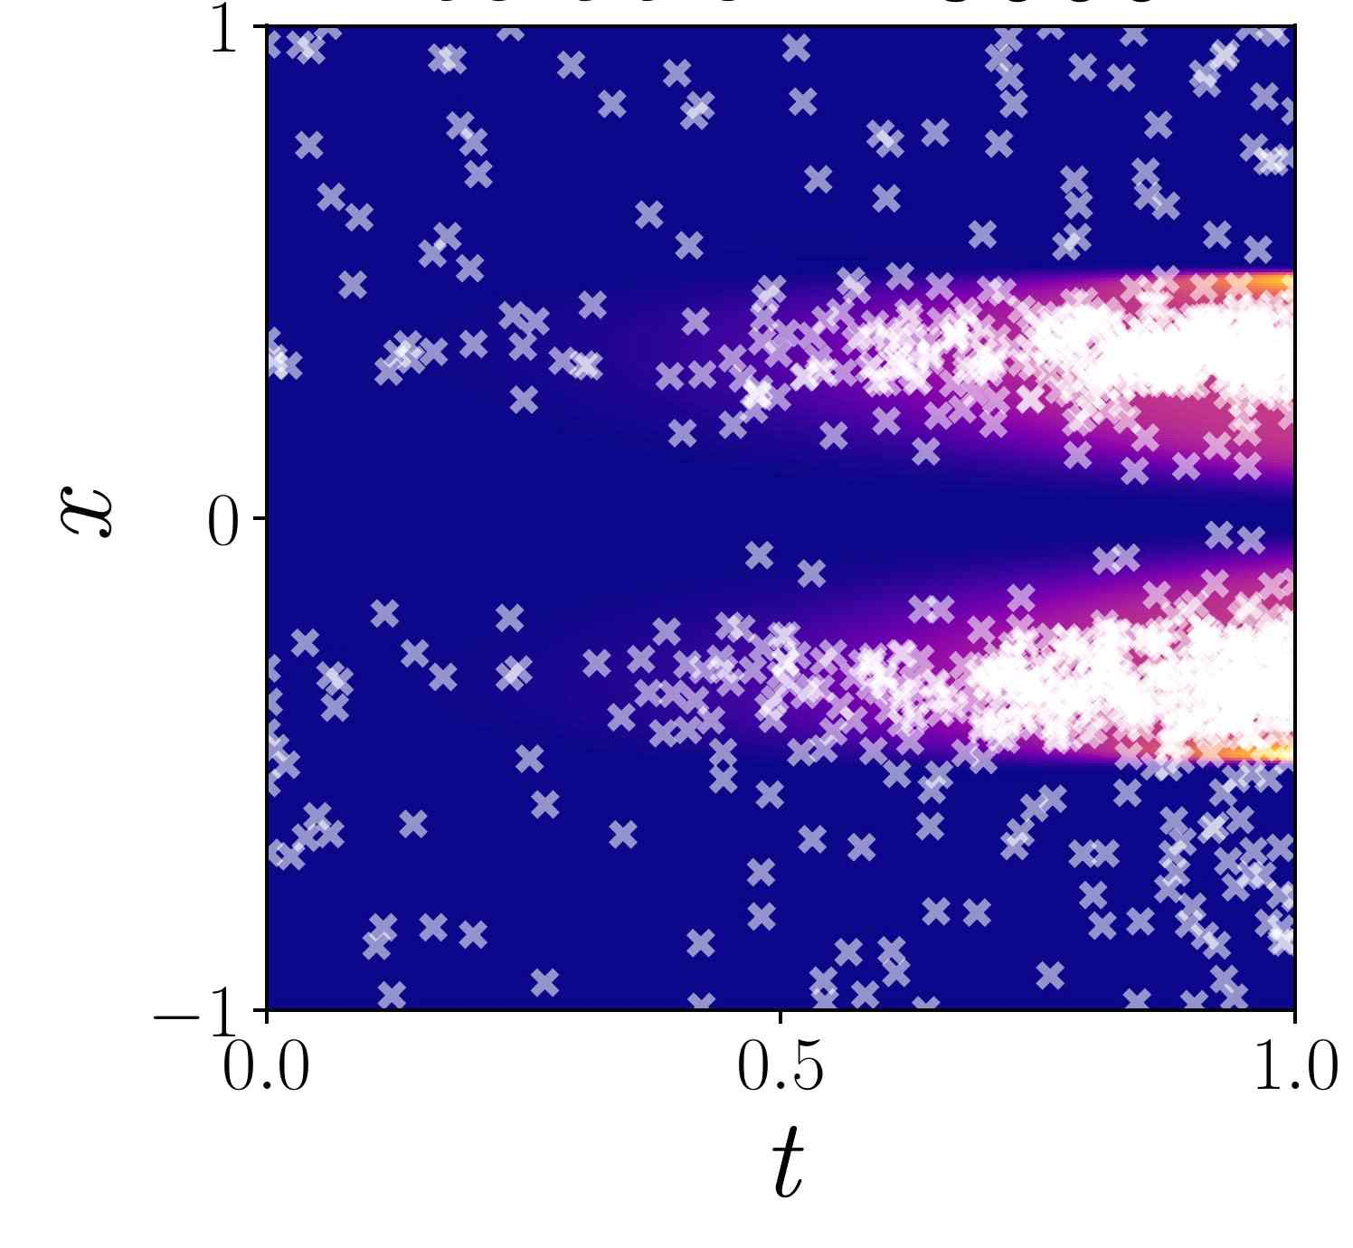

▲ LAS Sampling Points and Solution Error: The figure above shows the solution error (background color) of a one-dimensional Allen–Cahn PDE and the collocation points (white markers) sampled by LAS. As shown, collocation points are more concentrated in areas of high error, helping the model efficiently learn difficult areas. ※ Background color: (Blue → Purple → Pink → Yellow, indicating high to low residuals)

This research achievement is expected to significantly expand the scope of applications for physical information neural networks. Because it can reliably reproduce complex, multidimensional physical phenomena, it has significant potential for application in diverse engineering fields, including fluid dynamics, heat transfer, material simulation, and transportation and power grid analysis. Furthermore, its higher computational efficiency and superior data utilization compared to existing numerical analysis methods are expected to contribute to reducing simulation costs in industry.

Professor Euiseok Hwang stated, "This research presents a method that enables stable learning even in complex models while reducing computational costs. It will provide reliable AI solutions across industries that require close to accurate calculation results for high-dimensional partial differential equations, such as manufacturing and process engineering, energy and power generation, and the environment and climate."

This research, supervised by Professor Euiseok Hwang of the Department of Electrical Engineering and Computer Science at GIST and conducted by doctoral student Giup Seo and master's student Minseok Jeong, was supported by the National Research Foundation of Korea's Mid-Career Researcher Support Program and the Basic Research Support Program.

The research results were selected as a "Spotlight" paper, ranking within the top 3.5% of all papers submitted to NeurIPS (Conference on Neural Information Processing Systems), the world's most prestigious AI conference.

The paper was accepted for publication on September 18th and will be presented at NeurIPS 2025, held in San Diego, USA, from December 2nd to 7th.

Meanwhile, GIST stated that this research achievement considered both academic significance and industrial applicability, and that any inquiries regarding technology transfer can be made through the Technology Commercialization Center (hgmoon@gist.ac.kr).



