"It feels like you're actually underwater" GIST has developed the world's first pressure feedback technology that recreates the pressure felt by the eardrums in VR

- Professor SeungJun Kim's team from the Department of AI Convergence has developed an interface that precisely simulates changes in ear pressure using a VR headset... Using medical timpanometry technology, the team applies subtle pressure to the eardrum, allowing users to discern the direction and intensity of the pressure

- These applications are expected not only in specialized fields such as remote surgery, disaster relief, and diving training, but also in everyday content like exercise and music... Presented and demonstrated at the prestigious user interface conference, "ACM UIST 2025"



▲ (From left) GIST Professor SeungJun Kim, doctoral students Seongjun Kang and Gwangbin Kim, and master's students Bocheon Gim, Jeongju Park, and Semoo Shin

A Korean research team has developed an innovative haptic system that precisely controls the pressure inside the ear, enabling users to realistically experience changes in atmospheric pressure in virtual reality (VR)*. This is the first time that a VR experience has even achieved the sensation of ear-popping pressure.

* VR (Virtual Reality): A technology that allows users to experience a computer-generated, three-dimensional virtual environment as if it were real. It primarily utilizes a headset and sensors to stimulate various senses, including sight, hearing, and touch. Initially primarily used in gaming and entertainment, its application has rapidly expanded to include education, healthcare, industrial training, and remote collaboration, drawing attention as a next-generation immersive interface technology.

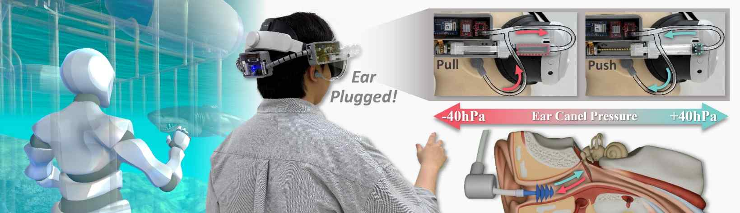

▲ Overview of the EarPressure VR System. This wearable haptic feedback device measures and analyzes changes in atmospheric and water pressure in a VR environment in real time, precisely controlling the pressure in the ear canal within a range of ±40 hPa. This allows users to experience the sensation of ear-popping, similar to the sensation experienced when descending underwater or ascending to high altitudes.

The Gwangju Institute of Science and Technology (GIST, President Kichul Lim) announced that Professor SeungJun Kim's research team in the Department of AI Convergence has developed a new technology called 'EarPressure VR' that implements a realistic sense of environmental pressure, such as stuffiness in the ears due to changes in atmospheric and water pressure, by attaching it to a VR headset and finely controlling the pressure inside the ear.

This technology safely reproduces the sensation of ear fullness, such as when changing altitude or diving underwater, in a VR environment, offering a new sensory interface that elevates existing visual and auditory-focused VR experiences to a whole new level.

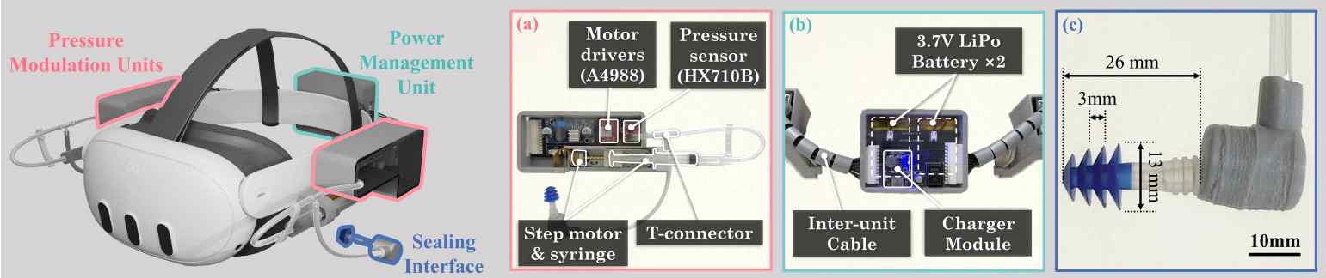

▲ EarPressure VR hardware configuration. (a) Pressure control module: Regulates ear canal pressure with a stepper motor and cylinder. (b) Power management: Drives and processes data with a pressure sensor, battery, and charging module. (c) Sealing tip: Seals the ear canal to prevent pressure leakage.

Until now, realistically reproducing pressure changes in VR has been technically challenging due to the need to control the air pressure throughout the space. The research team solved this problem by applying tympanometry* technology, which is used clinically to examine pressure in the eardrum and middle ear.

EarPressure VR monitors the internal state of the ear in real time with a pressure sensor and, using a built-in motor and medical syringe, reproduces pressure changes within a range of ±40 hectopascals (hPa)* in 0.57 seconds. This is similar to the speed a person feels when descending underwater.

* tympanometry: A clinical examination technique that injects air into the external auditory canal to measure the movement of the eardrum and the pressure in the middle ear. It is primarily used to diagnose pressure abnormalities within the middle ear, otitis media with effusion, and dysfunction of the eardrum and Eustachian tube. Its noninvasive and safe nature makes it widely used in medical settings.

* hectopascal (hPa): A unit of pressure, with 1 hPa equaling 100 pascals (Pa). It is widely used in barometric pressure reports from the Korea Meteorological Administration and in measuring middle ear pressure in the medical field. This study utilized hPa units to precisely control and numerically display pressure changes within the ear.

The research team conducted experiments to determine whether users could clearly perceive pressure changes within the ear by varying the direction and intensity of pressure.

As a result, it was possible to distinguish whether the pressure was applied inward or outward when a pressure difference of approximately 14.4 to 23.8 hPa or greater was present, and differences in intensity of 14.6 to 34.9 hPa or greater were also discernible. This is consistent with existing medical research showing that the eardrum is highly sensitive to pressure changes.

Furthermore, in experiments that applied changes in water depth or environmental changes, it was confirmed that conditions that provided pressure feedback together produced a significantly higher sense of realism and immersion than those that simply provided sound effects. Participants who experienced the technology's effects described it as "really feeling like I'm underwater" and "a completely new sensory experience."

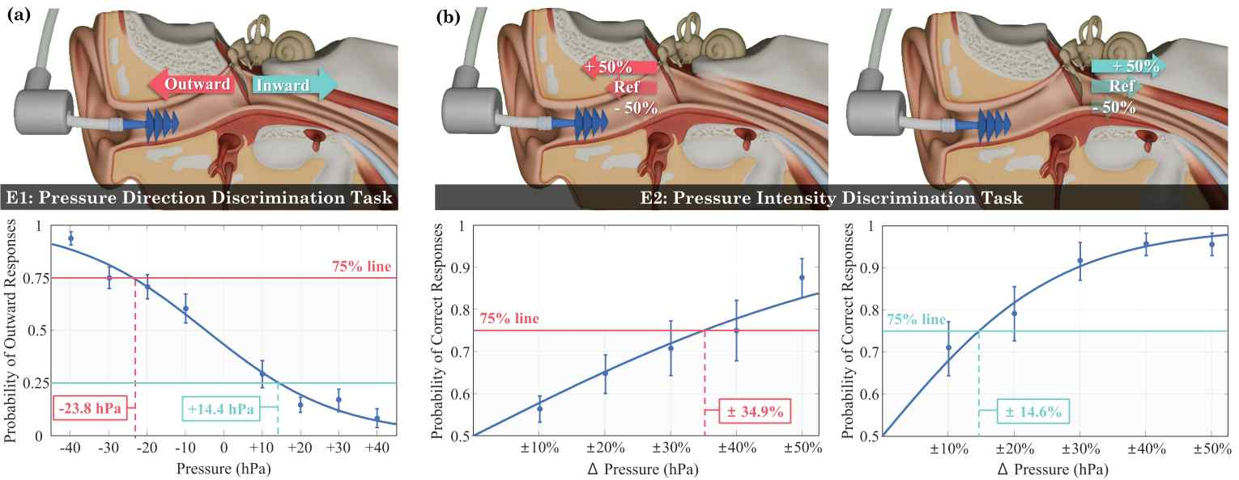

▲ Pressure perception experiment results. (a) Direction discrimination task: Pressure inside and outside the ear was distinguished with 75% accuracy at ±23.8 hPa and +14.4 hPa levels. (b) Intensity discrimination task: Pressure intensity differences were distinguished with 75% accuracy at ±34.9% and ±14.6% levels.

'EarPressure VR's lightweight, wearable design allows for pressure changes to be simulated without the need for additional bulky equipment. This allows for diverse applications, including: ▴ specialized fields such as remote surgery, disaster relief, and diving training; ▴ virtual mountaineering experiences in exercise and health apps; and ▴ the sensation of powerful low-frequency pressure when listening to music.

Professor SeungJun Kim described this research as "an innovative technology that allows users to directly experience environmental pressure changes, previously difficult to implement, through intra-ear pressure control." He emphasized that "it will fundamentally transform the user experience across future technologies, including VR, AR, remote work, and training simulations."

This research, led by Professor SeungJun Kim of the Department of AI Convergence at GIST and participated by researchers Seongjun Kang, Gwangbin Kim, Bocheon Gim, Jeongju Park, and Semoo Shin, was supported by the Ministry of Science and ICT (MSIT) through the Institute of Information and Communications Technology Planning (IITP) and the National Research Foundation of Korea (NRF).

The results of this research were presented at ACM UIST 2025 (September 28-October 1, Busan), one of the world's most prestigious academic conferences in the field of user interface and interaction technology. The on-site demonstration booth garnered significant interest from visitors who experienced "EarPressure VR."

The research team plans to continue follow-up research to integrate it with commercial VR devices and expand its application to various fields.

* ACM UIST 2025 (The ACM Symposium on User Interface Software and Technology): Hosted by the Association for Computing Machinery (ACM), this international academic conference presents and shares the latest research findings in the field of user interface and interaction technology. The 2025 competition was held in Busan from September 28 to October 1, with experts from academia and industry attending to demonstrate and evaluate innovative technologies and research.

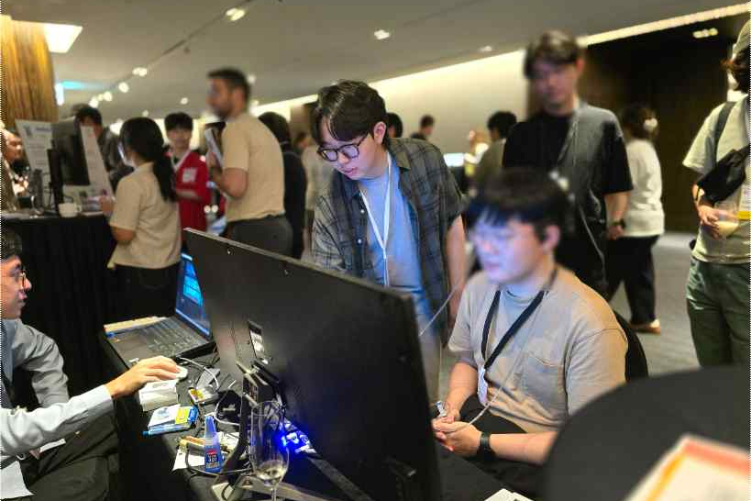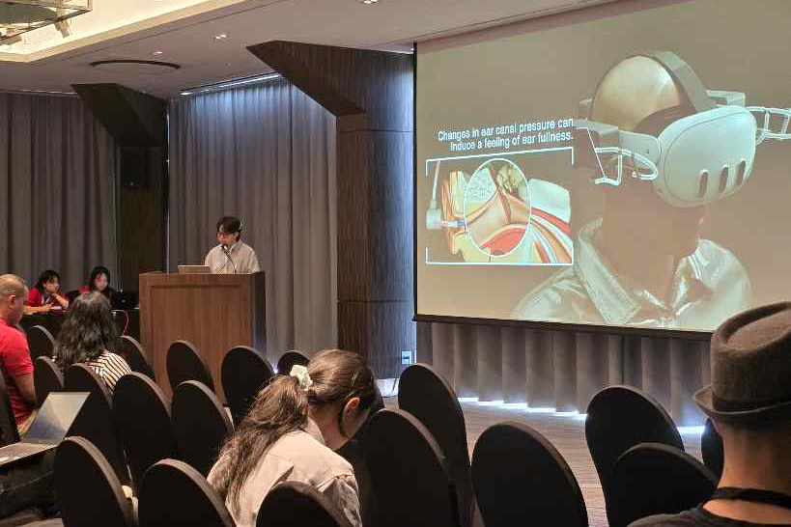

▲ (Left) Researcher Seongjun Kang guides conference attendees through the "EarPressure VR" device experience. (Right) Explaining the operating principles of "EarPressure VR" at "ACM UIST 2025."

Meanwhile, GIST stated that this research achievement considered both academic significance and industrial applicability, and that technology transfer-related discussions can be conducted through the Technology Commercialization Center (hgmoon@gist.ac.kr).



