"Ultrafine dust concentration alone is not enough" GIST developed an AI model that analyzes ultrafine dust components to precisely predict health risks

- Professor Kihong Park's team from the Department of Environment and Energy Engineering collected data on the composition and toxicity of ultrafine dust in urban and rural areas of Korea and China, developing a model to diagnose and predict the toxicity and causes of ultrafine dust... The model can be utilized even without actual toxicity data

- Using "Explainable AI" technology, the team identified key oxidizing toxic components such as manganese, lead, and copper, and even elucidated interactions between these components... This enables precise prediction of health risks, contributing to public health risk prevention and policymaking

- Published in the 《Journal of Hazardous Materials》

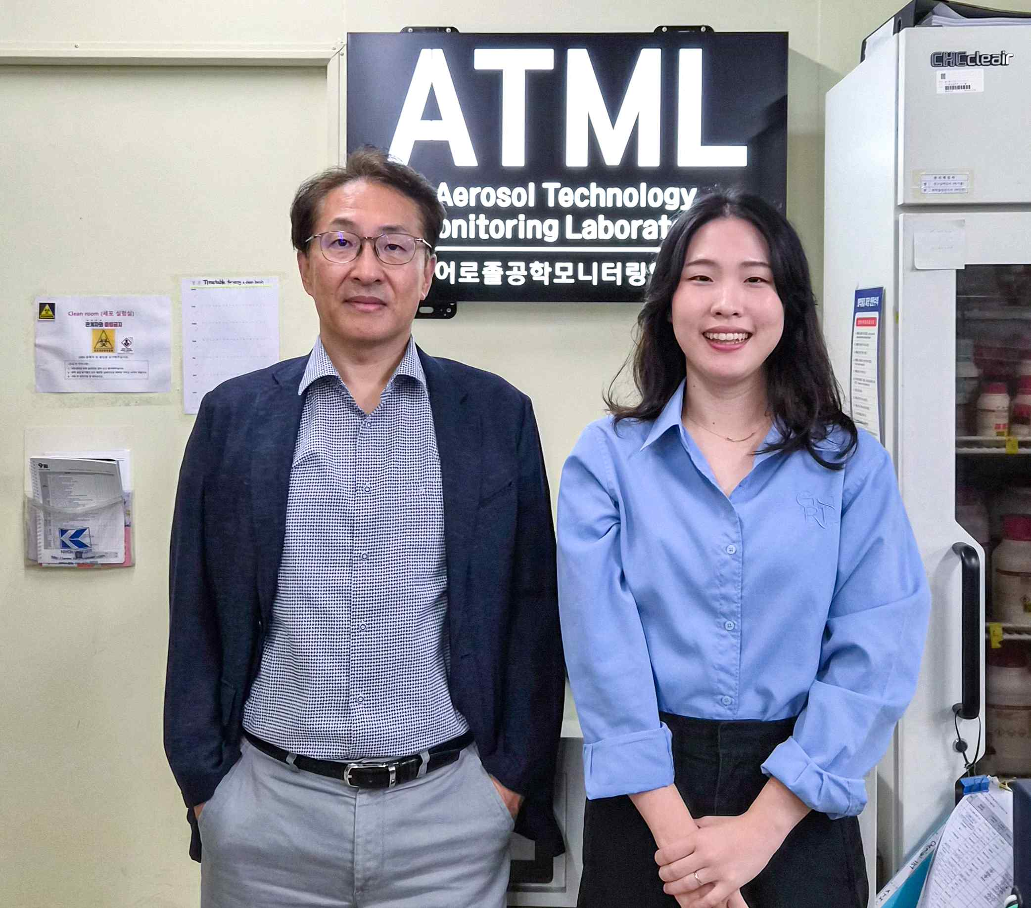

▲ (From left) Professor Kihong Park and Ph.D. student Seunghye Lee of the Department of Environment and Energy Engineering at GIST

In Korea, the risk of ultrafine dust is primarily assessed based on concentration*. However, the actual health impact varies significantly depending not only on concentration but also on the type and amount of hazardous substances that make up ultrafine dust.

Therefore, to more accurately understand the health impact, it is crucial to examine the hazardous substances and toxicity information contained in ultrafine dust.

* concentration: A numerical value indicating the amount of a specific substance contained in a given volume of air, typically expressed in µg/m³ (micrograms per cubic meter). Higher concentrations of ultrafine dust increase the risk of respiratory and cardiovascular diseases, leading to greater health impacts. Therefore, concentration is used as an important indicator for assessing and managing public health.

The Gwangju Institute of Science and Technology (GIST, President Kichul Lim) announced that a research team led by Professor Kihong Park of the Department of Environment and Energy Engineering analyzed the chemical composition and oxidative potential (OP)* of ultrafine dust (PM2.5) collected from China and Korea, and developed an artificial intelligence (AI) prediction model based on this.

The research team noted that the concentration of ultrafine dust alone cannot fully explain the impact on human health. Therefore, they utilized the oxidative stress capacity (oxidative potential) of fine dust in the body as a new health risk indicator.

* oxidative potential (OP): This index indicates the ability of fine dust to induce oxidative stress in the body. A higher OP indicates a greater likelihood of generating reactive oxygen species (ROS) within the body, potentially increasing the potential for adverse health effects on respiratory and cardiovascular systems.

Directly measuring the harmful components and toxicity of ultrafine dust* requires significant time and expense.

Consequently, the research team simultaneously collected data on ▴ concentration, ▴ chemical components, and ▴ oxidative toxicity (OP)* from urban and rural areas in Korea, China, and other countries for several years and trained an AI model. As a result, they selected an optimal model that most accurately predicted oxidative toxicity based solely on concentration and chemical components.

* Fine dust (PM2.5): Fine dust particles measuring 2.5 micrometers (㎛) or less in diameter, approximately 1/30th the diameter of a human hair. They can penetrate deep into the lungs, directly impacting health, including respiratory and cardiovascular diseases.

* oxidative potential: This is an indicator of the ability of fine dust to induce oxidative stress in the body. The higher the OP, the greater the impact on respiratory and cardiovascular health by generating active oxygen.

In particular, the research team applied "Explainable AI (XAI)*" to identify the chemical components most significantly impacting the oxidative toxicity of fine dust.

The results revealed that manganese (Mn), lead (Pb), copper (Cu), zinc (Zn), and water-soluble organic carbon (WSOC) were important contributors to fine dust. Among these, manganese (Mn) had the greatest impact on oxidative toxicity, followed by lead (Pb), water-soluble organic carbon (WSOC), copper (Cu), and zinc (Zn).

* Explainable AI (XAI): The research team developed an AI model that predicts oxidative toxicity (OP) using the chemical composition and concentration of ultrafine dust (PM2.5). By applying explainable AI technology, the research team was able to verify the basis for how the model determined oxidative toxicity. This increases the reliability of the prediction results and facilitates more transparent use in health impact assessments and policymaking.

XAI analysis also elucidated the interaction effects between chemical components.

For example, when the copper (Cu) concentration is 0.004㎍/㎥ (micrograms per cubic meter) or higher, a strong antagonistic effect (a phenomenon in which two substances weaken each other's influence) occurs in the interaction with water-soluble organic carbon (WSOC), and the phenomenon of suppressing the increase in oxidation potential (OP) was observed. This is an achievement that discovered a nonlinear interaction (mutual influence that appears in a complex way rather than a linear proportional relationship) that is difficult to reveal with existing statistical analysis alone.

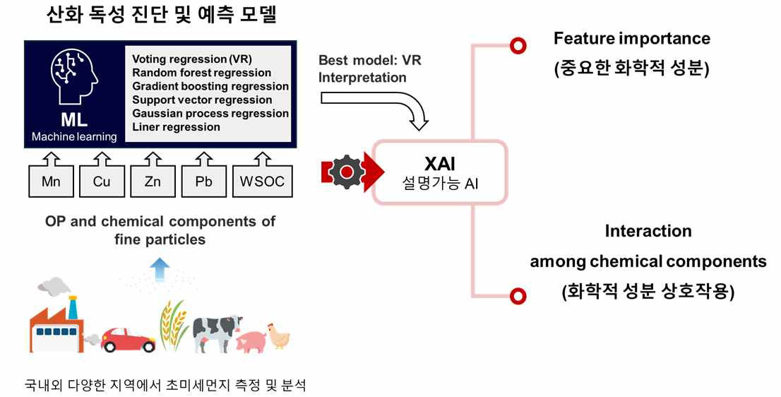

▲ Explainable AI-Based: The research team developed an AI model that predicts oxidative potential (OP) using the chemical composition and concentration of fine particulate matter (PM2.5). By applying explainable AI technology, the model can be used to verify the basis for its oxidative potential assessment. This increases the reliability of the prediction results and facilitates more transparent use in health impact assessments and policymaking.

The newly developed AI model can precisely diagnose the health risks of fine particulate matter and predict trends across diverse environments, transcending specific countries or regions. This allows it to be utilized for public health risk prevention and policymaking.

The research team anticipates that this technology will significantly contribute to the development of new fine particulate matter health indicators and can be applied to the health impacts of fine particulate matter generated indoors as well as outdoors.

Professor Kihong Park stated, "This study is significant in that it presents a precise health risk assessment method that considers not only the simple concentration of fine dust but also the chemical properties and interactions between its constituents." He added, "This 'explainable AI' technique can provide a scientific basis not only for air pollution management but also for national policymaking."

This research, supervised by Professor Kihong Park of the Department of Environment and Energy Engineering at GIST and conducted by doctoral student Seunghye Lee and others, was supported by the Ministry of Science and ICT and the National Research Foundation of Korea's Individual Basic Research Program (Mid-career Researcher).

The results were published online in the international academic journal 《Journal of Hazardous Materials》 on September 11, 2025.

Meanwhile, GIST stated that this research achievement considered both academic significance and industrial applicability, and that technology transfer inquiries can be made through the Technology Commercialization Center (hgmoon@gist.ac.kr).



