"Color-based warning of thermal changes!" GIST-KAIST joint research team develop a "nano-optical temperature visualization sensor" that warms before temperatures reach 80 degrees

- A joint research team led by Professor Hyeon-Ho Jeong of GIST and Professor Young Min Song of KAIST uses a thermochromic nanophotonic device to detect battery temperatures below 80 degrees Celsius within one second, providing a real-time visual warning of potential fire hazards

- This research is expected to prevent battery fires and improve safety in electric vehicles, smart devices, and other devices... Published in the international journal 《Advanced Materials》



▲ (From left in the front row) Professor Young Min Song of the School of Electrical Engineering at KAIST, Professor Hyeon-Ho Jeong of the Department of Electrical Engineering and Computer Science at GIST, (From left in the back row) researchers Juhwan Kim, Hyun Min Kim, and JuHyeong Lee of the Department of Electrical Engineering and Computer Science at GIST

A technology capable of detecting the risk of electric vehicle battery fires has been developed by a Korean research team. This technology is expected to prevent serious accidents such as fires and explosions by detecting signs of internal battery abnormalities early.

A joint research team led by Professor Hyeon-Ho Jeong of the Department of Electrical Engineering and Computer Science at the Gwangju Institute of Science and Technology (GIST, President Kichul Lim) and Professor Young Min Song of the School of Electrical Engineering at the Korea Advanced Institute of Science and Technology (KAIST) has developed a nano-optical temperature sensor that can detect the risk of thermal runaway in real time below 80 degrees Celsius (166 degrees Fahrenheit) before the internal temperature of a battery reaches dangerous levels and intuitively warn users.

Batteries are essential energy sources for cutting-edge technologies such as electric vehicles, wearable devices, and urban air mobility (UAM). However, safety concerns are rising due to the recent spate of fires and explosions caused by thermal runaway.

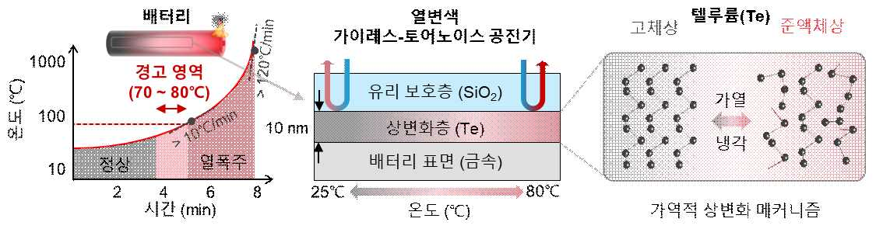

▲ Nano-optical Temperature Visualization Sensor: (Left) The relationship between battery temperature and operating status, and (Right) The structure and operating principle of the nano-optical device developed in this study to preemptively detect battery thermal runaway based on this relationship.

In particular, when the internal temperature of a battery exceeds 80°C, key internal components such as the electrolyte and separator begin to deteriorate, and temperatures can rapidly soar to over 500°C within a minute. Therefore, the development of technology capable of early temperature detection and early warning of danger is urgent.

Existing temperature sensors can only measure the area directly contacted by the thermocouple*, making it difficult to determine the overall temperature distribution. Infrared cameras also suffer from measurement accuracy limitations depending on the surface material. Furthermore, existing technologies utilizing thermochromic materials have slow response times, making them unsuitable for real-time detection.

* thermocouple: A sensor composed of two dissimilar metal wires joined together. It detects temperature by measuring the voltage change caused by the temperature difference at the junction.

The research team focused on the unique optical modulation properties of tellurium, a single-element element reported in the 1960s, and developed a thermochromic nanophotonic device utilizing a 10-nanometer (nm)-thick tellurium ultrathin film.

Tellurium partially melts from a solid state to a quasi-liquid state when the temperature rises from room temperature to 80°C. This exceptional optical modulation characteristic, with a refractive index of more than 0.7 changing in the visible light range, enables ultra-high-speed temperature sensing at scales of 100 millionths of a second.

* quasi-liquid: A state between a solid and a liquid, characterized by a substance that is not rigid like a complete solid but rather flows or moves like a liquid. In this state, solid and liquid phases coexist, exhibiting partial fluidity as the temperature rises.

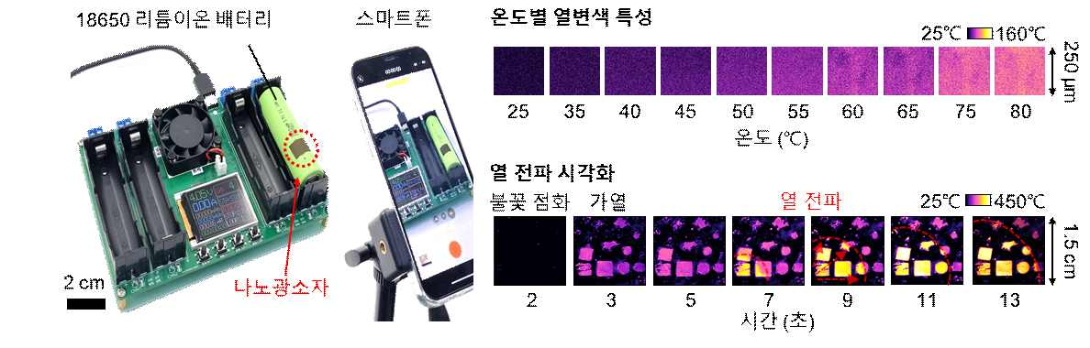

▲ Temperature sensing performance of the fabricated nanophotonic device: Visualization of temperature-dependent color change and heat propagation of the nanophotonic device developed in this study.

The research team deposited an ultra-thin layer of tellurium (Te), 10 nanometers (nm) thick, on the surface of an aluminum-based battery, and then laminated a glass (SiO2) protective layer, tens of nanometers thick, over it to create a Gires-Tournois resonator* whose reflection color changes with temperature.

This resonator maximizes the optical properties of tellurium due to its solid-to-quasi-liquid phase transition, even at relatively low temperatures below 80°C. The glass protective layer protects the tellurium from environmental damage, ensuring stability.

Furthermore, it operates without complex circuitry or a separate external power source. It exhibits reversible properties, changing color upon reaching a certain temperature and then returning to its original color upon cooling back to room temperature.

* Gires-Tournois resonator: An optical device that reflects light of a specific wavelength and causes a phase shift. It uses a thin film structure to control the interference phenomenon of light. This allows for precise control of light reflectance and color, which is utilized to maximize optical signal changes due to temperature changes.

The fabricated nanophotonic device can precisely distinguish temperature changes in color from room temperature (25°C) to 80°C, demonstrating temperature detection performance similar to that of commercial thermocouples. Furthermore, it visualizes the temperature distribution and heat diffusion process on the battery surface in real time with a fast video frame interval of 17 milliseconds (ms).

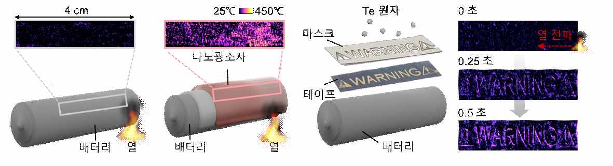

▲ Visualization of Battery Surface Temperature Distribution: Real-time monitoring of the battery's temperature distribution and heat propagation using nanophotonic devices patterned in various shapes.

Furthermore, it reliably detects temperature even after dozens of heating-cooling cycles and changes in ambient humidity, demonstrating excellent durability with thermochromic properties maintained even after nine months.

The research team successfully applied the developed nano-photonic device to commercial 18650 batteries and smartphones, monitoring the heat generated during charging and discharging in real time, thereby proving the practical applicability of the technology.

This optical element can be deposited directly onto battery cells or simply attached with tape, making it easily applicable to industrial settings. Anyone can easily check battery temperature using a smartphone or digital camera, without the need for specialized equipment or analysts, making its commercialization highly promising.

Professor Hyeon-Ho Jeong of GIST explained, "By combining tellurium's optical modulation properties with nanophotonics technology, we have secured a fundamental technology that can provide early warning of battery explosion risks. It is expected to be utilized in diverse fields, including electric vehicles, aviation, space, firefighting, and wearable devices."

Professor Young Min Song of KAIST stated, "With the recent string of battery fire incidents occurring both domestically and internationally, ensuring safety has become increasingly important. We anticipate that this technology will present a new paradigm for next-generation battery safety and contribute to solving societal problems."

This research, supervised by Professor Hyeon-Ho Jeong of the Department of Electrical Engineering and Computer Science at GIST and Professor Young Min Song of the School of Electrical Engineering at KAIST, and conducted by researchers Hyun Min Kim, JuHyeong Lee, Juhwan Kim, Gyurin Kim, Jang-Hwan Han, and Joo Hwan Ko at GIST, was supported by the Ministry of Science and ICT and the National Research Foundation of Korea through the Excellent Young Researcher Program, Future Technology Research Lab Program, and the GIST-MIT AI International Collaboration Program. It was published online in the renowned international materials journal Advanced Materials on July 23, 2025.

Meanwhile, GIST stated that this research achievement considered both academic significance and industrial applicability, and that technology transfer inquiries can be made through the Technology Commercialization Center (hgmoon@gist.ac.kr).



