"What if our windows could provide a clear view while also generating electricity?" GIST develops next-generation semitransparent solar cells, simultaneously achieving high transmittance and efficiency

- A joint research team led by Hongkyu Kang, Senior Researcher at the Research Institute for Solar and Sustainable Energies, and Professor Kwanghee Lee of the Department of Materials Science and Engineering, simultaneously overcomes the tradeoff between transparency and efficiency by incorporating additives that optimize charge transfer into a simple device design

- Achieved 37.5% transparency and 10.7% power generation efficiency, while also achieving a world-leading light utilization efficiency (LUE) of 4.01%, demonstrating potential for practical applications in windows, building exteriors, and vehicle glass

- Selected as a "Hot Paper" by the international academic journal 《Journal of Materials Chemistry A》



▲ (From left) GIST Research Institute for Solar and Sustainable Energies Senior Researcher Hongkyu Kang, Department of Materials Science and Engineering Professor Kwanghee Lee, master's and doctoral program student Juhui Oh (first author), and Dr. Ju-Hyeon Kim (first author)

The Gwangju Institute of Science and Technology (GIST, President Kichul Lim) announced that a joint research team led by Senior Researcher Hongkyu Kang of the Research Institute for Solar and Sustainable Energies and Professor Kwanghee Lee of the Department of Materials Science and Engineering has developed a fundamental technology that can significantly improve the transparency and power generation efficiency of next-generation semitransparent organic photovoltaics (ST-OPVs)*.

This achievement presents a new design strategy that achieves both transparency and power generation efficiency with a simple device design, eliminating the need for complex multilayer structures. This achievement demonstrates that semitransparent organic photovoltaics are a practical, next-generation energy technology.

* semitransparent organic photovoltaics: A type of organic photovoltaic (OPV) that generates electricity by absorbing light. These OPVs transmit a portion of visible light. Therefore, they can be applied to applications requiring transparency, such as windows and building exteriors, and have diverse applications, including building-integrated photovoltaics (BIPV), vehicle-integrated photovoltaics (VIPV), and portable electronic devices.

Organic solar cells* are lightweight, flexible, and amenable to mass production through solution processes, attracting attention as next-generation solar cells with diverse applications, including building-integrated photovoltaics (BIPV), vehicle-integrated photovoltaics (VIPV), and portable electronic devices. In particular, semitransparent organic solar cells can be utilized as “solar windows” because they transmit visible light and selectively absorb only near-infrared light to generate electricity.

However, due to the inherent nature of semitransparent structures, increasing transparency (AVT) reduces power generation efficiency (PCE), and increasing power generation efficiency reduces transparency. This trade-off has made it difficult to simultaneously achieve both performances.

* organic photovoltaics (OPVs): A type of solar cell that converts sunlight into electricity. These cells utilize organic semiconductor materials (e.g., polymers and small molecules) as the photoactive layer. They are lightweight, flexible, and can be manufactured at low cost and on a large area through printing processes, making them ideal for a wide range of applications, including building exteriors, windows, vehicles, and wearable devices.

* trade-off problem: Solar cells must absorb light to generate electricity. However, in cases like semitransparent organic solar cells, which require transparency, the more light they transmit, the less light is absorbed, lowering power generation efficiency. Conversely, increasing efficiency requires maximizing light absorption, which reduces transparency and makes the material unsuitable for applications requiring transparency, such as building windows and vehicle panels.

To solve this problem, the research team reduced the content of electron donors*, which are materials that absorb visible light, to increase transparency, and instead introduced a hole transport additive (Me-4PACz) that helps the electricity flow smoothly.

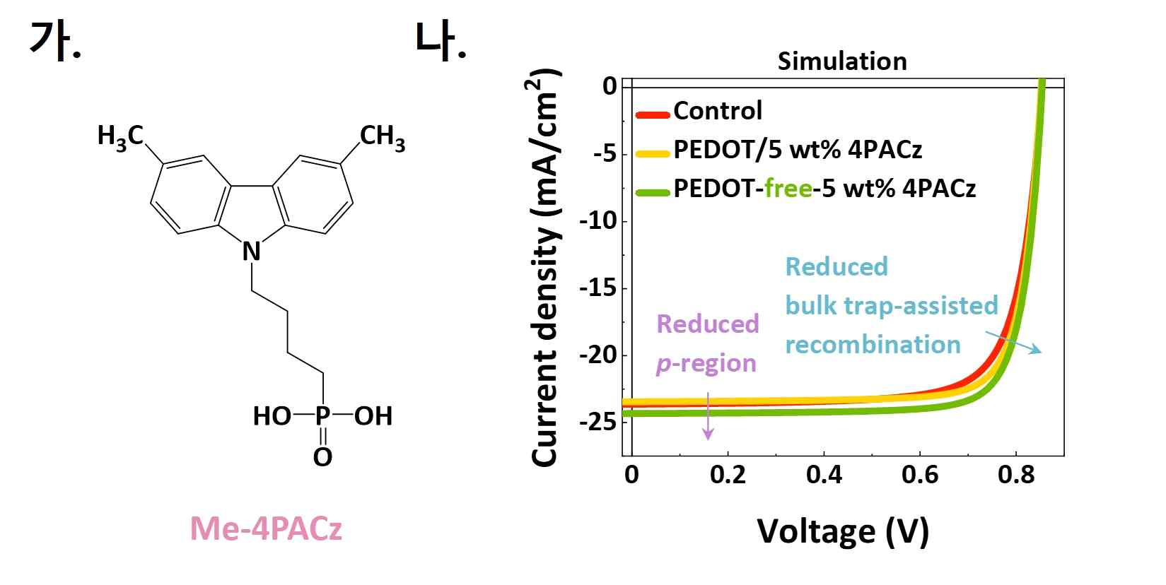

▲ (a) Chemical structure of the additive (Me-4PACz) used in this study; (b) Device performance simulation results (Me-4PACz is a self-assembling hole transport layer material. Its addition to the photoactive layer reduced defects and recombination at the ITO/photoactive layer interface and within the bulk, as confirmed through current-voltage (J-V) simulations).

This additive (Me-4PACz) has the property of uniformly dispersing within the photoactive layer of a solar cell while simultaneously forming a hole transport layer (HTL)*, a thin layer that facilitates current flow on the electrode surface. This optimizes the path of electric charge transfer and reduces unnecessary losses, successfully achieving both high transparency and power generation efficiency.

* electron donor: A material forming the photoactive layer of an organic solar cell. When it absorbs sunlight above its band gap, electrons and holes are generated in pairs. The generated electrons and holes separate at the interface between the electron donor and the electron acceptor, with electrons moving toward the electron acceptor and holes toward the electron donor. Generally, electron donors strongly absorb visible light, so their content must be reduced when making semitransparent organic solar cells. However, this disrupts the balance of electron and hole movement, leading to increased charge loss and lowered efficiency.

* hole: A vacancy created by the loss of an electron, a unit of charge that moves like a positive charge. In solar cells, a balanced movement of electrons and holes is essential for reducing charge loss and increasing power generation efficiency.

* hole transport layer (HTL): This layer efficiently transports holes generated in a solar cell toward the electrode. Separating the electron and hole paths and reducing charge recombination is crucial for increasing the charge transport efficiency and overall power generation efficiency of a solar cell.

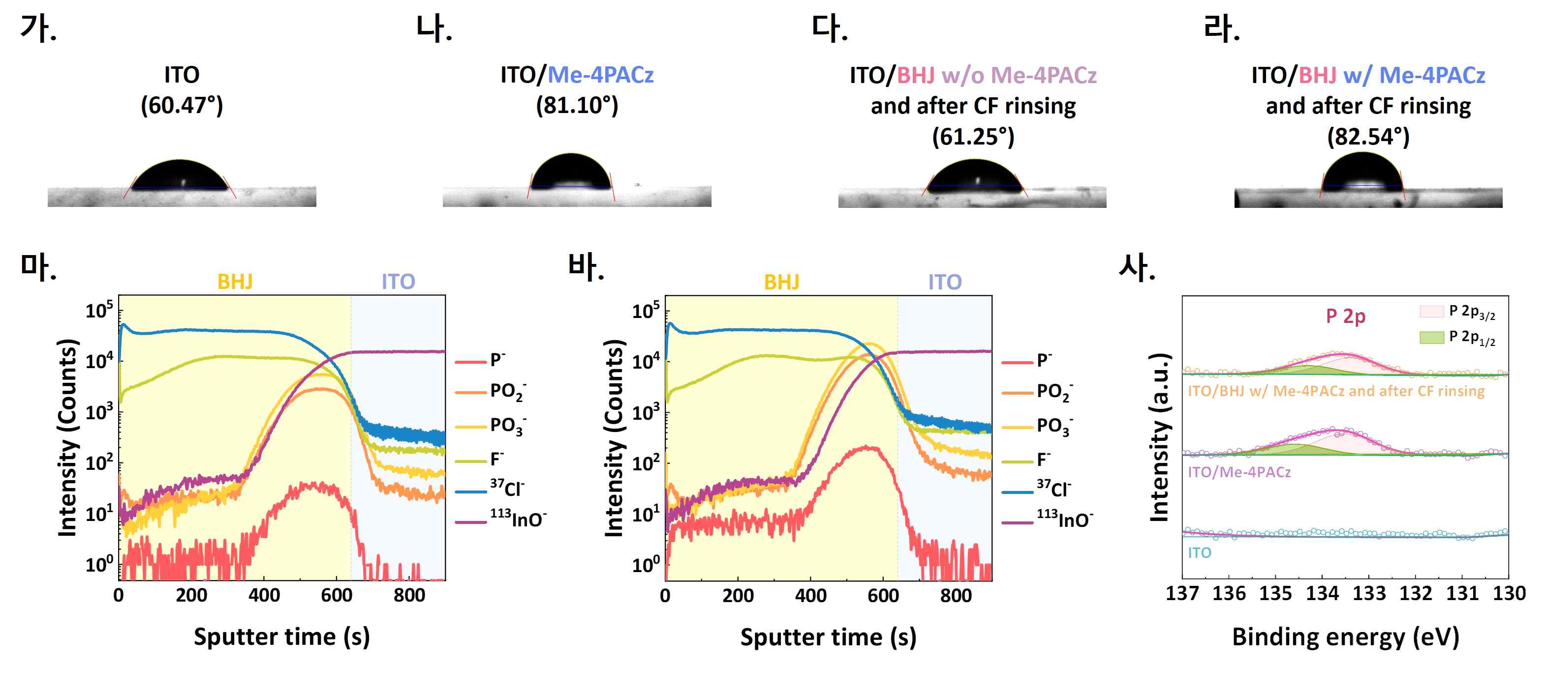

▲ (a-d) Water contact angle images of ITO, ITO/Me-4PACz, ITO/BHJ w/o Me-4PACz and after CF rinsing, and ITO/BHJ w/Me-4PACz and after CF rinsing, (e) Time-of-flight secondary ion mass spectrometry curve of ITO/PEDOT:PSS/BHJ, (f) Time-of-flight secondary ion mass spectrometry curve of ITO/BHJ w/Me-4PACz, (g) X-ray photoelectron spectroscopy graph (Me-4PACz self-assembles on the ITO surface to form a hole transport layer. In particular, it can be seen that this layer is formed with a gradual concentration distribution, which is more advantageous for hole transport).

The research team, in collaboration with Dr. Oskar J. Sandberg's research team at Åbo Akademi University in Finland, conducted electro-optical device simulations* to analyze how the additives actually contributed to performance enhancement.

The results confirmed that the additives acted both at the interface* and in the bulk* of the solar cell, suppressing recombination*, a phenomenon where charges reunite and dissipate.

* interface: The boundary where two different materials come into contact. In this study, it refers to the interface between the ITO electrode and the photoactive layer, playing a crucial role in charge transfer and separation.

* bulk: The term refers to the entire material or internal region. In organic solar cells, it refers to the interior of the photoactive layer, i.e., the region where electron donors and acceptors are mixed. The characteristics of charge generation and movement within this region determine solar cell efficiency.

* recombination: The phenomenon in which electrons and holes generated by light absorption in a solar cell reunite and annihilate. This process produces no electricity but instead results in energy loss. Therefore, minimizing recombination is a key challenge in developing high-efficiency solar cells.

More specifically, at the interface, the additive formed a self-contained hole transport layer, lowering contact resistance with the electrode and facilitating charge transfer. In the bulk region, it facilitated the stable separation and movement of electron-hole pairs (excitons) generated by light absorption, preventing unnecessary losses.

This mechanism is believed to significantly increase the potential for commercialization of semitransparent organic solar cells by reducing current loss and extending device lifespan.

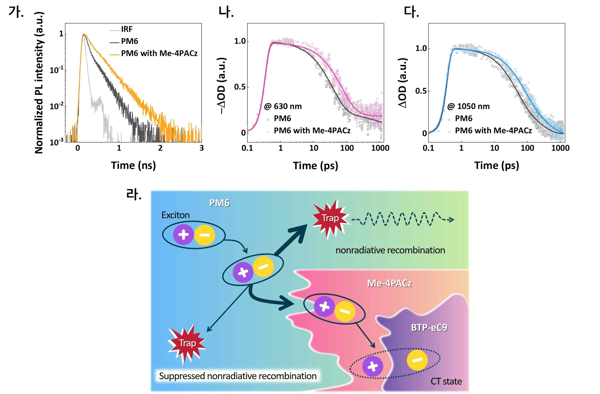

▲ (a) Time-resolved photoluminescence spectrum; (b) Decay curve in the ground-state bleaching region; (c) Dynamics curve in the photo-induced absorption region; (d) Schematic diagram of charge transfer within the bulk heterojunction with and without Me-4PACz (the addition of Me-4PACz confirmed that excitons generated from the electron donor migrate to the additive, reducing nonradiative recombination and trapping losses. The schematic diagram visually illustrates this charge transfer mechanism within the bulk).

Significant results were also achieved in actual performance. The research team achieved an average visible light transmittance (AVT)* of 37.53% and a power conversion efficiency (PCE) of 10.7%. Furthermore, the team achieved a top-notch 4.01% in Light Utilization Efficiency (LUE), a comprehensive evaluation of both indicators, demonstrating the best performance among semitransparent organic solar cells under similar conditions.

* average visible transmittance: This indicator indicates how much light a solar cell transmits in the visible light range (380-780 nm). A higher value indicates greater transparency, similar to glass.

* power conversion efficiency: This indicator indicates how much solar energy a solar cell can convert into electrical energy. A higher value indicates greater power generation capacity.

* light utilization efficiency: Defined as the product of the power conversion efficiency, which indicates the power generation performance of a semitransparent solar cell, and the average visible light transmittance, which indicates transparency.

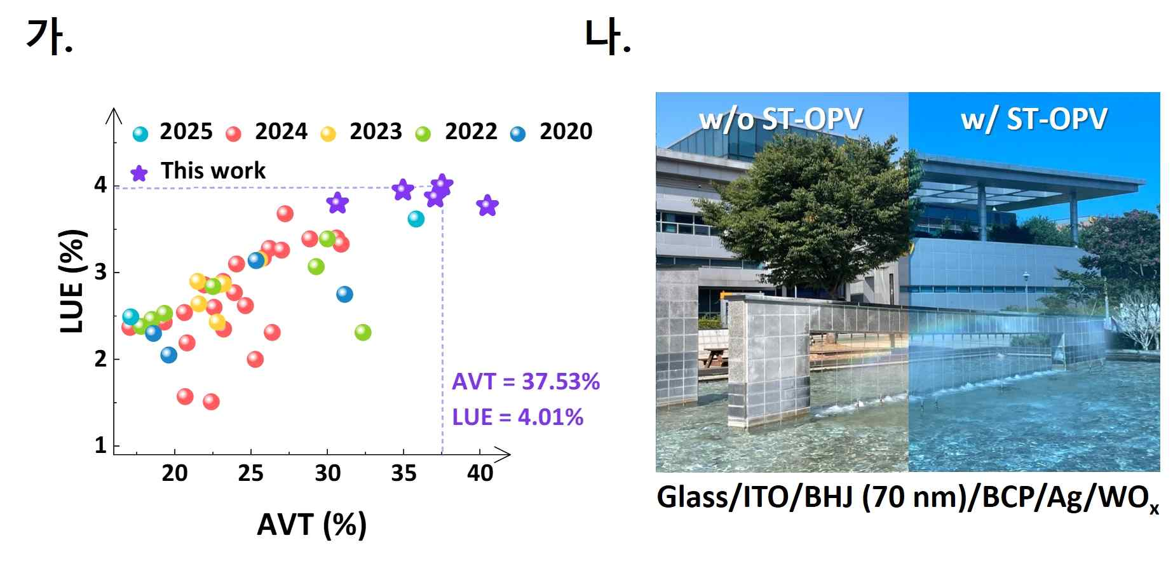

▲ (a) Graph of average visible light transmittance and light utilization efficiency, (b) Photograph of the semitransparent organic solar cell developed in this study. (The device developed in this study demonstrated excellent performance in both average visible light transmittance and light utilization efficiency. The actual photo also confirmed its high transparency, demonstrating its potential for application as transparent windows for buildings and vehicles).

Senior Researcher Hongkyu Kang stated, "This research is significant in that it resolves the long-standing tradeoff between transparency and efficiency in the field of semitransparent organic solar cells." He added, "If combined with transparent structures such as building windows and vehicle glass, it could significantly contribute to urban eco-friendly energy independence."

Professor Kwanghee Lee stated, "This achievement goes beyond simple material improvement. It presents a new approach that simultaneously controls the interface and internal regions of the device. The additives significantly enhanced performance by forming a hole transport layer at the interface and simultaneously suppressing charge loss within the photoactive layer."

This research, conducted by GIST Senior Researcher Hongkyu Kang of the Research Institute for Solar and Sustainable Energies and Professor Kwanghee Lee of the Department of Materials Science and Engineering as corresponding authors, and by Juhui Oh, a combined master's and doctoral student, and Dr. Ju-Hyeon Kim of Linköping University and the Heeger Center for Advanced Materials, was supported by the Ministry of Science and ICT (MSIT) and the National Research Foundation of Korea (NRF)'s Mid-Career Researcher Program and the Sejong Science Fellowship.

The results of this research were published online on August 21, 2025, in the international journal 《Journal of Materials Chemistry A》. The paper was selected as a "Hot Paper" in recognition of its significant academic and industrial impact and noteworthy achievement.



