GIST developed ultra-precision sensor calibration technology that can be installed on even a 27-gram ultra-small drone: Optimized for ultra-small drone environments with little data collection

- Professor Pyojin Kim's team from the Department of Mechanical and Robotics Engineering developed "SPLiCE" technology, which precisely aligns a single-directional lidar and camera... Even in situations where puzzle pieces are scattered, coordinate system alignment is possible, as if completing a picture

- Nano-drone experiments demonstrated high precision (positional error of 1 cm, angular error of 1°) for autonomous flight. Expected applications in disaster relief and exploration... Results to be presented at the IEEE International Conference on Intelligent Robot Systems (IROS 2025) in October

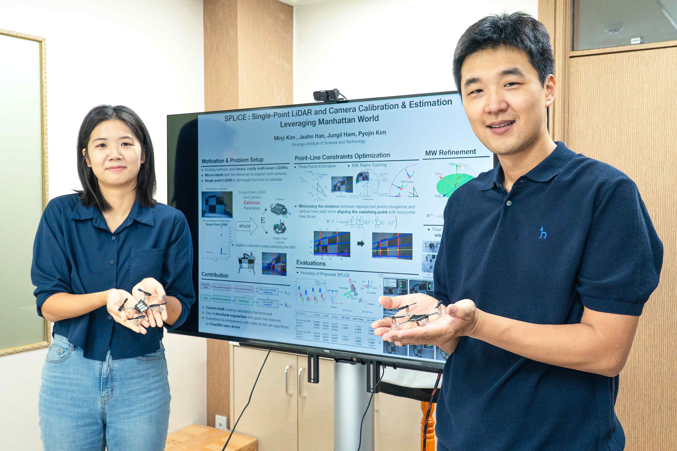

▲ (From left) Minji Kim, a student in the Department of Mechanical and Robotics Engineering, and Professor Pyojin Kim

The Gwangju Institute of Science and Technology (GIST, President Kichul Lim) announced that a research team led by Professor Pyojin Kim of the Department of Mechanical and Robotics Engineering has developed a new sensor calibration technology, SPLiCE (Single-Point LiDAR and Camera Calibration & Estimation), that can be utilized even in ultra-light drones.

This technology is designed to precisely align the position and orientation of a single-point LiDAR and camera, enabling accurate sensor alignment even in environments with significant weight and space constraints. This technology enables data fusion between sensors, enabling robots and drones to perform diverse missions, such as autonomous flight, exploration, and disaster relief, more reliably.

* Sensor Calibration: This process aligns the coordinate systems of information measured by different sensors and corrects any distortions or deviations that arise during the measurement process, ensuring an accurate reflection of the actual physical environment. Internal calibration reflects the internal characteristics of a single sensor, while external calibration precisely determines the position and orientation of different sensors.

* Data fusion (sensor fusion): This technology combines information from multiple sensors or data sources to produce more accurate and reliable results than a single sensor. Sensors complement each other and collaborate to reduce errors and generate new information. Techniques like Kalman filters and deep learning are utilized. Typical applications include autonomous driving, robot positioning, and military and medical applications.

Micro-drones are highly useful in disaster relief, industrial facility inspections, and narrow-space exploration. However, the weight of sensors that can be mounted on the drone is limited, necessitating the use of ultra-lightweight sensors like single-directional lidar instead of high-performance 3D lidar* sensors.

In these cases, the available data is extremely limited, making it much more challenging to precisely align the coordinate systems between sensors, much like assembling a puzzle with only a few pieces. This makes calibration technology all the more important.

* 3D LiDAR: A sensor technology that fires lasers in multiple directions, measures the time it takes for them to reflect, and then generates 3D point cloud data of the surrounding environment based on this data. It is used for precise spatial recognition in autonomous vehicles, robots, and drones.

Existing LiDAR-to-camera calibration methods have relied on the dense point cloud data obtained from multi-beam 3D LiDAR. However, ultra-small drones can only use single-directional LiDAR, resulting in very limited data. This means that the puzzle pieces needed to assemble the image are sparsely placed, making calibration difficult using existing methods.

To address this issue, the research team utilized the Manhattan World model*, a technique that simplifies calculations by assuming that buildings and indoor structures are mostly aligned horizontally and vertically.

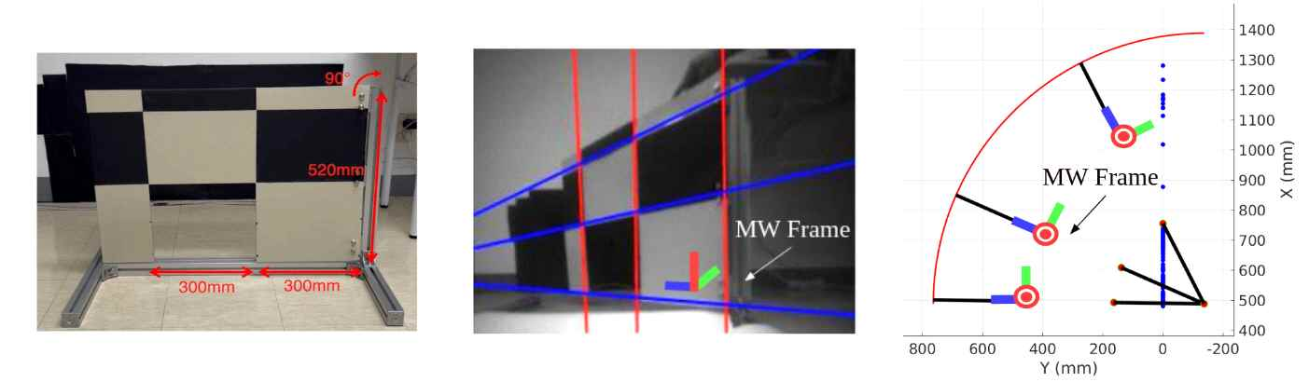
▲ The research team's designed rotational calibration board (left) and the Manhattan frame (center, right) based on straight lines and vanishing points extracted from the camera are shown.

The research team also presented a novel approach using their own calibration board. This board consists of a black-and-white grid and small square holes and can rotate like a door.

* Manhattan World model: A spatial structure model based on the assumption that buildings and indoor structures are mostly aligned horizontally and vertically. It is used in computer vision, robotics, and autonomous driving to simplify indoor and outdoor mapping, position estimation, and structure recognition, while improving computational efficiency.

LiDAR can only measure distances in one direction. However, by combining the distance changes caused by the board's rotation, along with information about the holes and the board's shape, a single measurement point can be accumulated and expanded into three reference points.

Meanwhile, the camera can reliably extract parallel lines and vanishing points through grid patterns and holes. By correlating the LiDAR reference points with the camera's linear information, the research team succeeded in precisely aligning the coordinate systems of the two sensors.

To verify the proposed technique, the research team mounted the sensor on a nano-drone platform, "Crazyflie (9cm x 9cm, 27g)*," and conducted various experiments.

As a result, the team reduced the average reprojection error*, a key metric for evaluating sensor calibration accuracy, to approximately 3 pixels, demonstrating significantly higher precision compared to existing methods. Furthermore, the positional error between sensors is approximately 1cm, and the 3-axis rotation (left/right, forward/backward, and directional) angle error is only approximately 1°, demonstrating stable calibration performance even in ultra-small drones.

* Crazyflie (ultra-small drone): Developed by Bitcraze in Sweden, this open-source ultra-small nano-drone measures 9cm x 9cm and weighs approximately 27g. It can accommodate small sensors weighing up to 15g and is equipped with various expansion decks, including cameras, distance sensors, and AI modules, making it widely used for research and education. Its lightweight and low-power structure makes it widely used for autonomous flight research and multi-swarm control in indoor or confined spaces.

* Reprojection Error: This metric quantifies the difference (in pixels) between the actually observed 2D point and the predicted projection point when projecting a 3D point onto the image plane using a camera model. It is primarily used as a performance evaluation criterion in camera calibration, SLAM, and 3D reconstruction. The error vector magnitude between the actual image coordinates and the projected coordinates is calculated as the average or sum of squares. A value closer to 0 indicates a better match between the projection model and actual observations.

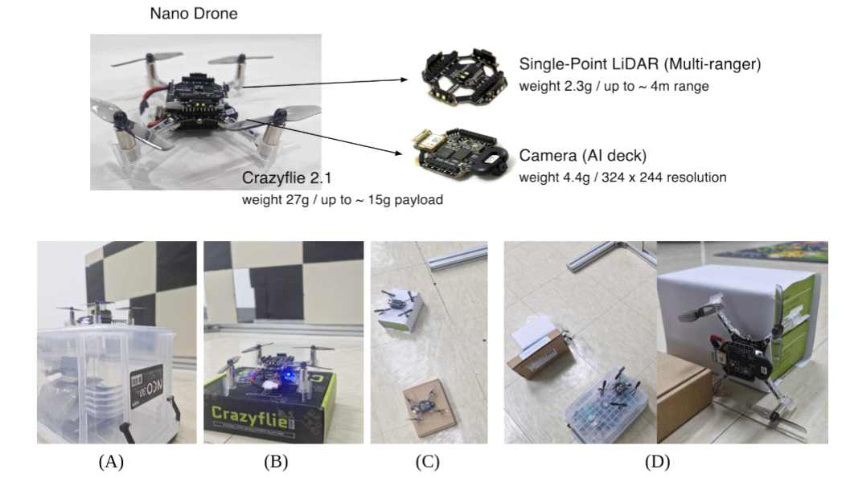

▲ This shows an experiment using a unidirectional LiDAR and camera (AI deck) mounted on the ultra-compact 27g drone "Crazyflie 2.1." (A–D) illustrate the sensor calibration and verification process in various environments.

In particular, 'SPLiCE' achieved high accuracy with significantly less data (15 pairs) than existing checkerboard-based techniques or virtual 2D LiDAR-based approaches. This significantly improves efficiency and practicality compared to existing methods that typically require 40 or more pairs of data.

This achievement enables stable sensor calibration even for ultra-small drones with significant weight and power constraints, and can develop into a core foundational technology that will support various future autonomous flight applications.

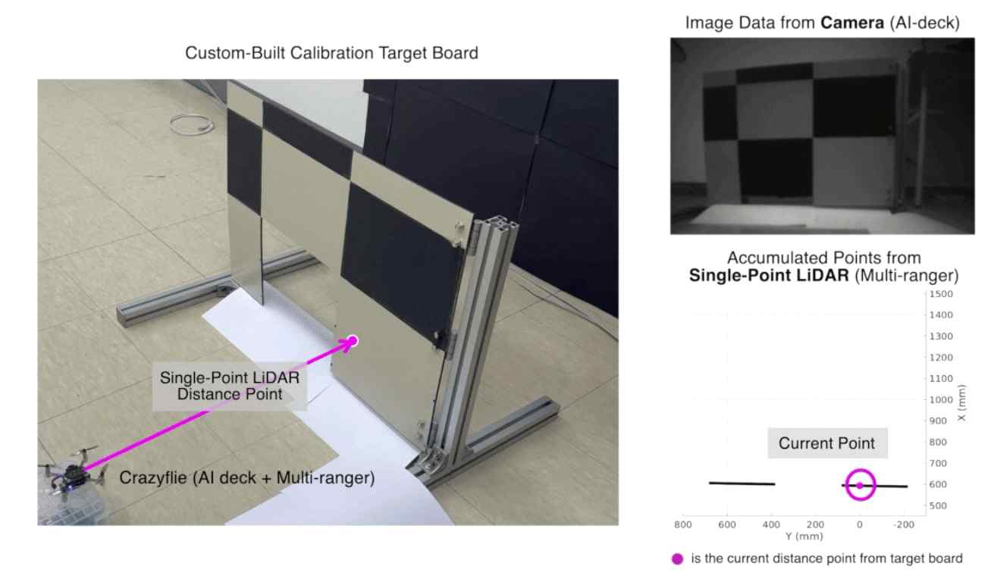

▲ The ultra-small drone 'Crazyflie' is shown collecting data using a unidirectional LiDAR and a camera (AI deck). The camera acquires grid images, and the LiDAR uses the accumulated distance values ​​from the rotation process for calibration.

Professor Pyojin Kim stated, "This research demonstrates a technology that enables precise calibration of LiDAR and cameras even in environments with significant sensor weight and performance constraints, such as ultra-small drones. It is expected that this technology will be utilized in the future for multiple drones to collaborate on missions such as mapping and exploration."

This research, supervised by Professor Pyojin Kim of the Department of Mechanical and Robotics Engineering at GIST and conducted by master's student Minji Kim, was supported by the Excellent Young Researcher Program of the Ministry of Science and ICT and the National Research Foundation of Korea (NRF).

The results of this research will be presented orally at the IEEE/RSJ International Conference on Intelligent Robots and Systems (IROS 2025), to be held in Hangzhou, China, in October 2025.

Meanwhile, GIST stated that this research achievement considered both academic significance and industrial applicability. Technology transfer inquiries can be made through the Technology Commercialization Center (hgmoon@gist.ac.kr).



